Introduction

The equatorial Atlantic region extends roughly from 10ºS - 10ºN and from 10ºE - 45ºW. The ocean is forced by the atmosphere through the Trade winds, northeasterly and southeasterly winds that converge in the equatorial region, generating Ekman divergence on the equator and downwelling to the south and north of it. In the atmosphere, where the Trade winds converge, there is a zone of strong convective activity, called the Intertropical Convergence Zone (ITCZ), which moves seasonally from around 3ºS in March-May to 10ºN in September-November. In the ocean, the equatorial circulation (Fig. 1) also exhibits strong seasonal variability and shows several zonal currents of small meridional and vertical scales (Stramma et al., 2003). The main near surface equatorial currents are the South Equatorial Current (SEC) flowing to the west between 3ºN and 8ºS, and the North Equatorial Counter Current (NECC) flowing to the east between 3ºN and 8ºN. Below the SEC, between 50 m and 300 m and centred at the equator, there is a strong eastward jet called the Equatorial Undercurrent (EUC). At intermediate depths, the mean currents are less documented. Nonetheless, intensive surveys at 35ºW have suggested the existence of a permanent westward current, the Equatorial Intermediate Current (Schott et al., 2003). The EIC is found below the EUC and extends to approximately 1000 m depth (Fig. 2).
The seasonal cycle is the largest atmosphere-ocean signal in the tropical Atlantic. At the equator, weak and variable winds prevail from January trough May when the ITCZ is in its southernmost position. As the ITCZ migrates northward, the south-easterly trade winds pick up and the winds along the equator intensify. Coupled with the wind velocities, the sea surface temperature (SST) along the equator also varies with a strong annual cycle. In the eastern tropical Atlantic, SSTs reach their maximum values in boreal spring, when the equatorial winds are weakest. As the year progresses, the trade winds along the equator intensify displacing eastern surface waters to the west. The resulting zonal pressure gradient in the ocean and associated uplifting of the thermocline leads to the cooling of SST in the eastern region. The upwelling in the Gulf of Guinea is an ongoing subject of study, since the magnitude and phase of the cold tongue cannot be explained by the forcing of local winds only (Picaut, 1982). As expected, the intensification of the zonal winds also leads to the intensification of the main surface currents.
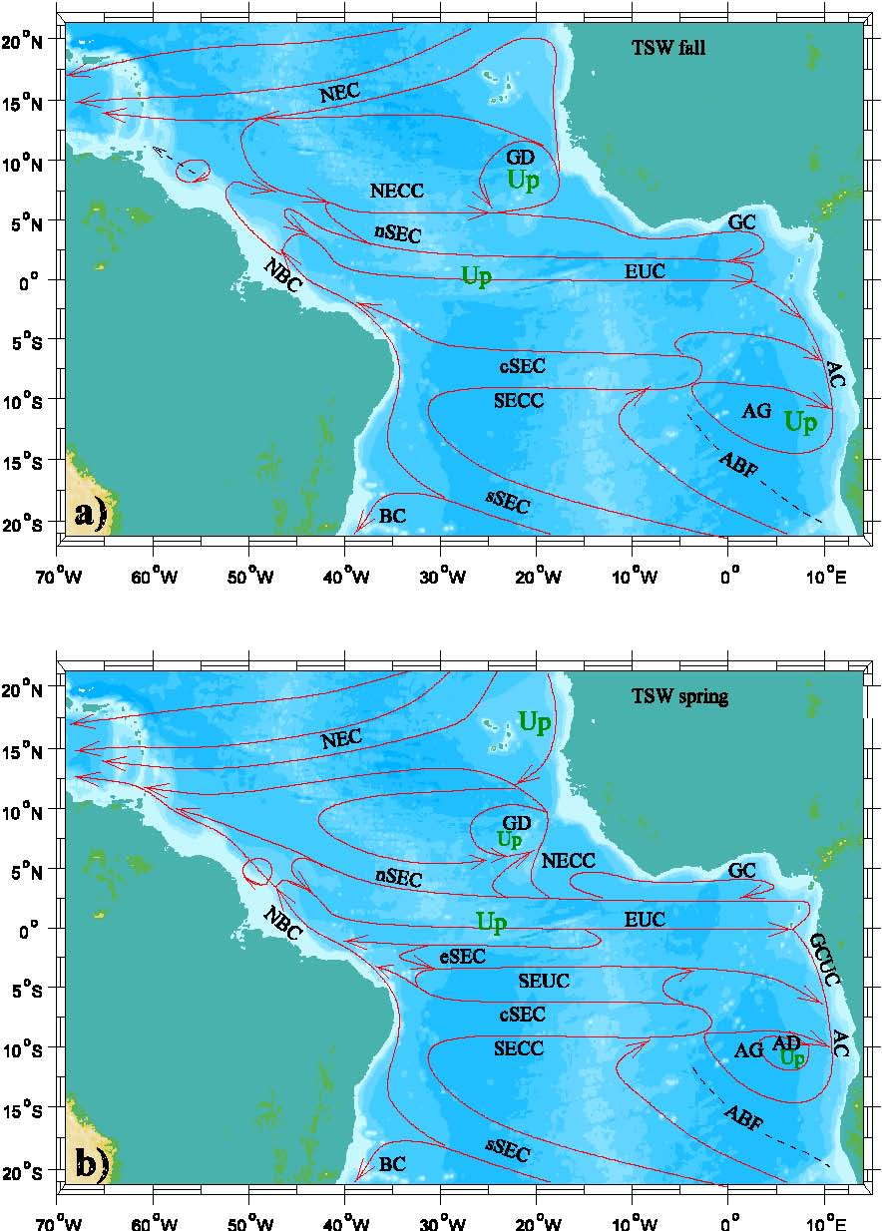
Figure 1: Schematic maps showing the horizontal distribution of the major tropical currents for the Tropical Surface Water layer at about 0-100 m depth for a) the northern spring and for b) the northern fall. Shown are the North Equatorial Current (NEC), the Guinea Dome (GD), the North Equatorial Countercurrent (NECC), the Guinea Current (GC), the South Equatorial Current (SEC) with the northern (nSEC), equatorial (eSEC), central (cSEC) and southern branches (sSEC), the Equatorial Undercurrent (EUC), the North Brazil Current (NBC), the Gabon-Congo Undercurrent (GCUC), the Angola Gyre (AG), the Angola Current (AC), the Angola Dome (AD), the South Equatorial Undercurrent (SEUC), the South Equatorial Countercurrent (SECC) and the Brazil Current (BC). The Angola-Benguela Front (ABF) is included as a dashed line. “Up” marks possible areas of upwelling. (after Stramma et al., 2003).

There are two modes of coupled ocean-atmosphere variability in the Tropical Atlantic affecting the weather in South America and Africa on annual and interannual time scales (Servain et al., 1998). The first mode is akin to the El Nino-Southern Oscillation (ENSO) in the Pacific, showing anomalous weak trade winds and warm SSTs during the warm phase and opposite conditions for the cold phase (e.g. Merle, 1980). The second mode is called the Atlantic dipole and consists of a north-south interhemispheric gradient in SST, intimately related to the position and intensity of the ITCZ (Nobre and Shukla, 1996). To the extent that sea surface temperatures (SSTs) are primarily driven by changes in surface winds, interannual variability in the equatorial Atlantic is mainly due to variations in the surface winds. Those variations can be forced either remotely or locally. The main variations in the remote forcing can be associated to events or variability over extratropical regions in the Atlantic while variations in the local forcing are due to changes in the position and intensity of the ITCZ (e.g. Chiang et al., 2002).

Figure 2: Mean zonal current distribution across 35ºW from the 13 sections, with transports (in Sv = 10⁶ m³/s) of the different current branches (from Schott et al., 2003).

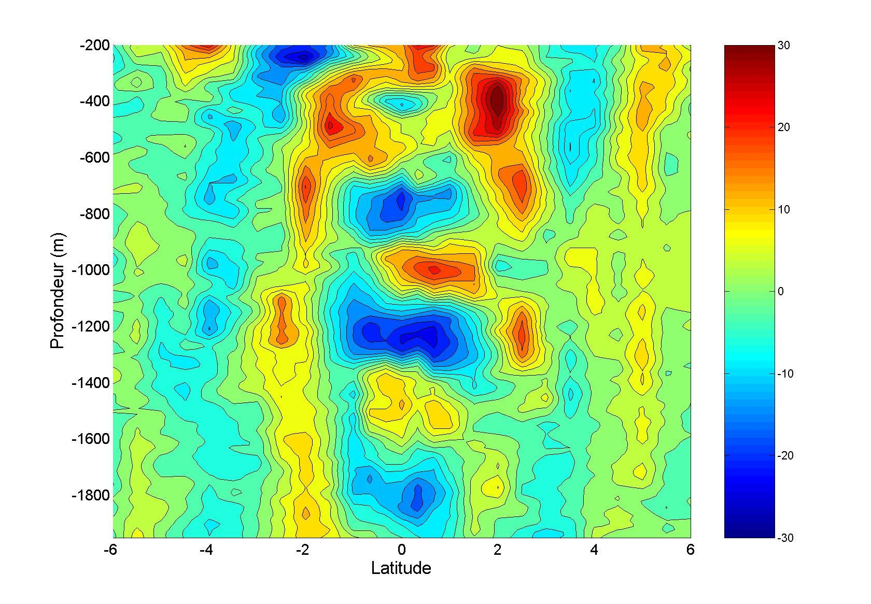
Figure 3: Meridional section of zonal velocity at 23ºW from EQUALANT campaign (Gouriou et al., 2001). Velocity units are in cm/s; positive values are eastward and negative values are westward. At the equator, Equatorial Deep Jets are easily detected and are confined between 2°N and 2°S. They have vertical scales of approximately 500 m and velocity magnitudes of more than 10 cm/s.

Near the surface, intraseasonal variability is due to many different processes. Among them are the forcing by intraseasonal winds and heat fluxes, and intrinsic mechanisms of the oceans like instabilities due to the velocity shear between zonal currents (Kessler, 2004). Although of smaller amplitude than the seasonal cycle, intra-seasonal variability can also play a role in climate variability. Results from Ocean General Circulation Model (OGCM) solutions suggest that intraseasonal atmospheric forcing acts to weaken the equatorial seasonal surface currents (Han, 2004) and that Tropical Instability Waves (TIWs) are potentially important in influencing the phase of the seasonal cycle and the position of the equatorial cold tongue and ITCZ (Jochum et al., 2003). In the Pacific Ocean, strong intraseasonal variability in the western Pacific is observed at the onset stages of El Nino events (e.g. McPhaden and Yu, 1999) and there is an ongoing debate on the role of intraseasonal variability in the ENSO cycle. In part because of this debate, most of the work on oceanic intraseasonal variability has been done in the Pacific and Indian Oceans. The few recent observational studies of intraseasonal variability in the Atlantic Ocean have principally focused on TIWs. They show that TIWs have a fully three dimensional circulation sustaining an entire ecosystem in the region (Menkes et al., 2002); that TIWs are equally maintained by baroclinic and barotropic conversions (Grodsky et al., 2005); and that TIWs present strong interannual variations and have an impact on the ITCZ position and intensity (Caltabiano et al., 2005).
At intermediate depths, velocity snapshots in all three equatorial oceans have shown vertically stacked alternating eastward and westward jets with small vertical scales. In the Atlantic (Fig. 3), these jets present vertical scales of 400-600 m (Gouriou et al., 1999; Bourles et al., 2003), but their temporal nature is not well understood. For instance, some observational studies suggested a periodic nature with timescales of one year (Gouriou et al., 1999), or at least five years (Johnson and Zhang, 2002) and others suggested and intermittent behavior (Send et al., 2002). There is an annual cycle signal throughout the water column. An annual cycle at intermediate depths has been detected in drifters at 800 m and 1000 m in the entire basin (e.g. Schmid et al., 2003; Ollitrault et al., 2006), and it has also been inferred from repeated LADCP sections above 1000 m at 35ºW (Schott et al., 2003). An annual cycle was also observed in velocity time series at 1700 m and deeper at 15ºW (Mercier and Speer, 1998; Thierry et al., 2006). Models and velocity data indicate that the annual cycle is consistent with a downward-propagating odd meridional-mode Rossby beam (e.g. Brandt and Eden, 2005; Thierry et al., 2006), but there is no agreement on the phase of the seasonal signal at different locations. In contrast with the zonal velocity component, the meridional velocity component at intermediate depths is dominated by intraseasonal oscillations. In the east of the basin, some of these fluctuations have been related to surface-forced mixed Rossby-gravity waves (Weisberg et al., 1979). In the west of the basin, intraseasonal oscillations have been related to fluctuations in the Deep Western Boundary Current (Richardson and Fratantoni, 1999).
Velocity time series near the surface in the equatorial Atlantic are scarce when compared to the available data in the Pacific. Since the FOCAL/SEQUAL experiment (1982-1984) in which 2-years of near surface velocity measurements were obtained at different locations (e.g. Weisberg and Weingartner, 1988), velocity observations have been sporadic and confined to single locations. Velocity time series at intermediate depths are scarce in all equatorial oceans. To our knowledge, excluding the datasets presented in this dissertation, only three other velocity time series datasets in the Atlantic at intermediate depths have been reported: one in the Gulf of Guinea by current meter moorings during a U.S.-French cooperative program which lasted from June 1976 to May 1978 (Weisberg and Horigan, 1981), a second from a mooring at 36ºW from 1992 to 1994 (Send et al., 2002), and a third at the Romanche fracture zone (Mercier and Speer, 1998; Thierry et al., 2006) also from 1992 to 1994
Since November 1999, the French program PATOM (Programme ATmosphère et Océan Multi-échelles) has provided funding for moorings at 23ºW and 10ºW at the equator in the Atlantic equipped with current meters at intermediate depths. The purpose of the PATOM program is to study Equatorial Deep Jets and the links between near-surface (upper 200m) and intermediate-depth (600-1700m) variability. The fine vertical resolution at intermediate depths provided by these measurements allows for the proper sampling of the small vertical scales of EDJs.
Simultaneously to the PATOM moorings program, the Pilot Research Moored Array in the Tropical Atlantic (PIRATA) project (http://www.brest.ird.fr/pirata/piratafr.html) also collected velocity measurements at the equator. The measurements were gathered at 23ºW and near the surface. The combined PATOM and PIRATA datasets, because of their simultaneity, permit to compare signals coherence and propagation (horizontal and vertical) at different locations. In this dissertation, we describe the variability observed in velocity measurements obtained from multiple mooring deployments at 10ºW and 23ºW, near the surface (upper 300 m) and at intermediate depths (600-1700 m) as part of the PIRATA and PATOM projects. The data were collected between the years 2000 and 2005. Near the surface, our focus is primarily on intraseasonal quasi-periodic oscillations. It is found that intraseasonal variability was dominated by two main types of waves, wind-forced and TIWs. The first ones are observed during boreal spring, when the ITCZ is in its south position. The second ones are observed during the summer and autumn, when the currents are stronger. At intermediate depths, our focus is on EDJs. Three different timescales for EDJs were found, 7-months, 18 months and 5 years.
This manuscript is organized following the chronological order of the velocity datasets. Chapter 1 describes data at 10ºW at the surface and at intermediate depths during the year 2000, classifying variability in period bands and comparing it between depths. Chapter 2 focuses on TIWs, 7-day and 14-day period oscillations and compares near surface velocity data at 10ºW and 23ºW. Satellite SST and surface wind velocities are also to support the interpretation of the current velocity observations. Chapter 3 analyzes velocity data at intermediate depth at 10ºW and 23ºW for the years 2002 to 2005, addressing EDJ timescales, structure, and coherence between locations, as well as the annual cycle at intermediate depths. Chapter 4 explores near surface velocity data at 10ºW and 23ºW and focus on a 13-day period oscillation occurring in the spring of 2004 with a strong SST signature. Finally, the last section presents general conclusions and perspectives. Although we notice interannual variability in the data, the topic is not fully addressed and left aside as perspective.

Chapter 1 was published as
Bunge, L., C. Provost, J. M. Lilly, M. D’Orgeville, A. Kartavtseff and J.-L. Melice, 2006: Variability of the horizontal velocity structure in the upper 1600 m of the water column on the equator at 10°W. J. Phys. Oceanogr., 36, 7, 1287-1304.
Chapter 2 has been accepted as
Bunge, L., C. Provost, and A. Kartavtseff, 2006: Variability in horizontal current velocities in the central and eastern equatorial Atlantic in 2002. J. Geophys. Res., in press.
Chapter 3 has been submitted as
Bunge, L., C. Provost, B. L. Hua, and A. Kartavtseff, 2006: Variability at intermediate depths at the equator in the Atlantic Ocean in 2002-2005: Equatorial deep jets and low-frequency meridional flows. Geophys. Res. Lett., submitted.
Chapter 4 has not yet been submitted and a manuscript is under preparation.

