JAM RSZ-517
The Role of an Advanced Land Model in Seasonal Dynamical Downscaling for Crop Model Application

D. W. Shin, J. G. Bellow, T. E. LaRow, S. Cocke, and James J. O’Brien
Center for Ocean-Atmospheric Prediction Studies, Florida State University
Tallahassee, FL, USA, 32306-2840

Tel: (850) 644-9138
Fax: (850) 644-4841
E-mail: shin@coaps.fsu.edu
(submitted to J. Appl. Meteor. on April 29, 2005, revised on September 6, 2005)

ABSTRACT
An advanced land model (the National Center for Atmospheric Research Community Land Model, NCAR CLM2) is coupled to the Florida State University (FSU) regional spectral model to improve seasonal surface climate outlooks at a very high spatial and temporal resolution and examine its potential for crop yield estimation. The regional model is placed over the southeast United States and run at 20 km resolution, roughly resolving the county level. Warm season (March-September) simulations from the regional model coupled to the CLM2 are compared to those from the model with a simple land surface scheme (i.e., the original FSU model). In this comparison, two convective schemes are also used to evaluate their roles in simulating seasonal climate, primarily for rainfall. It is shown that the inclusion of the CLM2 produces consistently better seasonal climate scenarios of surface maximum and minimum temperatures, precipitation, and shortwave radiation, hence provides superior inputs into a site-based crop model to simulate crop yields. The FSU regional model with the CLM2 exhibits some capability in the simulation of peanut (Arachis hypogaea L.) yields, depending upon the convective scheme employed and the site selected.
1. Introduction
Since seasonal climate information is very valuable and useful to many weather-sensitive activities, such as agriculture and hydrological modeling, much effort has been made to improve the accuracy of the seasonal climate predictions (e.g. Cocke and LaRow 2000; Kanamitsu et al. 2002; Palmer et al. 2004; Roads 2004). The state-of-the-art climate models can now provide somewhat reliable seasonal outlooks. They can project, for example, that the upcoming season will be normal, above the normal, or below the normal with some confidence, depending on the target season and the field of interest. However, these seasonal averages, often for 3 month periods, are not sufficient for some application models, such as agricultural crops. Since crops respond dynamically to both the magnitude and frequency of climate variables, daily weather/climate information is used in many crop models to simulate total yields and permit risk management and decision making several months ahead of time.
Seasonal climate outlooks must be very high resolution in both time and space (Dai and Trenberth 2004; Tomita et al. 2005) for crop model applications. In particular, the temporal interval should be daily with sufficient length to encompass the growing season and the spatial resolution must be high enough to catch the mesoscale nature of spatial variability (e.g., the county level (~ 20km) in the southeast United States). While the daily weather data can be drawn from a global climate model, the high spatial data can not be obtained from the global model. A simple interpolation of the global model output to a particular station may result in inaccurate results. Regional climate models, which are usually run at very high resolutions with the boundary information provided by the global model, may allow more accurate representation of the station-level data (Juang and Kanamitsu 1994; Giorgi et al. 1994; Cocke 1998).
The requisite high spatial resolution data can be achieved using so-called downscaling approaches. While many previous studies in agricultural applications of climate information have employed statistical/empirical methods to arrive at downscaled climate scenarios (e.g. Dubrovsky et al. 2000; Phillips et al. 1998), few studies have used a regional climate model directly to downscale global climate model outputs to create seasonal climate scenarios appropriate for driving site-based crop simulation models. More commonly, regional climate models have been used to study local effects of long-range (not seasonal) climate change resulting from increasing concentration of greenhouse gases in the atmosphere (e.g., Mearns et al. 2003). Moreover, the resolution of regional models in a few seasonal dynamical downscaling studies (Misra et al. 2003; Sun et al. 2005) was still too coarse (> 50km) to use in a crop model. The statistical/empirical methods have been preferred to the dynamical method due partly to their simplicity, partly to the scarcity of global and regional model outputs, and partly because the skill levels of current global and regional models are believed to be less accurate than those of statistical methods. However, the dynamical downscaling approach has the potential to outperform statistical/empirical approaches, particularly in the prediction of extreme events or in areas where observed data needed to train the statistical/empirical models are not available (Palmer et al. 2004).
The potential benefits of climate forecasting to agriculture have been discussed previously (e.g., Jones et al. 2000; Meinke and Stone 2005). Nevertheless, the accuracy and usefulness of dynamical downscaling has not been carefully evaluated for crop simulation models. A highly developed global and regional model system is expected to provide more accurate site- and year-specific climate forecasts and hence can be directly linked to various application models such as crop, hydrology, ecology, etc. Even though their skill levels are still being assessed, the examination of the regional climate models linked to agricultural models is warranted to produce relevant information for use by agricultural decision makers.
In order to make a better surface climate outlook which is important for these application models, it is necessary to have an advanced land model in a global and regional climate model system. The Florida State University (FSU) global climate model has recently been upgraded by including the National Center for Atmospheric Research Community Land Model (NCAR CLM2) as its land surface component (Shin et al. 2005). Noticeable improvements were shown in surface temperature and precipitation due to reduced latent heat flux and increased sensible heat flux. In order to generate climate data suitable for the site-based crop models (i.e., downscaled surface climate data), the NCAR CLM2 is coupled to the FSU regional spectral model as well in this study. The objectives of this paper include an examination of the role of the advanced land model in seasonal surface climate simulations and a demonstration of usefulness of dynamically downscaled seasonal climate information in a crop model application.
The paper is organized as follows. Brief descriptions of climate and crop models used in this study are given in section 2, followed by the experimental design in section 3. The results are presented in section 4 along with concluding remarks in section 5.

2. Model Description
2.1 Climate model
The climate model used in this study is the FSU regional spectral model nested within the FSU global spectral model. The regional model is a re-locatable spectral perturbation model that can be run at any horizontal resolution and uses base fields derived from the global model as boundary conditions. The perturbations in the regional model are defined as deviations from the global model solution. The base fields are spectrally transformed from the global grid directly to the regional grid. The regional spectral perturbations are then spectrally transformed and added to the global values on the regional grid to obtain the full regional field. A 6 hour nesting interval is used. The FSU regional model has the same options for physical parameterizations as the global model. In particular, there are six convective schemes that can be selected in the FSU model. For this study, we use the SAS (Simplified Arakawa-Schubert, Pan and Wu 1994) scheme from the National Center for Environmental Prediction and the RAS (Relaxed Arakawa-Schubert) scheme developed in the Naval Research Laboratory (Rosmond 1992) since they provided better precipitation simulations in our previous experiments (Shin et al. 2003). Details of the global and regional climate models can be found in Cocke and LaRow (2000) and Cocke (1998).
As mentioned in the previous section, the CLM2 is coupled to the FSU regional spectral model (hereafter, FSUCLM) to replace the simple FSU land surface scheme (FSUc) in this study. The simple land model is a three layer soil temperature model based on the force-restore method and has prescribed soil moisture, albedo and surface roughness based on climatology. Meanwhile, the CLM2 is a sophisticated land surface model which contains advanced biogeophysical parameterizations and a hydrological cycle with ten levels in the vertical for soil temperature and soil water content. A more detailed description of the CLM2 is provided in Bonan et al. (2002), Dai et al. (2003) and Oleson et al. (2004). The coupling method is the same as the method used in the FSU global model (see Shin et al. 2005 for details).

2.2 Crop model
The CSM CROPGRO is used and run within the Decision Support System for Agrotechnology Transfer Environment V 4.0 (Jones et al. 2003). The CROPGRO is a dynamic process-based crop model that simulates how crop development, crop carbon, soil water, and crop and soil nitrogen balances respond to different weather, soil profiles, and management. The model uses sub-modules for plant, soil, and environmental processes and soil-, management-, and species-specific genetic parameters are read from pre-prepared files. The model uses maximum and minimum temperature, precipitation, and solar irradiance from daily weather records. It computes plant development, growth, and partitioning processes on a daily basis in a specific site, from planting date to maturity date. As a result, the impact of weather, soils, and management decisions on the crop yield can be well estimated.

3. Experimental Setup
3.1 Seasonal dynamical downscaling
Seasonal integrations of the Northern Hemisphere warm season are carried out, starting from 1 March of each year, for a period of 10 year (1994-2003) using the FSU nested regional spectral model with four combinations of physical parameterization options. The integrations are seven months in length, that is, from 1 March to 30 September. The four physical parameterization setups are devised from the combinations of two surface land models and two convective schemes. The two land models are the original FSU land model and the CLM2. The two convective schemes are the SAS and the RAS. While atmospheric initial conditions were provided by European Centre for Medium-Range Weather Forecasts (ECMWF) analyses, land initial conditions are obtained from 10-yr spunup climatological simulations. All simulations use observed weekly sea surface temperatures (Reynolds et al. 2002) for the experiment period.
The global model is first run at T63 (~1.875º) horizontal resolution and 17 terrain-following sigma coordinate levels in the vertical to provide 6 hourly base fields. The regional model is centered over the southeast U.S. and run at about 20km resolution, roughly resolving the county scale, and uses the same number of levels in the vertical as the global model. The regional model uses a Mercator projection over the domain. The regional model domain studied is shown in Fig. 1 where the thick solid lines indicate the global model meshes and the thin lines represent the regional model grids. The choice of this domain is due to our on-going multidisciplinary project with the Southeast Climate Consortium (SECC, http://secc.coaps.fsu.edu), whose mission is to utilize cutting-edge climate sciences, including improved dynamical seasonal forecasts and to distribute scientifically sound information and decision support tools for agriculture, forestry, and water resources management in three states (Florida, Georgia, and Alabama) of the Southeastern United States.

3.2 Crop yield estimation
Daily regional model outputs from the FSUCLM with two convective schemes are used as weather inputs for the crop model for the 10 year period over three southeastern peanut production stations; Alachua in Florida, Tifton and Vidalia in Georgia (see Fig. 1). These three agricultural sites were selected due to being representative of multiple grid squares from the regional model. They are locations where peanut is commonly grown. The actual sites were selected based on convenience for the availability of data since agricultural research stations are present at each of these sites and the additional data required for crop simulations is more readily available. A verification crop model simulation is also performed using observed maximum and minimum temperatures and precipitation from the cooperative station network, and solar radiation calculated using the technique of Richardson and Wright (1984). The crop model is parameterized for the peanut (Arachis hypogaea L.) variety Georgia Green in this study as it is a well validated crop suitable for simulation during the season of interest. Soil profiles for the dominant agricultural soil are based on U.S. Soil Conservation Service county data for each site. Management conditions include no irrigation or fertilizer applications. Identical initial soil conditions, at each site, are used assuming 25 April as the planting date for each year.

4. Results and Discussion
4.1 Seasonal dynamical downscaling
a. General performance
Model performances are evaluated, in climatological, seasonal, and monthly average senses, by comparing the regional model outputs with the observed station data provided by the National Weather Service Cooperative Observed Program (COOP). The analyzed fields are maximum and minimum surface temperatures and precipitation. Since there are no observed shortwave radiation data available over the most of the region of study, no attempt has been made in the verification of this field except for the verification at a station level.
General model performance in a climatological sense (10-yr average, 1994-2003) can be seen from Figs 2 to 5. Spatial differences between the models and the observation are shown in Figs 2 to 4 where 10-yr (1994-2003) and 7-mo (March-September) time average is applied at each grid point. Meanwhile, in Fig. 5, the monthly mean fields (March-September) are separately computed by applying 10-yr time average and area average over the target states (FL, AL, and GA). Figure 2 shows maximum surface (2m) air temperature differences between the four simulations and the observation. The four simulations are based on the combinations of two land surface schemes (FSUc and FSUCLM) and two convective schemes (SAS and RAS) within the FSU regional model. While positive values (> 2ºC) are shaded light, negative values (<$−2$ºC) are shaded dark. The maximum temperature from the FSUc turns out to be much colder than the observation, regardless of the convective scheme. The target state average (FL, GA, and AL) values show about a 4 to 7 degree cold bias during all season (Fig. 5a). Meanwhile, the FSUCLM eliminates or reduces the cold bias in both convective schemes mainly over GA and AL. The reduction of cold bias is, however, smaller in FL (Fig. 3). Similarly, the minimum temperature differences are compared in Figs. 3 and 5b. The cold bias is relatively smaller than those of the maximum temperature in the FSUc simulations. The FSUCLM eliminated most of the biases outside of ±2ºC all over the target areas. The area-average biases of the FSUCLM with the SAS scheme are almost zero except March. Some warm biases are even introduced from June to September in the FSUCLM/RAS simulation. The reduction of cold bias found in both maximum and minimum surface air temperatures is primarily due to the increased sensible heat flux and reduced latent heat flux in the FSUCLM (Shin et al. 2005).
Average rainfall amount differences between the simulations and the COOP observation are evaluated in Fig. 4. Here, values greater than 1 mm d⁻¹ are shaded light. Values smaller than -1 mm d⁻¹ are shaded dark. Unlike the temperature simulation, the impact of the new land model turns out to be insignificant. Nevertheless, the new land model with the SAS scheme, i.e., FSUCLM/SAS provides a better rainfall simulation. The differences are less than 1 mm d⁻¹ in the northeastern FL and all of GA. The RAS scheme with the new land model introduces a much wetter rainfall bias over FL, resulting in more than 2 mm d⁻¹ wet bias for several months (Fig. 5c).
Skill scores of the FSUc and the FSUCLM in terms of RMSE (root mean square error) are compared using box-whisker plots for all three states (FL, AL, and GA) in Fig. 6. Only the skill scores from the SAS scheme are shown here because the RAS scheme gives similar results. Each box shows the upper and lower quartiles (i.e. interquartile), the line within the box shows the median and the whiskers show the full extent of the RMSE. Each box-whisker plot includes 10 individual year skill scores. Hence, this figure presents the interannual variability (1994 to 2003) of each month skill scores and the variability through the season (March to September) simultaneously. The gray box-whisker plots are for the FSUc and dark are for the FSUCLM. The large reduction of the RMSE in the FSUCLM is evident compared to the FSUc in the maximum temperature. The interannual variability of skill scores of FSUCLM is also much smaller during most months. In other words, the FSUCLM has a better ability in simulating interannual variability than the FSUc. Similar findings hold for the minimum temperature where overall skills are better than those of the maximum temperature. Meanwhile, limited improvement is obtained in the rainfall simulations from the new land model (Fig. 6c). This is because the convective scheme plays a much more important role than the land model in the precipitation simulation. Unlike the temperature, the seasonal dependence of skills is evident in precipitation. The skills of summer season (June to September) are worse than those of spring season (March to May). Table 1 summarizes 10-yr and 7-mo average RMSE over the target states. The best RSME is highlighted with bold character. While the FSUCLM/RAS shows the best score for maximum temperature, the FSUCLM/SAS combination shows the best scores for minimum temperature and precipitation. In general, the inclusion of the new land model provides a better simulation of surface temperatures for crop model application, but less important in the rainfall simulation.
b. Performance at a station level
Next, we will evaluate monthly mean fields simulated at a station level. To grasp general accuracies of model simulations at the station level, ten year average monthly observations (March to September) and four corresponding model simulations are compared for Tifton, GA (Fig. 7). Since similar explanations are valid to the other locations, they are not shown in this paper. The FSUc provides a strong cold bias even in this spatially downscaled temperature simulation, regardless of convective scheme employed. Both maximum and minimum temperatures from the FSUCLM/SAS generally coincide with the observations quite well. Interestingly, the RAS scheme in the old land model, i.e., FSUc/RAS, works reasonably well in the precipitation simulation (Fig. 7c). However, worse results (too wet bias) are obtained using the CLM2. Opposite arguments can be given to the SAS scheme.
Since Tifton is one of a few stations where observed daily surface solar irradiance data are available, direct comparison between the models and the observations is possible (Fig. 7d). The new land model produces better solar radiation amounts using both convective schemes. The solar radiation from the FSUCLM/RAS agrees well with the observation, except for two months which are overestimated. The surface solar radiation can be used as a proxy for total cloud amount. The higher the surface solar radiation amount is, the less the cloud amount. Much less cloud amounts are simulated in the FSUCLM. The RAS scheme, in particular, seems to precipitate atmospheric moisture out as soon as evaporation exceeds some threshold value, which might be related to the excessive rainfall amount shown previously.
It is evident now that the inclusion of the new land model improves the accuracy of the downscaled weather/climate simulation. In fact, the peanut crop model (see section 4.2) using the FSUc outputs fails because of its strong cold bias, which dramatically reduces crop development rates and prevents crop maturity. Hence, the remainder of the paper emphasizes results from the FSUCLM. In order to evaluate model performance for each year and assess the interannual variability, individual year (from 1994 to 2003) monthly mean observed maximum and minimum temperatures, precipitation, and solar radiation are compared to those of the simulations using the new land model with two convective schemes for Tifton, GA (Fig. 8). As anticipated, there are many more discrepancies between the observations and the simulations compared to the climatological evaluation (Fig. 7). Except for precipitation, the model simulated fields generally follow the observed. There exists obvious observed interannual variability of each variable. Although it is known that the winter time weather in the southeast U.S. is very sensitive to the El Niño Southern Oscillation (ENSO, Montroy 1997), the ENSO has little discernable influence on the summer time weather due to the strong convective activity contribution over this region. In other words, the ENSO signal is almost indistinguishable. Nevertheless, the FSUCLM captures the observed interannual variability, with some accuracy, depending on convective scheme and simulated field. In general, the SAS scheme seems to perform better in most fields than the RAS scheme.

4.2 Crop yield estimation
The basic idea of the dynamical downscaling in this study is to use output from a higher-resolution (regional) model to force a crop model. However, to simulate crop yields properly, higher temporal values of precipitation, surface maximum and minimum temperatures, and solar radiation have to be supplied at a station or county level. Monthly means alone are generally not sufficient. Daily data are required to drive a crop model.
Daily downscaled weather data in the grid cells containing three stations (see Fig. 1) are extracted from the seasonal simulations of the FSUCLM with the SAS and RAS convective schemes to force the CROPGRO-peanut model. The simulations with the old land model (FSUc) are not employed in this application since its strong cold biases slow crop development, resulting in crop failure to mature. At least, maximum and minimum temperatures must be bias-corrected to use the FSUc weather data in driving the crop model.
Dry seed yield and days to crop maturity (days after planting, DAP) are principal outputs from the crop model as measures of crop growth and development. Figure 9 shows the peanut variety Georgia Green maturity dates from three crop simulations using observed daily weather and the model daily values from the FSUCLM/SAS and the FSUCLM/RAS for a period of 10 years (1994 to 2003). Here, the average and error bars of maturity dates are computed from three stations in the southeast U.S. It is assumed that April 25 is the planting date for each year. No significant differences in the maturity dates of peanut are seen due to daily weather sources. It is also found that the Alachua site has significantly faster development to maturity than the Tifton or Vidalia sites because of its higher mean temperatures. In general, the crop maturity date from the observed weather coincides well with those of model weather data. The largest difference between them is still less than a week. This good agreement in the maturity date is due to the fact that the maturity date is primarily determined by maximum and minimum temperatures. It was already shown, in section 4.1, that the FSUCLM provides good temperature simulations.
Dry seed yield (kg ha⁻¹) is a much more interesting output from the crop model. Peanut yield responses for the above three weather data sources are examined in Fig. 10 at all three selected stations for the same period (1994-2003). Unlike the crop maturity date estimation, significant differences in the dry seed yield are detected due to weather data sources. Yields are significantly higher in the crop simulation with the FSUCLM/RAS data than with others. This might be due to the excessive rainfall amount in the RAS scheme which reduces the water stress. A much more skillful outlook of peanut yield is achieved from the simulation forced with the FSUCLM/SAS daily data, whose average rainfall amount is similar to the observation, resulting in similar water stresses during the reproductive phases of peanut growth. Although absolute values of simulated crop yields are important, it is also crucial to assess how well the model is capturing temporal variability of yields. The interannual variability of crop yields is well simulated by the FSUCLM/SAS, especially in Alachua, FL, even though some exception years exist in Tifton and Vidalia (e.g. 2002 and 2003).
In order to scrutinize the response of crop yields to different weather input data, an arbitrary year is selected, for demonstration, at Tifton, GA. The daily weather data for year 2000 are shown in Fig. 11 where the DAP is used in the abscissa. Many more discrepancies can be found between the observed and the simulated fields, as expected. These types of data are the actual input data used in the crop model for each year. Table 2 provides the detailed crop simulation responses at important development stages for three weather data sources. Here, Leaf Area Index (LAI) is a state variable of crop simulation models that influences the magnitude of total plant transpiration and the magnitude of photosynthesis. It is a very good indicator of growth throughout the vegetative period being closely related to biomass until pod set when alternate sinks for photosynthates are available. Number of leaf nodes (LN) is an alternate measure of the same effects as LAI being a growth process that is sensitive to water deficit. At the emergence stage, all three sources give the same values of LAI (Leaf Area Index) and LN (Number of leaf nodes) at the exact same date. This is mainly a function of identical starting conditions. A noticeable difference is found about 40 days after planting, i.e., at the first flower stage. Here, the RAS weather source produces much higher LAI and LN compared to the observed and SAS weather sources. With much greater canopy area for photosynthesis and numerous nodes for the formation of pods, the higher yield potential for simulation under the FSUCLM/RAS is evident. This stage is one of the critical periods for determining final peanut yield amounts since the monotonic increase of LAI and LN for all three data is observed after this stage. Water stress and planting dates are usually said to be the most important factors limiting peanut yield (Mavromatis et al. 2002). Since the same planting date and no irrigation are assumed in this study, the key determinant on yield is the water stress, i.e., rainfall amount and frequency, even though the impact of other fields (maximum and minimum temperatures and solar radiation) can not be ignored. The much higher peanut yield in the RAS is due to about 2 mm d⁻¹ higher rainfall amount (reduced or no water stress) than the observation during this water sensitive reproductive stages of peanut growth. However, this discussion can not be generalized to all different years and stations because of the strong non-linearity of crop responses to daily weather field.

5. Conclusion
This paper described the important role of the CLM2 (an advanced land model) in the seasonal dynamical downscaling of surface fields (maximum and minimum temperatures, precipitation, and solar radiation) through the FSU regional climate model and explored the suitability of these surface fields for crop yield estimations using the CSM CROPGRO-peanut model. Seasonal simulations for peanut growing season with the atmospheric regional model coupled to the CLM2 (FSUCLM) were compared to those with the control (FSUc). Two convective schemes (SAS and RAS) were also employed in this comparison.
The importance of the land model was clearly shown in seasonally downscaled surface climate simulations. While the FSU model with the simple land scheme could not reproduce a seasonal climate similar to the observation, the model with the sophisticated land model produced a greatly improved seasonal climate due to its realistic treatment of land processes within the parameterization. Three fields (maximum and minimum temperatures and solar radiation), among four input fields for use in a crop model, were simulated close to the observed seasonal climate in the new land model setup. However, precipitation was not since the amount of rainfall is mostly determined by the convective scheme. Nevertheless, the new land model modulated latent heat fluxes (or evaporation) better and provided a slightly better seasonal rainfall amount with the SAS scheme. Additional efforts to improve rainfall simulations are needed.
In spite of noticeable gaps between the observed and the model seasonal climates, the regional climate model with the CLM2 provided somewhat accurate site- and year-specific seasonal surface climates suitable for the crop model use. The FSUCLM with the SAS scheme exhibited its potential for simulating the interannual variability of crop yields. However, a conclusive statement cannot be made at this stage of the study. More work needs to be done to evaluate the skill of the model and to determine if the model has similar skill during other seasons, different locations, or different crop types.
In order to build a firm bridge between the numerical climate model (dynamical downscaling) and crop yield simulations, the following details must be studied in future work. First, a method should be developed to correct the inaccurate model precipitation by some dynamical and/or statistical methods (e.g. a posteriori bias correction). Second, ensemble simulations are needed to characterize uncertainty in the forecast. We plan on generating 10 to 20 member ensembles of the regional model using different initial conditions and/or model configurations (e.g., the ensemble methods based on different convective schemes, LaRow et al. 2005). These ensembles will be used to make probabilistic forecasts of the crop yield. Third, a coupled ocean-atmosphere model should be used instead of the prescribed sea surface temperature to provide an actual seasonal forecast to drive the crop model. Fourth, A comparison study is also needed to measure the current skill levels of dynamical downscaling approach compared to the statistical/empirical methods. Finally, a coupled version of atmospheric and crop models should be developed to capture the nonlinear seasonal weather-yield interactions (Tsvetsinskaya et al. 2001; Challinor et al. 2003).

Acknowledgements
The authors would like to thank Melissa Griffin for preparing the COOP data used in this study. Computations were performed on the IBM SP4 at the FSU. COAPS receives its base support from the Applied Research Center, funded by NOAA Office of Global Programs awarded to Dr. James J. O’Brien. Additional support is provided by the USDA, CSREES.
References
Bonan, G. B., K. W. Oleson, M. Vertenstein, S. Levis, X. Zeng, Y. Dai, R. E. Dickinson, and Z-L. Yang, 2002: The land surface climatology of the community land model coupled to the NCAR community climate model. J. Climate, 15, 3123-3149.
Challinor, A. J., J. M. Slingo, T. R. Wheeler, P. Q. Craufurd, and D. I. F. Grimes, 2003: Toward a combined seasonal weather and crop productivity forecasting system: Determination of he working spatial scale. J. Appl. Meteor., 42, 175-192.
Cocke, S., 1998: Case study of Erin using the FSU nested regional spectral model. Mon. Wea. Rev., 126, 1337-1346.
Cocke, S., and T. E. LaRow, 2000: Seasonal predictions using a regional spectral model embedded within a coupled ocean-atmosphere model. Mon. Wea. Rev., 128, 689-708.
Dai, A., and K. E. Trenberth, 2004: The diurnal cycle and its depiction in the Community Climate System Model. J. Climate, 17, 930-951.
Dai, Y., and Coauthors, 2003: The common land model. Bull. Amer. Meteor. Soc., 84, 1013-1023.
Dubrovsky, M., Z. Zalud, and M. Stastna, 2000: Sensitivity of CERES-maize yields to statistical structure of daily weather series. Climatic Change, 46, 447-472.
Giorgi, F., C. Shields-Brodeur, and G. T. Bates, 1994: Regional climate change scenarios over the United States produced with a nested regional climate model. J. Climate, 7, 375-399.
Juang, H.-M. H., and M. Kanamitsu, 1994: The NMC nested regional spectral model. Mon. Wea. Rev., 122, 3-26.
Jones, J. W., J. W. Hansen, F. S. Royce, and C. D. Messina, 2000: Potential benefits of climate forecasting to agriculture. Agric. Ecosys. Env., 82, 169-184.
Jones, J. W., G. Hoogenboom, C. H. Porter, K. J. Boote, W. D. Batchelor, L. A. Hunt, P. W. Wilkens, U. Singh, A. J. Gijsman, and J. T. Ritchie, 2003: The DSSAT cropping system model. Eur. J. Agron., 18, 235-265.
Kanamitsu, M., and Coauthors, 2002: NCEP dynamical seasonal forecast system 2000. Bull. Amer. Meteor. Soc., 83, 1019-1037.
LaRow, T. E., S. Cocke, and D. W. Shin, 2005: Multi-convective parameterizations as a multi-model proxy for seasonal climate studies. J. Climate, 18, xxx-xxx.
Mavromatis, T., S. S. Jagtap, and J. W. Jones, 2002: El Nino-Southern Oscillation effects on peanut yield and nitrogen leaching. Clim. Res., 22, 129-140.
Mearns, L. O., F. Giorgi, L. McDaniel, and C. Shields, 2003: Climate scenarios for the southeastern US based on GCM and regional model simulations. Climatic Change, 60, 7-35.
Meinke, H., and R. Stone, 2005: Seasonal and inter-annual climate forecasting: The new tool for increasing preparedness to climate variability and change in agricultural planning and operations. Climatic Change, 70, 221-253.
Misra, V., P. A. Dirmeyer, and B. P. Kirtman, 2003: Dynamic downscaling of seasonal simulations over South America. J. Climate, 16, 103-117.
Montroy, D. L., 1997: Linear relation of central and eastern North American precipitation to tropical Pacific sea surface temperature anomalies. J. Climate, 10, 541-558.
Oleson, K. W., and Coauthors, 2004: Technical description of the Community Land Model (CLM). NCAR Technical Note NCAR/TN-461+STR. National Center for Atmospheric Research, Boulder. CO.
Palmer T. N., and Coauthors, 2004: Development of a European multimodel ensemble system for seasonal-to-interannual prediction (DEMETER). Bull. Amer. Meteor. Soc., 85, 853-872.
Pan, H.-L., and W.-S. Wu, 1994: Implementing a mass flux convection parameterization scheme for the NMC Medium-Range forecast model. Tenth Conference on Numerical Weather Prediction, Am. Meteorol. Soc., Portland, Oreg.
Phillips, J. G., M. A. Cane, and C. Rosenzweig, 1998: ENSO, seasonal rainfall patterns, and simulated maize yield variability in Zimbabwe. Agric. For. Meteorol., 90, 39-50.
Reynolds, R. W., N. A. Rayner, T. M. Smith, D. C. Stokes, and W. Wang, 2002: An improved in situ and satellite SST analysis for climate. J. Climate, 15, 1609-1625.
Richardson, C. W., and D. A. Wright, 1984: WGEN: A model for generating daily weather variables. U.S. Department of Agriculture, Agricultural Research Service ARS-8:83.
Roads, J., 2004: Experimental weekly to seasonal U.S. forecasts with the regional spectral model. Bull. Amer. Meteor. Soc., 85, 1887-1902.
Rosmond, T. E., 1992: The design and testing of the Navy operational global atmospheric system. Weather Forecast., 7, 262-272.
Shin, D. W., T. E. LaRow, and S. Cocke, 2003: Convective scheme and resolution impacts on seasonal precipitation forecasts. Geophys. Res. Lett., 30, 2078, doi:10.1029/2003GL018297.
Shin, D. W., S. Cocke, T. E. LaRow, and J. J. O’Brien, 2005: Seasonal surface air temperature and precipitation in the FSU climate model coupled to the CLM2. J. Climate, 18, xxx-xxx.
Sun, L., D. F. Moncunill, H. Li, A. D. Moura, F. A. S. Filho, 2005: Climate downscaling over Nordeste, Brazil, using the NCEP RSM97. J. Climate, 18, 551-567.
Tomita, H., H. Miura, S. Iga, T. Nasuno, and M. Satoh, 2005: A global cloud-resolving simulation: Preliminary results from an aqua planet experiment, Geophys. Res. Lett., 32, L08805, doi:10.1029/2005GL022459.
Tsvetsinskaya, E. A., L. O. Mearns, and W. E. Easterling, 2001: Investigating the effect of seasonal plant growth and development in three-dimensional atmospheric simulations. Part II: Atmospheric response to crop growth and development. J. Climate, 14, 711-729.

List of Tables
Table 1: 10-yr and 7-mo average (1994-2003, March-September) RMSE for maximum and minimum temperatures and precipitation over the target states (FL, GA, and AL). Bold values indicate the best RMSE for each field.
Table 2: Peanut responses at critical growth stages from the crop simulations forced by three weather sources (the observation, the FSUCLM/SAS, and the FSUCLM/RAS) at Tifton, GA for year 2000.

List of Figures
Fig. 1: The regional model domain and the target states (FL, GA, and AL) analyzed in this study. While the global model cell grids are shown in thick solid lines, those of the regional model in thin lines. Crop yield estimations are performed in three sites indicated.
Fig. 2: Maximum surface (2m) air temperature difference between models [(a) FSUc/SAS, (b) FSUc/RAS, (c) FSUCLM/SAS and (d) FSUCLM/RAS] and the site-based observation after applying 10-yr 7-mo average (1994-2003, March-September). Values greater than 2ºC are shaded light. Values smaller than -2 ºC are shaded dark.
Fig. 3: Same as Fig. 2 but for minimum temperature.
Fig. 4: Same as Fig. 2 but for precipitation. Values greater than 1 mm d⁻¹ are shaded light. Values smaller than -1 mm d⁻¹ are shaded dark.
Fig. 5: Climatological (10-yr average) differences between model forecasts and the site-based observations for monthly mean (a) maximum temperature, (b) minimum temperature, and (c) rainfall amount. Values are averaged over the target states (FL, AL, and GA).
Fig. 6: Box-whisker diagrams of RMSE for monthly mean (a) maximum temperature, (b) minimum temperature, and (c) rainfall amount over the target states (FL, AL, and GA). The box shows the upper and lower quartiles, the line within the box shows the median and the whiskers show the full extent of the data (10 individual years). While gray boxes are for the FSUc/SAS, dark boxes are for the FSUCLM/SAS.
Fig. 7: Monthly mean (a) maximum temperature (ºC), (b) minimum temperature (ºC), (c) rainfall amount (mm d⁻¹), and (d) solar radiation (MJ m⁻²) for Tifton, GA from the climatology (10-yr average observation) and four corresponding model simulations.
Fig. 8: Individual year (1994-2003) monthly (March-September) mean (a) maximum temperature (ºC), (b) minimum temperature (ºC), (c) rainfall amount (mm d⁻¹), and (d) solar radiation (MJ m⁻²) for Tifton, GA from observations and two model simulations. Thick solid lines represent observations, lines with circle the FSUCLM/SAS, and those with x the FSUCLM/RAS.
Fig. 9: Crop development measured as days to maturity from crop simulations using observed daily weather (circle) and the model daily values from the FSUCLM/SAS (triangle) and the FSUCLM/RAS (square). Error bars represent standard error from three sites (see Fig. 1) in the southeast United States.
Fig. 10: Peanut (variety Georgia Green) yields from 1994 to 2003 simulated at three locations in the southeast U.S. using observed daily weather (circle) and the model daily values from the FSUCLM/SAS (triangle) and the FSUCLM/RAS (square).
Fig. 11: Same as Fig. 8 but for daily data for year 2000, April 25 to September 30.

Table 1: 10-yr and 7-mo average (1994-2003, March-September) RMSE for maximum and minimum temperatures and precipitation over the target states (FL, GA, and AL). Bold values indicate the best RMSE for each field.
 | Tmax (ºC) |  | Tmin (ºC) |  | PCP (mm d⁻¹)
 | SAS | RAS | SAS | RAS | SAS | RAS
FSUc | 6.50 | 5.80 | 3.37 | 2.88 | 3.86 | 3.59
FSUCLM | 2.76 | 2.55 | 1.92 | 2.18 | 3.21 | 4.04

Table 2: Peanut responses at critical growth stages from the crop simulations forced by three weather sources (the observation, the FSUCLM/SAS, and the FSUCLM/RAS) at Tifton, GA for year 2000.
Growth Stage | Observed |  |  | SAS |  |  | RAS
Growth Stage | DAP | LAI | LN | DAP | LAI | LN | DAP | LAI | LN
Planting | 0 |  |  | 0 |  |  | 0
Emergence | 10 | .04 | .10 | 10 | .04 | .10 | 10 | .04 | .10
First flower | 38 | .22 | 6.0 | 42 | .13 | 5.4 | 40 | .84 | 8.6
First pod | 55 | 1.58 | 10.3 | 57 | .82 | 9.9 | 54 | 2.71 | 12.5
First seed | 64 | 1.54 | 10.9 | 64 | 1.08 | 11.2 | 61 | 3.87 | 14.5
⋅⋅⋅
Maturity | 140 | 2.6 | 19.9 | 138 | 1.51 | 19.5 | 140 | 6.2 | 27.5

DAP: Day after planting, LAI: Leaf area index, a measure of the amount of leaf area present, LN: Number of leaf nodes.

Fig. 1: The regional model domain and the target states (FL, GA, and AL) analyzed in this study. While the global model cell grids are shown in thick solid lines, those of the regional model in thin lines. Crop yield estimations are performed in three sites indicated.

Fig. 2: Maximum surface (2m) air temperature difference between models [(a) FSUc/SAS, (b) FSUc/RAS, (c) FSUCLM/SAS and (d) FSUCLM/RAD] and the site-based observation after applying 10-yr 7-mo average (1994-2003, March-September). Values greater than 2ºC are shaded light. Values smaller than -2 ºC are shaded dark.

Fig. 3: Same as Fig. 2 but for minimum temperature.

Fig. 4: Same as Fig. 2 but for precipitation. Values greater than 1 mm d⁻¹ are shaded light. Values smaller than -1 mm d⁻¹ are shaded dark.

Fig. 5: Climatological (10-yr average) differences between model forecasts and the site-based observations for monthly mean (a) maximum temperature, (b) minimum temperature, and (c) rainfall amount. Values are averaged over the target states (FL, AL, and GA).

Fig. 6: Box-whisker diagrams of RMSE for monthly mean (a) maximum temperature, (b) minimum temperature, and (c) rainfall amount over the target states (FL, AL, and GA). The box shows the upper and lower quartiles, the line within the box shows the median and the whiskers show the full extent of the data (10 individual years). While gray boxes are for the FSUc/SAS, dark boxes are for the FSUCLM/SAS.

Fig. 7: Monthly mean (a) maximum temperature (ºC), (b) minimum temperature (ºC), (c) rainfall amount (mm d⁻¹), and (d) solar radiation (MJ m⁻²) for Tifton, GA from the climatology (10-yr average observation) and four corresponding model simulations.
Fig. 8: Individual year (1994-2003) monthly (March-September) mean (a) maximum temperature (ºC), (b) minimum temperature (ºC), (c) rainfall amount (mm d⁻¹), and (d) solar radiation (MJ m⁻²) for Tifton, GA from observations and two model simulations. Thick solid lines represent observations, lines with circle the FSUCLM/SAS, and those with x the FSUCLM/RAS.

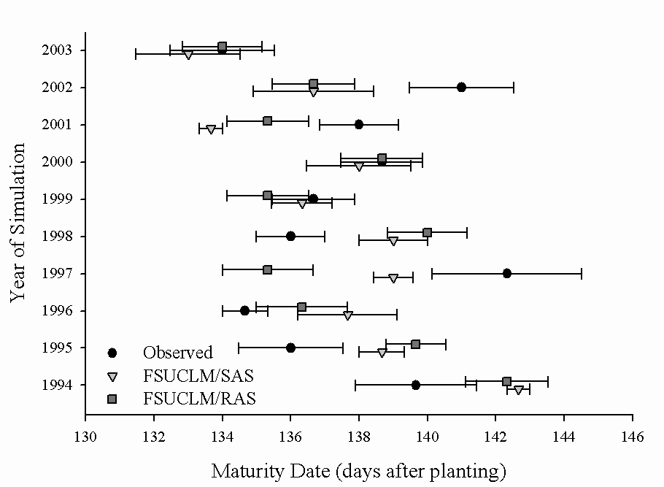

Fig. 9: Crop development measured as days to maturity from crop simulations using observed daily weather (circle) and the model daily values from the FSUCLM/SAS (triangle) and the FSUCLM/RAS (square). Error bars represent standard error from three sites (see Fig. 1) in the southeast United States.

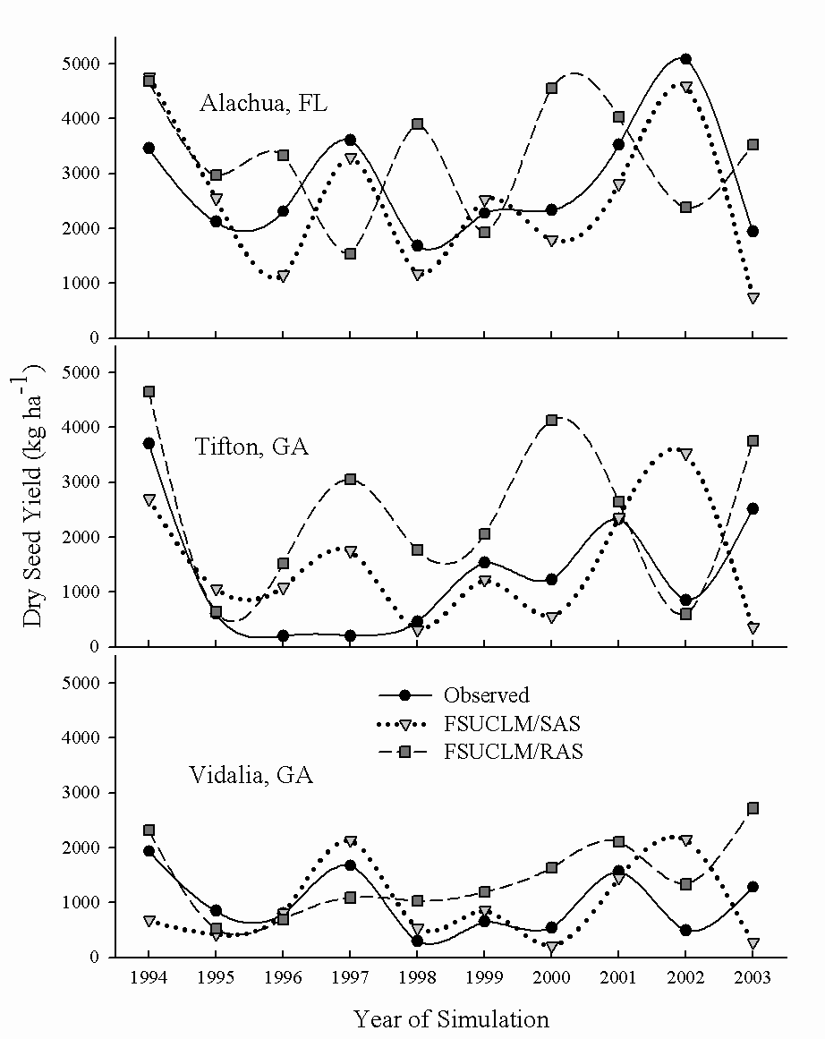

Fig. 10: Peanut (variety Georgia Green) yields from 1994 to 2003 simulated at three locations in the southeast U.S. using observed daily weather (circle) and the model daily values from the FSUCLM/SAS (triangle) and the FSUCLM/RAS (square).
Fig. 11: Same as Fig. 8 but for daily data for year 2000, April 25 to September 30.

