Incorporating SHEBA Turbulence Parameterizations in 1-D Model
O. Persson (3/5/2008)

The turbulent flux data from the Surface Heat Budget of the Arctic Ocean (SHEBA) program (Persson et al 2002) has resulted in improvements to stability profile functions (Grachev et al 2007) and roughness lengths over snow-covered surfaces (Andreas et al 2004). The impacts of these improvements on the parameterized surface heat and momentum fluxes are tested using the SHEBA data set and a 1-D snow and ice model. The snow and ice model is based one described by Semtner (1976), which is a simplification of that used by Maykut and Untersteiner (1969). A principal difference in our model is that both the snow and ice are represented by multiple layers rather than just the ice. A more detailed description of the model and model test results are given by Persson et al (2005).

Turbulent Fluxes: Theoretical Background
Symbolically, the surface heat budget of the Arctic Ocean is written
$B\text{}=\text{}Q_{s}\text{}−\text{}αQ_{s}\text{}+\text{}Q_{L↓}\text{}−\text{}Q_{L↑}\text{}−\text{}H_{s}\text{}−\text{}H_{L}\text{}+\text{}C$ . (1)
Here Q_{s} is the incoming shortwave radiation; α is the shortwave albedo; Q_{L↓} and Q_{L↑} are incoming and emitted longwave radiation; H_{s} is the turbulent sensible heat flux; H_{L} is the turbulent latent heat flux; and C is the flux conducted up to the surface from below. In our convention, positive terms in (1) represent heat gained by the surface; negative terms, heat lost. Thus, H_{s} and H_{L} are both positive when heat is being transferred from the surface to the air. If the balance term B in (1) is not zero, there must be phase changes at the surface.
Measuring the terms on the right side of (1) was Priority 1 in the SHEBA Science Plan (Moritz and Perovich 1996). The Atmospheric Surface Flux Group (ASFG) was the only group to measure H_{s} and H_{L} throughout the year, and one of several groups measuring the other terms. Not only are H_{s} and H_{L} the most difficult to measure, but parameterizing them for use in models is one of the biggest challenges for SHEBA.
By definition
, (2)
. (3)
Here ρ is the density of air; c_{P} is the specific heat of air at constant pressure; L_{v} is the latent heat of vaporization or sublimation; and w, t, and q are turbulent fluctuations in vertical velocity, temperature, and specific humidity, respectively. The overbar indicates a time-averaged covariance measurement for, nominally, one hour.
A related and necessary equation for the momentum flux or surface stress is
, (4)
where u is the longitudinal velocity fluctuation. Once (4) yields , the friction velocity, (2) and (3) provide the related scalar flux scales and .
A goal of SHEBA was to understand the surface heat budget well enough to accurately predict τ, H_{s}, and H_{L} in numerical models from readily available quantities. These predictions are usually based on the bulk-aerodynamic method, in which
, (5)
$H_{s}\text{}=\text{}ρ c_{P} C_{\text{Hr}} S\left(Θ_{s}\text{}−\text{}Θ_{r}\right)$ , (6)
$H_{L}\text{}=\text{}ρL_{v}C_{\text{Er}}S\left(Q_{s}\text{}−\text{}Q_{r}\right)$ . (7)
Here Θ_{s} is the time-averaged surface potential temperature; Θ_{r}, the average potential temperature at reference height r; Q_{s}, the average surface specific humidity; Q_{r}, the average specific humidity at height r; and S, a velocity scale that represents the wind velocity and the gustiness.
The heart of the bulk-aerodynamic method is finding the transfer coefficients (C's) in (5)-(7). C_{Dr} is the drag coefficient appropriate at height r, and C_{Hr} and C_{Er} are the corresponding sensible and latent heat transfer coefficients for height r. These coefficients depend on the reference height r and on the stability, which is quantified as L, the Obukhov length. That is (e.g., Andreas and Murphy 1986, Launiainen and Vihma 1989),
$C_{\text{Dr}}\text{}=\text{}c_{\text{Dr}}^{2}\text{}=\text{}{\left[\frac{k}{\text{ln}\left(r/{z_{0}}\right)\text{}−\text{}ψ_{m}\left(r/L\right)}\right]}^{2}$ , (8)

$C_{\text{Hr}}\text{}=\text{}c_{\text{Dr}}c_{\text{Hr}}\text{}=\text{}\left[\frac{k}{\text{ln}\left(r/{z_{0}}\right)\text{}−\text{}ψ_{m}\left(r/L\right)}\right]\left[\frac{k}{\text{ln}\left(r/{z_{T}}\right)\text{}−\text{}ψ_{h}\left(r/L\right)}\right]$ , (9)

$C_{\text{Er}}\text{}=\text{}c_{\text{Dr}}c_{\text{Er}}\text{}=\text{}\left[\frac{k}{\text{ln}\left(r/{z_{0}}\right)\text{}−\text{}ψ_{m}\left(r/L\right)}\right]\left[\frac{k}{\text{ln}\left(r/{z_{Q}}\right)\text{}−\text{}ψ_{h}\left(r/L\right)}\right]$ , (10)
where k (= 0.4) is the von Kármán constant, z₀ is the momentum roughness length, z_{T} and z_{Q} are the scalar roughness lengths, and ψ_{m} and ψ_{h} are empirical corrections for stability.
Equations (5)-(10) lay out three fundamental questions that have been addressed using the direct turbulence flux measurements obtained during SHEBA. These are as follows:
1. How to model z₀ and, thus, C_{D}?
2. How to model z_{T} and z_{Q} and, thus, C_{H} and C_{E}?
3. What are the appropriate ψ functions?
Andreas et al (2004) addressed the first two questions; Grachev et al (2007) addressed the last question. The best parameterization for S is a fourth issue yet to be addressed. The satisfactory resolution of these issues is crucial for the creation of an accurate numerical model of the local-scale fluxes.

Roughness Lengths
The parameterization for z₀ proposed by Jordan et al (2001) and Andreas et al (2003, 2004) includes a drifting snow, or saltation, regime and an aerodynamically smooth regime. It is expressed as

$z_{0}\text{}=\text{}\frac{0\text{.}\text{135} ν}{u_{}} + \frac{0\text{.}\text{035} u_{}^{2}}{g} \left\{1 + A\text{exp} \left[− {\left(\frac{u_{} − 0\text{.}\text{18}}{0\text{.}\text{10}}\right)}^{2}\right]\right\}$, (11)

where ν is the kinematic viscosity of air, and z₀ is in meters when is in . The left-most term on the right side of (11) models the aerodynamically smooth regime. The 1 in curly brackets, when multiplied by , models the saltation regime for values above about . The exponential term in (11), we believe, reflects the “fundamental” roughness of the surface because A is a dimensionless coefficient that varies among sites. For SHEBA, A=1; for the Weddell Sea, A = 5. This parameter can account for site variations in surface roughness characteristics, such as sastrugi. The expression for z_{T} and z_{Q} is

${z_{s}}/{z_{0}}\text{}=\text{}\text{exp} \left[b_{0} + b_{1}\left(\text{ln} R_{}\right) + b_{2}{\left(\text{ln} R_{}\right)}^{2}\right]$, (12)
where z_{s} is the scalar roughness—either z_{T} or z_{Q}—and is the roughness Reynolds number. Table 1 gives the coefficients b₀, b₁, and b₂ in the model.
Table 1. Values of the coefficients to use in (12) for estimating z_{T}/z₀ and z_{Q}/z₀ in three aerodynamic regions.
 | Smooth | Transition | Rough
Temperature (z_{T}/z₀)
b₀ | 1.250 | 0.149 | 0.317
b₁ | 0 | -0.550 | -0.565
b₂ | 0 | 0 | -0.183
Humidity (z_{Q}/z₀)
b₀ | 1.610 | 0.351 | 0.396
b₁ | 0 | -0.628 | -0.512
b₂ | 0 | 0 | -0.180

Stability Functions

insert SHEBA stability functions from Grachev et al 2007

Tests
The testing of these parameterizations involves evaluating whether the parameterized transfer coefficients in (5)-(7) accurately reproduce the observed relationships between the fluxes and the vertical gradients as expressed in these equations. Hence, for momentum flux, we will plot τ/ρ as a function of U_{r}², where U_{r} is the wind speed at the reference height. (We are assuming that S = U_{r} in (5)). These plots are done both for the observed data (measured fluxes and measured atmospheric parameters) and the parameterization output using the observed data as input (measured atmospheric parameters). For sensible heat flux, we plot H_{s}/(ρU) as a function of ΔΘ = Θ_{s} - Θ_{r}.

Rough. Form.  Stability Fcn | z₀ = 4.5e-4  z_{T}, z_{Q} = (12) | z₀ = (11)  z_{T}, z_{Q} = (12) | z₀ = 7.5e-4  z_{T}, z_{Q} = (12) | z₀ = (11)  z_{T}, z_{Q} = 1e-4 | z₀ = 7.5e-4  z_{T}, z_{Q} = 1e-4
BH91 | BHAT1 | BHAn | BHAT2 | BHATC | BHRC
SHEBA | SHAT1 | SHAn | SHAT2 | SHATC | SHRC

Test BHAT1 uses the Beljaars and Holtslag (1991) stability functions, a constant wind roughness parameter z₀ = 4.5 X 10⁻⁴ m, and equation (12) for the scalar roughness parameters. This is the configuration Persson et al (2002) used to compute the bulk flux values at the SHEBA site. Figure 1a shows that the observed normalized sensible heat fluxes decrease nearly linearly with increasing vertical potential temperature gradient (ΔΘ) until it reaches large negative values near ΔΘ ≈ 2° C. For ΔΘ >2° C, the data points are more scattered, but H_{s}/U increases slowly (becomes less negative) as ΔΘ increases, reaching zero near ΔΘ ≈ 5.5° C. The first regime corresponds to the region with significant turbulence and the magnitude of H_{s}/U is primarily a nearly linear function of the magnitude of ΔΘ. The regime where ΔΘ > 2° C corresponds to the regime where the stability-induced reduction of turbulence dominates over the increased vertical thermal gradient in determining H_{s}/U. Figures 1b, 1c, and 1d show that the parameterized heat flux estimates agree very well with each other and the mean observed values for the regime ΔΘ < 2° C. Though neither stability function formulation is able to reproduce the rapidity by which H_{s}/U approaches 0 for ΔΘ > 2° C, the SHEBA stability functions are significantly better than the BH91 functions in this regime. The lack of scatter in the data points for ΔΘ < 2° C in Figures 1b and 1c also suggest that H_{s}/U is primarily determined by ΔΘ in the parameterizations, perhaps even more than for the observations. However, this latter claim is dependent on the magnitude of the observational errors for H_{s} and U, which at least partially determines the scatter in 1a.
Furthermore, the large scatter in these figures for ΔΘ > 2° C suggests that ΔΘ only partially determines H_{s}/U in both the observations and in the parameterizations. In other words, factors other than the vertical thermal gradient play a significant role in determining H_{s}/U. Time series plots of observed vs parameterized H_{s} suggest that some of these important variables vary on the time scale of hours or more and that the variations in parameterized H_{s}/U in this thermal regime are not well correlated with the observed values. (Show??) Hence, the identities of the additional important parameters in this thermal regime are not well known, though many may already be in the parameterization. However, the formulation of the parameterizations do not adequately account for the effects of the variations of these parameters.
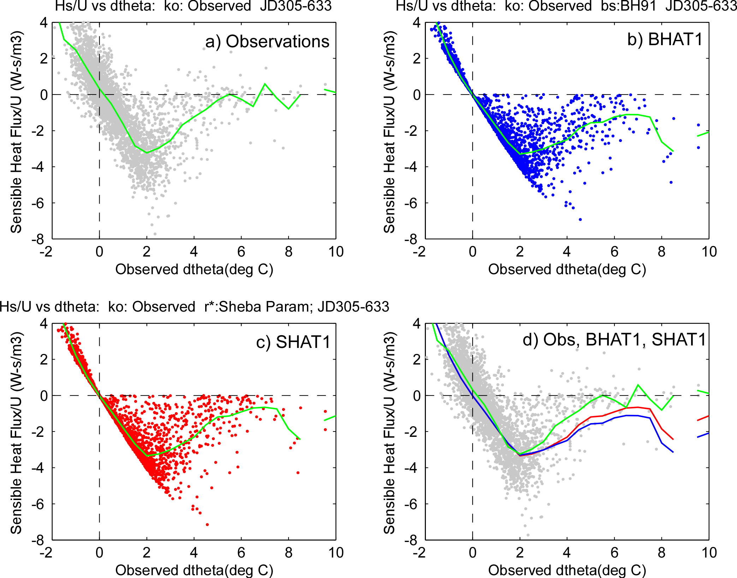
Fig. 1: Scatterplots of H_{s}/U as a function of the vertical potential temperature gradient for a) the SHEBA observations and the bulk flux parameterization of the SHEBA observations for b) the BH91 stability functions and c) the SHEBA stability functions. The green curves show the bin-averaged H_{s}/U values. Panel d) shows the bin-averaged curves for the observed (green), BH91 (blue), and SHEBA (red) values of H_{s}/U placed on top of the observed data points as in a).
The roughness length parameterizations have some subtle impacts on the H_{s}/U_{r}. If equation (11) is used to determine z₀, effectively accounting for drifting snow, (tests SHAn and SHATC; Figs. 2a,c), the H_{s}/U_{r} are slightly greater for ΔΘ = 1 - 4.5° C than when a constant z₀ = 4 X 10⁻⁴ m is used (test SHAT1, Fig. 1d) and in worse agreement with the observations for ΔΘ = 1-2° C (parameterized flux magnitudes are too small). Unfortunately, this latter ΔΘ range occurs frequently. If a larger constant value of z₀ = 7.5 x 10⁻⁴ m is used (tests SHAT2 and SHRC, Figs. 2b,d), the H_{s}/U are now too low (flux magnitudes are too large) for ΔΘ > 1.6° C. Using equation (12) for determining z_{T} or z_{Q} has no noticeable impact compared to setting z_{T} = z_{Q} = 1 X 10⁻⁴ m, as suggested by Andreas et al (2003).
Figure 3a shows that the observed stress is largely determined by U_{r}, though the extent is dependent on the errors in the measurements (estimate??). The lack of scatter in the parameterization output in Fig. 3a show that the parameterized stress is nearly entirely determined by U_{r}². Figure 3a suggests that the slope of the parameterized stresses (the C_{Dr}) may be slightly smaller than the observations suggest, especially at the higher values of U_{r}. Figure 3a

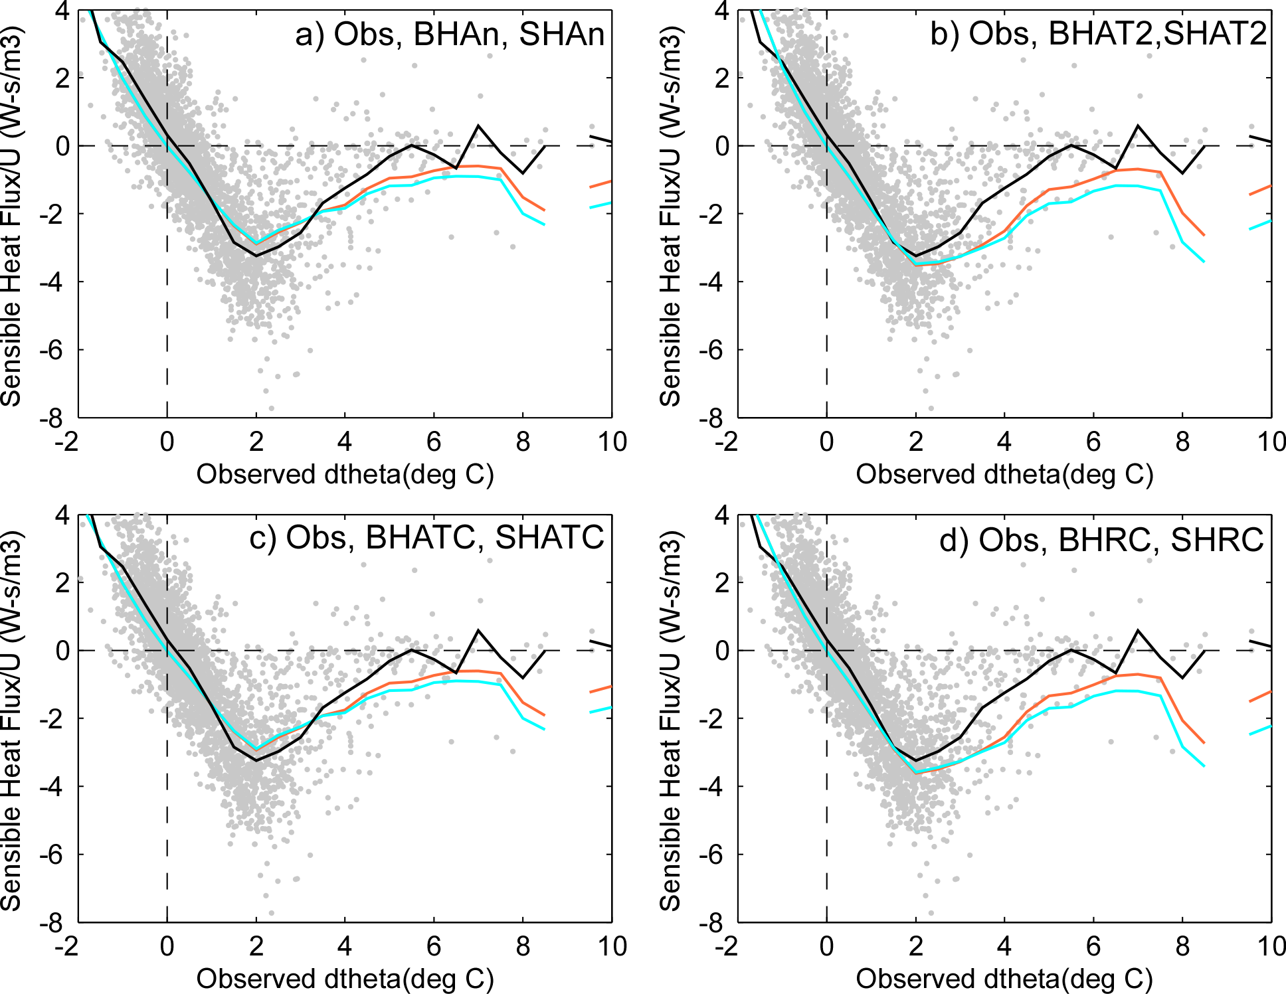

Fig. 2: As for Fig. 1d, but showing tests a) BHAn and SHAn, b) BHAT2 and SHAT2, c) BHATC and SHATC, and d) BHRC and SHRC.

also shows no noticeable differences between using the SHEBA stability functions compared to the BH91 functions. Using equation (11) for z₀ in the parameterizations produces a slightly curved τ/ρ as a function of U_{r}, allowing for a similar fit to the observations at low wind speeds as for test SHAT1 but a better fit at higher wind speeds. However, recall that some deleterious effects of using (11) occurred for H_{s}/U_{r}. Using a constant value of z₀ = 7.5 x 10⁻⁴ m (test SHRC, Fig. 3d) produces a better fit to the observations at high wind speeds, though perhaps a slightly worse fit at low wind speeds than for z₀ = 4 X 10⁻⁴ m. Recall that SHRC also produced some deleterious effects for H_{s}/U_{r} when ΔΘ > 1.6° C.
The results of these tests indicate that using the SHEBA stability functions provide a clear advantage over the BH91 functions for times with greater stability (ΔΘ > 2° C). The tests also suggest that using (11) for computing z₀ provides improvements in stress calculations for high wind speed conditions but may produces slightly worse heat flux calculations for a limited but common thermal gradient range of ΔΘ = 1 -2° C. Hence, the

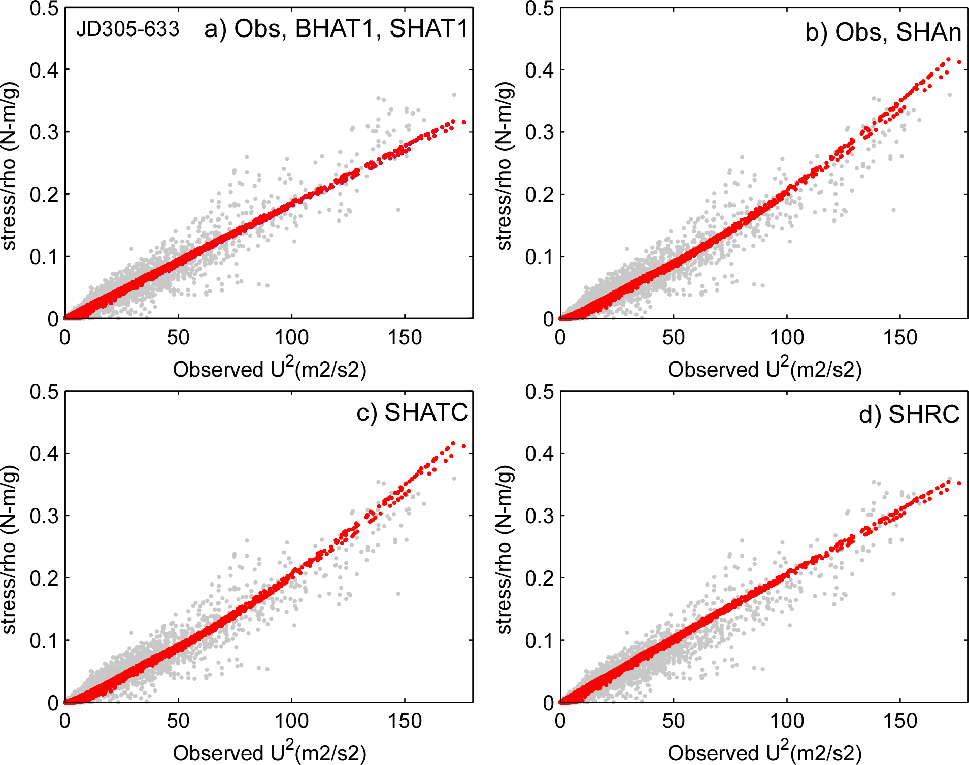
Fig. 3: Scatterplots of τ/ρ as a function of U_{r}² for tests a) BHAT1 and SHAT1, b) SHAn, c) SHATC, and d) SHRC. The observed values are shown as grey points in each frame. In a), BHAT1 and SHAT1 are so close that SHAT1 masks BHAT1.

advantages of using this formulation compared to a constant z₀ = 4 x 10⁻⁴ m are not as obvious. While using a larger, constant value for z₀ also improves the stress calculation at higher wind speeds, negative impacts are seen for both stress calculations at low wind speeds and for heat flux calculations with ΔΘ > 1.6° C. It is recommended that either equation (11) or a constant value of z₀ = 4 x 10⁻⁴ m is used, the former when accurate stress calculations at high wind speeds are needed and the latter when accurate sensible heat fluxes are more important. There appears to be no reason to not use z_{T} = z_{Q} = 1 x 10⁻⁴ m.
REFERENCES
Andreas, E. L, C. W. Fairall, A. A. Grachev, P. S. Guest, T. W. Horst, R. E. Jordan, and P. O. G. Persson, 2003: Turbulent transfer coefficients and roughness lengths over sea ice: The SHEBA results. CD-ROM of preprints, 7th Conf. on Polar Meteorology and Oceanography, Hyannis, MA, Amer. Meteor. Soc., 9 pp.
Andreas, E. L, R. E. Jordan, P. S. Guest, P. O. G. Persson, A. A. Grachev, and C. W. Fairall, 2004: Roughness lengths over snow. CD-ROM of Preprints, 18th Conference on Hydrology of the American Meteorological Society, Seattle, WA, 11-15 January 2004, 8 pp.
Andreas, E. L., R. E. Jordan, and A. P. Makshtas, 2004: Parameterizing turbulent exchange over sea ice: The Ice Station Weddell results. Bound.-Layer Meteor., submitted.
Andreas, E. L, and B. Murphy, 1986: Bulk transfer coefficients for heat and momentum over leads and polynyas. J. Phys. Oceanogr., 16, 1875-1883.
Grachev, A. A., E. L Andreas, C. W. Fairall, P. S. Guest, and P. O. G. Persson, 2007: The SHEBA profile functions in the stable atmospheric boundary layer. Boundary-Layer Meteor., DOI: 10.1007/s10546-007-9177-6, 124(3), 315 - 333.
Jordan, R. E., E. L Andreas, and A. P. Makshtas, 2001: Modeling the surface energy budget and the temperature structure of snow and brine-snow at Ice Station Weddell. Preprints, Sixth Conf. on Polar Meteorology and Oceanography, San Diego, CA, Amer. Meteor. Soc., 129–132.
Launiainen, J., and T. Vihma, 1990: Derivation of turbulent surface fluxes—An iterative flux-profile method allowing arbitrary observing heights. Environ. Software, 5, 113-124.
Maykut, G. A., and N. Untersteiner 1969: Numerical prediction of the thermodynamic response of sea ice to environmental changes. The Rand Corporation, Santa Monica, Calif., RM-6093-PR.
Moritz, R. E., and D. K. Perovich, Eds., 1996: SHEBA, A research program on the Surface Heat Budget of the Arctic Ocean: Science Plan. ARCSS/OAII Rept. No. 5, Polar Science Center, University of Washington, Seattle, 60 pp.
Persson, P. Ola G., C. W. Fairall, E. L. Andreas, P. S. Guest, and D. K. Perovich, 2002: Measurements near the Atmospheric Surface Flux Group tower at SHEBA: Near-surface conditions and surface energy budget. J. Geophys. Res. 107(C10), 8045, doi:10.1029/2000JC000705.
Persson, P. O. G., E. L Andreas, J-W. Bao, C. W. Fairall, A. A. Grachev, P. S. Guest, and R. E. Jordan, 2005: Determining wintertime heterogeneous pack ice characteristics and their impact on the aggregate atmospheric surface flux. Preprints, 8th Conf. on Polar Meteor. And Oceanog., 9-13 Jan. 2005, San Diego, CA.
Semtner, A. J., Jr., 1976: A model for the thermodynamic growth of sea ice in numerical investigation of climate. J. Phys. Oceanogr., 6, 379-389.

