Comparison of NWP Reanalyses and Satellite Flux Products

The points compared appear to be water covered ocean in all the products. The time period for this comparison is 03/1992 through 12/2000.

The number of data points in the NH comparison (lines for all products overlap):
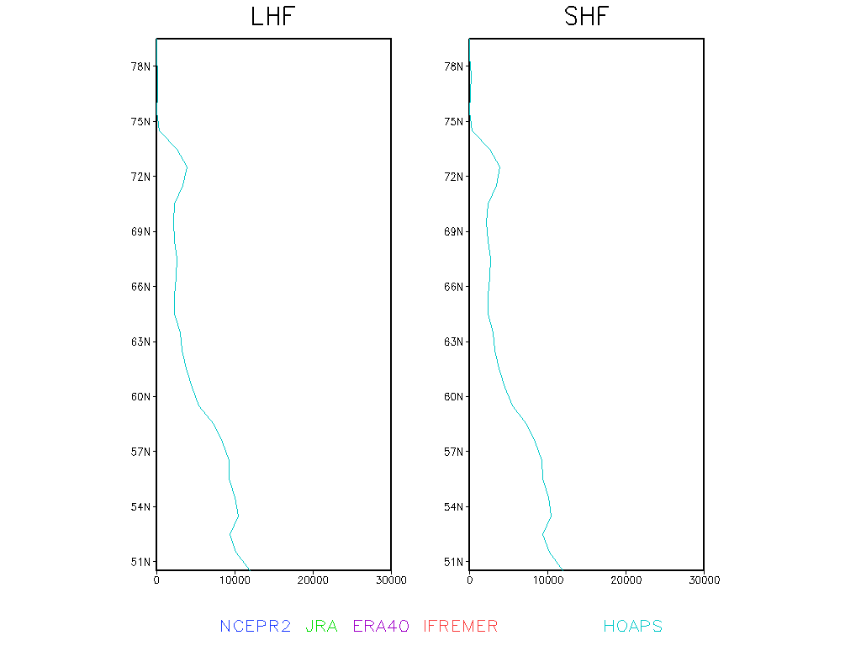

The number of data points in the SH comparison (lines for all products overlap):
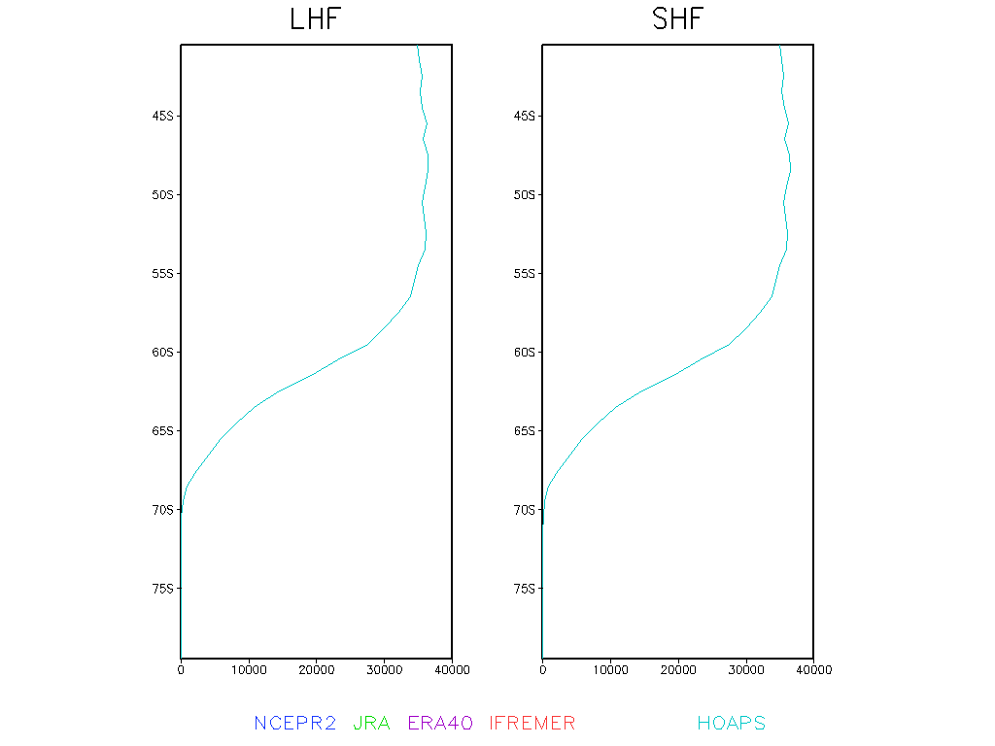

NH Latent Heat Fluxes
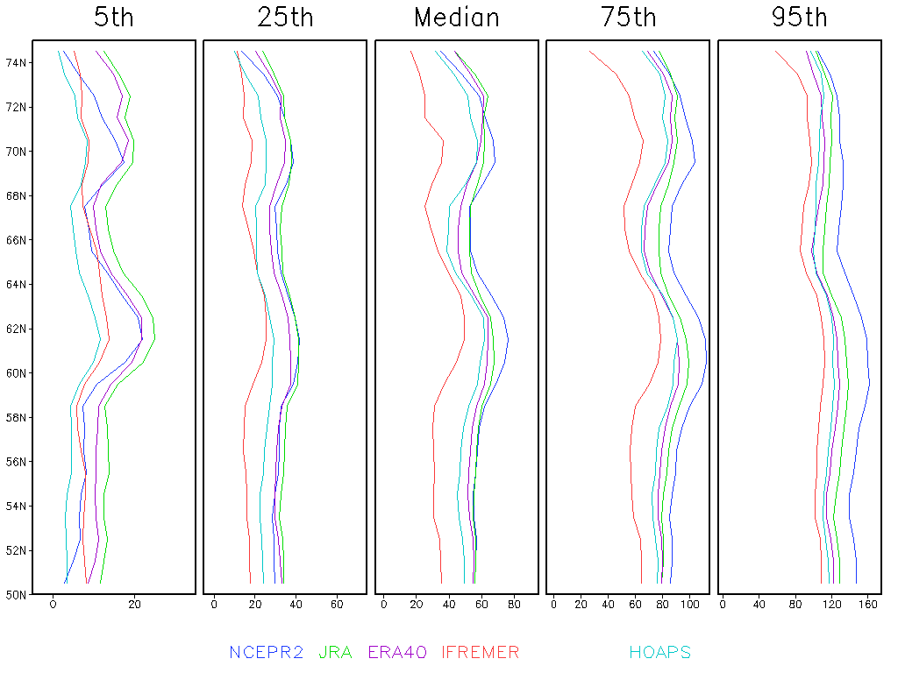

SH Latent Heat Fluxes
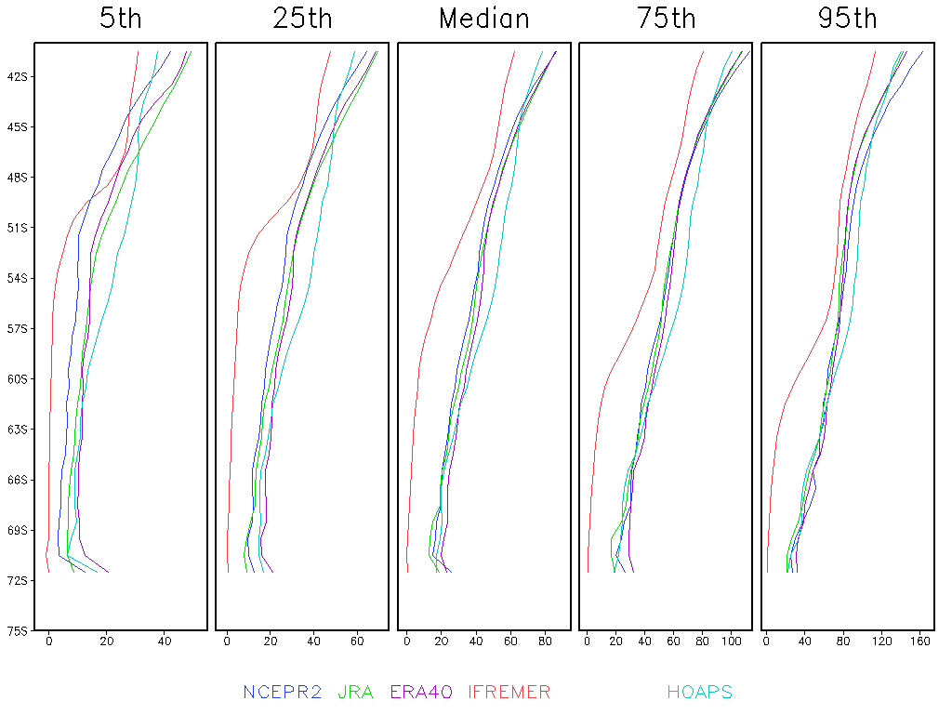
NH Sensible Heat Flux
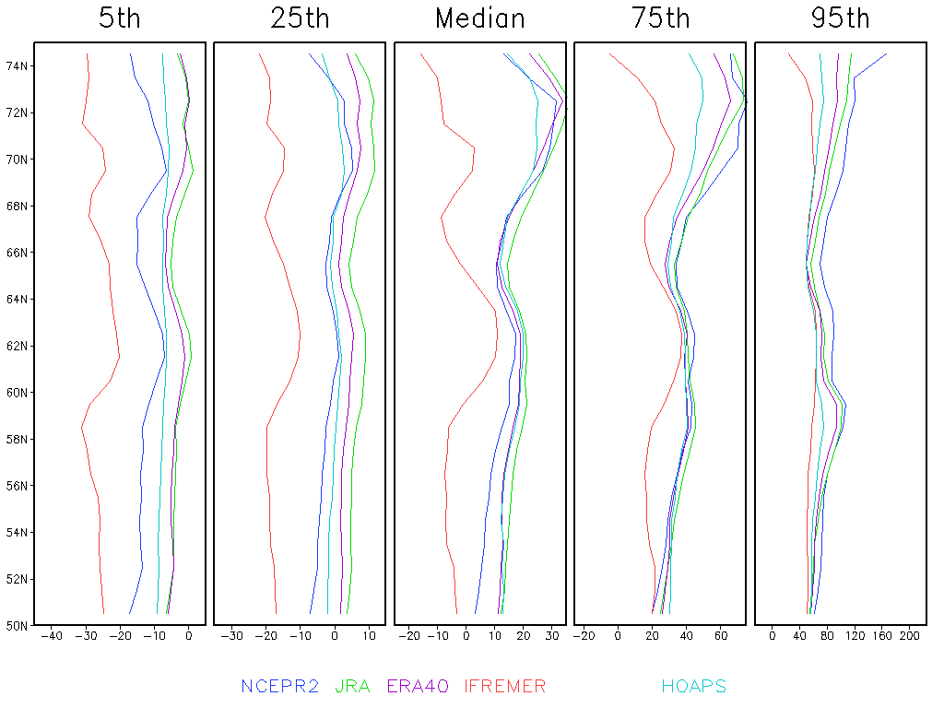
SH Sensible Heat Flux
