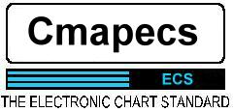

ECS
ELECTRONIC CHART SYSTEM
Version 4 – February 1999
(with revisions 2001)
Installation Manual and User Guide

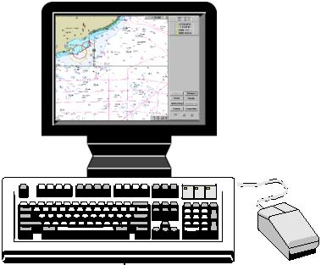

INDEX
Page 5 1.0 INTRODUCTION
1.1 Introduction
1.2 System Requirements
Page 6 2.0 INSTALLATION
2.1 Windows 95/98/2000 and NT
Page 7 3.0 ECS CONFIGURATION
3.1 The config program
Page 8 3.2 The Configuration General Settings Page
Page 9 3.3 The Demo mode config page
Page 10 3.4 Vessel Dimensions Page
Page 11 3.5 NMEA / COM Port configuration Page
Page 12 3.6 Autopilot / Ships parameters Page
Page 13 4.0 USING THE ECS
4.1 Starting the ECS program
Page 14 4.2 The Vessel Position and Track Indicator
Page 15 4.3 The Chart Scale & Zoom buttons
4.4 Status Lights & Alarms
Page 16 4.5 The Current Time Display
Page 17 4.6 The Vessel Status Box
Page 18 4.7 Anti-Grounding Sector Display
4.8 Menus and Function Buttons
4.9 Mouse Cursor Position Indicator
Page 19 5.0 FUNCTIONS
5.1 Centering the chart to the Vessel
5.2 Zooming
5.3 Full Screen Mode
5.4 Chart Scale
Page 20 5.5 Best Scale
5.6 Base/Standard/Full display
5.7 New Mariners Object or MARKS
5.8 Legend
5.9 Nav. Line
Page 21 5.10 Vessel
5.11 Map
Page 22 5.12 Route Planning
Page 27 5.13 Voyage
Page 28 5.14 Log Book
5.15 Log Event
5.16 Man over board
5.17 Autopilot
Page 29 5.18 Nav Mode
5.19 Dead Reckoning
5.20 Navigation Configuration
Page 30 5.21 New Map
Page 31 5.22 MARKS
5.23 Configuration
Page 32 5.24 ERBL
Page 33 5.25 Fixed Point Bearings
5.26 Exit
Page 34 6.0 GENERAL INFORMATION
6.1 Mouse Operations
6.2 Chart Scales
6.3 Viewing and panning
6.4 Tidal Predictions
Page 35 6.5 Relative Motion and Course Up Modes
Page 36 6.6 Object Information
Page 37 6.7 Palettes

- INTRODUCTION
1.1 System Requirements
The CMAPECS group was established in 1985 and is currently the world leader in the electronic cartography industry in terms of production capacity, sales volume of data and plotter systems as well as scientific contributions and technical innovations within the industry.
The CMAPECS program is an Electronic Chart System designed for use with CMAPECS’s CM93 chart databases. The system is designed to take full advantage of the functionality that only Digital Vector Charts can offer.
1.2 System Requirements
The CMAPECS software is a 32 bit PC based Windows application. The program will run on almost any IBM compatible PC with an Intel Pentium™ processor. The system must also contain a CD-ROM drive. Copy the CM93 and Cmapecs folder data to the hard disk in which case a minimum of 1GB will be required. The screen resolution should be set to 1024x768 or 1280x1040 at 256 colours (the system will not run in high colour16bit or true colour 24bit modes). ************If you wish to run in 800X600 mode, it is possible but it makes the fonts work better if you at least run the congfigecs prog in 1024 X 768 to set the system up.*************** The system will need to have at least two available RS232 serial ports for input from the GPS system and output to the autopilot and other navigational systems. One port is OK if the autopilot is disabled in the Config prog..
Please note that CMAPECS software is designed to run under either Microsoft Windows 95/98/2000 or Microsoft Windows NT 4 (service pack 3) or higher only. If the PC does not have either of these operating systems it must be upgraded before installation of this software can take place. This software with not run under Windows 3.1 or 3.11 even with the Win32s upgrade.

2.0 INSTALLATION MANUAL
2.1 Installation Procedure for Microsoft Windows 95/98/2000 and Windows NT 4.0
To run this altered version, unzip the file ecs.zip to any directory you like on C. Then run the config.exe file. i.e Now go to Section 3.
Below is standard installation for original version.
Hard disk run
Copy all files in the two CD to your hard disk (Use Copy - Paste). Remove write protection on this Configuration fil: Cmapecs, Desktop, Ecpalett, Navi, Talkers and Vessel. Do this in Windows Explorer in Properties. If the program not could find (OWL52T.DLL, BDS52T.DLL, CW3230MT.DLL OR CMENGDT.DLL), you can seek at this file on the CD and copy to the Cmapecs folder.
The program Config icons is created in the CMAPECS folder. Double click on the Icons to start the associated programs.
Note: Before you run the CMAPECS for the first time you should first configure the PC and Vessel parameters via the CONFIG.EXE program.
Click on the START button, choose RUN and type C:\Cmapecs\Cmapecs.exe. (The system can read data directly from the CD-ROM if your CD-ROM drive letter is D:)
Your file in the hard disk looks like this: (if you use the original Cmap CD1 & CD2)
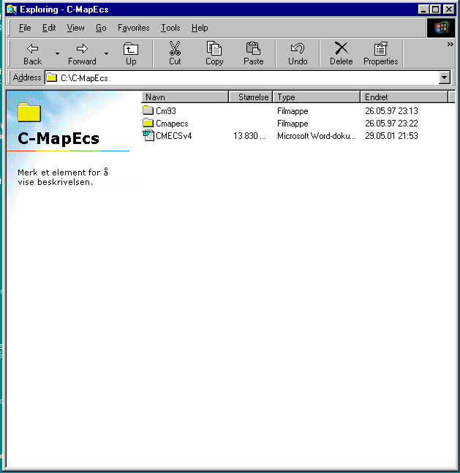
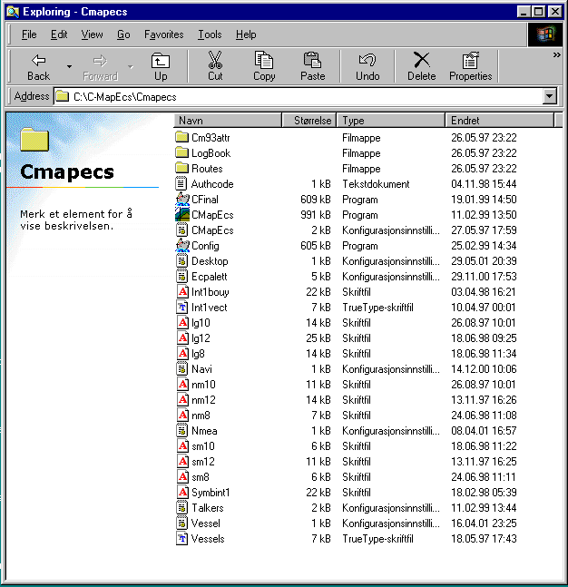
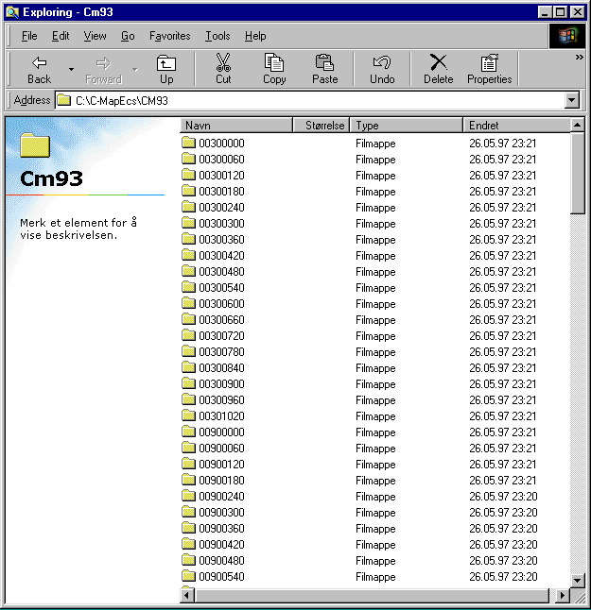
3.0 CONFIGURATION OF THE PC AND VESSEL PARAMETERS
3.1 The Config program
Double click on config.exe in the file where your Cmapecs Program was loaded.

If you wish to copy CD’s to your hard drive then do so manually, each one to a separate directory. In Config.exe General tab, select “HDD” copy and browse to the Cmap CD directory that the CD you wish to use was copied to. You can have multiple directories with a different CD in each, but you can only use the charts from one at a time.
The Config prog will NOT copy cd’s to your hard drive as it is expecting a different Cmap CD format. Otherwise manually select the drive or select autodetect for CDS’s in your CD drive.
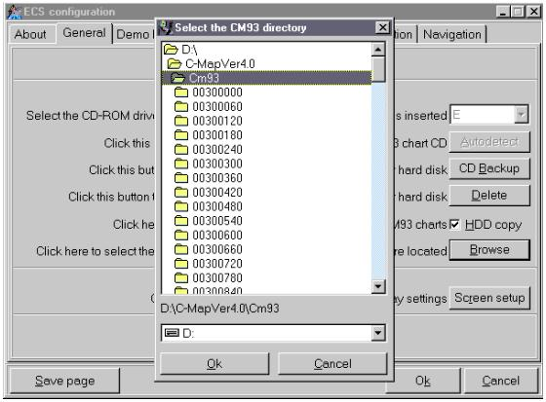
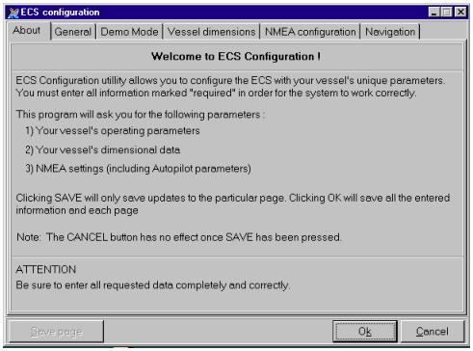
The ECS software is pre-configured to receive and send data (GPS, Autopilot etc.) via RS232 ports configured as COM1 and upwards. Running the CONFIG.EXE program will result in the following screen: -
This program is used to configure the following items, which are described below: -
1. GENERAL - Used to configure such items as the drive location of the CM93 charts (CD-ROM or hard disk).
2. DEMO MODE - Used to configure the parameters used when running in demo mode (position etc.)
3. SHIP DIMENSIONS - Here you must configure all the dimension information relating to the vessel. Please note that this is very important for the anti-grounding system. -especially if you have a supertanker!
4. NMEA - Used to configure all the external talkers.
5. Ship and Autopilot Parameters
3.2 The Configuration General Settings Page
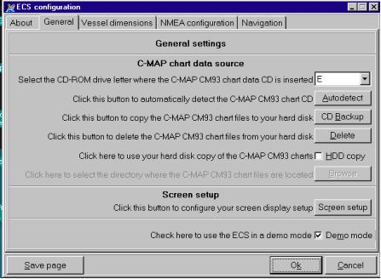
This page allows you to do the following routines: -
A) Select the drive where the CM93/2 CD-ROM is located.
OR
B) Choose AUTODETECT to automatically find the CM93/2 CD-ROM
C) To install CM93/2 from the CD-ROM over to the hard disk Will not work unless you have original CD1 &CD2 from CMap!! Manually copy instead.
D) Delete an existing CM93/2 database from your hard disk
E) Manually specify the location of the CM93/2 database on a hard disk or network drive. Use this to select which CD region copy on your HDD you wish to use.
F) Setup your screen display (dimensions) Only necessary if you wish screen scales to be calibrated to real scales.
G) Configure the ECS to run in DEMO mode only (NOW Separate Demo Screen)
Once the configuration has been completed, click on SAVE PAGE.
3.3 The Demo Mode Configuration Page
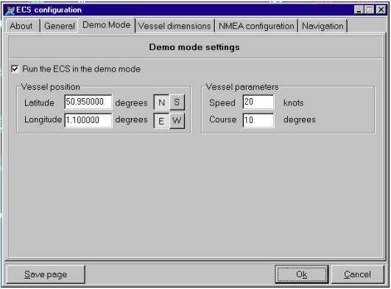
This page is used to configure the vessel information when the system is running in DEMO mode. If the demo mode checkbox is enabled, the ECS will start with the vessel placed at the location given on this page with the given heading and speed. Deselect for real use!
Once the configuration has been completed, click on SAVE PAGE
3.4 The Vessel Dimensions Settings Page
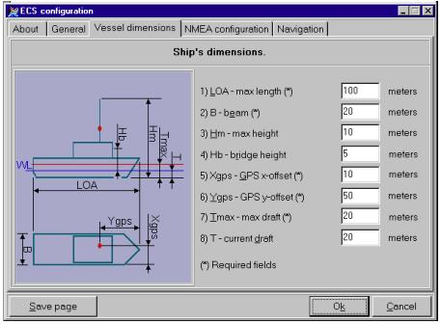
This page allows the user to specify the unique vessel dimensions. Great care must be taken when completing this form as this data is used in the Anti-Grounding and Alarm functions of the ECS. All fields marked with an * must be filled out. It is sensible to set at least 3m for both draft settings to give ample warnings for small (less than 25metre length) boats.
Once the configuration has been completed, click on SAVE PAGE.
3.5 The NMEA Configuration Page
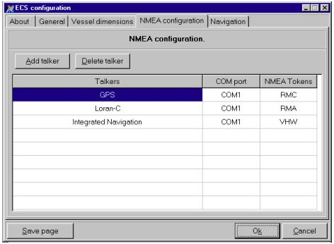
This page is used to configure the NMEA talkers. To Add a talker simply click on the ADD TALKER button. Choose the type of talker from the drop down box, the COM port to which it is attached and the correct NMEA tokens.
To delete a talker simply click on the talker and then on the DELETE TALKER button.
Once the configuration has been completed, click on SAVE PAGE.
Set your GPS data:
NMEA 183
8 DATA bits
2 STOP bits
without parity
4800 BAUDS
Additional instrument interfaces can be set up here, but it is better to use the nmea.ini file, i.e. don’t play unless you know what you’re doing.
3.6 The NMEA Configuration Page
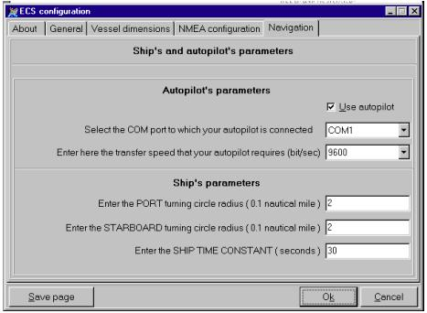
This last configuration page is used to configure the Autopiliot parameters.
Once the configuration has been completed, click on SAVE PAGE.
4.0 USING THE ECS
4.1 Starting the C-MAP Electronic Chart System
To start the program, double click on the C-MAP ECS Icon as shown below.
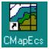
The program will now start and the main screen will be displayed. This is the main view at a scale of 1:75 000 and looks as follows:
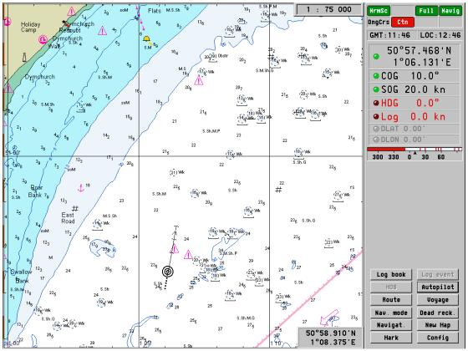
Figure 1. The main ECS screen at a scale of 1:75 000
Using the C-MAP ECS program involves using a set of Pop-Up Menus, Function buttons and information boxes. On the main screen there are eight standard information displays which also allow access to the menus, as well as the standard vessel position indicator.
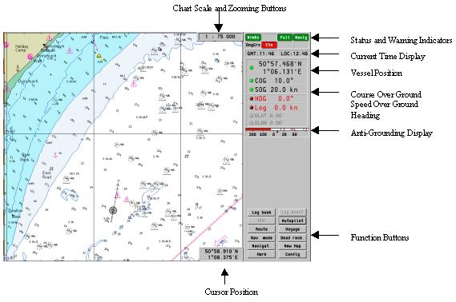
Figure 2: The standard Information displays
4.2 The Vessel Position and Track Indicator
The following symbol indicates the Vessel position, heading and position after a specified time frame: -
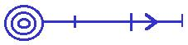
4.3 The Chart Scale and Zoom buttons
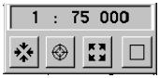
The main function of this box is to show the scale of the displayed chart. There are four buttons located under the scale indicator. These have the following functions:-
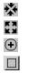
Zoom in - This loads the next lower scale chart
Zoom out - This loads the next higher scale chart
Returns to the vessel display at the standard scale
Changes to Full Screen Mode
If “Best Scale” has been selected (described later in this document), the zoom in and zoom out buttons will not be enabled (greyed out).
Clicking on the Right Mouse button when the cursor is placed over this box will call the following sub-menu. The functions of this sub-menu are described in section 5.0.
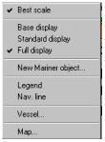
4.4 Status Lights and Warning Indicators
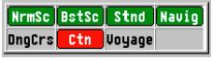
The Status Lights and Warning Indicators box contains 7 different lights. These are: -
- Normal Scale Chart
- Best Scale Chart
- Standard Chart
- Navigation Aid Status
- Dangerous Course
- Caution
- Voyage Mode messages and alarms
The various alarms and status displays can be switched on and off by clicking with the right mouse button when the cursor is placed in the above display box. This will open the following window. Within this window it is possible to check which displays and audible alarms should enabled: -
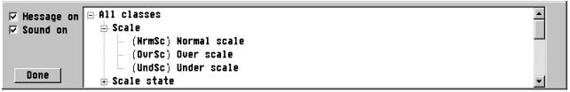
4.5 The Current Time Display
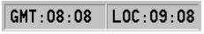
This box displays the current GMT and corresponding Local Time according to the settings in the Time/Date option in the Windows control panel. Clicking on the Right Mouse button when the cursor is placed over this box will call up the following sub-menu. The functions of this sub-menu are described later in this document under section 5.0
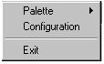
4.6 The Vessel Status Box
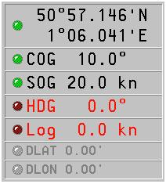
This status box displays the following information:-
Position - This gives the Lon/Lat position from the GPS system. The status light will be green as long as the system is correctly receiving GPS data.
COG - Shows the “Course Over Ground” information. The status light will be green as long as information is being received from the GPS
SOG - Shows the “Speed over Ground” information. The status light will be green as long as information is being received from the GPS
HDG - Show the current vessel heading
LOG - Displays the Log speed
The DLAT and DLON displays show the user entered Delta Position information for DGPS.
4.7 The Anti-Grounding Sectors display
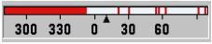
This display shows the dangerous sector prognosis for the time frame set in the configuration menu (default 10 minutes). The red lines indicate dangerous sectors that will be reached in the specified time frame.
4.8 Menu and Function Buttons
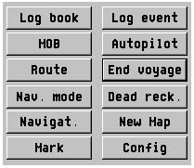
Menus and Functions such as Route Planning, Autopilot and Log options, can be accessed by clicking on one of the buttons in this area. Each function is described in section 5.0
4.9 The Mouse Cursor Position Indicator
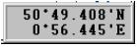
This shows the Lon/Lat position of the mouse cursor as it is moved around the screen. This box will automatically appear when the cursor is placed on the map part of the screen.
Clicking on the Right Mouse button when the cursor is placed over this box will call up a sub-menu for ERBL and fixed point bearings. These functions are described later in section 5.0
5.0 FUNCTIONS
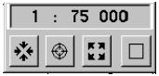
5.1 Centering the chart to the vessel
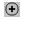Clicking on Centre will cause the chart to return to the current vessel position.
5.2 Zooming In/Out
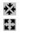Zoom in - This loads the next lower scale chart (see scale below)
Zoom out - This loads the next higher scale chart (see scale below)
5.3 Full Screen Mode
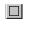Changes between Full Screen Mode (wihout menus) and Default Mode (with menus)
5.4 Scale
Clicking on the Scale button will allow the user to manually choose between the different Chart Scales, which are: -
1. W - The Global scale of 1:20,000,000
2. A - The World scale ranging from 1: 3,500,000 to 1: 1,500,000
3. B - The General nautical scale ranging from 1: 1,500,000 to 1: 500,000
4. C - The Coastal scale ranging from 1: 500,000 to 1: 150,000
5. D - The Intermediate coastal / approach scale1: 1: 50,000 to 1: 50,000
6. E - The Approach scale ranging from 1: 50,000 to 1: 15,000
7. F - The Harbour scale ranging from 1: 15,000 to 1: 5,000
8. G - The Plan scale which is larger than 1: 7,500
These scale levels can of course also be accessed by using the Zoom In and Zoom Out buttons.
5.10 Vessel
Turns on and off the Past Track display and allows Relative motion and Course up to be selected.
5.11 Map
The Map dialog box shows and allows selection of position and display options and is available by clicking on the right mouse button while the cursor is on the scale box at the top of the screen. The box looks as follows:-
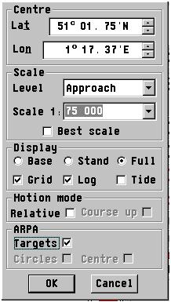
- Centre Lat./Lon - Shows and allows selection of the Lat./Lon position at the centre of the screen.
- Scale Level- Shows and allows manual selection of the Level and Scale of the current chart (if best scale is not selected).
- Best Scale on or off
- Display - Allows selection of the Base, Standard or Full Display (see section 5.6).
- Grid - Turns On or Off the Map Grid Display
- Log – Turns the display of the logged course off or on.
- Tide – Turns the display of the tidal diamonds on or off. Once these are turned on the tidal predictions can be obtained by clicking with the right mouse button when the cursor is inside the required tidal diamond. This operation is described later in this document under General Information Section 6.4.
- Motion Mode – turns on or off Relative Motion and Course Up options
- ARPA - Turns the display of ARPA Targets and Circles on and off.
5.12 Route Planning
Clicking on the ROUTE function button starts Route Planning.
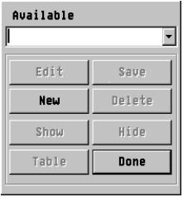
Route Planning allows creation, editing or checking of a planned Route. To create a route click on NEW and type in the name of the route, then click EDIT. To edit a route, type in the name of the existing route or choose the route by means of the drop-down box and click on EDIT.
The Route Planning options are now enabled (a small red circle will appear on the end of the cursor arrow). To insert waypoints and create your route, simply click on the left mouse button. Clicking the Right mouse button will cause the last waypoint to become the current End Point.
If the cursor is placed around the edge of the chart the cursor shape will change and normal panning is enabled.
There are 5 different menus available by clicking the right mouse button at various points on a route. These are as follows: -
1. Edit mode – Start/End waypoint
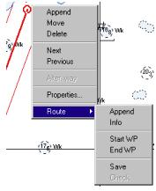
This allows the user to Append, Move or Delete the start or end waypoint. The waypoint properties can be entered by choosing properties (turn radius etc.) and the route can be saved with the Save option.
2. Edit mode – Intermediate waypoint
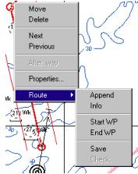
This allows the user to Move or Delete the intermediate waypoint or to Append a new waypoint. The waypoint properties can be entered by choosing properties (turn radius etc.) and the route can be saved with the Save option.
3. Edit mode – On Leg
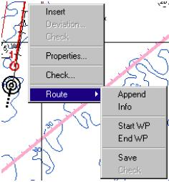
This allows the user to Insert a waypoint. The waypoint properties can be entered by choosing properties (turn radius etc.) and the route can be saved with the Save option. In addition there is the Check option. This will start the Route Checking function that looks for dangerous objects and unsafe waters on the chosen leg according to the vessel parameters specified in the CONFIG program.
Once the Route Checking is started the screen will look as follows: -
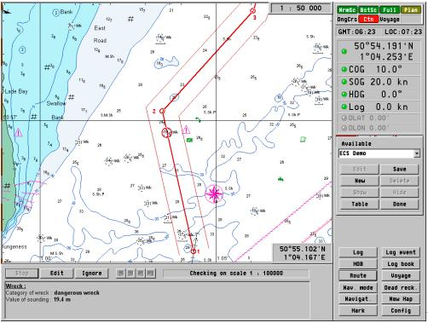
A red circle is drawn around every item on the leg that is deemed unsafe or dangerous and a description is given at the bottom of the screen. The user can choose to ignore the warning or to Edit the leg. After this has been done the leg check will continue.
4. Non-Edit mode – On Waypoint
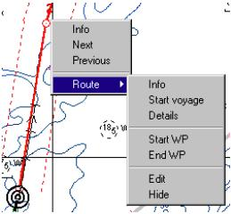
Info – Displays the following Route Information table.
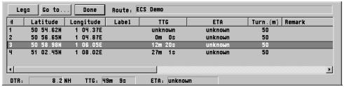
Next – Move to the next waypoint.
Previous – Moves to the previous waypoint.
Start Voyage – This starts the voyage and is described under the VOYAGE function in section 5.13.
Details – Adjusts the level of waypoint information that is displayed on the chart for each waypoint.
5.13 Voyage
Once the Route has been planned and checked the voyage can begin. This is done by clicking on the VOYAGE function button. The following dialogue box appears at the bottom of the screen.
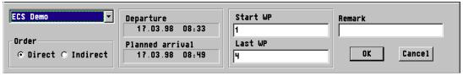
In this box the user selects which voyage is to be sailed along with the start and end waypoints of the route. It also shows the planned departure and arrival time. Once the information has been given clicking OK starts the Voyage. The following display appears on the right of the screen which shows Heading To Steer (HTS), Distance To Wheel Over Point (DTWOP), Time To Wheel Over Point (TTWOP), Cros Track Error (XTE), the route name and current waypoint and the calculated Estimated time of Attival (ETA).
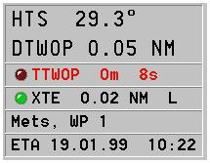
The voyage can be ended by clicking on the END VOYAGE function button.

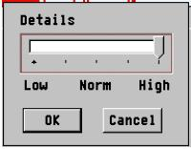
Start WP – Assigned the starting waypoint for the planned voyage.
End WP – Assigns the end waypoint for the planned voyage.
Edit – Allows editing of the waypoint
Hide – Hides the route from the chart
5. Non-Edit mode – On Leg
The above functions are all called from the menu obtained by right clicking on a waypoint. If the right click is done in the middle of a leg a different menu will appear and looks as follows: -
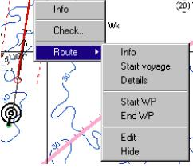
This menu contains much the same functions as the menu above but in addition has the possibility for checking the route for dangerous objects and unsafe waters.
5.14 Log Book
Displays the logbook at the bottom of the screen, which looks as follows. The ability to REPLAY a voyage is also available here.
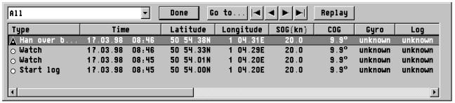
5.15 Log Event.
Log Event is started by clicking on the Log Event button. The following Log Entry dialog box appears at the bottom of the screen. Here the user can choose what type of event has occurred (f.ex. Man Over Board). Remarks can also be added to the event. The position and navigation data is automatically added.
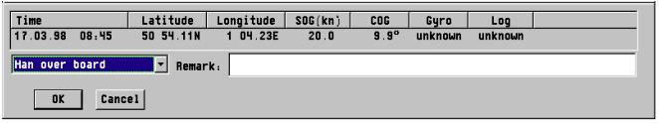
5.16 MOB Man Over Board
Enters a “Man Over Board” entry into the logbook.
5.17 Autopilot
Clicking on Autopilot brings up the following window: -
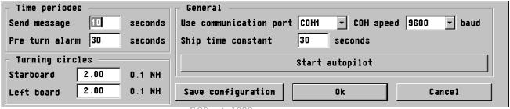
The information here is taken from the Autopilot page of the CONFIG program. Make any required changed and then click on Start Autopilot to enable the system. Autopilot can only be engaged if a voyage has been started (section 5.13).
5.18 Nav. Mode
Clicking the Nav.Mode function button will immediately close all functions such as route planning and return the user to Navigation Mode. The vessel will be automatically returned to the centre of the display.
5.19 Dead Reckoning
The DEAD RECKONING function button will display the following information. Here the user can uncheck the various items and enter dead-reckoning related data.
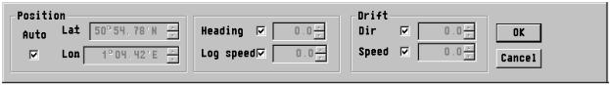
5.20 Navigation
Pressing the NAVIGATION function button will allow the user to edit the following information (watch interval, primary navigation aid, secondary navigation aid, delta position etc.).
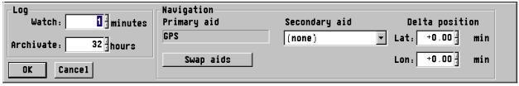
5.21 New Map
Clicking the NEW MAP function button will result in the user being able to open a new Map window. Before the map is opened, the user is prompted to choose the information and scale to be displayed (as in option 5.11 Map). The resulting display is shown below. The Map windows are completely separate from each other allowing each one to show totally different information (charts, scales, zooms, objects etc.)
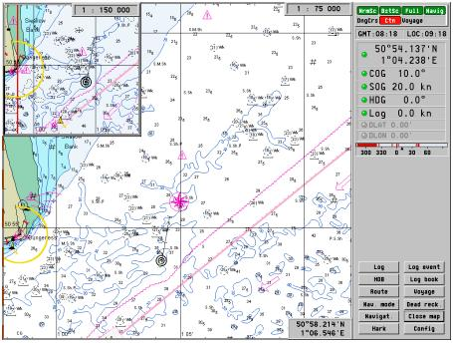
5.22 Mark
The MARK function button allows users to draw their own areas or objects on the chart display. This can be for example a dangerous area, areas of interest or user defined objects. Once the areas have been drawn they can be queried for information or deleted by clicking on them with the right mouse button.
All these objects are taken into account when the Route Checking function is run.
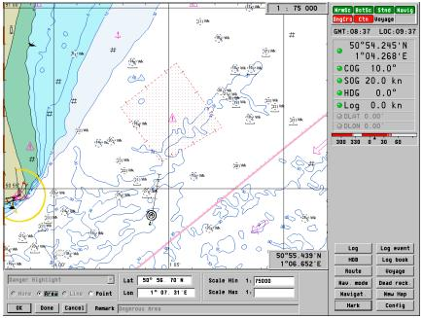
5.23 Config
Clicking on the CONFIG button starts the configuration utility. This allows the user to choose between dawn/day/dusk/night palettes and set the Anti-Grounding and Safety Sector parameters.
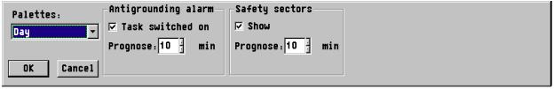
5.24 ERBL
The ERBL or Electronic Range and Bearing Line is started by clicking on the Cursor Position box with the right mouse button (located on the lower right side of the chart display).
Once started, it shows a red line from the vessel indicator with a moveable circle placed on the line. The bearing and range shown is FROM the vessel. To find the range from a point TO the vessel, click on the left mouse button while the circle is placed on the point to take the bearing from. Move the other end of the line to the vessel. Clicking on the left mouse button alternates between Bearing and Range TO and FROM.
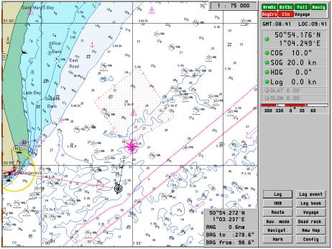
5.25 Fixed Point Bearings
Fixed Point bearings are started by clicking on the Cursor Position box with the right mouse button. There are 3 available Fixed Point Range and Bearing indicators. Click on the Fixed Point 1 line and move the red line to the point to take the bearing from. The indicator box will now display the Range and Bearing from the vessel to this point
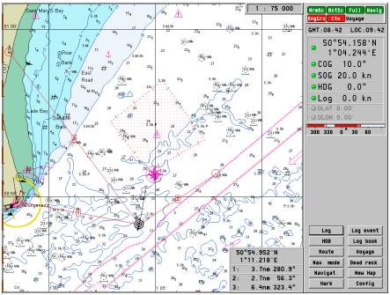
5.26 Exit
This will close down the ECS and is available by clicking on the right mouse button when the cursor is on the current time box at the top of the screen. ALT-F4 will also cause the program to exit.
6.0 GENERAL INFORMATION
6.1 Mouse Operations
In general, the Left Mouse Button is used to “Execute Commands” while the Right Mouse Button is used to “Call up Sub-Menu’s and Object boxes”
6.2 Chart Scales
The program enables charts grouped in eight specific scale ranges to be selected using the scale options box. These range in the scales of 1:20.000.000 through to detailed charts of 1: 5.000. The charts are grouped in the respective categories based on the scale of the original paper charts. If a chart of a specific are is not available, the “nearest best chart” will always be loaded automatically.
6.3 Viewing cartography
It possible to ‘pan’ around freely in the chart display by placing the cursor on the screen and clicking the left mouse button on the mouse, the point where the cursor was located will be the centre of the chart.
6.4 Tides
Tidal predications can be obtained for approximately 4000 locations. Enable tides in the Map menu (see section 5.11) and click with the right mouse button inside a tidal diamond. The related tidal prediction graph will now be displayed and looks as follows: -
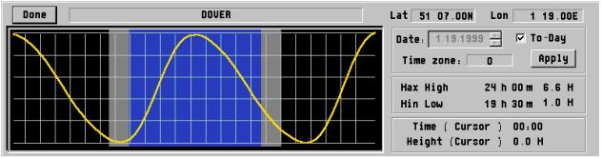
The prediction shown is always for the current date. To obtain a prediction for another date, uncheck the "To-Day" box and choose the required date. Click on APPLY and the prediction will be updated. Move the mouse cursor along the prediction line to see the high/low water level.
6.5 Relative Motion and Course Up Modes
It is possible to select Relative motion and Course up modes by clicking on the vessel centre with the right mouse button and checking the appropriate boxes. The screen will change after a short time to the required mode. The same procedure is used to change back to default modes.
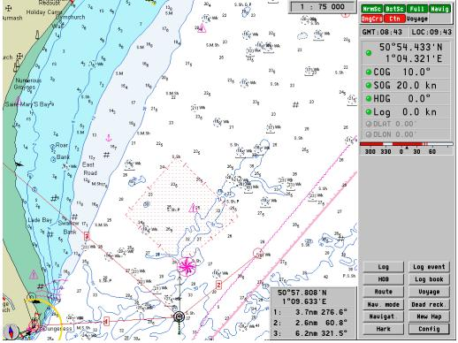
6.6 Object Information
Clicking on any object with the right mouse button will call up the object information box. If there is more than one object in the area selected, click on the Object Information box with the
left mouse button to cycle through the various objects. Click on this box with the right mouse button to remove the Information box. The Object Information box looks as follows: -
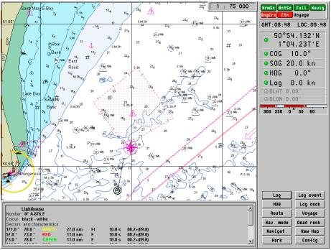
6.7 Palettes
There are four available palettes for different conditions. These are: -
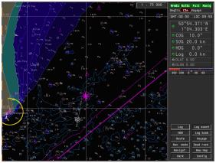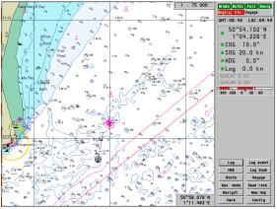
Dusk Day
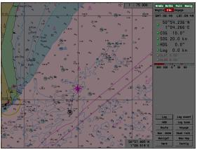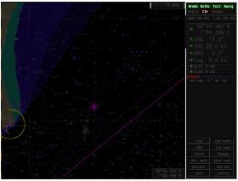
Twilight Night

