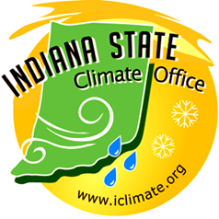
Indiana State Climate Office
Department of Agronomy
Purdue University
West Lafayette IN 47907
Phone: (765)-494-6574
Fax: (765)-496-2926
Email: iclimate@purdue.edu
Website: www.iclimate.org

Dr. Dev Niyogi, State Climatologist
Ken Scheeringa, Associate State Climatologist

2008 AASC SCEP grant progress report

In 2008 the Indiana State Climate office received a SCEP grant from AASC in the category of Monthly State Climate Summary enhancement.

This grant enabled us to continue the services of Joseph Mays, Data Specialist, to research and write an enhanced version of our Indiana monthly state climate summaries.
These reports have been posted monthly to the AASC State Climatologist web site per the grant requirements.

Under the SCEP grant significant improvements were made in impact reporting. Email subscriptions to two Internet news clipping services were begun to receive near current weather impact alerts under specific topic and regional keywords. As we become aware of localized impacts we also contact the affected county Cooperative Extension Service (CES) personnel for possible additional information. In April we were able to link CES input with NWS Indianapolis forecasters when freeze warnings were being considered.

A detailed weekly summary with paragraphs specific to temperature and precipitation anomalies and weather impacts are submitted to Steve Hilberg at the Midwestern Regional Climate Center (MRCC) for use in their online Midwest Climate Watch. A monthly wrap up is also provided to MRCC as they compile their monthly Midwest summary for NCDC. These reports are in addition to the monthly Indiana climate summary we post to the AASC website www.stateclimate.org.

