Oklahoma Climatological Survey
The University of Oklahoma
120 David L. Boren Blvd., Suite 2900
Norman, OK 73072
Ph: 405/325-2541 Fax: 405/325-2550
http://climate.ok.gov E-mail: ocs@ou.edu

Dr. Ken Crawford, State Climatologist
Mark Shafer, Derek Arndt, Gary McManus, Staff Climatologists

The Oklahoma Climatological Survey was very active and visible locally, nationally and internationally in 2008. OCS played important roles in assessing and publicizing extraordinary drought conditions in the Oklahoma Panhandle; transitioning a new ice accumulation product to statewide production; launching a new multi-million dollar effort at reducing weather-related hazard losses; expanding engagement with teachers, students, and public safety officials; continuing extensive contacts with the media; and participating in national dialogues on weather and climate.

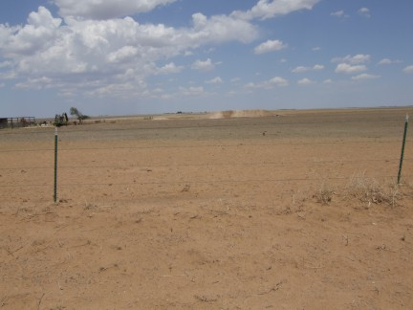
A severe drought in the Oklahoma Panhandle had gone virtually unnoticed in state media until OCS became involved. Through travels to the affected areas and dialogues in national forums such as the Drought Monitor discussion group, international attention was drawn to their plight. Television reports were shown on Japanese TV, Fox News and local channels, while newspaper reports went national, including reports in the USA Today and the New York Times. The attention also drew senior state leadership, including Secretary of Agriculture Terry Peach and Governor Brad Henry, to visit the Panhandle.

Reeling from the aftermath of yet another ice storm in December 2007, OCS was engaged in several efforts to mitigate the effects of future winter weather events. OCS advised the Oklahoma Corporation Commission on ice storm frequencies and climate change, which was included in a study of the costs and benefits of burying power lines. Operationally, OCS collaborated with the Oklahoma Association of Electric Cooperatives (OAEC) and local National Weather Service (NWS) forecast offices to implement a statewide version of the Sperry-Piltz Ice Accumulation Utility Damage Index, developed by OAEC and the NWS Forecast Office in Tulsa. The new winter weather product won the American Public Works Association’s Technical Innovation Award, one of few such awards in APWA’s history.

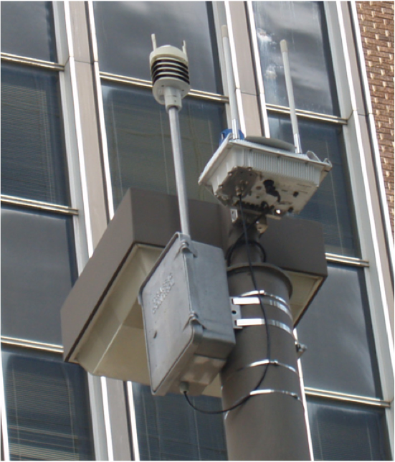
In November, OCS unveiled a new Oklahoma City Micronet (http://okc.mesonet.org), consisting of 36 additional miniature weather stations mounted on traffic signals across Oklahoma City, supplemented by three additional full Mesonet stations. The multipurpose network provides critical weather information for the daily operations of Oklahoma City, supports new scientific research focused on urban meteorology, and serves as a resource for the citizens of central Oklahoma. It was developed during a 5-year collaboration between OCS, the Oklahoma Mesonet, the University of Oklahoma, and the City of Oklahoma City.

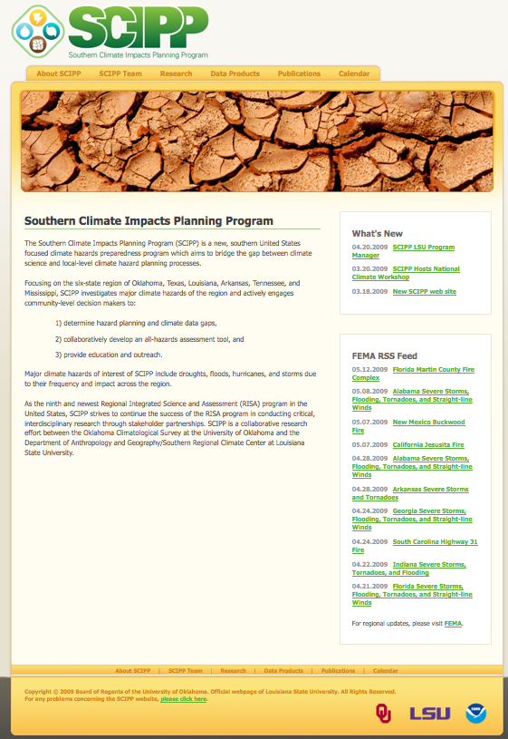
The RISA-funded Southern Climate Impacts Planning Program (SCIPP; http://www.southernclimate.org) began in August 2008. The program is designed to engage communities in the six-state region of Oklahoma, Texas, Louisiana, Arkansas, Mississippi and Tennessee to improve their planning for a range of climate hazards. The program is collaboration between the University of Oklahoma and Louisiana State University (Mark Shafer and Barry Keim, Principal Investigators) in partnership with the Southern Regional Climate Center (SRCC). The design allows research and products developed as part of the RISA to be transitioned into operations of the SRCC.

OCS hosted six 1-day workshops on “Making Sense of Oklahoma’s Climate”. These workshops (funded by NOAA’s Sector Applications and Research Program in 2007) were designed to provide an understanding of the basics of climate, climate variability and change, special topics such as drought, and how to find and interpret information on the web. The workshops drew 60 participants and included a formal evaluation process to assess the effectiveness of the instruction.

Internationally, OCS scientists led a feasibility study for modernizing the meteorological and hydrological services of the Republic of Croatia, and OCS engineers continued to help the Province of Quebec expand services from their provincial mesonet. OCS was represented at a drought workshop in Canberra, Australia, which was a joint effort between NIDIS and Australia’s Bureau of Rural Sciences.

OCS served the climate community through participation in many committees, including several AASC action teams: the American Meteorological Society (Board on Societal Impacts, Symposium on Policy and Socio-Economic Research, Committee on Measurements, Intelligent Transportation Systems), the National Integrated Drought Information System (NIDIS), a NOAA “tiger team” on national climate services, the National Ecological Observing Network, and a UCAR Atmospheric Sciences Literacy Committee.

Information Services

OCS served 7.65 Terabytes of information from 862 million hits to our web pages. We also fulfilled 265 detailed information requests from phone or e-mail – the most logged since 2003. OCS was referenced in 89 articles in the state’s major newspapers and issued another 83 news releases.

OCS introduced a new radar display application, RadarFirst. The application is designed as a lightweight radar viewer for OK-First participants and their colleagues. RadarFirst is a stand-alone desktop application that views live radar images from any radar site in the U.S. with easy zoom and scrolling capabilities.

WeatherScope desktop applications software and the associated browser plug-in received a major new release in 2008 plus three updates. The new releases improve system performance, provide for the display of new products and allowed OCS to update and consolidate some key web products.

Outreach

OCS hosted or provided content to 23 K-12 programs, providing education to 1,817 students and 66 teachers, and conducted 14 OK-First workshops, educating 179 public safety officials. ScienceFest at the Oklahoma City Zoo drew 5,135 fourth- and fifth-grade students, and 2,500 members of the public attended WeatherFest at the National Weather Center. OCS partnered with the state Insurance Department to host the 4th annual Climate and Loss Mitigation Conference, which drew nearly 200 insurance agents and adjusters.

OCS staff provided more than 30 presentations to the public. Topics included climate change, the dust bowl, top 10 weather events that influenced Oklahoma’s history, and public safety. Numerous television interviews were provided, including national exposure in The Weather Channel’s series “When Weather Changed History: The Dust Bowl.” Presentations at many national professional meetings were also given.

Research

Two publications were accepted in Physical Geography as part of a special issue on climate literacy (organized by Lesley-Ann Dupigny-Giroux, Vermont State Climatologist). An article on Tropical Storm Erin was accepted for publication in the Bulletin of the American Meteorological Society. During 2008, 33 publications appeared in print that utilized Mesonet data.

OCS sponsored two students in the Research Experience for Undergraduates program. Their studies looked at freezing rain patterns in the south central United States and the frequency of weather conditions that met criteria for prescribed burns. Both projects were presented at the annual AMS meeting.

Monitoring and Assessments

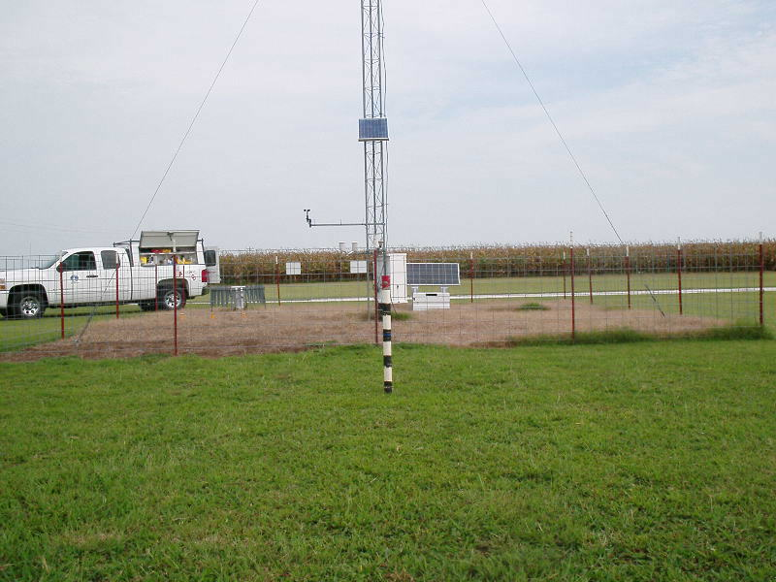
During 2008, the Mesonet completed 2,351 laboratory calibrations of sensors. To maintain our remote sites and sensors in the field, we conducted 817 site visits to 120 Oklahoma Mesonet stations, 78 visits to 35 Little Washita and Fort Cobb Micronet stations, and 56 visits to 36 Oklahoma City Micronet stations. We found and repaired 294 sensor or communications problems in these four networks. Technicians took more than 5,000 photos to document the characteristics of vegetation before and after maintenance was performed at each Mesonet site.

A new Mesonet station was installed at the Lake Carl Blackwell Irrigated Research Farm. The new station, designated CARL, became our 120th Mesonet station. To improve siting conditions, we also moved our Webbers Falls Mesonet station to a new location approximately 1 mile NNE of the old station.

A Capital Bond allowed us to make several major upgrades across the Mesonet in 2008. New auxiliary power systems were installed at all sites, increasing the available solar-generated power at each station by a factor of six. The added power allowed us to install fan-aspirated temperature shelters at each station to improve the quality of our air temperature measurements. New air temperature sensors were also deployed at all stations and all wind direction sensors were refurbished.
About OCS
The Oklahoma Climatological Survey was established in 1980 to provide climatological services to the people of Oklahoma, conduct research on the impacts of climate on human activities, and serve as a support facility for the State Climatologist. OCS has a legislative mandate to acquire, process, and disseminate climate and weather data and information for use by the state's citizens. The Survey maintains an extensive array of climatological information, operates the Oklahoma Mesonet, and hosts a wide variety of educational outreach and scientific research projects. OCS, a research unit of the College of Atmospheric & Geographic Sciences at the University of Oklahoma, employs 34 full-time staff and 14 part-time or student employees.

