2008 Annual report May 1, 2009
www.climate.washington.edu

Personnel

Philip Mote, PhD, State Climatologist
Gary Grove, PhD, Associate SC, Washington State University
Josiah Mault, Assistant SC (until 9/08)
Karin Bumbaco, Assistant SC (11/08- )
Rob Norheim, Assistant SC
Eliza Keeley, Student assistant
Nathaniel Mote, Student assistant

Major accomplishments

New Assistant SC
Continued development of web tools
CoCoRaHS
Surface lapse rates
Homogenizing precipitation records
Three flavors of drought
Optimal network design; SCEP
Legislation
Now entering its seventh year, OWSC has achieved many of its initial goals and has shifted to more of a research focus while maintaining a strong commitment to service and responding quickly and knowledgeably to inquiries from the public, agencies, and the press.
New Assistant SC
Josiah Mault, who joined OWSC as a student assistant in 2005 while still an undergraduate and then became full-time assistant state climatologist in 2006, moved to Boston and now works with DNV Global Energy Concepts, providing meteorological data and analysis for the wind energy industry.

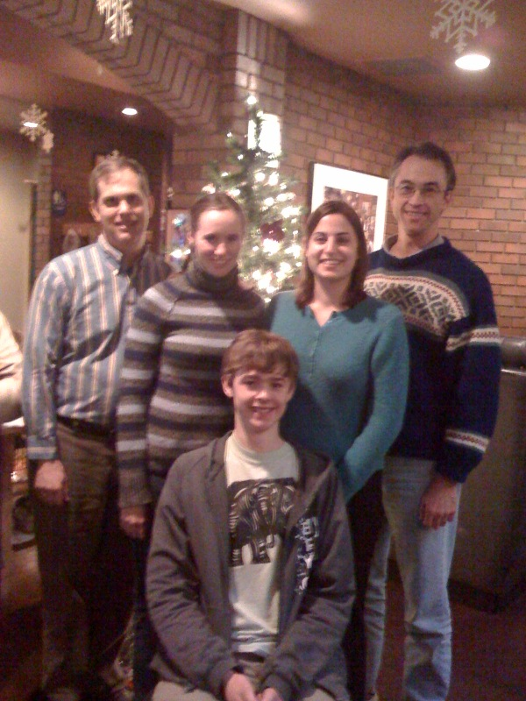
We are pleased to introduce Josiah’s successor, Karin Bumbaco. Karin completed an MS in Atmospheric Science at Ohio State University. Her thesis project compared hydrometeorological variables from automated weather stations in the Peruvian Andes, where she spent time doing fieldwork, with NCEP/NCAR reanalysis. Before that she earned a BS in meteorology from The Pennsylvania State University, where she was a member of the Penn State Campus Weather Service all four years and also worked in the Pennsylvania State Climatology Office.
Continued development of web tools
Having completed a survey of US Historical Climate Network (HCN) stations in the state, we created an online inventory of photos for each station. The inventory includes photos from 8 compass points, toward and away from each instrument, as well as aerial photos of the surroundings if available (www.climate.washington.edu/statetour)
We now serve up snow depth data collected semimonthly by the Northwest Weather and Avalanche Center (www.climate.washington.edu/snowdepth); data are automatically updated twice a month.
We also updated the MODIS satellite cloud fraction data and are working on updating the utility to plot HCN data, using HCN version 2.

CoCoRaHS.org
In June 2008 Washington joined CoCoRaHS, with Phil and Josiah serving as state coordinators. Karin has become the state coordinator, with the assistance of Eliza Keeley, and we have 577 observers as of this writing. Observers got quite a workout during the winter, when the Puget Sound region had more than 15 snowstorms and Spokane at times had more than 24” of snow on the ground. NWS personnel expressed great appreciation for the contributions of our new CoCoRaHS observers.
Surface lapse rates
Phil teamed up with colleagues Prof. Jessica Lundquist (UW Civil and Environmental Engineering) and Justin Minder (UW Atmospheric Sciences) and wrote a paper, soon to be submitted to Geophysical Research Letters, on surface temperature lapse rates in Washington’s Cascade mountains, using a combination of five data sources. Standard assumptions about moist adiabatic are inappropriate.
Homogenizing precipitation records
Karin has been working with Dr. John Abotzoglou, formerly of Western Regional Climate Center, on identifying and correcting nonclimatic discontinuities in precipitation records in the state. Not an easy task - now we see why the major data centers like NCDC have thus far only homogenized temperature.
Three flavors of drought
Karin arrived and immediately got to work carrying across the finish line a manuscript Phil had begun entitled “Three flavors of drought in the Northwest” using recent examples. In common with much of the West, Washington has dry summers when much of the streamflow exists as snowmelt. The first flavor, then, is low winter precipitation which produces low snowpack, as occurred in 2001. The second flavor is an exceptionally dry summer, as happened in 2003 and 2004 (broken by heavy rain in late August). The third flavor of drought is when low snowpack is caused by high winter or spring temperatures, roughly like 2005.
Optimal network design; SCEP
In collaboration with Prof. Greg Hakim, UW Atmospheric Sciences, and Dr. Guillaume Mauger, a recent graduate of UC San Diego, we have been developing an approach to selecting an optimal distribution of observing stations. The approach, ensemble sensitivity, selects the point that explains the most variance, then iteratively selects the next most valuable point after accounting for the variance explained by the first point, and so on, incorporating an estimate of the instrumental error.
Part of this effort, funded by an AASC SCEP grant, evaluated the effectiveness of the Climate Reference Network in explaining the variance in precipitation in the Northwest. Using the 11 CRN sites in Washington, Oregon, Idaho, and western Montana, and 4-km monthly mean precipitation for March 2004-September 2007 from the MM5 forecast model, we regressed grid point precipitation values onto the precipitation records at the 11 CRN sites (or their MM5 proxies if the CRN records were too short). The percent variance explained at each grid point is shown in the map on the next page. Our analysis shows that the variance in western Washington and western Oregon is very well explained; in fact, the stations in Marblemount and Quinault, Washington, are nearly redundant. An exception in western Washington is the low variance explained on the northeast part of the Olympic peninsula. Variance in the drier parts of the region, especially the Yakima Valley in Washington, is poorly explained. This suggests that for monitoring long-term trends in drought, climate-quality stations in those areas should have been a higher priority than in the western parts.
We also changed our monthly newsletter for another SCEP grant, adding a human impacts and moving the publication date up a week. Among other things, we featured the impacts of winter storms and flooding, and the consequent federal disaster declaration. Newsletters are available from www.climate.washington.edu/newsletter/
Legislation
During its 2009 session, the Washington State Legislature for the third time considered a bill that would establish the Office of Washington State Climatologist, specify how the state climatologist would be appointed, and delineate the duties and functions of the Office, in the context of a bill to create a working group to oversee state agency responses on adapting to climate change. The language establishing the state climate office was stripped from the bill.

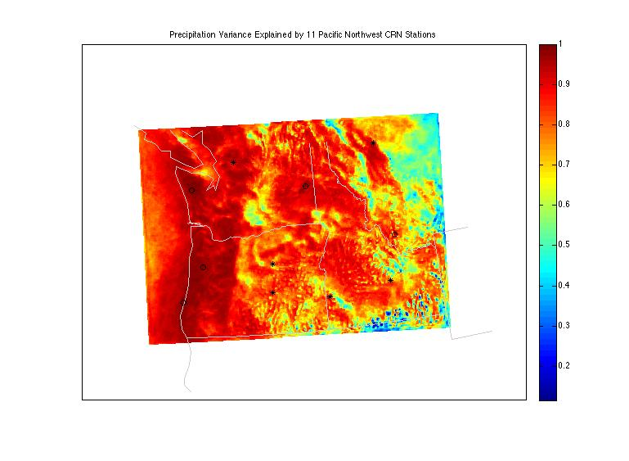
This is my last report as SC for Washington. I am in transition to a faculty position at Oregon State University where I serve as director of the Oregon Climate Change Research Institute and Oregon Climate Services.

Percent variance explained at each 4-km MM5 grid point by a linear regression on the 11 CRN stations (symbols). Stations shown by a star had complete data and the station data were used; stations marked by a diamond were installed after March 2004 and the model time series at that location was used.

Respectfully submitted,

Philip Mote, SC Washington

