

Paul Knight, Pennsylvania State Climatologist 2008 ARSCO Summary
605 Walker Building
University Park, PA 16802
Ph: (814)863-1842 Fax: (814)865-3663
psc@mail.meteo.psu.edu http://climate.psu.edu/

The Pennsylvania State Climate Office database continues to incorporate observations from more than a half dozen separate networks within the Commonwealth. Approximately 250 hourly reporting stations (primarily from the Citizen Weather Observation Program) are now being ingested into the office’s relational database. When combined with hourly reports from the FAA and Pennsylvania’s DEP, there are nearly 400 observations of temperature, dew-point and wind each hour. The State Climate Office has also implemented a new interactive data archive and a new web interface.
The vision for a Pennsylvania Mesonet remains a priority for the State Climate Office. Opportunities that arose late in 2007 evaporated in 2008 as available funds shrunk during the latter half of the year. The CoCoRaHS network continues to expand across Pennsylvania under the auspices of the state climate office and with the name FROST. By the end of the year, over 180 volunteer observers had enrolled and typically, one hundred faithfully report each day.

Information Technology Capabilities:
• About fifty web data requests were logged each month (besides those by phone and US mail)
• Primary users are commercial, educational and government organizations
• The entire North American Regional Reanalysis data set (approximately 4.5 terabytes) has been augmented routinely so that the complete data set is through 12/31/08.

Communication Capabilities:
- The web server was separated from the database host to increase the capacity of numerous web inquiries simultaneously. Development of new products has mainly focused on grant-related items, such as those connected with a data inventory for the National Park Service and Wheat Scab model predictions.

Information Services:
- The development of an Interactive Data Archive continues. This archive allows users to easily obtain data as well as metadata from any of our primary data sources. A collaborative effort with the Northeast Regional Climate Center continues to bring evapo-transpiration data to users and is part of a water budget project.

User Base Growth:
• Τhe number of sites has continued to increase from year to year. We anticipate this trend to continue as we work with more state agencies and provide more data products. The following charts show the 2008 user volume and city probes:

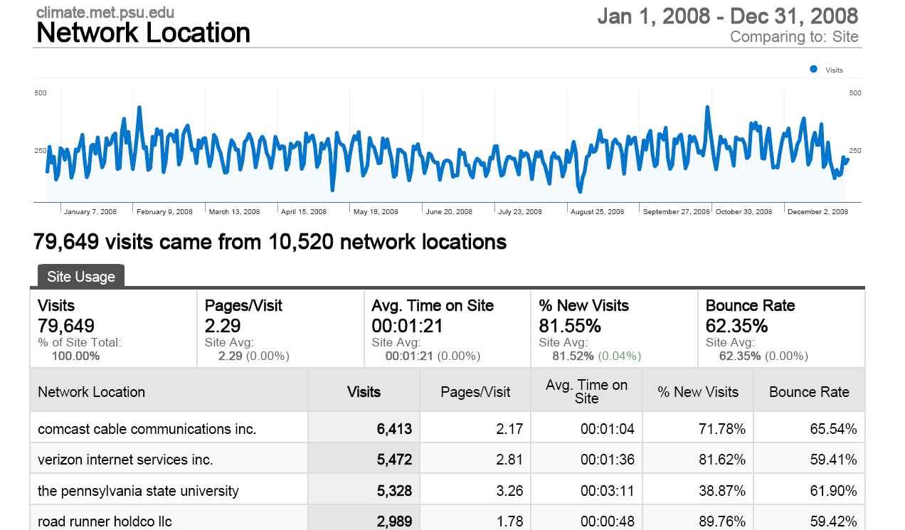

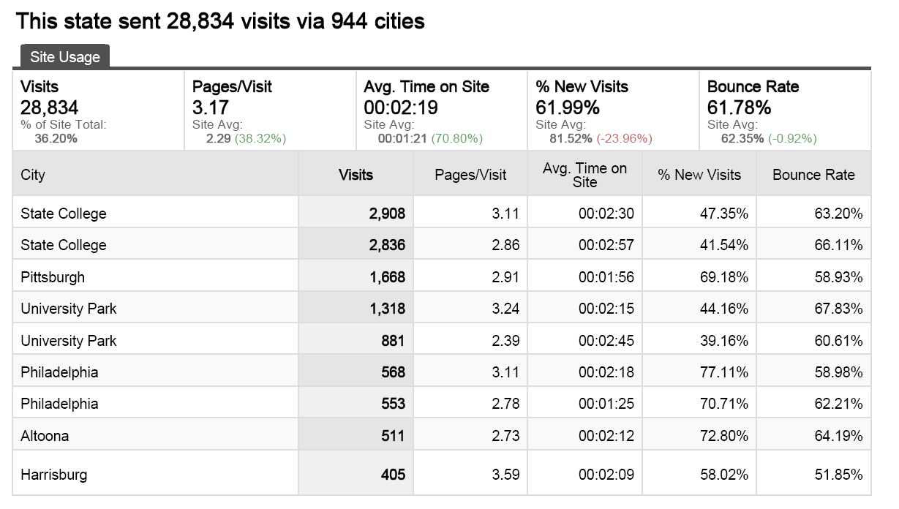

Data Quality Control/Assurance:
- The PA Climate office takes advantage of the sophisticated DQ control routines provided by MADIS on CWOP. Other data is manually QA by student support. A trend comparison of surface temperature and dew point (comparing FAA sites and NARR grid point data) has shown the quality of both data sets for long-term trends.

Climate Office Projects:
- In collaboration with the National Park Service, a climate data inventory project is now in its fourth year. Annual and seasonal summaries have been designed which will have applicability to Pennsylvania climate stations that are not part of this project. The interface for the National Park Service data inventory and retrieval has been upgraded to the current state climate interface.

Special Projects:
- Collaboration with experts in the College of Agricultural Sciences continues with the development of environmental data monitoring systems for a Wheat Scab project. A project with Pennsylvania DOT and the top forecasters from the forecasting practicum continued in providing an early alert for hazardous winter weather for surface transportation.

SCEP:
• The Pennsylvania State Climate Office contributed monthly state weather summaries including its societal impacts to the Northeast Regional Climate Center starting in October 2008 and continuing into September, 2009 as per Task 2.1 of the 2008-2009 NCDC-SCEP agreement.

