Office of the Delaware State Climatologist  212A Pearson Hall  University of Delaware  Newark, DE 19716-2541  Phone: (302) 831-4920  http://www.deos.udel.edu/osc  David R. Legates, State Climatologist  Daniel J. Leathers, Associate State Climatologist  Kevin R. Brinson, Assistant State Climatologist | 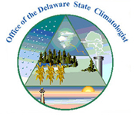

The Office of the Delaware State Climatologist is located in Newark, Delaware at the University of Delaware and is co-operated and co-located with the Delaware Environmental Observing System (DEOS). In July of 2009, both DEOS and the Office of the State Climatologist will move to a new College of Earth, Oceans, and Environment and join a new University-wide environmental institute. Both the Office and the State Climatologist continue to provide climate support services to the State of Delaware, albeit without state or federal funding.

The Office of the Delaware State Climatologist is an AASC Recognized State Climate Office (ARSCO) and partners with the National Climatic Data Center, the Northeast Regional Climate Center, and the National Weather Service in Mt. Holly NJ to provide data and climate services to the citizens of the State of Delaware. As with most State Climate Offices, we provide climate data and expertise to the public and private sector as well as conduct newspaper, radio, and television interviews, give public lectures, and provide legal expertise and court testimony. The Delaware State Climatologist also serves in the Technical Assistance Center of the Delaware Emergency Management Agency during critical weather events. A bill pending in the State legislature will formally appoint the State Climatologist to the State’s Water Supply Coordinating Council. The Office currently has two main projects:

The Delaware Environmental Observing System (DEOS)

Our main funding effort has been the establishment of a real-time system dedicated to monitoring environmental conditions across the Delmarva Peninsula. The Delaware Environmental Observing System (DEOS) is designed as a tool for decision makers involved with emergency management, natural resource monitoring, transportation, and other activities throughout the State of Delaware. DEOS also provides both State agencies and the citizens of Delaware with immediate information as to environmental conditions in and around the State. Being that it is supported by the Office of the Delaware State Climatologist, DEOS also provides a climate archive of the data to support the developing needs of high-resolution (in time and space) requests for environmental data. (http://www.deos.udel.edu)

Being a peninsula, isolated by the Delaware Bay, the Delaware River, and the Chesapeake Bay, the Delmarva Peninsula is very much affected by coastal storms and processes. To make appropriate decisions that depend upon these environmental conditions, decision makers must have environmental data with the highest spatial and temporal resolution possible. Data needs include weather information, observations of streamflow, bay and ocean conditions, and water and air quality. But more importantly, these data must be of the highest quality, readily available, and easily applied. DEOS integrates existing observations from federal, state, and local sources and augments these existing observations with approximately twenty additional observing sites (primarily weather stations, but installed sensors also have included water temperature, wave period, and water quality for the Delaware Bay) around Delaware, Maryland, and Pennsylvania. These observations are connected to a central data collection facility through existing telecommunications capabilities. DEOS currently provides timely data dissemination to State agencies, the National Weather Service, and the public and also is in the process of developing reliable data quality control and quality assurance procedures.

DEOS consists of three main components: (1) the DEOS Environmental Monitoring and Observing Network (DEMON), a network of thirty-one new meteorological observation sites coupled with existing weather and other environmental observation sites in and around Delmarva, (2) the DEOS Integrated Visualization and Analysis System (DIVAS), a GIS-based integration of surface weather observations with National Weather Service WSR-88D radar estimates of precipitation, thereby providing estimates of meteorological and environmental variables over a high spatial resolution grid, and (3) a number of DEOS Analysis Systems (DAS), designed to provide decision support in a variety of environmentally-sensitive areas. One such system will provide transportation and emergency management officials with real-time assessments of coastal and stream flood risk potentials.

Our network has now grown to a total of forty-one stations located in the three counties of Delaware, Chester County in Pennsylvania (in cooperation with Chester County Emergency Management), and Cecil County in Maryland. With new projects focusing on coastal flood monitoring and enhancing agricultural weather information, we expect that several more stations – including the development of a portable DEOS system – will be available in the coming years.

The Delaware Green Energy Spatial Calculator

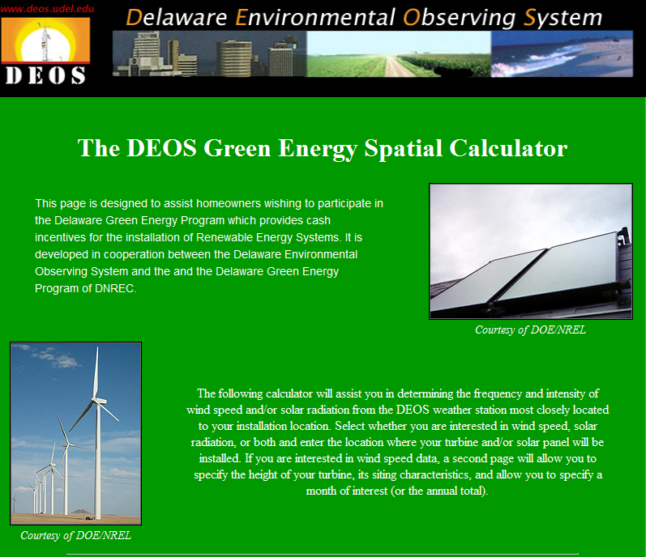
The Delaware Energy Office coordinates the Delaware Green Energy Program. This program operates in cooperation with the local energy provider and makes available cash incentives for homeowners and businesses to install renewable energy systems, including solar power and wind turbines (up to 50% of the cost of the system). One of the requirements to obtain a grant, however, is that the homeowner or business must demonstrate the ability to generate a significant amount of energy via wind and/or solar power at the proposed location.
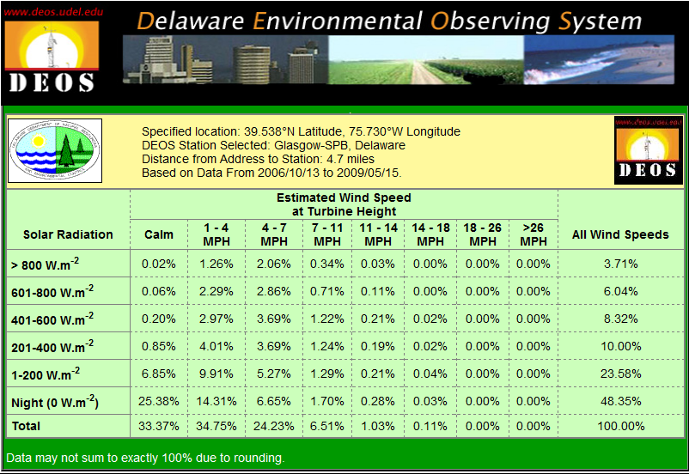
To assist in this project, DEOS has developed the Delaware Green Energy Spatial Calculator. It allows the user to determine the frequency and intensity of wind speed and/or solar radiation from the nearest DEOS weather station to their proposed location (interpolation is unnecessary owing to the relatively dense DEOS network). The user specifies the location (street address or latitude/longitude) and whether wind speed or solar radiation data, or both, are desired. If wind speed is selected, the height of the turbine is entered along with general siting characteristics (i.e., ground cover and relative nearby obstructions) and the logarithmic wind speed profile is used to estimate wind speed at turbine height; roughness length is estimated from the siting characteristics. Output from the Spatial Calculator provides information on annual patterns and stratified by month, with data in tabular form showing the percentage of time wind speed or solar radiation fell within a given range for the entire period of record. For users who specify both wind speed and solar radiation, a contingency table is displayed to show what percentage of the time they can expect to receive significant effects from solar power, wind power, both, and neither. Row and column sums provide the marginal probabilities. Data are updated monthly and stored on the computer so each table is not regenerated each time a request is made (see http://www.deos.udel.edu/dgep).

The DEOS Environmental Monitors Program (DEMs)

We also continue to operate the DEOS Environmental Monitors Program (DEMs). DEMs is a statewide spotter network of more than thirty volunteers that make daily measurements of rainfall, snowfall, and (for some) air temperature. DEM volunteers also serve as local spotters to inform State Weather Officials of breaking severe weather as well as provide local conditions during emergency weather events.

DEMs volunteers enter their data directly into the DEOS database through webpage access (a few, however, still prefer to use mail-in cards). This program is a way to identify those people that are truly interested in taking long-term climate measurements and make them official cooperative observers by providing them with more accurate (and more expensive) equipment. We also have been investigating the possibility of folding the DEMs system into CoCoRaHs.

In summary, the Office of the Delaware State Climatologist is growing. In the past three years, we have obtained support for three undergraduate and three graduate students working on specific projects with DEOS and State Climate personnel. We also have obtained permanent support for a technician and a programmer to continue our development of DEOS. We hope to expand to include support for an administrative position in the coming year.

