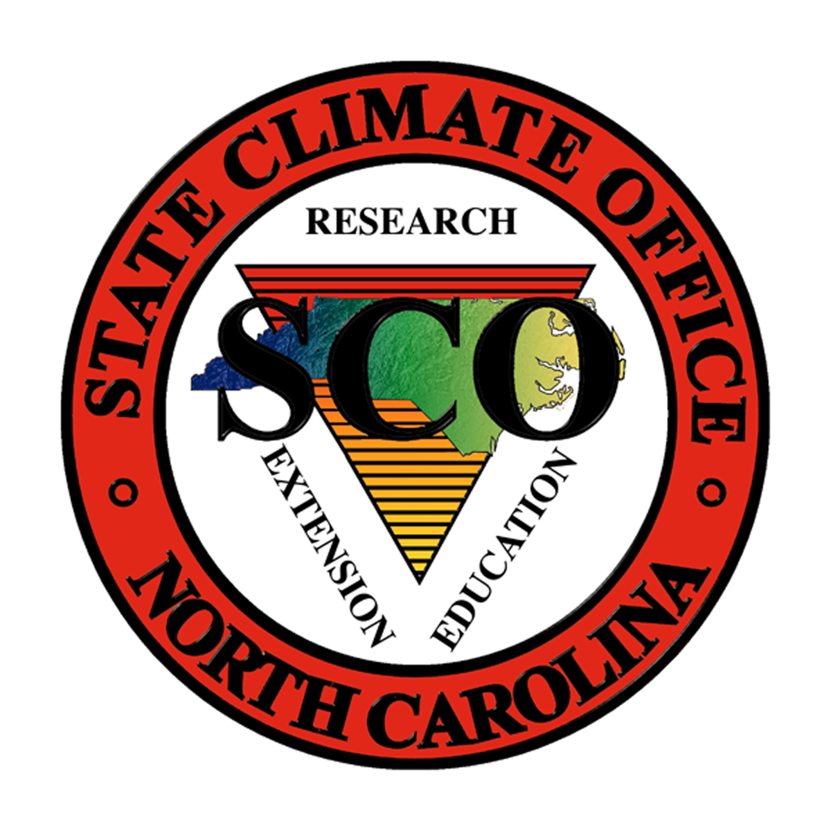
State Climate Office of North Carolina
1005 Capability Drive, Suite 100
N
O
R
T
H

C
A
R
O
L
I
N
A

Box 7236, NC State University
Raleigh, NC 27695-7236
(PH) 919-515-3056 (FAX) 919-515-1441
sco@climate.ncsu.edu
http://www.nc-climate.ncsu.edu

Ryan Boyles, Director and State Climatologist
Ameenulla Syed, Associate Director and Manager, NC ECONet
Aaron Sims, Assistant State Climatologist
Mark Brooks, Climate Services Coordinator
Ashley Frazier, Environmental Meteorologist
Bryan Aldridge, Systems Administrator and Developer
Sean Heuser, Instrumentation Meteorologist
John McGuire, Environmental Meteorologist
Bic Fort, Assistant to the Director

The State Climate Office of North Carolina is a public service center for climate-environment interactions at NC State University. It serves the State of North Carolina as the American Association of State Climatologists Recognized State Climate Office (ARSCO) for North Carolina. Its public service mission includes extension, research, and educational components.
Extension efforts were focused on delivery of services through direct interaction and communication with clients, partnerships with state agencies, and collaboration with extension specialists and scientists at NC State University. Significant extension activities in 2008-2009 included the development of several new climate information tools, deployment of five new ECONet monitoring stations, initiation of new projects in collaboration with agricultural scientists, active monitoring and response to drought conditions in NC, development of climate database and information tools for the NOAA Southeastern Regional Climate Center, and membership in the Southeast Climate Consortium.
Research efforts in the past year focused on study of North Carolina's climate and its interaction with the environment, and investigations into the effects of climatic variations on agriculture and natural resources to assist in resource management. Highlights of our applied research efforts include evaluation of new models and precipitation estimation tools, winter and tropical storm climatologies, a new climatology for recreational activities in NC, and advancements in short-term and seasonal agricultural forecasts.
Educational outreach activities in the State Climate Office are designed so that climate scientists interact with K-12, community college teachers and students, and with other community organizations on different aspects of NC climate and environment. There continues to be overwhelming demand from the public for education on climate variability and climate change, as well as severe events. Activities in the past year include dozens of invited presentations, development of severe weather training programs for Emergency Managers, participation in the FIRST Lego League Challenge and NC Science Olympiad, and a start of new climate education tools in partnership with the NCSU Science House.

Highlights of Climate Services
Requests for Services: 2% increase in time spent directly responding to requests for services from clients. Clients request services via email, phone, and through the Climate Office website.
Monthly climate summaries: Climate summary reports are prepared each month to highlight climate patterns and impact to agriculture and water resources in NC. These are distributed via a monthly online newsletter, reports to NOAA through the Southeast Regional Climate Center (SERCC), and reports to the American Association of State Climatologists (AASC). The SCO uses the newsletters to also inform users about new products and services. The AASC is providing $2500 to support these services.
National Catalog of Climate Services: SCO is the lead state working with the American Association of State Climatologists to develop a catalog of climate products and services provided by the state climatologists and NOAA regional climate centers. SCO is collecting data from AASC members to showcase the economic benefit of these local products and services and contribute to the NOAA Economics website. The Catalog will illustrate the value of state and regional expertise in the context of a National Climate Service and other NOAA initiatives. AASC is providing $5000 to support this effort.
NCDA Monitoring: NC Department of Agriculture now receives a feed of climate data from the SCO to develop their weekly weather and crop status reports.
Holiday Climatology: New tool to provide public and media with local climatologies for most holidays, including those that do not occur on the same calendar date each year (e.g. Thanksgiving, Easter, Labor Day). http://www.nc-climate.ncsu.edu/holiday_climatology.php
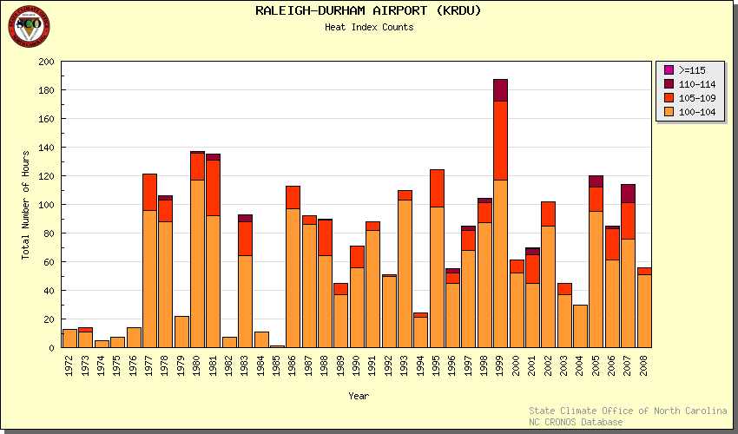
Heat Index Climatology: New page that provides a historical climatology of heat events as measured by heat index thresholds.
Web Usage: 19% increase in website activity as measured by the number of unique visitors. The SCO website averages nearly 14,000 unique visitors every month. Other measure of website activity such as bandwidth and hit counts are available but may be biased by the increase in the number of pages and content added to the site over the past year.
A sample of what some clients have said during the past year:
“Excellent service....very responsive and exactly the information I needed to do my job.” – Landon D.
“Thanks for your prompt response. The data you have provided will help me get part of my research done. I do appreciate your help so so much.“ – Naser A.
“Thanks very much for the rainfall info you sent to me. It has helped greatly in pinpointing the amounts of rain required to trigger the leak in the property.” – Jason M.
“Thank you for the prompt response and information, it has been very helpful for my Viticulture report.” – Renee S.
“Thank you for making my job more productive and helping me provide accurate information to our clients.” – Mary T.

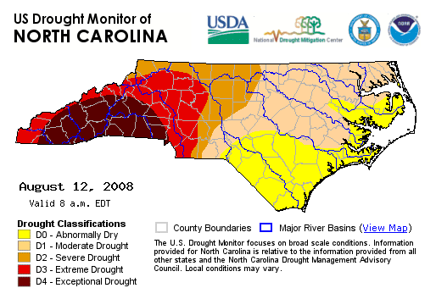
Drought Monitoring and Response
SCO is a key member of the NC Drought Management Advisory Committee, participating in weekly drought monitoring conference calls and providing public presentations on drought in NC. In the past year, drought conditions were widespread and persistent. In response, SCO staff frequently provided public presentations and media interviews. Through CRONOS, SCO provides state agencies with climate and weather data for drought monitoring and management planning. Drought monitoring products have been developed and are used each week for discussions on depictions of drought severity as part of communicated recommendations to the US Drought Monitor.
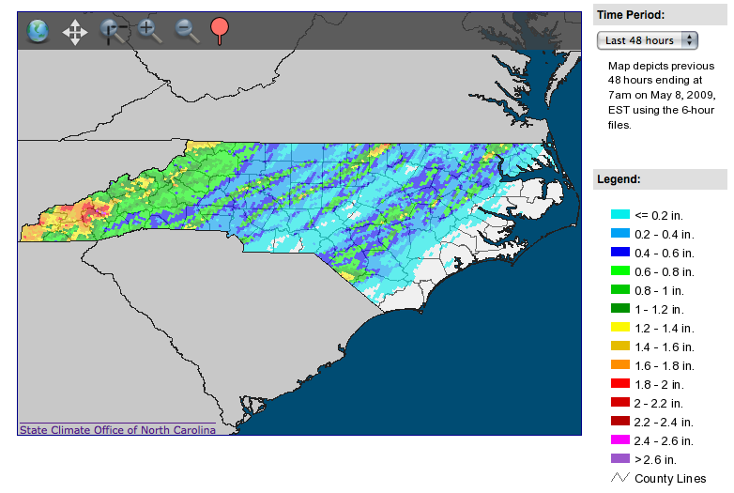
Water Data Support for DENR Division of Water Resources (DWR)
SCO contracted with DWR to provide ongoing climate and water data to support drought monitoring and water resource planning in North Carolina. As part of this effort, SCO developed new software to ingest, process, and integrate streamflow, groundwater, reservoir, and precipitation observations from several providers, including US Geological Survey, US Army Corps of Engineers, Duke Energy, National Weather Service, and DWR. As part of a separate contract with DWR, SCO developed a tool to provide multi-sensor precipitation estimates (MPE) via a simple URL and developed an interface that provides MPE-based comparisons with normal precipitation. http://www.nc-climate.ncsu.edu/cronosh2o/
Turfgrass Irrigation Management System (TIMS)
SCO collaborated with partners in NCSU Crop Science to develop irrigation guidance tools for urban lawn maintenance, called TIMS. Phase 3 of this project was funded by the Center for Turfgrass Environmental Research and Education through June 2009. Phase 3 will add CoCoRaHS data and NWS forecasts to the TIMS website tool. Also included in the phase 3 proposal is an evaluation of the next generation of precipitation estimates, called Q2. http://www.turffiles.ncsu.edu/TIMS/
Peanut Disease Advisories
Working Dr. Barbara Shew (NCSU Plant Pathology), SCO provided daily guidance for fungicide spraying to peanut growers in NC from June-October 2008. These advisories take advantage of research into the relationships between climate and the development of two peanut fungal diseases.
Berry Chill and Heat Models
Working with Dr. Gina Fernandez (NCSU Horticulture Science) and Dr. Bill Cline (NCSU Plant Pathology), SCO developed web-based climate monitoring tools to support blackberry and blueberry growers through heat and chill accumulation tools. SCO presented the blueberry tool at the annual Blueberry Open House.
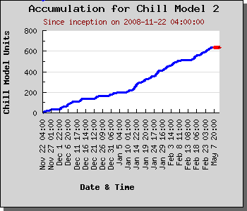
http://www.nc-climate.ncsu.edu/cronos/blackberry/
http://www.nc-climate.ncsu.edu/cronos/blueberry/chill_model
Southeast Climate Consortium
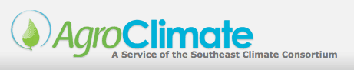
The Southeast Climate Consortium is a group of Universities in FL, AL, and GA working to develop climate risk research and decision support tools for agriculture in the southeastern US. NCSU was invited into this Consortium in 2008. This effort has research, education, and extension components. NC hosted two workshops for extension specialists and county extension agents to introduce them to AgroClimate.org and get their feedback. Workshops involved direct participation and presentations from collaborators in Georgia and Florida. Working with our SECC partners, tools for NC have been added to the SECC decision portal http://agroclimate.org/
Climate Information Support for the NOAA Southeast Regional Climate Center
NCSU and UNC-Chapel Hill were awarded the NOAA Southeast Regional Climate Center (SERCC) in 2007. As part of that award, the SCO is responsible for supporting and maintaining the Applied Climate Information System (ACIS), which serves as the climate database for all six NOAA Regional Climate Centers. Additionally, SCO is responsible for developing and maintaining the SERCC web services and online climate tools.
Over the past year, SCO has provided operational support for ACIS and the SERCC website. Additionally, SCO has enhanced server reliability and developed a new Climate Perspectives tool that places recent climate observations in geographical and historical context. http://www.sercc.com/perspectives/
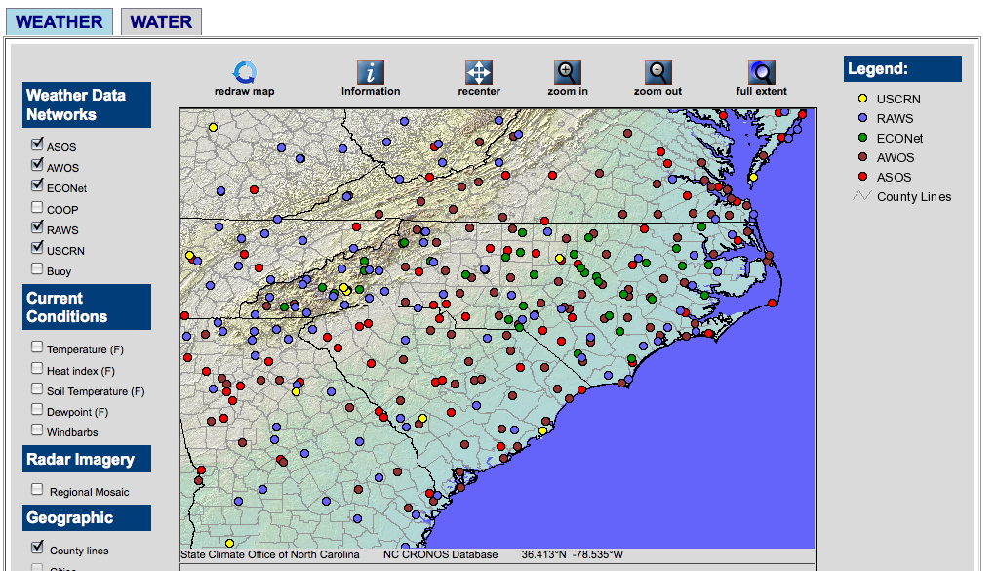
CRONOS Database
CRONOS is the name given to the SCO’s climate database, which includes data from surface observational networks, severe weather data, and every type of climate data that we can insert. The CRONOS database serves as the foundation for most SCO products and services.
Usage: Average of 4400 queries per month to CRONOS, the SCO online climate database.
Soil Erosivity: Collaboration with Dr. Manuel Reyes (NC A&T State University) to develop and launch database calculations of soil erosivity for monitoring stations that report data at 1-minute intervals.
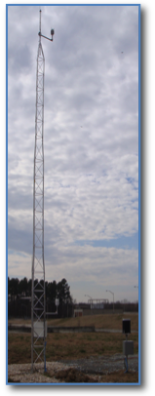
SCOUT Data availability tool: A tool to visually explore database inventory. This tool will be helpful for both staff and the public, as they would be able to see if the data they want is available before submitting a data request.
NC Environment and Climate Observing Network (ECONet )
The ECONet is a network of real-time research-grade monitoring stations that provide observational data on atmospheric and soil conditions.
New Installations: Five new stations were installed at Burnsville (Yancey County), Mount Mitchell (Yancey County), Taylorsville (Alexander County), Wallace (Duplin County), and Durham (Durham County).
Sensor Upgrades: Upgrades for the network are underway to provide new data loggers, solar radiation sensors, sonic wind sensors, and impact precipitation sensors. These upgrades also provide data recorded every minute.

