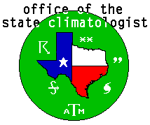

Annual Report

Texas

2008

submitted May 14, 2009

Physical Location and Funding:
The Office of the State Climatologist is housed in the Department of Atmospheric Sciences, Texas A&M University. Direct University support for this fiscal year included 50% salary of a research associate (Brent McRoberts) from the Department of Atmospheric Sciences. The College of Geosciences contributed $5,000. Remaining operating expenses were paid by the State Climatogist through returned indirect costs and salary savings. Office space is provided free of charge by the University. In addition to the State Climatologist and the Research Associate, an undergraduate student (Zachary Adian) provides assistance with phone inquiries and data requests. Steven Quiring, a faculty member in the Geography Department, also assisted with OSC activities. Cost recovery is available for large data requests. External funding is provided for sponsored research projects.

Communication and Information Services:
In 2008, about 200 electronic climate requests were received and responded to. Annually, the Office receives approximately 100-150 phone calls and sends dozens of facsimiles and mailings.
For the Texas Almanac, the Office provides and verifies a significant amount of climatological data for the publication. On the Office website, http://atmo.tamu.edu/osc, the Office posts monthly climate summaries for the state and the Bryan/College Station area as well as weekly weather forecasts for Texas. The Texas Monthly summary includes a crop report, precipitation and temperature deviations from normal for the major cities in Texas, and a summary of the previous month’s weather.

Research:
The Office of the State Climatologist is working on a project directed toward documenting and understanding decade-scale changes in the observed precipitation climate of Texas. The basis of this project was the use of an interpolation technique to estimate missing monthly precipitation observations from surrounding stations, thereby eliminating biases associated with changes in network configuration. Though the conventional climate division data in Texas lacks a long-term trend, we have found that overall precipitation has actually been steadily increasing in Texas over the past century. The OSC has produced maps showing the estimated spatial extent and severity of droughts in Texas and neighboring states during the past century.

A similar analysis carried out over the 48 contiguous states identified two sources of inhomogeneity. The first was the use of linear regression that interpolates monthly climate division precipitation averages from linear regression of state averages prior to 1931. The second was the lack of station consistency in the post-1931 calculations of the monthly precipitation average. The Office is generating two new climate division precipitation data sets free of these inhomogeneities, one using all available station locations and one compatible with the current NCDC climate division values using only the same stations that NCDC used in December 2008.

In another project, the OSC has created a high resolution daily SPI product to encapsulate the state of drought in Texas. The product utilizes the Advanced Hydrologic Prediction System (AHPS) daily 4 km precipitation analyses. To calculate SPI, it was necessary to derive historical probability distributions for every grid point. The initial steps used a clustering technique to group Texas stations with long-term precipitation data into quasi-homogeneous regions. A regional frequency analysis algorithm was applied to each station’s daily precipitation data and resulted in the creation of station L-moment parameters. Historical CDFs at each station were created for every day of the year and filtered using a harmonic smoothing technique to ensure continuity between days. This yielded the higher-order moments, which were then extrapolated to grid points. The zeroth-order moment, or mean, was assigned from the PRISM 30-year precipitation normals.
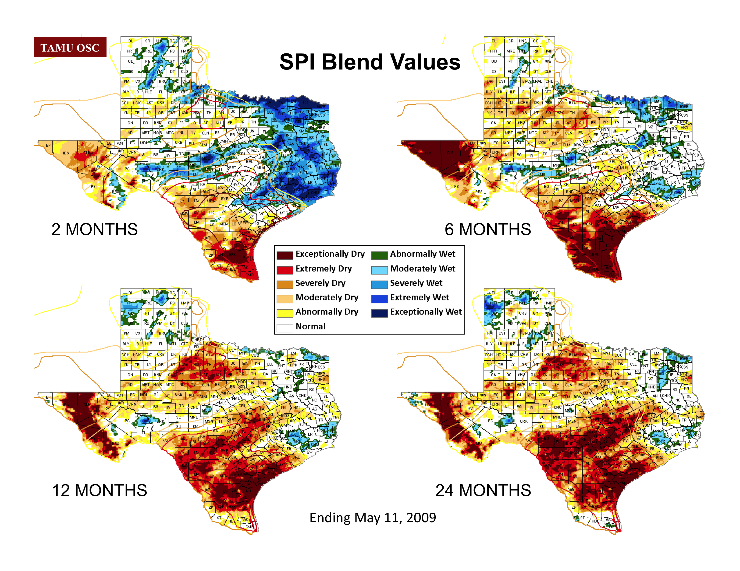
In addition to computing SPI in this fashion, we have implemented a new drought index called the SPI blend. The SPI blend is an SPI based on a range of accumulation times, instead of the single accumulation times that the conventional SPI uses. Maps of the SPI Blend are created in ArcGIS to graphically determine the magnitude of drought for several accumulation periods in Texas and help provide local input for the United States Drought Monitor. A sample output product from the SPI blend is included on the previous page.

The Office is continuing its investigation into the local-scale and large-scale controls on summertime precipitation in Texas with three research papers presently in the revision stage. The study was designed to examine direct relationships between precipitation and the factors that control it, using tools developed for convective forecasting. Our study found that precipitation on monthly time scales during the summer in Texas is primarily controlled by variations in convective inhibition (CIN) and is almost unaffected by CAPE. Other research projects have involved historical weather events, wintertime weather variability, and expert review of development of updated storm surge probability maps for Texas.

Outreach:
The Office’s primary means of outreach is through data access and publications available on the OSC web site. In addition, the OSC responds regularly to media requests and requests for guest lectures. During the past year, the greatest interest among the public has been with regard to topics related to drought, hurricanes, and climate change. During 2008, the Texas State Climatologist gave invited lectures to the following groups and venues: the Gideon Lycecum Master Naturalist Class, University of the Incarnate Word, Texas Region C Water Planning Group, Rio Grande Valley Livestock Show and Exhibition, Upper Trinity Regional Water Planning District, Climate Change Impacts on Texas Water Conference, Far West Texas Climate Change Conference, and Big Bend Rio Grande Workshop.

A newer form of outreach is the blog Atmo.Sphere, hosted by the Houston Chronicle and located at the URL (http://www.chron.com/commons/readerblogs/atmosphere). The blog focuses on climate change, with some discussion of current weather events as well. The blog is written by the State Climatologist and by Barry Lefer, a faculty member at the University of Houston.

Monitoring and Impact Assessments:
The State Climatologist is an appointed member of the Texas Drought Preparedness Council, a statewide interagency committee created by the Texas Legislature in 1998 to monitor drought conditions and coordinate drought mitigation activities. The Council meets monthly in Austin. The State Climatologist is also an active participant in the U.S. Drought Monitor mailing list.

Since December 2008, with SCEP funding from NOAA, the Office has produced a monthly climate impacts report that documents the print media coverage of weather and climate effects on the general public and is posted on both the OSC and AASC websites. Because of an ongoing severe drought in Texas, climate impacts have been widespread. The most recent report, covering the month of April, included over fifty impact reports. Reports are gathered from newspapers and other sources throughout the state. The monthly report includes links to the original source material. The reports are posted on our own web site http://atmo.tamu.edu/osc as well as on http://www.stateclimate.org .

