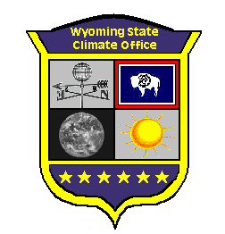

Wyoming State Climate Office
Water Resources Data System
Dept 3943, 1000 E. University Ave.
Laramie, Wyoming 82071
Phone: (307) 766-6651
Email: stateclim@wrds.uwyo.edu

Steve Gray
Director and State Climatologist

Tony Bergantino Assistant State Climatologist
Chris Nicholson Outreach and Technology Coordinator
Barbara Muller Librarian and Archivist
Jodi Preston Office Administrator and Data Manager
Scott Laursen Data Services/Research Associate
Michelle Ogden Data Services/Research Associate

The Wyoming Water Resources Data System (WRDS; http://www.wrds.uwyo.edu/) and its State Climate Office branch (SCO; http://www.wrds.uwyo.edu/wrds/wsc/wsc.html) are the single largest providers of water and climate-related data in the state. Housed within the Department of Civil and Architectural Engineering at the University of Wyoming, WRDS and the SCO are funded primarily through contracts with the Wyoming Water Development Commission.

The WRDS-SCO office provides a variety of services, ranging from the development of enhanced drought-monitoring products to the online dissemination of water and climate data. WRDS and the SCO also support a wide range of groups by assisting in the development of the State Water Plan and helping to coordinate climate- and hydrologic-monitoring efforts throughout Wyoming.

Activities Related to the ARSCO Mission

Information Services
Data and information services at the Wyoming SCO are provided primarily via the World Wide Web. The links below provide a sampling of related products:
- http://www.wrds.uwyo.edu/
- http://library.wrds.uwyo.edu/
- http://www.wrds.uwyo.edu/sco/data/data.html

In addition to internet services, we also responded to almost 150 direct requests (i.e. via phone, mail, or other personal contact) for climate data and climate-related information. We also continued to work with several state and federal agencies to (1) improve infrastructure related to climate monitoring and (2) improve methods for online access to climate data. Towards these ends we developed cooperative agreements with the NRCS, NOAA-NWS, Wyoming Dept. of Agriculture and Wyoming State Engineers Office that allowed for cost sharing on new instrumentation, upgrades to existing climate/water monitoring sites, and improved data access. Highlights of this work include new equipment installations or upgrades at 25 soil-moisture monitoring sites since mid-2007, and a cooperative agreement that brought six new NRCS SNOTEL sites to the state.

Outreach
While dry conditions eased somewhat in 2008, drought and water supplies continued to be a major concern in Wyoming. Climate change also continues to be a topic of tremendous interest. In turn, we focused much of our effort on high-impact events designed to educate the public and members of state government about drought and climate science. Out of some 25 invited presentations, key examples include:
- S.T. Gray, “Potential Climate Change Impacts and Natural Resource Management in Wyoming”. Invited presentation to the Director and Executive Committee, Wyoming Game and Fish Department. Cheyenne, Wyoming. January 2008.
- S.T. Gray, “Drought, Climate Change and Water Resources in the Platte River Basin ”. Annual Water Policy Conference, Platte River Recovery Program. Scotts Bluff, Nebraska. March 2008.
- S.T. Gray, “Climate Change and Wyoming Agriculture”. Invited Presentation to the Director and Board, Wyoming Department of Agriculture. Cheyenne, Wyoming. May 2008.
- S.T. Gray, “Drought, Climate Change and the Future of Wyoming’s Water Resources”. Invited presentation to the Wyoming Water Development Commission. Alpine, Wyoming. August 2008.
- S.T. Gray, “Climate Change Impacts and Wyoming Water”. Stroock Forum on Wyoming Lands and People. Pinedale, Wyoming. November 2008.

In addition, the Wyoming SCO co-organized a workshop on drought, climate variability and climate change with Montana Game and Fish, USGS, the World Wildlife Fund and Wilderness Conservation Society. In total, we conducted over 50 print, radio and television interviews with media outlets from throughout the state and surrounding region.

Developing Improved Communications Capabilities
One of our most important accomplishments in 2008 was the launch of a new Wyoming SCO website: http://www.wrds.uwyo.edu/sco/climate_office.html. The new website features improved navigation and overall ease-of-use. Launch of the new website also allowed us to concentrate on the development of new data products tailored to address specific stakeholder needs. Examples of specific products can be found at:
http://www.wrds.uwyo.edu/sco/data/normals/1971-2000/delta_TMin.html
http://www.wrds.uwyo.edu/sco/data/wtryr/wtryr.html

Work also continues on the development of an Internet Map Server that supplements existing methods of data retrieval. In early 2008 we launched a fully operational version of this system that allows users to access real-time and historical climate data provided by multiple state and federal agencies. This system provides “one stop shopping” for data, and allows users to explore and view Wyoming’s climate in a variety of user-friendly contexts. In mid-2008 we expanded this system to include several features driven by PRISM-based estimates. The example below shows a feature where users can view maps of average annual precipitation based on PRISM and then click on any cell to retrieve monthly and annual precipitation statistics for that location.
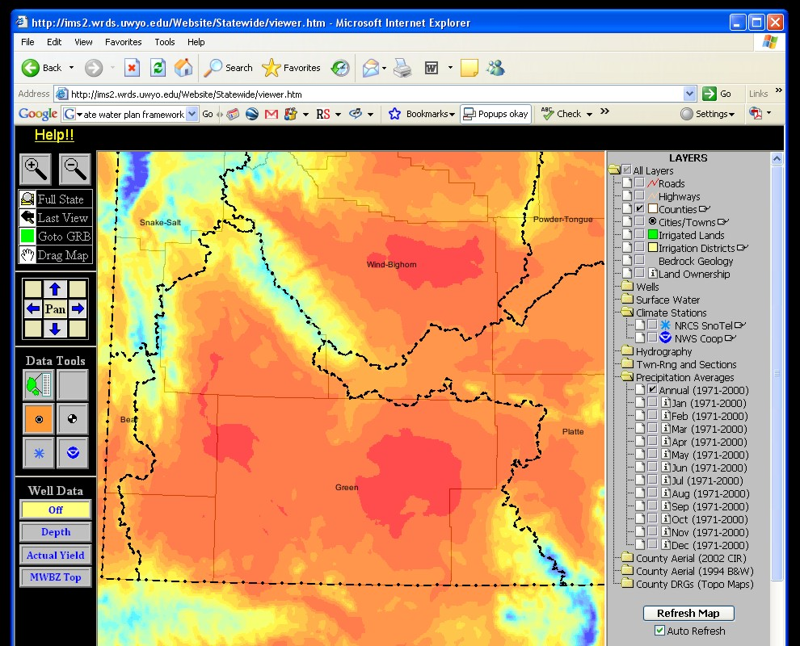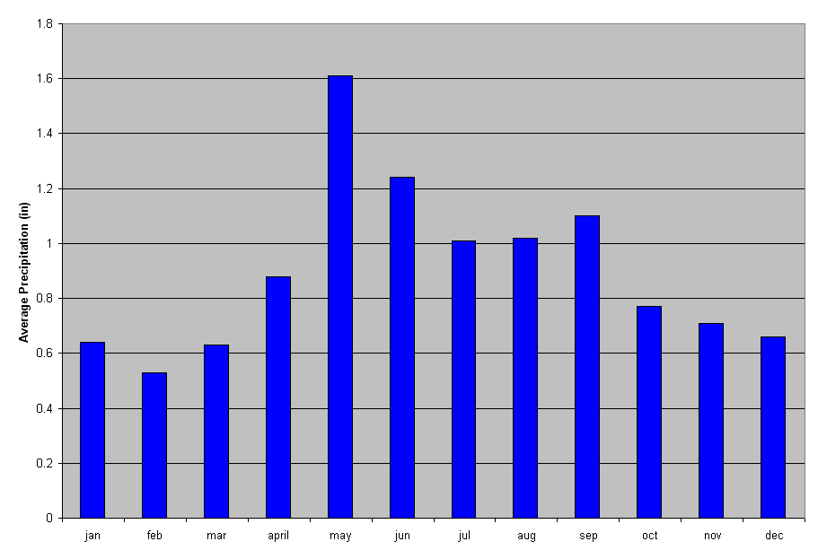

Research
In 2008 the Wyoming SCO was directly involved in a variety of research projects, including work related to:
- Design of climate monitoring systems for high-mountain areas
- Long-term history of Wyoming and western U.S. climate
- Ecosystem impacts of drought

Examples of papers published or accepted for publication in 2008 include:
McCabe, G.J., J.L. Betancourt, S.T. Gray, M.A. Palecki, and H.H. Hidalgo. 2008. Associations
of multi-decadal sea-surface temperature variability with U.S. Drought. Quaternary
International, doi:10.1016/j.quaint.2007.07.001.
Watson, T.A., F.A. Barnett, S.T. Gray and G.A. Tootle. 2009. Reconstructed stream flows for
the headwaters of the Wind River, Wyoming, USA. Journal of the American Water Resources Association, 45:224-236.
Kelleners, T., V.B. Paige, S.T. Gray. 2009. Measurement of the dielectric properties of
Wyoming soils using electromagnetic sensors. Soil Science Society of America Journal, In press.

Compiled by Steve Gray

