Multi-Sensor Examination of Hurricane Dennis (2005): Hot Towers and Rapid Intensification

Stephen R. Guimond¹, Gerald M. Heymsfield², and F. Joseph Turk³

¹Center for Ocean-Atmospheric Prediction Studies and Department of Meteorology, Florida State University, Tallahassee, FL
²NASA Goddard Space Flight Center, Greenbelt, Maryland
³Naval Research Laboratory, Monterey, CA

January 3, 2009

Corresponding author address: Stephen R. Guimond, Center for Ocean-Atmospheric Prediction Studies, Florida State University, Tallahassee, FL 32310.
E-mail: guimond@coaps.fsu.edu

Abstract. A synthesis of remote sensing and in situ observations throughout the lifecycle of Hurricane Dennis (2005) during the National Aeronautics and Space Administration (NASA) Tropical Cloud Systems and Processes (TCSP) mission is presented. Measurements from the ER-2 Doppler radar (EDOP), the Advanced Microwave Sounding Unit (AMSU) and flight-level instruments are used to provide a multi-scale examination of the storm lifecycle. The main focus is an episode of deep, convective bursts (“hot towers”) occuring during a mature stage of the storm and preceding a period of rapid intensification (11 mb pressure drop in 1 hour 35 minutes). The vigorous hot towers penetrated to ~16 km height, had a maximum updraft of 20 m/s at the 10 km level and possessed a strong transverse circulation through the core of the convection including significant downdrafts. Microwave radiometer 85 GHz ice-scattering signatures as well as increased values of the linear depolarization ratio indicate the presence of dry ice particles or graupel lofted to high altitudues within the convective towers.
Fourier analysis on the AMSU measurements revealed a large shift in the storm’s warm core structure, from asymmetric to symmetric, coincident with the hot tower observations. In addition, flight-level wind calculations of the symmetric tangential velocity and relative inertial stability showed a contraction of the increased maximum winds and more efficient transverse circulation in the ~12 hours after the hot tower observations.
These multi-platform, multi-scale observations reveal unique details on hot towers and their interplay with the parent vortex, thus verifying the axisymmetrization and efficiency theories presented by previous authors.

1. Introduction
a. Instruments for tropical cyclone observation
Advancements in the field of atmospheric science, and science in general, often arise due to new and innovative observations of the entity being studied. Such is the case with the problem of tropical cyclone (TC) genesis and intensification. In recent years, the conglomeration of various instruments (e.g. dropsondes, aircraft Doppler radars, microwave satellite imagers and sounders) has led to an increase in the frequency and quality of observations of the TC inner core providing for improvement in the forecasting of TC evolution (Kepert et al. 2006). For example, the use of passive microwave instruments flying on a variety of satellites has assisted in the monitoring of eyewall replacement cycles, one important aspect of the intensification process (Willoughby et al. 1982; Hawkins et al. 2006; Jones et al. 2006). In addition, the Advanced Microwave Sounding Unit (AMSU) series of satellites has assisted researchers and forecasters alike through the ability to monitor the broad upper-level warm-core of a TC, another important aspect of intensification that leads directly to lowered surface pressures and increased winds through thermal wind adjustment (Kidder et al. 2000, Spencer and Braswell 2001; Brueske and Velden 2003; Knaff et al. 2004).
Airborne Doppler radar has arguably had the most extensive and fruitful role in TC research particularly in the observation of storm structure and dynamics. For thirty years, the National Oceanic and Atmospheric Administration (NOAA) WP-3D (P-3) aircraft have been providing a wealth of details on TCs that has revolutionized the understanding and operational forecasting of these systems (e.g. Jorgensen 1984; Marks and Houze 1987; Marks et al. 1992; Reasor et al. 2000; Aberson et al. 2006; Reasor et al. 2008). The along-track sampling of the P-3 tail (TA) radar in normal-plane scanning mode and fore/aft (FAST) scanning mode is ~0.75 km and ~1.5 km, respectively with ~0.15 km gate spacing (Gamache et al. 1995; Black et al. 1996). Taking into account the 1.9° vertical and 1.35° horizontal beamwidths of the TA antenna and the sampling intervals using FAST, grid resolutions from the P-3s range from 1.5 - 2.0 km in the horizontal to 0.5 - 1.0 km in the vertical (Reasor et al. 2000; Reasor et al. 2008).
In addition to the NOAA P-3s, the more advanced Electra Doppler Radar (ELDORA) operated by the National Center for Atmospheric Research (NCAR) has flown recent missions into TCs revealing convective scale detail in rainband and inner-core regions (Houze et al. 2006). The scanning geometry of ELDORA is similar to that of the P-3s with the exception of a faster antenna rotation rate yielding finer along-track sampling of 0.4 km. The gate spacing of ELDORA is 0.15 km and when combined with the 1.8° beamwidth, results in grid resolutions of ~0.4 km in the horizontal and 0.30 km in the vertical (Hildebrand et al. 1996; Wakimoto et al. 1996; Houze et al. 2008).
A unique radar system with experience in several research missions into TCs is the National Aeronautics and Space Administration (NASA)’s ER-2 Doppler Radar (EDOP). EDOP is an X-band (9.6 GHz) Doppler radar with fixed nadir and forward (33° off nadir) beams each with a 2.9° beamwidth. Measurements are taken from the high-altitude (20 km) ER-2 every 0.5 s with a ~ 200 m s⁻¹ ground speed providing some of the finest sampling of any current airborne radar (100 m along-track and 37.5 m gate spacing; Heymsfield et al. 1996). The along-track spacing results in significant oversampling of precipitation yielding an effective horizontal resolution somewhere between 100 m and the 2.9° beamwidth (~0.55 km at surface and ~0.30 km at 10 km altitude), although the data are typically considered as point measurements. The main advantage of EDOP is the nadir-viewing geometry that allows for superior resolution when compared to the P-3s and ELDORA along with the direct measurement of vertical velocity. In addition, the ER-2 is able to over-fly intense convection (such as hot towers) with a quasi-stable platform, whereas other aircraft typically rely on side-looking views of high reflectivity regions because of safety concerns (Heymsfield et al. 1996). The main disadvantage in using EDOP is the inability to retrieve 3-D winds, as the non-scanning beams only measure Doppler velocities along the vertical plane of the aircraft track. More details on EDOP and the derived velocities are given in Section 2b.
b. Hot Towers
Several decades of research has highlighted the role of horizontally small, intense cores of rapidly rising, nearly undilute air that reach and/or penetrate the tropopause (“hot towers”) in the tropical atmosphere including TCs (Riehl and Malkus 1958; Malkus and Riehl 1960; Gentry et al. 1970; Steranka et al. 1986; Simpson et al. 1998; Heymsfield et al. 2001; Kelley et al. 2004; Hendricks et al. 2004; Montgomery et al. 2006a). Although hot towers have been studied sporadically for quite some time, many more details are yet to be observed and understood about these complex, yet seemingly important features within the TC lifecycle. Only recently has new information about convective bursts and hot towers in TCs been uncovered (Reasor et al. 2008; Houze et al. 2008) including theories on how they fit into the TC genesis problem (Hendricks et al. 2004; Montgomery et al. 2006a).
Hot towers occuring in an environment of sufficient background rotation generate potential vorticity (PV) anomalies through (i) transport of high-entropy air (θ_{e}) extracted at the ocean surface leading to a release of latent heat in the mid-troposphere and (ii) tilting and stretching of ambient vorticity by strong updrafts in the core (“vortical hot towers”; VHTs; Hendricks et al. 2004; Montgomery et al. 2006a). The updraft appears to be the most important feature of the VHT, providing a medium for θ_{e} transport and formation of large, collocated vertical vorticity anomalies (i.e. rotating updraft).
Montgomery et al. (2006a) created a model-derived composite VHT and found maximum mean vertical velocities of 15 m s⁻¹ at 9 km height with maximum instantaneous vertical velocities between 20-35 m s⁻¹ in the 9-12 km height range. The mean VHT was found to last approximately one hour with individual diameters ranging from 5-20 km. The exact processes by which VHTs are initiated and how they act to intensify the mature storm is still largely unknown, although work on their role in the dynamics of cyclogenesis and intensification is building (Montgomery and Enagonio 1998; Moller and Montgomery 1999; Nolan and Grasso 2003; Montgomery et al. 2006b; Nolan et al. 2007).
In general, the PV anomalies associated with an asymmetric distribution of hot towers are axisymmetrized into the parent circulation via vortex Rossby wave dynamics (Montgomery and Kallenbach 1997; Montgomery and Enagonio 1998). Montgomery and Enagonio (1998) showed how convectively-induced eddy heat and momentum fluxes (a by-product of vortex Rossby waves) can force the development of subsidence near the center of the vortex, yielding intensification of the warm-core in a simple quasi-geostrophic model. Similarly, Willoughby (1998) presented a conceptual model, based on observations, for the development and intensification of the warm-core whereby deep convection acts to draw mass from the low-level eye into the eyewall forcing subsidence at the center of the vortex. Schubert and Hack (1982) found, using an analytical approach, that the efficiency of the above processes (ratio of eye warming to convective heating) is highly dependent on the inertial stability of the background vortex. Large increases in the efficiency and thus, intensification were found to scale with increases in the inertial stability, a result of the vortex’s ability to resist radial parcel displacements and concentrate the transverse circulation (Eliassen 1951; Shapiro and Willoughby 1982).
In this paper, we examine the lifecycle of Hurricane Dennis (2005) with a focus on an outbreak of hot towers during a mature stage of the storm just prior to a period of rapid intensification. The purpose of this study is to document unique observations of hot towers from EDOP and fit them, using observations, into the larger scale evolution of the vortex. To this end, we use satellite and in situ measurements to examine the thermodynamics and dynamics, respectively of the vortex and show how the results are consistent with the theory discussed above.

2. Data and processing
a. AMSU
The AMSU is a cross-track scanning microwave radiometer operating primarily through 12 channels in the oxygen absorption band (50 – 60 GHz) with a swath width of 2179 km and horizontal resolution near nadir of 48 km (Kidder et al. 2000). Due to the relatively coarse resolution, the AMSU can only resolve the broad scale warm anomaly of a TC, however the routine operational use of these data for estimating TC intensity at the National Hurricane Center (NHC) demonstrates the utility of these measurements (Guimond et al. 2005; DeMuth et al. 2006). Although HTs are not resolvable by the AMSU, it is expected that the collective effects of multiple HTs will be discernable in the AMSU data due to the large amount of diabatic heating, subsidence and attendant falling surface pressure both theory and observations show following convective burst episodes (Shapiro and Willoughby 1982; Montgomery and Enagonio 1998; Heymsfield et al. 2001; Kelley et al. 2004).
Retrievals of AMSU temperature profiles are provided by the Cooperative Institute for Research in the Atmosphere (CIRA) following the procedures outlined in Goldberg et al. (2001) and Demuth et al. (2004). Important steps in the retrievals are the corrections for antenna sidelobes, adjustment of off-nadir scan angles to nadir incidence, statistical determination of temperature as a function of pressure and correction for hydrometeor contamination (radiation that is attenuated by cloud liquid water and scattered by graupel/ice particles). The root-mean-square errors for the retrievals (outside of heavy precipitation) are less than 2°C (Goldberg 1999; Kidder et al. 2000).
An examination of raw (uncorrected for hydrometeor contamination) versus hydrometeor corrected temperature fields revealed large discrepancies (~ 2.5 K) in the maximum warm anomaly of Hurricane Dennis. To apply the hydrometeor corrections, the data are first interpolated from the native swath grid to a Cartesian grid with uniform 0.2° spacing using a distance-weighted averaging method (Barnes 1964). This procedure utilizes an e-folding radius (100 km; Demuth et al. 2004) that smoothes the temperature fields, which may be the reason for the discrepancies mentioned above. The intensity of a TC has the potential to be significantly under estimated using the present correction procedure (a comprehensive evaluation of this problem is currently underway) and thus, the raw temperatures in the 100 – 300 hPa layer on the native swath points are analyzed in this paper. These raw temperatures will still under estimate the warm core of a TC due to the resolution limitations and possible scattering of radiation by graupel/ice particles. Note that above 350 hPa, Demuth et al. 2004 do not correct for frozen particles and at ≥ 48 km resolution, they show that cloud liquid water has virtually no contribution to the radiation signal.
b. EDOP
The basic details of EDOP are given in the introduction. Here, we note some of the procedures used to retrieve the vertical and along-track velocities. The removal of aircraft motions and mapping to an earth-fixed reference frame are completed following Lee et al. (1994). Next, the nadir and forward beams are interpolated to a common grid (100 m horizontal, 37.5 m vertical) and the equations for the vertical and along-track velocities outlined in Heymsfield et al. (1996) are solved. Finally, an estimation of hydrometeor fallspeeds is computed based on a gamma raindrop size distribution (Ulbrich and Chilson 1994) and the reflectivity relationships tuned for the EDOP described in Heymsfield et al. (1999). Gamma distributions are found to be significantly better (Heymsfield et al. 1999) than the power law reflectivity-fallspeed relationships typically used in TC studies (i.e. Marks and Houze 1987; Reasor et al. 2000; Houze et al. 2008). Before the relationships are applied, the nadir beam reflectivity is corrected for attenuation using the surface reference technique (Iguchi and Meneghini 1994). Uncertainties in fallspeeds translate to errors in vertical velocities of several meters per second in the mixed-phase regions of convection (value?; Heymsfield et al. 1999). The along-track winds are more accurate than the vertical winds because of their independence on fallspeeds, although minor sensitivity to data filtering was found (filtering was not done in this study to preserve raw magnitudes).
In addition to EDOP, the ER-2 carried the Advanced Microwave Precipitation Radiometer (AMPR), a cross-track scanning (±45° about nadir) microwave radiometer sensing upwelling radiation at several frequencies (10.7, 19.35, 37.1 and 85.5 GHz) ideal for studying precipitating convection. At 20 km altitude, the AMPR maintains a 40 km swath width at the surface with a horizontal resolution at nadir of 0.6 km for the 85 GHz channel, which will be utilized for both qualitative and quantitative purposes in this study.
c. Flight-Level Data
Quality controlled (“ten second files”; frequency of 0.1 Hz) flight-level winds from two NOAA P-3 aircraft and several United States Air Force (USAF) WC-130 aircraft provided by the Hurricane Research Division (HRD) were used to analyze the storm-relative, tangential wind over the lifecycle of Dennis. Detailed descriptions of the data processing and instrumentation onboard these aircraft can be found in Jorgensen (1984). The flight-level winds were converted to storm-relative tangential velocities as follows. First, the center of circulation in the flight-level measurements was found by minimizing the separation (in space and time) between storm center estimates from Willoughby and Chelmow (1982) and the aircraft radial passes through the storm. Second, an estimate of storm motion was computed from the Willoughby and Chelmow (1982) centers and removed from the winds. Finally, a coordinate transformation was applied. The data were then interpolated to a radial grid extending from the center of rotation out to 60 km with 1 km grid spacing and smoothed with a 4 km (5 point) running mean. The tangential winds are accurate to within 1 – 2 m s⁻¹ (OFCM 1993) and are found to be insensitive to small storm center perturbations. The mean height of the P3 and USAF aircraft were ~3.6 km (~650 hPa) and ~3 km (~700 hPa), respectively.

3. Results
a. Overview of Hurricane Dennis
During the summer of 2005, NASA conducted the Tropical Cloud Systems and Processes (TCSP) field experiment in the Caribbean, Gulf of Mexico and Eastern Pacific Ocean basins with the purpose of discovering new insights into the life cycle of TCs (Halverson et al. 2007). Hurricane Dennis tracked through this region in early July forming from a tropical wave in the eastern Carribean and growing to a category four Hurricane before weakening over Cuba. Dennis then emerged into the Gulf of Mexico at 0900 UTC 9 July as a category one storm and rapidly intensified to category four status, making a final landfall in the western Florida panhandle at 1930 UTC 10 July (Beven 2005). Figure 1 shows the best-track of Hurricane Dennis along with the location of the overpasses of the storm from the NASA ER-2 aircraft under scrutiny in this paper.
Figure 2 shows the evolution of the maximum sustained winds, minimum surface pressure and storm-relative, large scale (symmetric vortex removed) vertical wind shear (using ECMWF operational analyses) for the lifecycle of Dennis. Landfall of the system in Cuba occurs late on July 8th and as the system moved into the Gulf of Mexico with sea surface temperatures (SSTs) of 28.5 – 29.0 °C, the storm begins a period of rapid increase in surface winds (Fig. 2a; most notable between 1800 UTC 9 July and 0600 UTC 10 July) just after the high-resolution observations of hot towers from EDOP. The central pressure of Dennis (Fig. 2a) was falling at a rate of ~0.80 hPa h⁻¹ at the time of the ER-2 overpasses, but in the next 15 hours the average rate of pressure fall more than doubled to ~2 hPa h⁻¹ including an astounding 11 hPa pressure drop in 1 hour and 35 mintues (~6 hours from the ER-2 overpasses; Beven 2005). The vertical wind shear (Fig. 2b) was elevated before landfall in Cuba and then oscillated between ~ 4 – 7 m s⁻¹ from the southwest to west-southwest when the storm was located in the Gulf of Mexico. After emerging into the Gulf of Mexico and at the time of the ER-2 overpasses, the storm had attained only 57% of its empirically derived maximum potential intensity (MPI; DeMaria and Kaplan 1994). The environmental conditions described above (low-shear/weak momentum forcing, high SSTs and far from MPI) make up a large percentage of the factors that statistically define rapid intensification as outlined by Kaplan and DeMaria (2003). With a favorable environment in place, we hypothesize that hot towers and the inner core dynamics they trigger may be the driving mechanism behind Dennis’ transformation.
The stars in Fig. 2a represent the AMSU overpasses of Dennis. A total of fourteen quality (storm center and satellite swath center within 600 km) overpasses from several National Oceanic and Atmospheric Administration (NOAA) satellites were synthesized to analyze the development of the warm core from genesis to landfall. Temperature anomalies were computed using a 600 km radius of influence from the NHC best-track position interpolated to the satellite overpass time. Figure 3 shows the evolution of the maximum warm anomaly in a column above the storm center. The AMSU captures much of the evolution of Dennis including growth of the storm to a Hurricane on July 7th, landfall in Cuba early on July 9th and the intensification episode after the ER-2 observations. However, the peaks and valleys associated with intensification episodes are sometimes different from the wind and pressure evolution in Fig. 2a.
The AMSU is a cross-track scanning radiometer and as a result, the resolution of the footprint decreases as the instrument scans away from nadir. This effect can complicate the interpretation of the evolution of the warm anomaly. For example, in Fig. 3 at 1947 UTC 9 July the AMSU measured a weaker (relative to previous overpass) warm anomaly even though the winds were clearly increasing at this time (Fig. 2a). This decrease in warm anomaly is likely due to the 20 km decrease in the AMSU footprint resolution (Fig. 3) and therefore cannot be attributed to physical processes. However, if this overpass is removed from the time series (allowing little footprint variability) the pattern closely matches the wind evolution in Fig 2a. Between 0829 UTC 9 July and 2321 UTC 9 July (ER-2 overpasses between ~1400-1500 UTC 9 July) the AMSU measured an increase of 1.6 K in the warm anomaly and a 1.8 K increase between 1947 UTC 9 July and 1144 UTC 10 July. We hypothesize that these increases in the warm core on the broad vortex scale are due to the cumulative effects of an outbreak of hot towers observed in detail in the next section.

In the next section, the outbreak of convection in Dennis is shown to be consistent with the shear forcing (i.e. The hot towers are located in the Many previous authors have found that weak momentum/shear forcing of TCs produces ascent and deep convection in the down-shear to down-shear left portions of the storm.

b. Hot tower remote sensing observations
Inspection of infrared satellite animations for small-scale, cold cloud tops (proxy for hot towers; Heymsfield et al. 2001) revealed an asymmetric distribution of convection oriented in the down-shear to down-shear left portions of the storm for most of July 9th. The prevalence for convection to develop in the down-shear to down-shear left quadrants is a well recognized phenomena that has been shown through various numerical modeling and observational studies (Frank and Ritchie 2001; Corbosiero and Molinari 2002; Rogers et al. 2003; Reasor et al. 2008).

Figure X shows the nadir beam, attenuation corrected EDOP reflectivity on July 9, 2005 between 1420-1432 UTC when the ER-2 was flying from west to east across the eyewall of Dennis. The aircraft cut through just to the south (~10 km) of the true center, so the approximate position of the eye is marked on the figure for visual interpretation. The high reflectivity region on the eastern edge of the eyewall at ~110 km is a HT penetrating to nearly 16 km height and with width of ~6-8 km. Figure 2 shows strong convergence of zonal winds throughout a large depth of the VHT with divergence of zonal winds seen in the upper portions of the cloud. The corresponding plot of vertical velocities is shown in Fig. 3 with maximum updrafts of 20 m s⁻¹ at ~10 km altitude at the center of the VHT (~110 km). In addition, downdrafts between 5 – 10 m s⁻¹ flanking either side of the main updraft within the HT core are observed. The vertical (Fig. 3) winds are used to compute divergence, through solving the anelastic mass continuity equation at each point in the EDOP grid, shown in the zoomed image of the VHT in Fig. 4. Strong convergence with values between -1 to -2 ×10⁻² s⁻¹ are seen from 4 – 11 km within the core of the VHT with scattered regions of divergence seen mainly above 8 km altitude. The strong, deep filament of convergence seen in Fig. 4 corresponds with the updraft axis seen in the vertical winds in Fig. 3. Measurements of the LDR from the forward beam of the EDOP on 9 July, 1420-1432 UTC indicate the presence of lump graupel or dry ice particles with values of -17 to -20 dB in the upper portions of the VHT.

4. Implications for understanding TC intensity change
Some of the main questions that still need to be addressed in the VHT view of TC intensification are: (1) how do the mature TC vortex scales symmetrize the locally, convectively generated PV anomalies of the VHTs that leads to a spin-up of the system? ; (2) what are the collective effects of VHTs on the TC warm-core and how does this impact the efficiency of the storm? In addition, what makes VHTs different from the “general” convection often found in the TC eyewall? Although several studies have commented on the role of VHTs in the TC intensification process (i.e., Heymsfield et al. 2001), few papers have described dynamically how VHTs affect the mature TC vortex, especially from an observational viewpoint.
To address questions (1) and (2), one hypothesized effect of VHTs on a TC is through modification of the vortex scale inertial stability and an increase in the thermal efficiency of the storm (Schubert and Hack, 1982). The symmetric, relative inertial stability can be represented as
(1)
where v is tangential wind and r is the radius from the TC center. VHTs add a large source of vertical vorticity (tangential wind) into the vortex that increases (1) and leads to stronger resistance to parcel displacement in the radial plane. Increased resistance allows for greater efficiency, defined as the ratio of net heating (convective heating plus adiabatic cooling) to convective heating, to be realized within the storm core with the hydrostatic response to the net heating producing lowered surface pressures (Schubert and Hack, 1982). By analyzing both the horizontal and vertical vorticity from EDOP and P-3 winds, an estimation of how the inertial stability changes during periods of intensification can be computed. This information can then be correlated with measurements of temperature anomalies from the AMSU to show how the dynamics and thermodynamics of the vortex evolve in a coupled fashion. Idealized numerical modeling will be conducted to gain further insight into (1) and (2) while validating the observational arguements.
Several studies have analyzed the problem of tropical cyclogenesis through asymmetric convective forcing (i.e., Montgomery and Enagonio 1998, Enagonio and Montgomery 2001, Montgomery et al. 2006a), but less work has been done analyzing TC intensification through VHTs, especially from an observational viewpoint. The radar observations shown in this paper are being combined with others from previous field experiments to create a composite VHT. This composite can then be used to initialize a numerical simulation to help address the problem of TC intensification. Previous studies have used prescribed initial convective asymmetries that have not been representative of “true” TC structures. The observationally focused simulations described here should help to provide new insights into the TC intensification issue.
The thermal efficiency argument of Schubert and Hack (1982) implies that the inertial stability of the storm should evolve in a coupled fashion with the warm core. As inertial stability increases and the transverse flow of air parcels is constrained, warming from latent heat release will dominate over cooling from adiabatic ascent within the core of the TC leading to an increase in the warm core. To examine this theory in Dennis, flight level winds from two NOAA P-3 aircraft and several United States Air Force (USAF) hurricane hunters were used to compute the inertial stability according to (1) as a function of radius from the TC center. The aircraft flight legs for each day were azimuthally averaged into 50 km radial rings surrounding the one-hourly interpolated best-track TC center out to a 500 km radius. Inside of ~ 250 km radius, the mean heights of the aircraft (P-3s and USAF) are 3-4 km while outside of 250 km, the mean heights are 6-7 km. Figure X displays the number of azimuthally averaged aircraft wind observations throught the lifecyle of Dennis. The region inside of 250 km is sampled roughly 3-6 times more than outside of this radius due to the research and operations missions of the USAF and P-3 aircraft. Two maxima in aircraft sampling occur on the 7th and 10th of July, corresponding to the classification of Dennis as a hurricane and the approach of the storm to land, respectively. Thus, the inertial stability computed from the aircraft flight level winds presented in the next section best represents the low to mid level evolution of Dennis’ near-core (< 250 km) vortex.

5. Discussion and conclusions

Acknowledgments. Much of this work was completed while the first author was an intern at the Naval Research Laboratory (NRL) in Monterey, CA through the Naval Research Enterprise Internship Program (NREIP). We would like to thank Dr. Steven Miller and Mr. Jeffery Hawkins of NRL Monterey for many discussions that helped to improve the manuscript. Thanks goes to John Knaff with the Cooperative Institude for Research in the Atmosphere (CIRA) for providing and assisting with the AMSU data. In addition, comments from Pat Harr, Mike Montgomery and Chris Velden are acknowledged.

REFERENCES
Aberson, S.D., M.L. Black, R.A. Black, R.W. Burpee, J.J. Cione, C.W. Landsea, and
F.D. Marks, Jr., 2006: Thirty years of tropical cyclone research with the NOAA P-3
aircraft. Bull. Amer. Meteor. Soc., 87, 1039-1055.

Brueske, K.F., and C.S. Velden, 2003: Satellite-based tropical cyclone intensity
estimation using the NOAA-KLM series Advanced Microwave Sounding Unit
(AMSU). Mon. Wea. Rev., 131, 687-697.

Beven, J., 2005: Tropical cyclone report: Hurricane Dennis 4 – 13 July 2005. NCEP
Rep., 24 pp. [Available online at http://www.nhc.noaa.gov/2005atlan.shtml]

DeMaria, M., and J. Kaplan, 1999: An updated statistical hurricane intensity predictive
scheme (SHIPS) for the Atlantic and eastern North Pacific basins. Wea. Forecasting,
14, 326-337.

Enagonio, J., and M.T. Montgomery, 2001: Tropical cyclogenesis via convectively
forced vortex Rossby waves in a shallow water primitive equation model. J. Atmos.
Sci., 58, 685-706.

Guimond, S.R., F. J. Turk, C.B. Blankenship, and J.D. Hawkins, 2006: Detecting
tropical cyclone structural change with the TRMM PR, AMSU and TMPA. 27th
Conference on Hurricanes and Tropical Meteorology, Amer. Meteor. Soc., Monterey,
CA. CD-ROM.

——, ——, ——, ——, 2006: Detecting tropical cyclone structural change with the
TRMM PR and AMSU. 14th Conference on Satellite Meteorology and
Oceanography. Amer. Meteor. Soc., Atlanta, GA. CD-ROM.

Hawkins, J. D., M. Helveston, T. F. Lee, F. J. Turk, K. Richardson, C. Sampson, J. Kent
and R. Wade, 2006: Tropical cyclone multiple eyewall configurations, 27th
Conference on Hurricanes and Tropical Meteorology. Amer. Meteor. Soc., Monterey,
CA. CD-ROM.

Hendricks, E. A., M.T. Montgomery, and C.A. Davis, 2004: On the role of “vortical” hot
towers in the formation of tropical cyclone Diana (1984). J. Atmos. Sci., 61, 1209-
1232.

Heymsfield, G.M., and Coauthors, 1996: The EDOP radar system on the high-altitude
NASA ER-2 aircraft. J. Atmos. Oceanic Technol., 13, 795-809.

——, J.B. Halverson, and I.J. Caylor, 1999: A wintertime Gulf Coast squall line
observed by EDOP airborne Doppler radar. Mon. Wea. Rev., 127, 2928-2949.

——, J.B. Halverson, J. Simpson, L. Tian, and T.P. Bui, 2001: ER-2 Doppler radar
investigations of the eyewall of Hurricane Bonnie during the Convection and Moisture
Experiment-3. J. Appl. Meteor., 40, 1310-1330.

Jones, T.A., D. Cecil, and M. DeMaria, 2006: Passive-microwave-enhanced statistical
hurricane intensity prediction scheme. Wea. Forecasting, 21, 613-635.

Kelley, O.A., J. Stout, and J.B. Halverson, 2004: Tall precipitation cells in tropical
cyclone eyewalls are associated with tropical cyclone intensification. Geophys. Res.
Lett., 31, L24112.

Kepert, J.D., and Coauthors, 2006: Tropical cyclone inner core dynamics, 6th
International Workshop on Tropical Cyclones (IWTC-VI), San Jose, Costa Rica.

Kidder, S.Q., M.D. Goldberg, R.M. Zehr, M. DeMaria, J.F.W. Purdom, C.S. Velden,
N.C. Grody, and S.J. Kusselson, 2000: Satellite analysis of tropical cyclones using the
Advanced Microwave Sounding Unit (AMSU). Bull. Amer. Meteor. Soc., 81, 1241-
1259.

Knaff, J.A., S.A. Seseske, M. DeMaria, and J.L. Demuth, 2004: On the influences of
vertical wind shear on symmetric tropical cylcone structure derived from AMSU.
Mon. Wea. Rev., 132, 2503-2510.

Lee, W.C., P. Dodge, F.D. Marks, Jr., and P.H. Hildebrand, 1994: Mapping of airborne
Doppler radar data. J. Atmos. Oceanic Technol., 11, 572-578.

Malkus, J., and H. Riehl, 1960: On the dynamics and energy transformations in steady
state hurricanes. Tellus, 12, 1-20.

Marks, F.D., Jr., and R.A. Houze, Jr., 1987: Inner core structure of Hurricane Alicia
from airborne Doppler radar observations. J. Atmos. Sci., 44, 1296-1317.

Moller, J.D., and M.T. Montgomery, 1999: Vortex Rossby waves and hurricane
intensification in a barotropic model. J. Atmos. Sci., 56, 1674-1687.

Montgomery, M.T., M.E. Nicholls, T.A. Cram and A. Saunders, 2006a: A vortical hot
tower route to tropical cyclogenesis. J. Atmos. Sci., 63, 355-386.

——, M. Bell, S.D. Aberson, and M.L. Black, 2006b: Hurricane Isabel (2003): New
insights into the physics of intense storms. Part I: Mean vortex structure and
maximum intensity estimates. Bull. Amer. Meteor. Soc., 87, 1335-1347.

Riehl, H. and J. S. Malkus, 1958: On the heat balance in the equatorial trough zone,
Geophysica, 6, 503-538.

Schubert, W.H., and J.J. Hack, 1982: Inertial stability and tropical cyclone development.
J. Atmos. Sci., 39, 1687-1697

Simpson, J., J.B. Halverson, B.S. Ferrier, W.A. Petersen, R.H. Simpson, R. Blakeslee,
and S.L. Durden, 1998: On the role of “hot towers” in tropical cyclone formation.
Meteor. Atmos. Phys., 67, 15-35.

Spencer, R.W., and W.D. Braswell, 2001: Atlantic tropical cyclone monitoring with
AMSU-A: Estimation of maximum sustained wind speeds. Mon. Wea. Rev., 129,
1518-1532.

Figure 1. Best-track positions for the life-cycle of Hurricane Dennis (2005) including location of NASA ER-2 aircraft passes above the storm. Image courtesy of National Hurricane Center (NHC).
ER-2 flight

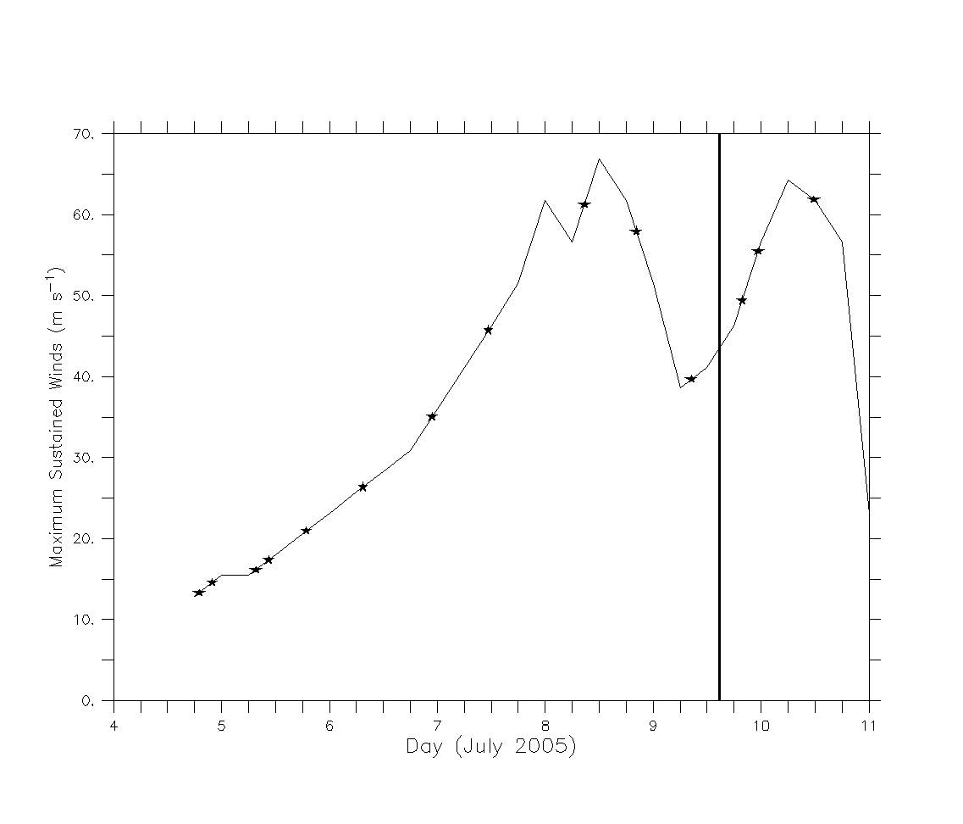

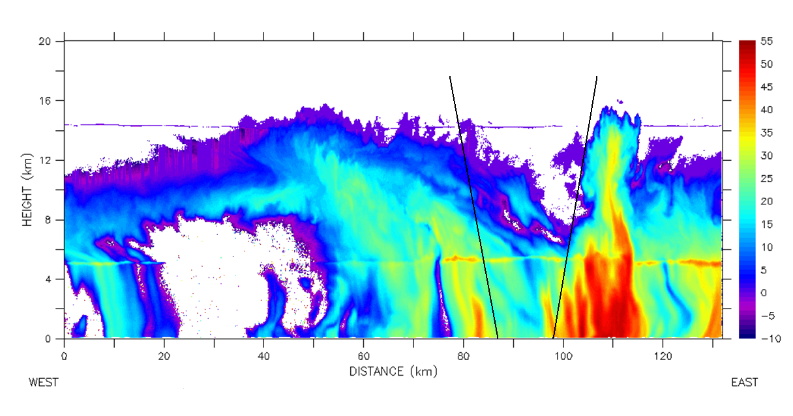
Figure 1. EDOP attenuation corrected nadir beam reflectivity (dBZ) of Hurricane Dennis on July 9, 2005 between 1420-1432 UTC. The ER-2 flew from west to east across the eyewall at 20 km altitude. Black lines mark the approximate position of the eye.

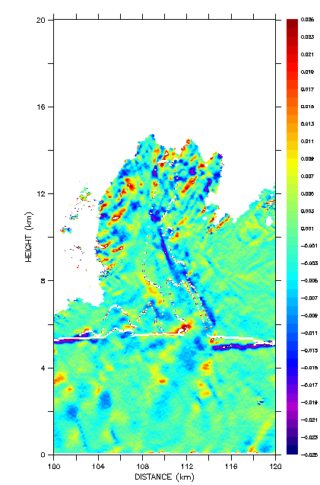

Figure 4. EDOP derived divergence (s⁻¹) for the same cross section as described in Fig. 1, only for a zoomed image of the VHT seen at ~110 km. Positive (negative) values indicate divergence (convergence). All other details can be found in Fig. 1.

