Dear reviewers,

Thank you for taking the time to provide such detailed comments. We have spent a good bit of time making these revisions and hope you find that the paper has improved. The manuscript is a few pages longer due to the extra analysis and clarification each reviewer requested, but we feel these changes have enriched the study. Note that all figure numbers in responses relate to the newest version of the paper. The reviewer comments are in red and our responses are in blue.

Steve, Gerry and Joe

Responses to reviewer A

1) The use of the AMSU temperature retrievals is troubling for a few
reasons. Most or all of these are listed separately in the specific
comments. First, the paper uses “raw” AMSU temperature retrievals
instead of correcting for hydrometeor contamination in the brightness
temperatures. The EDOP and AMPR observations strongly suggest that
hydrometeor contamination would be a problem in this case, leading to
inadequate retrievals of teh warm core. Second, issues with the AMSU
grid geometry and footprint size are clearly noted in the text, but they
complicate interpretation of the figures. The figures should be modified
to better account for these. Third, there are multiple comments in the
text about limitations of AMSU horizontal resolution. The NASA ER-2
carried two temperature profilers - HAMSR and MTP - during this
mission. This type of case study seems like the perfect place to include
those measurements. I don’t recall ever seeing them used in a study like
this, even though NASA has flown them in most (all?) of its recent
hurricane experiments. Is there something with the measurements from
those instruments? If so, maybe it is worth mentioning. If not, they
seem like a perfect fit for addressing some of the limitations in this
study.

The comments above are all addressed in specific comments below.

2) There are a few references to a suspected “mesovortice”. First, I am
not familiar with that being an accepted spelling instead of mesovortex.
More importantly, I saw no observational evidence for the existence of
this feature. NOAA P-3 data are included in the study; the tail radar
should be sufficient for providing evidence for or against the presence of
a mesovortex. Or perhaps the Key West WSR-88D was close enough.
Without some supporting evidence, this “suspected” feature should not
be mentioned in the abstract and conclusions. I can imagine another
author skimming those sections and then citing this paper as showing
an example of an eyewall mesovortex!

The eastern eyewall in Figures 15a and 15b sparked our interest since this is not typical inflow for a hurricane. We state in the text…” This structure is significantly different from the general inflow found in mature hurricanes (such as that in the western eyewall of Fig. 15a; Jorgensen 1984; Marks and Houze 1987)”.

The question is: what is responsible for the 15 – 20 m s⁻¹ flow occuring over a deep layer (0.5 – 10 km) in the eastern eyewall at this time? The roll of the aircraft was very small (aircraft motions are removed from the data) and the track of the ER-2 was nearly right down the center, so tangential motion contamination is not affecting these along-track winds. It is possible that EDOP is sampling part of the tilt in the vortex due to the weak vertical wind shear. However, the tilt would probably be greatest at upper levels and would not necessarily extend all the way down to 0.5 km above the ocean surface, which is one level where we are observing the intense inflow. Further, in the region of the eyewall where hot towers are observed, the eyewall is vertically erect (see response to comment 17b).

The storm was too far to the west of the Key West 88D for the data to be of any value. We did analyze the P-3 TA radar data 3 – 4 hours before and after the ER-2 overpass. Unfortunately, this was all the data available for the P-3s (there was no coincident or near-coincident flights with the ER-2) and the quality wasn’t all that great (at least from the automatic analyses). Fig. 1 (below) shows a vertical cross-section of zonal winds through the storm center (radial winds) just after 1000 UTC 9 July (~ 4 hours from the ER-2 overpass at 1420 UTC). There is some weak to moderate inflow at upper levels in the eastern eyewall, but this structure is very different from what we are seeing. This inflow could be a result of several things (i.e. response to the heat forcing in the convective burst, vorticity asymmetry, etc.) most of which are inter-related. Figure 2 (below) shows vorticity at 3 km height near 1115 UTC 9 July from the P-3 TA radar. A clear vorticity asymmetry in the down-shear portion of the storm is evident. Braun et al. (2006) showed that a storm with weak vertical wind shear forcing can produce down-shear vorticity asymmetries and mesovortices. So, its certainly possible that what we observed is a mesovortex based on the reasoning above.

However, the P-3 data is simply not sufficient (timing, coarse resolution) to back up our claim of observing a mesovortex. In mesovortex land, 3 – 4 hours between observations is an eternity. Thus, we have removed the mention of a mesovortex from our paper. However, our results still show very intense inflow over a deep layer in the eastern eyewall. This inflow is likely forced by the hot towers and has implications for understanding the dynamics of intensity change.

3) The ER-2 leg in Figures 7-10 missed the low level eye and instead was
tangent to the southern eyewall. This makes it improper and confusing
to interpret the cross sections in terms of radial motions, transverse
circulations, and convergence / divergence. Seeing the velocity data
(Figures 8 and 10) presented that way can unnecessarily hurt the paper’s
credibility with a reader (it did on my first reading of the paper!). The
subsequent leg in Figures 11-14 are well suited for those interpretations
instead. The discussion of Figures 7-10 should be kept to a minimum,
perhaps even deleting Figure 10.

We do not mention radial motions associated with Figures 8 and 10. Here is an excerpt from the section in question…

“The west to east track of the third ER-2 overpass (1420 – 1432 UTC 9 July) provides a cross section of zonal winds (Fig. 10a), with the storm motion removed, within the eyewall and HT. Although these winds are not radial because the ER-2 did not pass through the TC center (7 – 8 km off center), they still show common features of the hurricane secondary circulation, which can be quite broad, such as a region of strong (~ 20 m s⁻¹), sloping outflow in the western eyewall.”

“Below ~ 8 km altitude, EDOP is sampling the zonal component of the eyewall tangential flow with values near 25 m s⁻¹ as low as 0.5 km (first clutter free gate in forward beam) above the ocean surface.”

We think this is fairly clear as it stands.

Even though these are not radial winds, they are still useful because we are observing a portion of the outflow. The outflow of a hurricane is quite broad and observing this outflow 7-8 km off the “true” center will change the values, but most of the structure should remain. For example, if you look at Fig. 10a in the western eyewall (around 50 km along track, between 8 km and cloud top), there is air flowing outward from the storm as well as a thin region of air flowing toward the storm. Now, if you look at Fig. 15a in the western eyewall and around the same heights, the same features are present. The cross section in Fig. 15a is basically right down the center of the storm. Thus, even though the cross sections are 7-8 km off from one another, similar structure (and even some magnitudes) exist.

A similar arguement can be made for the “transverse” circulation seen in the core of the hot tower in Fig. 10b. For Fig. 10b think of this flow relative to the hot tower “center” rather than the system center. Although we are probably not cutting right down the “center” of the hot tower (we use center in quotes because it could be very difficult to define a true center in a hot tower), we are likely fairly close (based on the updraft magnitudes and how they fit into a larger population of hot tower updrafts; Heymsfield et al. 2009). Even if we are just off the “center”, there is clearly converging zonal winds at mid-levels and diverging zonal winds in upper levels in Fig. 10b (as well as strong updrafts through the core; these features define a transverse circulation). The magnitudes will change moving to the “center” of the hot tower, but the structure probably would not (again, we see a similar structure in Fig. 15b). We have used the word “core” in the abstract to describe the location of these transverse circulations. We think this is safer then using the word “center” because center means one point while core can embody a larger region. We will make sure this wording extends throughout the rest of the text.

We tried to avoid the word “convergence” when describing the features in Fig. 10b and 15b and instead used “converging air”. However, by making use of the anelastic mass continuity equation, we can prove that what we observe in these figures is truly convergence....

∂u/∂x + ∂v/∂y = -ρ⁻¹∂ρw/∂z

We can compute the RHS from EDOP. These figures were computed for the zoomed images in each overpass and are now in the paper.

1) do a search and replace for mesovortice / mesovortex

We removed this discussion.

2) P. 4-5 looks like a “data” section for instruments that are not even
included in the study. I think your point is that EDOP provides superior
resolution in its nadir view, compared to NOAA and NCAR radars. To
make that point more directly and concisely, you can give the brief EDOP
description and then state the NOAA and NCAR resolutions for
comparison. But this belongs in section 2.

Done.

3) P. 5, near bottom: “Only recently has new information about deep
convective bursts in TCs been uncovered”
That is an odd statement to make here, given how many studies can be
referenced over the years. Several have been referenced already in this
paragraph, and many more could be referenced (but no need to give an
exhaustive list). People have been uncovering new information on this
topic for decades!

There has been a definite resurgence of interest in hot towers and “vortical hot towers” (partly due to new observations and partly due to new theoretical and modeling studies) in the last say 10 years. This is clearly evident if one looks at the literature and attends hurricane meetings. We have edited this sentence a bit to reflect this…

“In the last decade, there has been a resurgence of interest in hot towers (and deep convective bursts) in TCs with new observational information uncovered (Houze et al. 2009; Reasor et al. 2009) and theories on how they fit into the TC genesis and intensification problems presented (Montgomery and Enagonio 1998; Moller and Montgomery 1999; Nolan and Grasso 2003; Nolan et al. 2007).”

Note that we added the Houze et al. 2009 paper...

Houze, R.A., W.C. Lee and M.M. Bell, 2009: Convective contribution to the genesis of Hurricane Ophelia (2005). Mon. Wea. Rev. Early online release.

4) p. 8-9: Either the hydrometeor-corrected temperature fields should
be used, or a better / more complete justification for not using them
needs to be presented. It looks like your complaint about the Demuth et
al. (2004) method is only a complaint about the Cartesian grid and
associated smoothing - not the hydrometeor correction itself. Why not
make the corrections on the native swath, or on some grid that you do
find acceptable? Ice scattering in convective cores (such as those in this
Dennis case) can substantially reduce the AMSU brightness
temperatures, and lead to a poor temperature retrieval if not accounted
for. If you want to argue that the raw temperatures are acceptable in
this case, you should show plots of brightness temperature and retrieved
temperature, and make the case that hydrometeor contamination does
not affect your results.

The AMSU temperature retrievals and hydrometeor corrections we are using follow DeMuth et al. (2004). At the levels we are focusing on in this study (~ 200 hPa), cloud liquid water is essentially zero (DeMuth et al. 2004). In addition, DeMuth et al. (2004) do not make ice scattering corrections above 350 hPa, they only correct (cloud liquid water and ice) from 350 hPa and downwards. They don’t mention why ice corrections were not implemented above 350 hPa. However, we suspect that they don’t see much scattering at these heights probably due to the size of the AMSU footprint and the fact that ice particles are fairly small above ~10 km.

To test this, we took one overpass during a rapidly intensifying period of Dennis on July 9 2005 at 1947 UTC. Figure 3 (below) shows the brightness temperatures (BTs; limb corrected) for Channel 7 (54.94 GHz). This plot is storm centered on a 48 km resolution grid. Looking at Fig. 3, we don't see any scattering effects in the TC core. If there were scattering effects, then there should be some asymmetry with colder BTs (relative to the surrounding field). This BT field looks uniformly warm. Figure 4 (below) shows the retrieved temperatures (uncorrected for hydrometeors) averaged between 200 and 250 hPa. Of course, a straight comparison is difficult here because the BTs from any channel have a Gaussian like weighting in height (thus the BTs represent more of a layer mean), which can be complicated to replicate. However, it appears that the max temp at the TC center matches very well with the BTs in Fig. 3.

Essentially what we have showed above is probably what DeMuth et al. (2004) already knew, but didn’t communicate well. That is, ice scattering effects are fairly small at these upper levels for AMSU. Again, a reason for this could be due to the large footprint size of AMSU, which blurs out the very small size ice contributions.

We have added some clarification to the paper on our use of the un-corrected temperature retrievals based on the above.

5) In that same paragraph:
a) “larger discrepancies (~2.5 K) in the warm anomaly”: which was
warmer, the raw or corrected fields?

The raw fields are warmer. Changed this to “large discrepancies (raw fields were ~2.5 K larger)”.

b) the interpolation procedure “may be the reason for the discrepancies
mentioned above.” Isn’t hydrometeor contamination the main reason for
the discrepancies? If not, show us!

As mentioned above, the CIRA AMSU retrievals follow DeMuth et al. (2004). They do not apply a hydrometeor correction at the levels where the discrepancies were found (they start at 350 hPa and downward). Even though they don’t apply a correction at these levels, they still interpolate the data to a regular grid with a 100 km e-folding radius. Thus, this is likely the culprit for the differences at these levels. The first author will hopefully be submitting a note on this subject in the near future, but it’s not necessary to dig into this here. The clarification from above should be enough.

6) P. 12, 3rd line should reference Fig. 3a, not 2a; same mistake in first
line of next paragraph

Thank you.

7) P. 12, near middle: “define rapid intensification” should be “predict
rapid intensification”

Thank you.

8) P. 13, first line: “AMSU captures much of the evolution of Dennis...”
That looks like an overtstatement, given how choppy those lines are in
Figure 4.

We think the time series in Fig. 4 matches the wind evolution in Fig. 3a fairly well. This looks better now that we have grouped different classes of resolution.

9) P. 13, middle and Figure 4: “if this overpass is removed from the time
series...”
The text on p. 13 successfully (and inadvertently?) makes the case that
some of the data points in Figure 4 should NOT be shown (e.g., those
with resolution > ~55 km). At the very least, the line should not be
drawn connecting all these data points. Please remove the low-resolution
points, or use separate lines to connect the low-resolution points and the
higher-resolution points. Using separate lines would make it easier for
the reader to see why the text cites temperature changes for two
overlapping time periods (0829-2321 and 1947-1144).

Thank you for the suggestion. We grouped data points with resolution less than or equal to 65 km into “finer” resolution and plotted that data (with linear interpolation between data points for a smooth curve). Resolution greater than 65 km is “coarser” resolution and plotted as squares to make the plot easier to read. See the new Fig. 4 in the manuscript.

10) Figure 4: caption should have a comma after “overpasses”. Does
the figure show the maximum temperature anomaly regardless of height,
or is it for a particular height?

Put in comma. The figure shows the maximum temperature anomaly regardless of height…” Figure 4. Time series of Dennis’ maximum temperature anomaly in the column above the storm center computed from AMSU overpasses, along with the footprint resolution. The thick black line is the same as that in Fig. 3.” This is also mentioned in the text...

“Figure 4 shows the evolution of the maximum temperature anomaly in a column above the storm center.”

11) P. 13, “Temperature measurements at a resolution finer than that of
AMSU...”
Why not show a HAMSR or MTP temperature retrieval? It seems odd to
exclude HAMSR from this study - isn’t this topic one of the main reasons
HAMSR has been on the ER-2 for the NASA hurricane field programs?

We considered using HAMSR data for this paper. The problem is that no temperature retrievals were provided to the TCSP team and it was difficult to get any help from the HAMSR team. Completing the retrievals on our own was not an option. Performing temperature retrievals in a hurricane is a major endeavor and could be the topic of an entire paper. Our main focus in this paper is EDOP. In addition, even if a retrieval was provided, there would be large uncertainty in deep convection and thus, in these regions, the data might be more trouble than their worth. This is why we originally ditched the HAMSR or MTP data. We agree that the HAMSR data could be a great asset to our analysis (i.e. complementing Fig. 4). However, the analysis presented on the warm core spatial structure (Fig. 17) can only be done from satellite, as the aircraft only sample a small section of the storm for a small period of time. The AMSU is well suited to provide a large-scale survey of the warm core, which we have done.

Nevertheless, we took your advice and looked into the HAMSR data for July 9 (when the hot towers from EDOP were observed and rapid intensification commenced). We analyzed the brightness temperatures at similar frequencies to AMSU (54.94 and 55.50 GHz with weighting function peaks at 250 and 150 hPa, respectively). In the eye of the storm and at these levels, the brightness temperature is approximately equal to the actual temperature. Very little processing of the HAMSR data was provided to us and we thus had to analyze raw brightness temperatures. We mapped the data from scan coordinates to Earth coordinates taking into account the heading, pitch and roll of the aircraft. We used operational model analyses (which have data assimilation) to compute a reference temperature profile for the Gulf of Mexico away from the storm. We then computed temperature anomalies from the HAMSR brightness temperatures at the weighting function peak. Fig. 5 (below) shows the temperature anomalies at ~150 hPa (55.50 GHz) where the largest signal in the warm core was found (lower levels were much weaker and some channels had scattering effects). The data did not cover the storm center in the upper right and lower left overpasses. The storm center in the upper left overpass is straddling the most off-nadir scan. The only useful overpass is the lower right where the temperature anomaly at the TC center is 15.77 K. We have added this overpass into the paper along with a short discussion. Note that the data have not been limb corrected (this is part of the retrieval process), but even if they were, this correction would not help the other overpasses much since they miss the storm center.

12) Section 4 in general: It seems like this section would be more
effective if the IR, AMPR, and EDOP descriptions were integrated
together, describing the measurements of a particular convective feature
all at once. That might cause more harm than good - just consider it.

The way this section was organized was to show the large scale structure (from IR), then increasingly zoom in on the convection with AMPR and EDOP. We think this fits nicely with the title of the paper (showing multi-scale observations). Thank you for the suggestion, though.

13) P. 14, last sentence of first paragraph: You are hypothesizing that
symmetric distribution of cloud tops and development of a clear eye are
aggregate effects of the convective burst episodes. I have no problem
with that as a hypothesis, but the phrasing on p. 14 looks more like an
unsupported assertion of fact than a hypothesis.

Agreed. The sentence now reads…
“Three hours later (Fig. 5d), the hypothesized aggregate effect of the convective burst episodes has resulted in a strikingly symmetric distribution of cloud tops and the development of a distinct, broad eye that persisted into July 10th.”

14) P. 14 and Fig. 5: Since the color scale only goes to 215 K (no
warmer), please confirm to the reader that this was indeed a clear eye
(not just a warm spot that looks clear with that color table). How warm
was the IR eye?

The eye was indeed clear in IR imagery and even VIS channels with the exception of some low-level cloud. The IR eye appears to be at or above 273 K.

Added this to Fig. 5 caption…

“Note that the color scale only goes up to 215 K for visualization purposes. A nearly clear eye was confirmed for panel (d) with a broader color scale and visible imagery.”

15) P. 14, first line of last paragraph: “ER-2 flight segments”.

Done.

16) P. 15, 2nd line: Cold TBs are already well inside the RMW in Figure
6b, and I even see a light orange shade at the same location in 6a. It
looks like convection is strengthening at a location well inside the RMW
in this sequence, but not noticeably contracting.

On a second look, it seems as though the convection is just organizing into a linear feature and not really contracting. Changed this sentence to…

“During the third ER-2 overpass (Fig. 6c), the T_{B}s organized into a thin band inside the mean RMW and dropped to ≤ 100 K in ~ 15 min...”

17) P. 15, last 3 sentences: I have major problems with these
interpretations of Figure 7.

a) When discussing the brightness temperatures to the south of the
flight track, keep in mind that parallax should exaggerate the apparent
slope. For a hypothetical vertically erect column away from the flight
track, the low-altitude signal (10 and 19 GHz) would be projected to a
location closer to the plane than the high altitude signal (85 GHz).
Figure 1 is somewhat effective for visualizing this. I’m not suggesting the
southern eyewall in this case is vertically erect, just that parallax
exaggerates the slope.

We had a discussion of this sort before submitting the original paper. It comes down to what coordinate system (scan or mapped) the data is presented. If the eyewall is sloped (away from storm center with height) in reality, then the 10/19 GHz signal will be closer to the plane (in both scan and mapped coordinates). Now, if the eyewall is perfectly vertically erect (as the reviewer mentions), the 10/19 GHz signal will only appear closer to the plane in scan coordinates (as we have done for Fig. 7). If the data is mapped to lat/lon coordinates, then the 85 GHz signal is the same distance off nadir as the 10/19 GHz signal, which would show an erect eyewall.
The problem is, we don't really know a priori what the tilt of the eyewall is (or if there is any tilt at all), thus it can be confusing to interpret the passive microwave data. One reason why we show Fig. 7 in scan coordinates is to avoid having to make an assumption on what height the radiation scattering and emission are coming from.
To augment the plot in Fig. 7, we have made a line plot for the cross track data closest to the TC center. After some discussion, we decided to map all the channels to the surface (essentially, they are still in scan coordinates to be consistent with Fig. 7). There is a ~7 km displacement between the 85 GHz min and the 10 GHz max. If the 85 GHz was mapped to 10 km altitude, then the two channels would be closely aligned. However, the 85 GHz min is right at the scan edge and the true “center” of the eyewall was probably not viewed by AMPR on the southern side. Thus, there would still be some slope to the southern eyewall. We think this discussion clears up your question and allows better definition of max/min TB values.
b) “eastern eyewall is vertically erect, shown by the near collocation of
the 85 GHz and 19/10 GHz signatures” - No... the inner portion of the
low-level eyewall (defined by high TB at 10, 19, and 37 GHz) is clearly to
the left (west) of the upper scattering core. This is easiest for me to see
in the 19 GHz, but also in the 37 GHz - for both channels, the TB max
(from liquid rain) is located inward from the TB depression (from
convective ice).

Depends on what you mean by “eyewall”. What we were intending to show here is that the “peak” of the eastern eyewall (where the hot towers are) is vertically erect. You can see this if you look at the scattering at 85 and 37 GHz in Fig. 7 (they are nearly collocated). We even see some slight scattering at 19 GHz in the same location. Now, the entire eyewall is not made up of hot towers, there is some hydrometeor "debris" (or shallower cloud) at lower levels closer to the storm center than the hot tower scattering signature, which gives the appearance of a slope. So, it would appear that the portion of the eyewall with the hot tower is vertically erect, while the rest of the eyewall is sloped. We have added this discussion into the text…

“The western eyewall also appears to be sloped whereas the peak of the eastern eyewall (where the HTs are located, revealed by the 85 GHz scattering) is vertically erect, shown by the collocation of the 85, 37 and even some 19 GHz scattering signatures (Fig. 7). Outside of the HTs, the eastern eyewall is sloped indicated most clearly by the high T_{B}s at 19 and 37 GHz located closer to the storm center than the low T_{B}s at 85 GHz.”

18) P. 16: The 2nd paragraph notes that EDOP only allows 2-d crosssections
through 3-d updrafts, but the bottom paragraph seems to lose
track of that point. The “core updraft” separated by a downdraft between
6-8 km altitude can’t be a single feature, unless it has spiraled all the
way around the eye while ascending from the lower section to the upper
section. Is that what you are suggesting? (The same comment applies
near the bottom of p. 19)

No, we aren’t suggesting that the structure seen in Figs. 9b and 14b is from the updrafts spiraling around. What is interesting is that both Fig. 9b and 14b are similar around the melting layer (5-6 km height). Mixed phase particle fallspeeds are difficult to characterize and thus there are larger uncertainties of several m/s in these regions. This would change the magnitudes of the velocities in these regions but not the structure (i.e. there will still be a minimum in updraft velocities near the melting region). Heymsfield et al. (2009) shows 13 peak updrafts in hurricane hot towers and finds this same structure (i.e. there is a clear minimum in updraft velocities around 5 – 6 km height along with a local maximum in downdraft velocities). They attribute this feature to drag from hydrometeor loading. We have added this reference and their explanation into the paper to give insight into this vertical velocity structure.

19) P. 17, middle: “downdraft... at an altitude of 5-6 km was likely
enhanced by cooling of air due to melting hydrometeors”:
But it looks like that downdraft is centered slightly above the radar
bright band... a melting-induced downdraft should be below that.

The center of the feature described is just below 6 km height. While the radar bright band is at ~ 5 km height in stratiform precipitation, the feature is located within the hot tower and thus the freezing level is likely much higher so the downdraft could have been enhanced from melting. Heymsfield et al. (2009) also mention that hydrometeor loading could affect these motions. We have added a few words to clarify this.

20) P. 17, 2nd from last sentence of first paragraph: How is it known that
errors in fallspeed would not significantly change the structure observed?
There is a big difference between liquid and snow fallspeeds - if liquid
particles are mis-classified as snow, that would “create” strong
downdrafts.

We removed the mention of “significantly changing the structure observed” here because it is mentioned just above this sentence (pertaining to comment 19).

The reflectivity in the region of question (114 km along track and 5 – 6 km height) is at least 30 dBZ. It is unlikely that pure snow would produce a 30 dBZ echo. It is likely that these are mixed phase particles (graupel/melting snow/rain). The differences in fallspeed for graupel and rain at a certain dBZ threshold are only 2 -3 m/s (Heymsfield et al. 1999; Heymsfield et al. 2009) and would thus not change the downdraft structure observed.

21) P. 17-18, Figure 10: The discussion of zonal wind for this ER-2 pass
is troubling because the track is significantly off-center, mixing the
tangential and radial components of the huricane’s flow. Because of this,
some of the diagnosis of converging or diverging airflow and inflow or
outflow is dubious. The pass shown in Figures 12 and 14 is effective for
this instead. The analysis would be more convincing of you stick to
Figures 12 and 14 for this topic, and omit Figure 10 entirely.

We don’t agree and think that Fig. 10 is useful. Please see the discussion given in response to major comment (3) above.

22) P. 21, near middle: The eye-eyewall interface is mentioned in the
text, but it’s hard to identify in these figures - just where should we be
looking?

The eye is labeled in Fig. 14b and mentioned in the caption in Fig. 15. We added this to the text…

“...eye-eyewall interface (the scatter free eye is labeled in Fig. 14b for reference).”

23) P. 21, near bottom: “It is possible that EDOP is sampling the
rotational portion of a mesovortex...” Is there evidence for or against this
from the other aircraft? Was there a P-3 with a scanning radar that
could be checked? If not, was this too far away from the Key West 88D?

See discussion in major comments.

24) P. 22, 1st sentence of 2nd paragraph: as mentioned before, this is not
a truly vertically oriented eyewall (it is less sloped than the other side,
but not vertical)

Changed this to the sentence below based on the response in 17b.

“The GOES IR imagery and high-resolution AMPR and EDOP data shown in the previous section clearly reveal an asymmetric, vertically oriented distribution of convection in the down-shear to down-shear left portions of the storm for much of July 9th”.

25) P. 22, last sentence of 2nd paragraph: Nothing was shown to
specifically support neutrality to slantwise moist ascent. The transverse
circulation does not require that. Similarly, some might also argue about
the “significant local buoyancy”, since no measurements of temperature
or density were shown.

The reviewer is correct; the transverse circulation does not require that the eyewall maintains neutrality to slantwise moist ascent. However, we mention this in the context of Emanuel (1986) in which neutrality to slantwise moist ascent was shown to support/characterize the azimuthal mean hurricane quite well. From the AMPR data (Figs. 7 and 12) it is clear that the eyewall is sloped to some extent in all directions. The EDOP data in the western eyewall (Figs. 8 and 13) show this as well with a sloping structure to the reflectivity and wind vectors. Based on these observations it is possible that most of the eyewall of Dennis is composed of the axisymmetric mode outlined by Emanuel (1986).

There is an asymmetric mode as well related to the hot towers. We don’t know of anyone who has measurements of temperature or density within a hot tower. If the reviewer does, then we would love to speak with them! Based on the vertical momentum equation, significant local buoyancy (such as latent heat release) must be present to produce such strong updrafts. Braun (2002) showed this for hot towers in a numerical setting.

To be conservative (since we are inferring the above structural mechanisms), we have placed the word “potential” in front of the neutrality and local buoyancy discussion while clarifying our argument a bit better…

“The GOES IR imagery and high-resolution AMPR and EDOP data shown in the previous section clearly reveal an asymmetric, vertically oriented distribution of convection in the down-shear to down-shear left portions of the storm for much of July 9th. In contrast, a sloping eyewall structure is observed by AMPR (Figs. 7 and 11) and EDOP (in terms of reflectivity and circulation; Figs. 8 and 12) mainly on the up-shear sides of the storm. These microphysical and kinematic observations imply that during the ER-2 overpass periods, the eyewall of Dennis was composed of a superposition of modes including (1) an axisymmetric mode (characterized by an eyewall possibly neutral to slantwise moist ascent; Emanuel 1986) shown by the sloping structure on the up-shear sides of the storm and (2) an asymmetric mode with the potential for significant local buoyancy to vertical displacements shown by the HTs in the down-shear eyewall (Braun 2002).”

26) P. 23, equation 1: Wouldn’t an asymmetric component be artificially
imposed, simply by having the AMSU footprint and the storm-relative
grid mis-aligned from each other? If not, why not? I think this is
addressed at the bottom of the page, but it should be addressed when
the procedure is first introduced.

We examined the impact of artificial asymmetries by displacing the storm center 10-25 km in all four cardinal directions and re-computing Fig. 17. We found that the analysis is insensitive to grid mis-alignment. We moved this discussion up a bit.

27) P. 23, bottom: “Spatial plots of the warm core (not shown)...” I
imagine it would be more effective to show a few spatial plots of the warm
core instead of Fig. 15. Please consider replacing that figure with the
spatial plots.

Fig. 17 is more useful than spatial plots because the Fourier analysis quantifies the degree of symmetry. Dynamically, transitions from asymmetric to symmetric structure are very important for the storm. As far as we know, this is the first time that hot towers (or bursts of convection) have been shown (i.e. quantified) to organize the warm core (at least on this scale) from observations.

28) P. 24, 1st paragraph: “This subsidence, coupled with the cyclonic
rotation of the initial down-shear downdrafts...” How is the cyclonic
rotation of those downdrafts different from what was cited in the
previous sentence?

Removed.

29) P. 24, about Figure 16 should note the HT location (~20-25 km from
center).

Done.

30) P. 25, bottom: Was the aircraft coverage fairly symmetric, and was
the wind field based on those aircraft passes basically symmetric?

Over a ~ 12 h period, the aircraft coverage is fairly symmetric. The symmetric part of a hurricane’s wind field is much larger than the purely asymmetric component (e.g. Reasor et al. 2000).

31) P. 26, 7th line from bottom: EDOP does not give a “direct
measurement of vertical velocity” of the wind. It gives a direct
measurement of Doppler velocity of the scatterers, relative to the plane.
There is fallspeed uncertainty and removal of aircraft motion needed to
retrieve vertical wind.

Of course. Changed to “direct measurement of vertical component of Doppler velocity”. Yes, it’s also relative to the aircraft, but it’s simpler to state the above and the reader should know this based on Section 2b where we put the same sentence along with “relative to the aircraft”.

32) Figure 3: Please add words “solid” and “dashed” to the caption to
identify the lines.

Done.

33) Figure 6: Is the color scale the same for all? The numbers in a and
b are different than c and d.

Yes. The color bars are all the same, but different TB values are listed on the color bar.
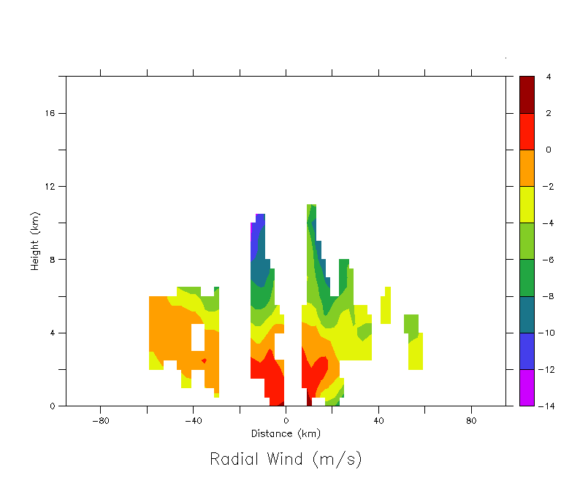
Figure 1. Vertical slice of zonal wind through the storm center (radial wind) near 1000 UTC 9 July.
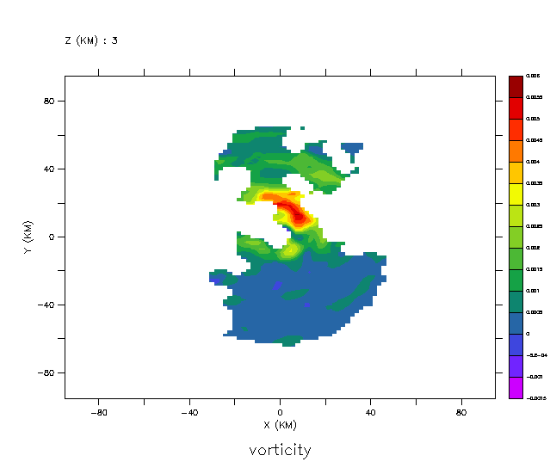
Figure 2. Horizontal slice of relative vorticity from the P-3 at 1115 UTC 9 July.

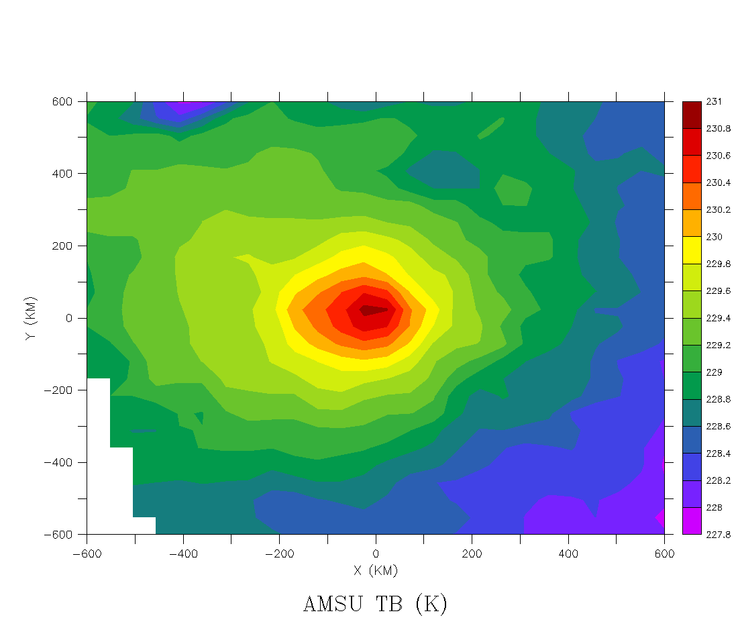
Figure 3. Brightness temperatues for Channel 7 (54.94 GHz). Overpass is July 9 2005 at 1947 UTC.

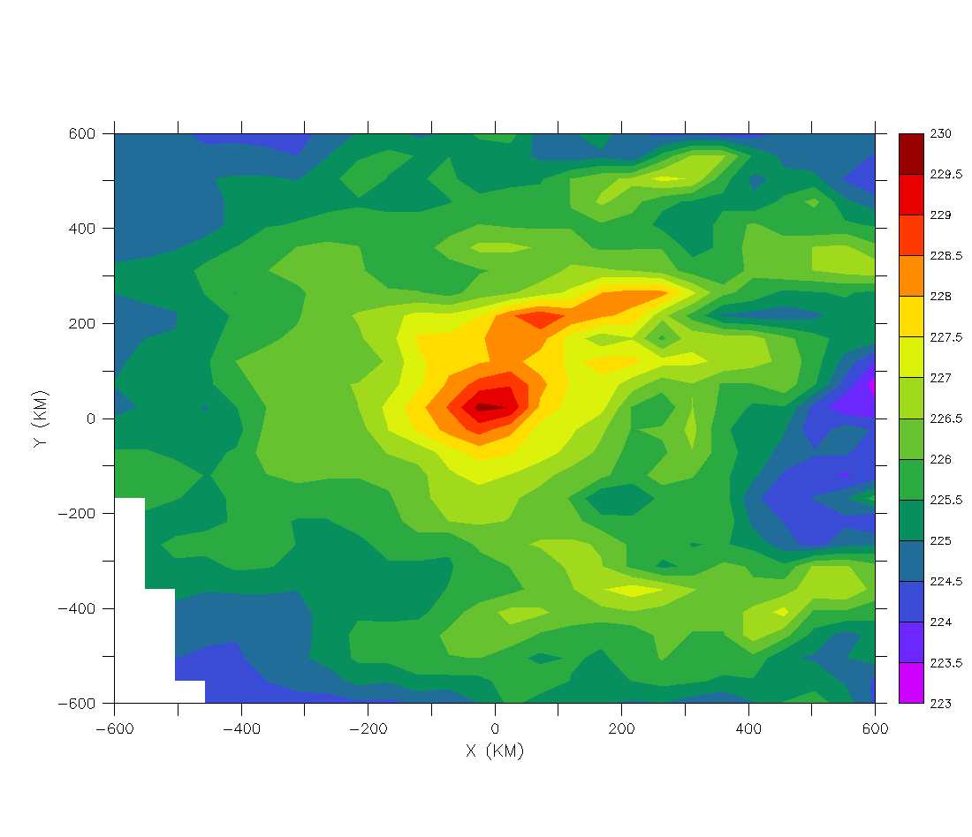
Figure 4. Mean (200 - 250 mb) retrieved temperatures (uncorrected for hydrometeors). Overpass is same as Fig. 5.

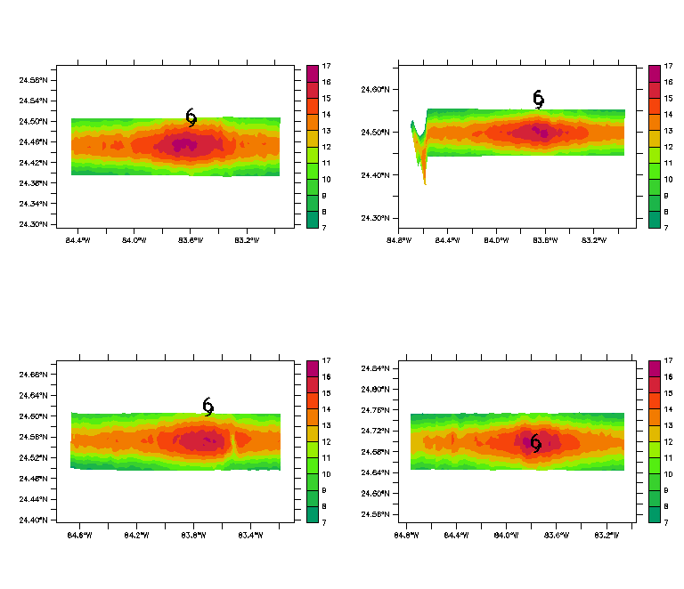

Figure 5. HAMSR temperature anomalies (K) at 55.50 GHz for the same overpass times as Fig. 6 in the paper. The data are mapped to the approximate emission altitude for this channel (~150 hPa or 13.6 km). Note the cooling towards the edges of the swath is the limb effect.

Responses to reviewer C

MAJOR COMMENTS:

1) I question the fixation on HTs vs. just stating that deep convection drives
intensification. The amount of deep convection present near the center is an
excellent predictor of future intensity (e.g., Cecil and Zipser, 1999). Are the
authors claiming that there is something special about HTs that’s not true of deep
convection in general? Also, the definition of a HT relies strongly upon the
“undiluted” core. No observations of theta-e are shown anywhere in this paper,
so strong use the term ‘hot tower’ doesn’t seem to be entirely justified.

There is no clear threshold which distinguishes “deep convection” from “hot towers” as deep convection is an ambiguous term that could encompass a wide range of updraft speeds, radar reflectivity and microwave brightness temperatures.

Black et al. (1996) find that the broadest distribution of vertical motion is in the eyewall region where ~1% of updrafts are > 8 m/s. The vertical motions we present here are much larger than 8 m/s, so hot towers might be defined as a “special class” of deep convection (where deep convection might be defined as updrafts between 5 – 10 m/s). Heymsfield et al. (2009) compiled 13 “deep convection” updraft profiles in hurricanes with EDOP. The peak value of the mean profile is 13-14 m/s, well below our peak values of 20 m/s. The updrafts we present in this paper rank among the top 3-4 of that sample, supporting our classification of hot towers as a special class of deep convection. So yes, there does appear to be something special about hot towers that is not true of deep convection in general. Based on the Black et al. (1996) and Heymsfield et al. (2009) observational studies as well as the Braun (2002) numerical study, the special property of hot towers is updraft strength.

As an example of what we might call the difference between general “deep convection” and “hot towers”, see Fig. 13. In the western eyewall at 140 km along track, there is a fairly strong core of reflectivity with 30-35 dBZ up to ~ 10 km height. Examining Fig. 14a in the same region, there are updrafts of ~ 10 m/s at 10 km height. We might call this feature “deep convection”. In the eastern eyewall at 100 km along track, large reflectivity values approach 16 km height (Fig. 13) with updrafts twice as large as the “deep convection” feature. We call this feature a “hot tower”.

We have used the Black et al. (1996) and Heymsfield et al. (2009) studies to classify what we observe in this paper as hot towers…

” Using the P-3 TA radar in vertical incidence (~ 750 m along-track sampling), Black et al. (1996) found maximum vertical velocities between 10 – 26 m s⁻¹ in seven intense Atlantic hurricanes with ~ 5 % of eyewall updrafts > 5 m s⁻¹. Heymsfield et al. (2009) compiled thirteen vertical velocity profiles of deep convection (defined as updrafts > 10 m s⁻¹ over at least a kilometer along track) in hurricanes and found that the peak value of the mean profile was ~ 13 – 14 m s⁻¹. The updrafts we analyze in this paper are larger than this and thus, we define hot towers as a special class of deep convection (the largest peak updrafts in the Black et al. 2006 and Heymsfield et al. 2009 population).”

Based on the vertical momentum equation, significant local buoyancy (latent heat release) must be present to produce such strong updrafts. Braun (2002) showed this for hot towers in a numerical setting. We think the term “hot towers” is justified.

2) Related to major comment 1, this study makes no mention of the wealth of studies
that have found that the net amount of convection (latent heat release) near the
center of a TC is very well correlated with its future intensity. For example, the
Cecil and Zipser (1999) study mentioned above shows that observationally. Rao
and MacArthur (1994) had a similar finding. Other modeling studies, such as the
series by Tory et al [starting with Tory et al. (2006)] strongly suggests that net
heating drives tropical cyclone intensification. Finally, Sippel and Zhang (2008)
and their follow-up study, Zhang and Sippel (2009) showed in a model that
intensification is strongly correlated to net precipitation. There are numerous
other studies that have also shown this, and considering that a key finding is: “We
believe that the growth and organization of Dennis’ warm core was due to the
outbreak of HTs <i.e., deep convection> …”, the aforementioned studies are
highly relevant.

As the reviewer mentions, tropical cyclone intensification is correlated with net latent heat release. We agree with this statement.

Houze et al. (2009) found that much of the stratiform region (with net upward motion) in Hurricane Ophelia (2005) was generated from the decay of deep convective cells. This suggests that hot towers or deep convective bursts can contribute both directly and indirectly to net heating.

Without making the introduction too long and the reference list exhaustive, we have added the Cecil and Zipser (1999) and Tory et al. (2006) references to our paper as recommended by the reviewer. We have also added in the Houze et al. (2009) paper.

“Despite the focus on hot towers, several studies have shown that net heating drives TC intensification (i.e. Cecil and Zipser 1999; Tory et al. 2006) although there is evidence that decaying convective bursts (or hot towers) can produce a large amount of stratiform heating in addition to convective heating (Houze et al. 2009).”

3) Throughout the paper “upshear rotation” is mentioned as a mechanism by which
convection intensifies in the western eyewall. For example, on p. 24 you say: “As
the HTs ignite on the down-shear side of the storm, their rotation upshear
stimulates regions of strong vertical motion”. The implication is that convection
is reaching the western eyewall solely via advection. However, nowhere in the
paper is the advective timescale from the eastern to the western eyewall
calculated. Is the amount of time that it takes for convection (or a HT) to reach
the western eyewall consistent with the tangential velocity and distance/time, etc
where convection occurs in the eastern eyewall? Couldn’t another process also be
acting to ignite convection in the western eyewall?

Using flight level data at ~ 3.5 km height (Fig. 16), we find that the orbital period at the location of the hot towers (~20 km radius) is ~ 50 minutes. Thus, everything else held constant, it would take ~ 25 minutes for a parcel to go from the eastern to western eyewall. There is ~ 24 minutes between Fig. 8 and 12. Thus, it is very plausible that the stronger vertical motion we observe in the western eyewall of Fig. 12 is “driven” by the hot towers in the eastern eyewall as they move around the vortex. This is also shown in Fig. 5 and the IR movie that is listed in the paper (ftp://ftp.coaps.fsu.edu/pub/guimond/dennis1.mov). We have added the orbital period discussion into the text.

4) The term “convergence” is often used to describe what is essentially only radially
converging air. This leaves the other half – tangentially converging air –
uninvestigated. Instead of leaving the reader in the dark on this, the authors
should use the vertical profile of w to show where horizontal convergence is
occurring (i.e., of dw/dz accompanying the plots of zonal and vertical winds
would go a long way in this study!). Then, “convergence” can be more correctly
used to describe what’s going on.

Please see the response to reviewer A comment 3.

5) I see that inertial stability arguments are presented to relate convection to
warming and warming to intensification, but a much simpler approach that gets
you to the same place is to look at voriticty. The local time tendency of vertical
vorticity is proportional to the amount of vorticity present (ref. the stretching term
in the vorticity tendency equation). If you ignite convection in a strong vortex,
vorticity will grow quickly. The warming and vortex intensification must happen
in lockstep if the mass field is to be balanced with the momentum field. In my
opinion, getting into inertial stability just makes things more complicated than
they really need to be, but at the very least the authors should present the
momentum (vorticity) framework alongside the mass (temperature/inertial
stability) framework. I would also consider shortening or removing the inertial
stability framework altogether.

Our paper is primarily a remote sensing study, but we still think it is useful to address the question, “so what?” That is, we have shown some new observations, but where do they fit into the dynamics of hurricane intensification? We address this to some extent in section 5.

As the reviewer is aware, the inertial stability parameter comes out of a derivation of the symmetric balanced model of Eliassen (1951). This parameter controls much of the character (i.e. efficiency) of the response to injected heating. Recently, Nolan et al. (2007) analyzed the inertial stability term in their paper and found that the kinetic energy efficiency of their vortices has a constant proportionality with inertial stability. They also found that vortex intensification (and efficiency) is independent of the temporal distribution of the heating (for the linear problem). In order to be consistent with the above theory (and the warm core analysis in our paper), we decided to analyze the inertial stability term. Our analysis is much simpler than the studies mentioned above (although it would be hard to do much more with the observations available).

The reviewer is correct that inertial stability is proportional to vorticity and conceptually will look the same as that plotted in Fig. 17. Theoretically, however, the Eliassen (1951) and Schubert and Hack (1982) models (which we are using to understand the dynamics of Dennis) make it clear that inertial stability is the relevant parameter. Since conceptually either one is valid, and given the fact we have spent some time developing the discussion on inertial stability and its relationship to the warm core, we feel that Fig. 17 should remain.

It may not be surprising that an increase in inertial stability/vorticity is observed following the hot tower activity. However, we think Fig. 17 closes a loop of logic and provides quantification of the impact of EDOP observed hot towers on the symmetric vortex, both of which may be useful for a reader. We have added the vorticity framework alongside the inertial stability framework as suggested by the reviewer. We also added the Nolan et al. (2007) reference into this discussion.

“It should be noted that the inertial stability framework for vortex intensification discussed above can also be thought of in terms of vorticity, where HTs stretch pre-existing vorticity locally leading to changes in the symmetric part of the mass (warm core) and momentum (tangential wind) field to maintain thermal wind balance.”

MINOR COMMENTS:

1. Mesovortice should be mesovortex – multiple locations in paper.

This is no longer an issue, see response to reviewer A, comment 2.

2. P3, ¶2, Sentence 1 – comma should go between “research” and “particularly”

Fixed, thank you.

3. P5, ¶2, “seemingly important features” – it’s not clear that hot towers themselves
are important. It’s clear that the net amount of deep convection is important for
TCs, but saying the features are important implies there’s something crucial about
the features that’s not true of other deep convection. See major comment 1.

See response to major comment 1.

4. P9, last sentence of first partial paragraph – magnitudes of what?

Raw temperatures. This is mentioned in the beginning of the sentence.

5. P10, ¶2 – Some elaboration is needed regarding the expected patterns that
convection produces in TBs at the different channels. An explanation of why
those patterns are observed would also be nice. As is, the casual reader is left
somewhat in the dark. It appears some attempt is made to do this on pgs. 14 and
15, but it would make more sense to dedicate more time/space to a more full
explanation in the methods section with perhaps a reminder later when the results
are displayed

We think its better to briefly explain the physical mechanisms behind the radiometric signatures when they are brought up in the text and figures. Page 10 just gives a brief overview of AMPR (including a schematic figure that shows the viewing geometries), which we think is sufficient. If the reader needs more info on passive microwave data, the appropriate references are given “…(Turk et al. 1998; Spencer et al. 1994; Hood et al. 2006).”

In the text, the physical mechanisms behind the radiometric signatures (and references) are brought up often. The Spencer et al. (1994) reference is also in the Fig. 7 caption.

In the new version of the paper (page 15)…

” The 85 GHz brightness temperature (T_{B}) depressions are sensitive to radiation scattering by precipitation-sized ice hydrometeors (Spencer et al. 1994).”

“In addition to the 85 GHz ice scattering, the 37 GHz channel (peaking between 5 – 8 km height) also shows notable T_{B} depressions, providing further evidence of large graupel/ice particles in the convective band to the east of the storm center.”

Page 15/16...

“To the south of the storm center, the maximum T_{B}s in the 19 and 10 GHz channels, representing low level (3 – 5 km) radiation emission by liquid hydrometeors, are closer to the center than the minimum T_{B}s in the 85 GHz channel (southern edge of swath). “

6. P10, ¶2, sentence 2 – “85 GHz channel to 2.8 km” should be “85 GHz channel
and 2.8 km”

Fixed, thank you.

7. P12, end of first partial paragraph – again, what’s so special about HTs aside from
the fact that they’re a manifestation of deep convection?

See response to major comment 1.

8. P13, first whole paragraph, sentence 6 and Fig. 4 – This sentence is a little
confusing because you’re essentially comparing two different resolutions at two
different times in the same sentence. To facilitate comparison from one time to
the next in Fig. 4, you should consider adding another plot to the figure that
shows the temperature anomaly weighted by a factor proportional to the
resolution.

We cleaned up the discussion a bit and remade Fig. 4. See the response to reviewer A, comment 9.

9. P13, first whole paragraph, sentence 8 – There is insufficient evidence to make
the claim that a higher resolution sensor would observe the same difference in
temperature. Regardless, this claim doesn’t even seem necessary to the paper, so
it should be deleted.

The reviewer is right, it’s not necessary for the paper. Deleted.

10. P14, paragraph 2 – elaboration would be nice here… see minor comment 5

See response to minor comment 5.

11. P15, first two sentences – in Fig. 6a and c, the lowest TBs are just inside the
RMW, not outside

In Fig. 6a/6b, the low TBs are straddling the RMW and in 6c/6d they have organized in to a linear feature inside the RMW. We updated this in the paper…
“The region of low T_{B}s on the eastern (down-shear) side of the storm in each panel is observed to begin development during the first two overpasses (Fig. 6a and 6b). During this time period, the convection is disorganized and straddling the mean radius of maximum wind (RMW; 25 km) shown as a circle in each panel of Fig. 6. During the third ER-2 overpass (Fig. 6c), the low T_{B}s organized into a thin band inside the mean RMW...”

12. P15, second sentence: “the TBs” should probably be “the low TBs”

Thank you.

13. P15, ¶2, sentence 3: insert comma between “depressions” and “providing”

Thank you.

14. P17, last sentence of first paragraph: More elaboration is needed here. What is
the implication of the subsidence observed in Heymsfield et al. (2001)?

One of the main findings of Heymsfield et al. (2001) was the observation of a deep, wide subsidence current on the inner edge of an eyewall hot tower in Hurricane Bonnie (1998). They showed that up to 3 degrees of warming could have resulted from one or more convective burst episodes with embedded hot towers. It is relevant to our study because we also observe similar features (Fig. 13b) and compute similar warming increases (~2 K from AMSU).

We already mention the above in the introduction…

“Heymsfield et al. (2001) analyzed EDOP data from Hurricane Bonnie (1998) and found a deep, broad subsidence current on the inner-edge of a HT that they hypothesized played a large role in the development of the warm core.”

And also later in the paper on page 21...

“We believe that the intense, wide region of descent on the inner edge of the HT in Fig. 13b is similar to the subsidence observed by Heymsfield et al. (2001) in Hurricane Bonnie (1998).”

“The cumulative effects of descent along the inner edge of HTs embedded in the eyewall can produce significant drying and warming (up to 3°C; Heymsfield et al. 2001) of the eye.”

And in the conclusions...

“Using EDOP data, Heymsfield et al. (2001) also observed a broad, strong subsidence region on the inner edge of a HT in Hurricane Bonnie (1998) during the end of an intensification cycle. They estimated that up to 3° C of eye warming resulted from one or more of the convectively induced downdrafts, within the range of growth shown in this paper (~ 2 K).”

We don’t repeat this discussion again where the reviewer mentioned above because it doesn’t quite look like Heymsfield et al. (2001) yet and that’s why we say...

“The downdrafts in Fig. 9b may be the start of a broader region of subsidence similar to that observed in Heymsfield et al. (2001).”

15. P17, ¶2, sentence 3: the current of air could also be natural inflow seen just under
the anvil of many TCs… this might be part of the basic-state circulation w/o
vertical shear

Removed this, it wasn’t important. Reworded as…

“The 10 m s⁻¹ current of air just under the outflow flowing towards the core of the storm appears to be dry as the reflectivity in this region has been diminished (Fig. 8).”

16. P18, last partial paragraph, sentence 1, suggest rewording to: “In the western
eyewall, the 85-GHz low-TB signature is narrower than in previous overpass, and
it has little displacement from the 19-GHz maximum.” Also, your wording
implies that the narrower signature indicates that the eyewall slopes less than in
the previous overpass. Is this what you intend? If not, then perhaps you should
remove mention of the width of the signature.

We think this section is clear as it stands. Yes, we did intend to indicate that the present eyewall slopes less than the previous overpass…

“In the western eyewall, the width of the 85 GHz ice scattering is smaller than the previous overpass and only little displacement with the 19 GHz maximum TBs is evident. This indicates that the western eyewall is sloping less than the previous overpass, probably due to the upshear rotation and growth of convection in this region allowing a more vertically oriented structure.”

17. P20, 1st sentence: I think more examples are needed to make the statement that
this is a characteristic of many of the HTs in Dennis at this time. You may be
seeing the same updraft twice, or you may be seeing two different updrafts… the
distinction is never made in the paper. Regardless, it’s not clear that this structure
isn’t anomalous unless you have more examples that you haven’t shown.

Actually, this structure is characteristic of HTs (at least observed by EDOP)…

“In fact, this feature is characterisitic of many more HTs than just the ones described here. Heymsfield et al. (2009) analyzed thirteen peak updraft profiles in hurricane HTs (including the two from this paper) and find a very similar updraft minimum at 6 km altitude in the mean profile. They attribute this feature to drag from hydrometeor loading just above the freezing level.”

Note the Heymsfield et al. (2009) paper has been added to the reference list.

18. P20, ¶2. Again, what’s the implication of the resemblance to Heymsfield et al.
(2001)?

We are observing similar subsidence structure (and increases in the warm core) from two different storms. This is mentioned in the paper. See response to comment 14.

19. P20, ¶2, sentence 4: Where are you suggesting the TB field is uniform? Along
the track of the plane there is very strong variance, as the plane goes right through
deep convection…

If the reviewer looks in the across track direction (at the aircraft track and south) where the low TBs are, the TB values are fairly uniform. The reviewer can also see this in Fig. 6d. In the previous overpass (Fig. 6c and Fig. 7), the TBs across-track have more variance. This gives some indication that what we observe with EDOP in Fig. 12 could be operating in a larger portion of the convection.

“The AMPR 85 GHz data (Fig. 6d and Fig. 11) shows a fairly uniform low T_{B} field across track, suggesting that the structure observed by EDOP in the eastern eyewall (i.e. Fig. 12) may be operating in a larger portion of the eyewall.”

20. P21, third to last sentence: Can you provide any more evidence or explanation
regarding why you think this may be a mesovortex? This is warranted, especially
since you mention it twice in the conclusion.

The mesovortex discussion was removed.

21. P24, first whole paragraph: Vortex Rossby waves (VRWs) are cited as being a
critical part of the dynamics, but no evidence is given to support this. In fact, the
last sentence states that the details are different from the VRW study of
Montgomery and Enagonio (1998). Some softening of tone is necessary here.

Hot towers (or deep convection) are essentially large heating perturbations, which form quasi-balanced potential vorticity anomalies through the adjustment process. Montgomery and Kallenbach (1997) and others have shown that the axisymmetrization process can lead to intensification of the vortex through eddy heat and momentum fluxes (i.e. vortex Rossby waves). They also showed that this process can lead to growth of the warm core. This discussion is in the introduction.

For the most part, we are hypothesizing that vortex Rossby waves are dominating the dynamics, but we do show some evidence in support of the above view. The sharp transition of the warm core from asymmetric to much more axisymmetric was shown in the paper (Fig. 17), ~12 hours after the convective bursts began. This fits in well with the studies mentioned above. We also show upgradient momentum transports (Fig. 14b). Since we don’t specifically compute upgradient heat/momentum transports, we have added the word “hypothesize” to the first sentence and linked to the discussion in the introduction…

“We hypothesize that the growth (Fig. 4 and section 3) and axisymmetric transition (Fig. 15) of Dennis’ warm core was due to the outbreak of HTs and the vortex Rossby wave dynamics that comprise the axisymmetrization process (see discussion in introduction; Montgomery and Kallenbach 1997; Montgomery and Enagonio 1998).”

There are differences between the above studies and what we are seeing, part of which has to do with the transport of subsidence towards the eye, but its not important to state this here. We reworded the last sentence in the first paragraph to…

“The development of subsidence that projects onto wavenumber zero and its relationship to intensifying the warm core is similar to the idealized study of Montgomery and Enagonio (1998).”

