**CLOUD LATENT HEAT RETRIEVALS IN HURRICANES FROM CONICALLY SCANNING AIRBORNE DOPPLER RADARS**

Submitted to

NASA Research Accouncement

Research Opportunities in Space and Earth Sciences – 2011

ROSES 2011:

By

Stephen R. Guimond, Science Principal Investigator

Goddard Space Flight Center

Mesoscale Atmospheric Processes Branch

Bldg. 33, Rm A426

Greenbelt, MD 20771

Tel: 301-614-5809

E-mail: stephen.guimond@nasa.gov

**1. Statement of problem**

Tropical cyclones (TCs) can inflict great human suffering and pose a significant risk to the economic security of many nations through their impacts on energy and infrastructure. For example, for victims of Hurricanes Katrina and Rita in 2005, the U.S. Congress provided $110.6 × 109 for rescue, relief and recovery operations, which is more than all the federal aid for the September 11, 2001 terrorist attacks, the hurricane season of 2004 and Hurricane Andrew combined (USDHS 2006). The primary means of addressing these risks is through forecasts that provide decision-makers with timely information on the state of the atmosphere and ocean. Another method of mitigating TC risk is through the design of structures (e.g. building codes) that minimize damage from wind and water. If science cannot find a way to modify the TC or secure regions in their path via a prediction, then efforts to cope with their impacts through engineering solutions are probably the best option.

It is well known within the meteorological community that current TC intensity and structure forecasts contain large uncertainty with little improvement relative to forecasts of track over the past 20 – 30 years. An integral part of the forecasting and coping strategies for mitigating TC related risk is the understanding of the physical mechanisms governing storm evolution. Although significant strides have been made in our understanding of the TC, several issues still impede our ability to advance the science including:

(1) lack of observations spanning the storm lifecycle, especially those on the scales of convection and turbulence

(2) incomplete knowledge of the physics on a multitude of scales, which can lead to oversimplification of processes in numerical models

(3) difficulty in solving a system of coupled, non-linear partial differential equations (e.g. numerical approximations in space/time and predictability).

This proposal will attempt to address (1) and (2) by using new observations from airborne Doppler radar to understand the basic inner-core dynamics of TCs.

**2. Background and relevance to previous work**

The main driver of TC genesis, intensity and structure change is the release of latent heat in clouds where the source of moist entropy flux comes from the thermodynamic disequilibrium at the ocean-atmosphere interface (Charney and Eliassen 1964; Kuo 1965; Emanuel 1986). It is believed that integrated cloud heating over the entire volume of the storm is responsible for intensity and structure change (Cecil and Zipser 2003) although realistic modeling studies (Braun 2002) and observational composites (Black et al. 1996) show that small-scale, intense convection (“hot towers”) contribute a large percentage (~ 65 % from updrafts stronger than 2 m s-1) of the total mass transport.

Despite the fundamental importance of latent heat release, little is known of the structure in both space and time within a TC and balanced non-linear models describing the storm evolution, show large sensitivity to the structural characteristics of the heating (Hack and Schubert 1986). Most observational estimates of latent heat are from satellites, which have coarse resolution in both space and time. Thus, the eyewall regions of a TC with embedded hot towers are poorly resolved leading to large errors in the latent heating field.

In Guimond et al. (2011), a new latent heat retrieval method was developed and applied to NOAA WP-3D airborne Doppler radar data collected in rapidly intensifying Hurricane Guillermo (1997) at a spatial resolution of 2 km in the horizontal and 1 km in the vertical. Figure 1 shows three-dimensional (3D) snapshots of the retrieved latent heating field revealing deep convective clouds rotating around the eyewall of the storm. Although the retrievals have advanced our knowledge of the structure of latent heating in TCs, several uncertainties remain. Some of these include: uncertainty in radar reflectivity derived parameters, errors in the derived vertical velocities and the relatively coarse resolution (although the resolution was improved over satellite based estimates). The use of a new airborne Doppler radar developed at NASA GSFC (Heymsfield et al. 2007) should help to reduce these uncertainties and allow more accurate retrievals of latent heating. Details will be

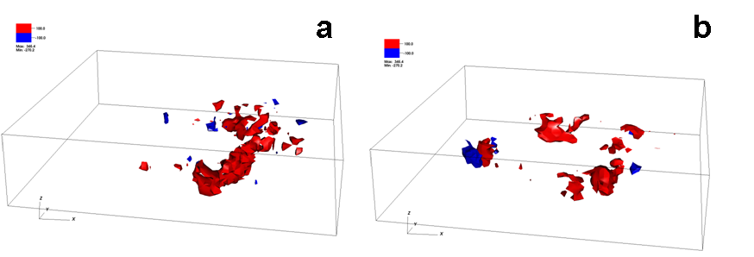

*Figure 1. Three-dimensional isosurfaces of the latent heat of condensation/evaporation (K h-1) retrieved from Doppler radar observations in Hurricane Guillermo (1997) at (a) 1855 UTC 2 August and (b) 2225 UTC 2 August. The grid volume is storm-centered extending 120 km on each side and 19 km in the vertical with a grid spacing of 2 km in the horizontal and 1 km in the vertical. Red indicates condensation while blue shows evaporation.*

explained in sections 3 and 4.

The full spectrum of latent heating excites two general classes of dynamical modes in the TC relative to the storm center: axisymmetric and asymmetric (departures from axisymmetry). Although the wind and vorticity fields of a TC are highly axisymmetric (Reasor et al. 2000), the distribution of convection and latent heating is often asymmetric with seemingly disorganized variations in time. Axisymmetric theories for TC evolution such as the Wind Induced Surface Heat Exchange (WISHE) mechanism focus on mean structure (Emanuel 1986). In the WISHE model, boundary layer radial inflow to the storm center acquires moist entropy from the underlying warm ocean and through frictional convergence at the sea surface, deposits this energy aloft where it can power the storm to generate stronger winds. The air is then expelled outward far from the storm center where it sinks and can start the cycle over again (Emanuel 1986). While considerable insight has been gained from the WISHE model, asymmetries such as eddy angular momentum fluxes, vortex Rossby waves, potential vorticity mixing, mesovortices and vortical hot towers have been shown to be integral to TC intensity and structure change (Montgomery and Kallenbach 1997; Schubert et al. 1999; Montgomery et al. 2006) yet they can only be parameterized in axisymmetric theory because the model is fundamentally two-dimensional.

Many of the mechanics behind TC structure and intensity change outlined above either rely on or are sensitive to turbulent properties of the flow. For example, Emanuel (1997) described the eyewall of a TC as an atmospheric front where the frictionally induced inflow concentrates moist entropy inside the radius of maximum winds (RMW) leading to strong radial gradients in angular momentum. In order for enhanced periods of intensification to occur (rapid intensification) in the WISHE model, mechanical spin-up of the eye by radial turbulent fluxes of angular momentum (asymmetries) from the eyewall is necessary to invigorate the energy cycle. However, little is known of the structure of turbulence in TCs and its role in the 3D evolution of the storm (Bryan and Rotunno 2009). As noted above, most airborne Doppler radar observational analyses (such as those from the NOAA WP-3Ds) are 2 km in the horizontal and 1 km in the vertical (Reasor et al. 2009), which is likely insufficient to resolve turbulent eddies. Furthermore, exploratory numerical simulations at turbulence resolving scales (on the order of 100 meters or less) are only beginning to be conducted (Rotunno et al. 2009).

It is clear that many unknowns exist in our knowledge of convection, latent heating and turbulence and their role in TC dynamics. **My proposed research at NASA will address these unknowns by utilizing new and existing NASA high resolution Doppler radar observations and numerical simulations performed on NASA supercomputers.** Now is the time to capitalize on these unique NASA resources (including upcoming field experiments) that may lead to significant progress in our understanding (and forecasting) of the TC. Details of the research plan are presented in the next section.

**3. General methodology and procedure**