c. Data manipulation and selection procedure

One of the most fundamental quantities that drives both intensity and structure change in hurricanes is the release of latent heat in clouds. Doppler radars only measure the reflectivity and radial velocity of precipitation particles averaged over the pulse volume and thus, retrievals of dynamically relevant quantities (such as the Cartesian wind components and latent heat) are required. Guillermo’s 3-D wind field was retrieved using a variational approach on a system of equations that includes the radar projection equations, the anelastic mass continuity equation and a Laplacian filter including boundary conditions for the surface and just above the echo top (Gamache 1997; Gao et al. 1999; Reasor et al. 2009). This wind field and estimates of the liquid water content (derived from the reflectivity measurements) are used to retrieve the latent heat of condensation/evaporation following Guimond et al. (2011). There are two main steps in the latent heat retrieval algorithm: (1) determine the saturation state at each grid point using the precipitation continuity equation and (2) compute the magnitude of heat released using the first law of thermodynamics and the vertical velocity estimates described in Reasor et al. (2009). Relying on radar reflectivity for quantitative purposes (such as computing the latent heat magnitude) can lead to significant errors in the heating retrieval due to the large uncertainty in single frequency radar derived water parameters (Doviak and Zrnic 1984; Gamache et al. 1993). Guimond et al. (2011) focus on the qualitative nature of the reflectivity measurements to reduce the consequences of these errors.

Figure X (from Guimond et al. 2011) shows three-dimensional isosurfaces of the retrieved latent heat in Guillermo at each of the ten aircraft sampling periods. The uncertainties in the magnitude of the retrieved heating are dominated by errors in the vertical velocity. Using a combination of error propagation and Monte Carlo uncertainty techniques, biases are found to be small, and randomly distributed errors in the heating magnitude are ~16 % for updrafts greater than 5 m s and ~156 % for updrafts of 1 m s (Guimond et al. 2011). Even though errors in the vertical velocity can lead to large uncertainties in the latent heating field for small updrafts/downdrafts, in an integrated sense the errors are not as drastic.

References

Doviak, R.J., and D.S. Zrnic, 1984: *Doppler Radar and Weather Observations*.

Academic Press, 458 pp.

Gamache, J.F., R.A. Houze, Jr., and F.D. Marks, Jr., 1993: Dual-aircraft investigation of

the inner core of Hurricane Norbert. Part III: Water budget. *J. Atmos. Sci.*, **50,** 3221-3243.

——, 1997: Evaluation of a fully three-dimensional variational Doppler analysis

technique. Preprints, *28th Conf. on Radar Meteorology*, Austin, TX, Amer. Meteor.

Soc., 422-423.

Gao, J., M. Xue, A. Shaprio, and K.K. Droegemeier, 1999: A variational method for the

analysis of three-dimensional wind fields from two Doppler radars. *Mon. Wea. Rev.*, **127,** 2128-2142.

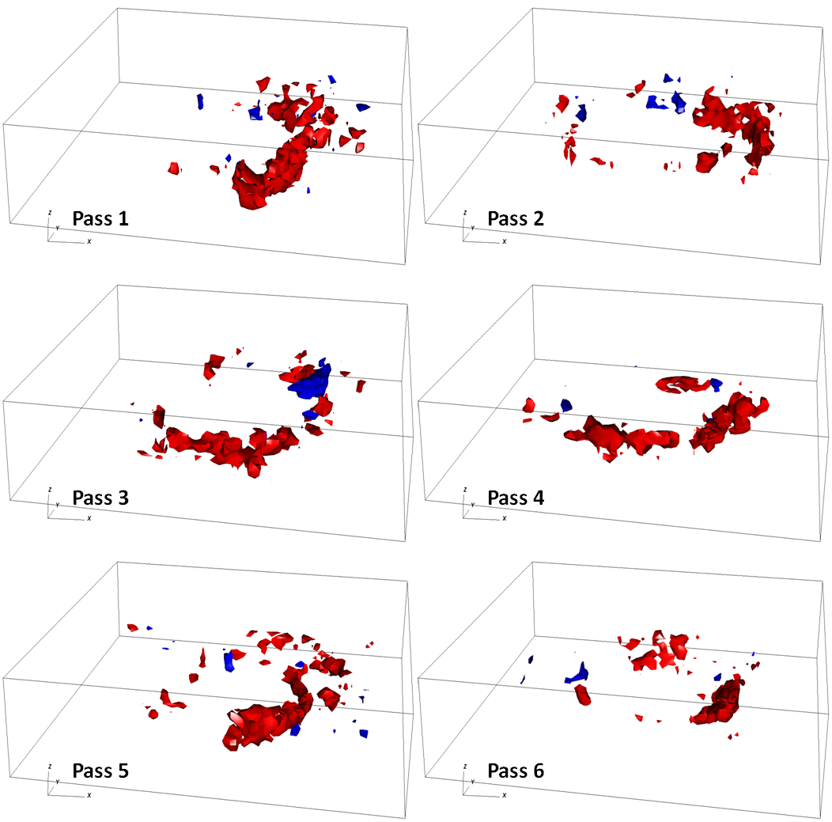

Figure X. Three-dimensional isosurfaces of the latent heat of condensation (red, 100 K h-1) and evaporation (blue, -100 K h-1) retrieved from airborne Doppler radar observations in Hurricane Guillermo (1997) at the times shown in Fig. 2. The grid volume is storm-centered extending 120 km on each side and 19 km in the vertical with a grid spacing of 2 km in the horizontal and 1 km in the vertical. The first useful level is at 1 km due to ocean surface contamination.

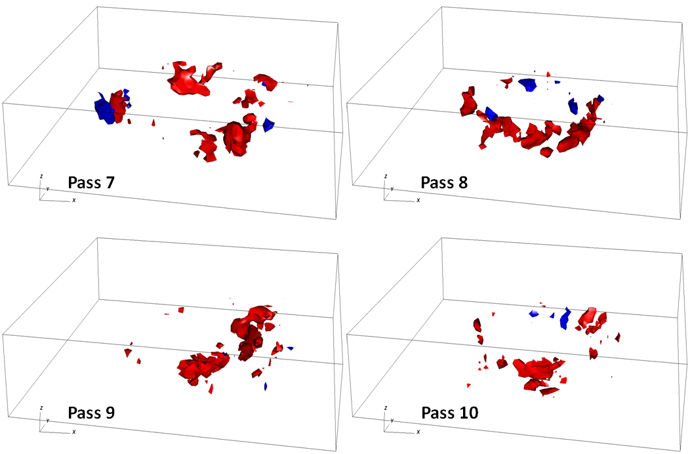

Figure X. continued.