**A LATENT HEAT RETRIEVAL AND ITS EFFECTS ON THE INTENSITY AND STRUCTURE CHANGE OF HURRICANE GUILLERMO (1997). PART II: NUMERICAL SIMULATIONS.**

Stephen R. Guimond1# and Jon M. Reisner2

1*Center for Ocean-Atmospheric Prediction Studies and Department of Earth, Ocean and Atmospheric Science, Tallahassee, FL*

2*Los Alamos National Laboratory, Earth and Environmental Sciences Division, Los Alamos, NM*

Submitted to the *Journal of the Atmospheric Sciences*

June 26, 2011

*#Current affiliation: NASA Goddard Space Flight Center, Greenbelt, Maryland*

*Corresponding author address*: Stephen R. Guimond, NASA Goddard Space Flight Center, Code 613.1, Greenbelt, MD 20771.

E-mail: stephen.guimond@nasa.gov

**ABSTRACT**

In part one of this study, a new algorithm for retrieving the latent heat field in tropical cyclones from airborne Doppler radar was presented and fields from rapidly intensifying Hurricane Guillermo (1997) were shown. In this second part, the utility of the retrievals is assessed by inserting the heating into realistic numerical simulations at 2 km resolution and comparing the generated wind structure to the Doppler radar observations of Guillermo.

Results show that using the latent heat retrievals as forcing (“retrieval” run) produced very low errors (in terms of volume integrated wind speed errors and explained wind variance) and significantly improved simulations relative to a “predictive” run that is highly tuned to the latent heat retrievals by using an EnKF procedure to estimate values of key model parameters (Godinez et al. 2011).

Releasing all the heating/cooling in the latent heat retrieval results in a simulation that produces a large positive bias in Guillermo’s intensity, which further motivates the need to determine the saturation state in the hurricane inner-core through a procedure similar to that described in part one. The heating retrievals accomplish high quality structure statistics (explained wind variance) by forcing asymmetries in the wind field to occur with the correct amplitude and in the right place and time. In contrast, the latent heating fields generated in the predictive simulation contain a significant bias toward large values and are concentrated in bands (rather than discrete cells) stretched around the vortex.

The Doppler radar based latent heat retrievals presented in this series of papers should prove useful for convection initialization and data assimilation to reduce errors in numerical simulations of tropical cyclones.

**1. Introduction**

The main tool used by the community for predicting the track, intensity and structure of tropical cyclones (TCs) are numerical simulations. While great progress has been made in our ability to simulate these phenomena, many sources of uncertainty (e.g. initial conditions, numerical approximations of the governing equations and physical parameterizations) remain that limits the quantitative and qualitative use of model data. The primary driving force of TC intensity and structure change is the release of latent heat in clouds where the source of moist entropy flux comes from the thermodynamic disequilibrium at the ocean-atmosphere interface (Charney and Eliassen 1964; Emanuel 1986). This physical process is parameterized in current numerical models (e.g. Reisner et al. 1998) with few studies rigorously comparing the simulated fields to observations. Rogers et al. (2007) performed a detailed comparison of vertical velocity and hydrometeor fields from two TC numerical simulations with aircraft Doppler radar and microphysical probe measurements. For the vertical velocity field, they found that the general distribution was similar but the magnitudes were weaker in the simulations. For the hydrometeor field, Rogers et al. (2007) confirmed that their simulated radar reflectivities are much higher than observed which, when combined with vertical velocity, have a direct connection to latent heating.

Several studies have documented considerable sensitivity to numerical model microphysical schemes when simulating TC intensity and structure change. For example, McFarquhar et al. (2006) found that choice of microphysics parameterization (including alterations to the basic condensation scheme) led to variations in simulated storm intensity by nearly 10 hPa. Uncertainty in graupel characteristics were found to also produce large changes in storm intensity and are likely one of the culprits behind the consistent and significant positive bias of radar reflectivities when compared to observations (McFarquhar et al. 2006; Rogers et al. 2007). Furthermore, Pattnaik and Krishnamurti (2007) conducted several microphysical sensitivity experiments with a numerical model and found that omission of cooling processes associated with the melting of mixed phase hydrometeors and the evaporation of rainwater can produce important changes to a storm’s intensity. Cloud microphysical heating is a complex, dynamic process that is highly coupled to various other physical parameterizations and model numerical solutions and it is not surprising that uncertainty in the schemes and their effects on storm intensity/structure exist.

Another physical parameterization in numerical models with significant uncertainty that can lead to large changes in the simulated intensity and structure of TCs is turbulence. Braun and Tao (2000) found that by changing the boundary layer scheme (the vertical mixing and surface fluxes of mass, momentum and energy accomplished by turbulent eddies) in their simulations of Hurricane Bob (1991), minimum central pressures varied by up to 16 hPa and maximum winds by 15 m s-1. Using an axisymmetric numerical model, Bryan and Rotunno (2009) found that the maximum possible intensity of TCs is most sensitive to the intensity of turbulence in the radial direction (defined through the turbulent length scale). For larger values of the turbulent length scale (more intense turbulent activity), the radial gradients of angular momentum become weaker, which requires a concomitant response in the energy field to maintain thermal wind balance. This process results in increased surface pressures and reduced maximum winds (Bryan and Rotunno 2009).

Given the uncertainty in current model microphysical schemes and associated latent heating fields, which feed directly into effects on storm structure/intensity, it is clear that work needs to be done to retrieve latent heating fields from observations and examine their utility in a modeling framework. In part one of this study, a new algorithm for retrieving the latent heat field in TCs from airborne Doppler radar was presented and fields from rapidly intensifying Hurricane Guillermo (1997) were shown. In this second part, the goal is to determine the value of the retrievals by inserting the heating into realistic numerical simulations at 2 km resolution and comparing the generated wind structure to the Doppler radar wind analyses of Guillermo. Comparisons of the retrieved heating run to simulations that employ a very well calibrated predictive model with a microphysics parameterization are analyzed (Godinez et al. 2011). These comparisons highlight important parts of both the latent heat retrieval algorithm and predictive modeling system needing more work. The paper is organized as follows. In section 2, background on the numerical model, extensive initialization procedures and simulation setups are described. Section 3 shows the results of the simulations and their comparisons to Doppler radar observations. In addition, the latent heating fields from the predictive simulation are compared to the retrievals in this section. Section 4 provides conclusions from the work and offers recommendations for improving the prediction of TC intensity and structure change.

**2. Numerical model and simulation setup**

*a. Numerical model*

An overview of Hurricane Guillermo (1997) including a detailed explanation of a rapid intensification episode sampled by the NOAA P-3 aircraft can be found in Reasor et al. (2009), Sitkowski and Barnes (2009) and Guimond et al. (2011). The HIgh GRADient (HIGRAD) atmospheric model developed at the Los Alamos National Laboratory (LANL) was used to simulate this rapidly intensifying period of Guillermo. The HIGRAD model solves the three-dimensional (3D), rotating, compressible Navier-Stokes equations written in conservative form and framed in generalized coordinates with additional equations for cloud processes and turbulence (see Reisner et al. 2005 and Reisner and Jeffery 2010 for the complete equation set). The discrete model employs a semi-implicit time-stepping procedure (Reisner et al. 2005) along with a finite volume approach computed on an A-grid (collocated grid points). The Quadratic Upstream Interpolation for Convective Kinematics including Estimated Streaming Terms (QUICKEST; Leonard and Drummond 1995) was used to approximate advective terms with these quantities potentially limited by a flux-corrected transport procedure (Zalesak 1979).

*b. Setup procedures for simulations*

The model domain extends 1,276 km on a side with a 120 km square region in the center with constant 2 km horizontal resolution (matching the Guillermo airborne Doppler radar analysis from part one; see Guimond et al. 2011) stretching to ~ 15 km horizontal resolution at the boundaries using a differentiable hyperbolic tangent function. The first model level is at 35 m above the ocean surface and the vertical domain stretches to 22 km at the model top for a total of 71 levels. The environmental potential temperature, density and water vapor initial conditions are taken from 1.125° European Centre for Medium-Range Weather Forecasts (ECMWF) operational analyses closest in time to the start of the aircraft observations of Guillermo (1855 UTC 2 August 1997). Newtonian relaxation zones on the sides and top of the model domain were used to nudge the fields back towards the ECMWF environmental conditions and control the reflection of oscillations into the domain interior. A full Coriolis force was used with the domain center at a latitude of 22°N (center of Guillermo at start of aircraft penetrations). A high-resolution (0.25°, daily) sea surface temperature dataset that relies on passive microwave satellite data (Reynolds et al. 2007) was used to initialize the ocean. Finally, a time step of two seconds was used for all simulations.

Unless stated otherwise, the eddy viscosity/diffusivity (κ) found in the equation set of Reisner et al. (2005) and Reisner and Jeffery (2010) is determined from the grid spacing,

(1)



where represents the grid spacing in each of the three Cartesian directions and is a time scale equal to 10-3 s-1 in the horizontal directions and 10-2 s-1 in the vertical direction. In numerical models, eddy diffusivities characterize the strength of sub-grid scale mixing, which is accomplished mainly by turbulent eddies for the 2 km resolution radar portion of the model domain used in this study.



Values of κ in the horizontal located in the radar domain are 4,000 m2 s-1. In the vertical, κ varies between ~ 30 m2 s-1 near the ocean surface to ~ 3,000 m2 s-1at the model top. At the ocean surface, the eddy viscosity for momentum in the vertical direction is expressed as

(2)



where is the horizontal wind speed and is a length scale equal to 25 m. We chose to use the above expressions for the eddy viscosity/diffusivity in order to simplify the turbulence model so that changes in the intensity/structure of the simulated storm could be more easily ascribed to the latent heat forcing.



The initial vortex is taken directly from the first Doppler radar composite of Guillermo (1855 UTC 2 August 1997; Reasor et al. 2009). This vortex only covers the inner portion of the model domain and therefore an extended Doppler vortex was created according to the following procedure. First, the Doppler winds are interpolated to a cylindrical grid extending out to the edge of the model domain with 2 km radial and 5° azimuthal spacing. Next, the ECMWF analyses are used to compute the environmental, horizontal winds impacting Guillermo by averaging in annuli around the analysis depicted storm out to 500 km radius. The annulus averaging is weighted with a large weight given to outer radii and a small weight given to inner radii. This procedure effectively removes the symmetric part of the vortex from the ECMWF analyses leaving a reasonable estimate of the environmental winds impacting the storm (Hanley et al. 2001). The outer radius of the cylindrical grid is then set to the computed environmental winds and a smooth, exponentially decaying function is used to merge the edge of the Doppler domain into the environmental winds at each radial. Finally, the merged winds are interpolated back to the model Cartesian grid.

Figure 1 shows the 3D wind speed structure of the merged vortex on a subset of the full model grid (500 km on each side, but still 22 km in the vertical). Figure 2 shows a horizontal cross section through the merged vortex at ~ 1 km altitude on the full model grid for reference. The above procedure is able to retain the important asymmetric structure of the observed vortex in the interior while gradually relaxing the winds back to the environment on the domain boundaries.

The vortex is introduced into the model using a dynamic initialization procedure where forcing terms are added to the horizontal momentum equations,

(3)



The represents all the standard forcing on the right-hand-side of the horizontal momentum equations, the horizontal velocities from the merged vortex, the model velocities, is the dry air density and the chosen nudging coefficient of 10-3 s-1. The dynamic initialization (or “nudging”) procedure has been used successfully for over thirty years (e.g. Hoke and Anthes 1976) including studies of tropical cyclones (Chang 1981; Krishnamurti et al. 1998; Tory et al. 2006). The goal of the process is to develop a set of initial conditions, based on observations, which are balanced (i.e. steady-state) with respect to the full model equations. Several other methods exist for vortex initialization such as 3D and 4D variational approaches (e.g. Navon et al. 1992). We chose the nudging method for both its simplicity and effectiveness.



In this study, only the merged Guillermo vortex (Figs. 1 and 2) is nudged into the model as described above, allowing the other model variables (such as vertical velocity, potential temperature, density and water vapor) to develop in a consistent and balanced manner with the horizontal momentum field. The nudging coefficient was chosen by trial-and-error, which is not without precedent (Krishnamurti et al. 1998) although more sophisticated methods have been used (Zou et al. 1992). Using too large of a coefficient produced large amplitude gravity wave oscillations along with a perpetually unbalanced mass and momentum field. On the other hand, using too small of a value did not provide enough forcing to spin-up a quasi-balanced vortex in a reasonable amount of time. A value of 10-3 s-1 seemed to provide a good compromise between these two effects. Note that nudging different variables with a different observational dataset and especially with a different numerical model and setup will likely change the optimal coefficient (Hoke and Anthes 1976; Zou et al. 1992).

The model is integrated using (3) for a period of 9 – 10 h at which time the vortex reached a steady-state minimum pressure of ~ 958 hPa, which matches observations of the storm at this time (Mayfield 1997). Note that during the initialization, the model microphysical scheme is enabled, but the forcing associated with heat released from phase changes is set to zero. This allows some consistency between the spun-up vortex and the moisture field while not allowing heat release that would change the wind field from that which was specified. Figure 3 shows a time series of minimum pressure for the dynamic initialization of the merged Guillermo vortex. After a period of ~ 2 h, the minimum pressure begins to asymptote towards the observed value of ~ 958 hPa. An offline, iterative thermal wind balance solver using the symmetric part of the merged vortex and an ECMWF environmental sounding as input revealed that the model is approaching thermal wind balance which, in terms of minimum pressure, is ~ 958 hPa for this vortex. For the purposes of the simulations in this paper, the dynamic initialization is stopped at 9 h and the nudging coefficient is set to zero. At this time, nearly the exact structure of the merged vortex (Figs. 1 and 2) exists in the model along with the potential temperature and density fields that hold the vortex in approximate thermal wind balance.

After the nudging is stopped at 9 h, four simulations are spawned. In the first simulation, the latent heat retrievals presented in part one of this study (Guimond et al. 2011) are used as forcing in the thermodynamic equation,

(4) where the **F** represents only the diffusive tendencies on potential temperature (θ; the release of heat through the model’s microphysical scheme was shut off for this run), which includes sensible heat fluxes from the ocean surface and is the forcing from the latent heat retrievals. The variable represents the time evolution of the latent heat forcing, which over the first ten minutes takes the form



(5) with τ = 600 – *t* and α = 300 s. The function in (5) acts to smoothly ramp up the first latent heat composite (see Fig. 12 pass 1 in Guimond et al. 2011) in a ten-minute period. After this interval, the function in (5) is replaced by a linear interpolation operator that transitions each latent heat composite over a 35-minute period (commensurate with the model time step of 2 s) extending out to 5.25 h. This simulation will be called the “retrieval” run.



The second simulation is very similar to the first one except that every grid point in the Doppler radar analysis (corresponding to the center of the model domain) is assumed saturated when performing the latent heat retrieval, which releases heating/cooling wherever there is an updraft/downdraft, regardless of vertical velocity magnitude. The latent heat retrieval presented in part one of this study and used in the “retrieval” run described above, solves for the saturation state which ultimately releases less heating/cooling in the radar portion of the model domain when compared with the saturation assumption. However, as part one of this study demonstrates, assuming saturation over the entire inner-core of TCs is not accurate because for |*w*| < ~ 5 m s-1, there is large variability in the saturation state of the air (Guimond et al. 2011). The present simulation is conducted in order to continue to assess the need for computing the saturation state over the inner-core of Guillermo and to determine the accuracy of the method relative to the saturated case. This simulation will be called the “saturated” run.

In the third simulation, the latent heat retrievals are not used, but the heating produced through the model’s microphysical scheme is turned on instead, which can be represented through the bold forcing variable shown in (4). Only warm rain processes were considered in this simulation for two reasons. First and foremost, sensitivity tests with mixed phase microphysics revealed small differences in wind speed magnitude and structure (not shown) relative to the moist phase only results. This is consistent with the dual-polarization radar study of deep convection by Tong et al. (1998) and the Hurricane Andrew (1992) modeling results of Zhang et al. (2002). Secondly, the latent heat forcing used in the “retrieval” run described above (including the algorithm in part one) only incorporates warm-rain processes and so warm-rain only simulations were conducted here to enable fair comparisons.

The microphysics scheme relies partly on the water vapor field to release energy. Although a water vapor field consistent with Guillermo’s vortex was produced during the dynamic initialization process, this moisture field is only representative of the basic-state (vortex) and not the perturbations (convection). Figure 4a shows a horizontal cross section of the water vapor mixing ratio at 5 km height after 9 h of vortex nudging revealing a relatively featureless field with fairly low values throughout the domain. In order to assist the microphysics scheme with the placement and magnitude of water vapor that would result in the observed convection, the first latent heat composite (a condensation rate; see Fig. 12 pass 1 in Guimond et al. 2011) is converted to a cloud water tendency using the expression

, (6) where *Fqc* is cloud water mixing ratio tendency in kg kg-1 s-1, *T* is temperature, *Cp* is the specific heat of dry air at constant pressure and *Lc* is the latent heat of condensation at 0° C. The converted cloud water was then assumed to have originated as a source of water vapor (from turbulent fluxes at the air-sea interface). This source of water vapor was added as a forcing term to the water vapor and mass continuity equations in the model over a ten-minute period using the time evolution equation shown in (5).



Figure 4b shows the water vapor field at 5 km height after the dynamic initialization and the ten-minute moisture forcing. The moisture field in Fig. 4b is clearly more realistic than that in Fig. 4a, showing an asymmetric distribution of water vapor that is consistent with observed convection at this time (see Fig. 1 pass 1 and Fig. 12 pass 1 in Guimond et al. 2011). After ten minutes, the water vapor forcing is shut off and the model is allowed to run in a mode free from observational forcing with the microphysics scheme determining the release of heat. The large extent of the circulation initialized in the model could result in convection and latent heat release over large portions of the domain. In order to enable fair comparisons with the retrieval run, which releases latent heat only over the radar portion of the model domain (microphysics scheme was shut off for theses runs), the heating in the current simulation was only allowed over the radar portion of the model domain as well. This was accomplished by multiplying the microphysical heating, represented by the bold term in (4), by an array that masks the outer portions of the domain.

Simulations that rely on the microphysics scheme for generating latent heat forcing are dependent not only on the moisture field, but also turbulence parameters including surface friction. All of these parameters are highly uncertain aspects of the modeling system that can have large impacts on the intensity and structure of a simulated storm (Emanuel 1995; Braun and Tao 2000; Bryan and Rotunno 2009). Godinez et al. (2011) used the latent heat retrievals presented in part one of this study (Guimond et al. 2011) in a unique Ensemble Kalman Filter (EnKF) approach to estimate several key model parameters for HIGRAD simulations of Hurricane Guillermo (1997). Using a 120-member ensemble, Godinez et al. (2011) computed mean estimates of coefficients that determine the strength of (a) the ocean surface turbulent (sub-grid) flux of water vapor, (b) the ocean surface dissipation of momentum (see eq. 2 in this paper), (c) the turbulent transfer of all variables throughout the model domain defined through the turbulent length scale, and (d) the vertical wind shear affecting Guillermo. The coefficients estimated from the assimilation of the latent heat retrievals were found to produce the lowest overall error when used in a predictive simulation relative to the assimilation of the Doppler radar horizontal wind analysis. For the third simulation in the present paper, we used the parameter estimates in (a) – (c) along with a 1.5 order Turbulent Kinetic Energy (TKE) turbulence closure (see equation 3 in Reisner and Jeffery 2009) with the eddy viscosity/diffusivity expressed as

(7)



where *Ls* is the turbulent length scale determined from Godinez et al. (2011). The wind shear coefficient was not used since a reasonable estimate was produced through the initialization procedure described above. We call this third simulation, which is a very well calibrated modeling system, the “predictive” run.

A summary of the three main simulations described above can be found in Table 1. Each simulation is run out to 6 h but only data up to 5.25 h (with output every 35 minutes to approximate the radar composite time separations; Reasor et al. 2009) is used for comparisons to observations.

**3. Results**

Figure 5 provides an overview of the performance of each simulation described in section 2 in terms of minimum surface pressure along with observational estimates from the National Hurricane Center (NHC), which are produced every 6 h, interpolated to the radar composite times. At the beginning of the time series, each simulation experienced a ~ 0.5 h period of slight weakening (or reduced intensification in the saturated run case), which is due to both minor adjustments of the spun-up vortex as the nudging coefficient is set to zero and the gradual introduction of heating into the model. The retrieval run performed quite well capturing most of the observed deepening of Guillermo with an error of only ~ 5 hPa at the end of the simulation. However, on average the retrieval simulation was a bit too strong possibly due to errors in the vertical velocity and the computation of saturation (Guimond et al. 2011). The saturated run is clearly much too strong indicating that the inner-core of Guillermo was not completely saturated. This is consistent with Fig. 2 in Guimond et al. (2011) and further highlights the need for an accurate estimation of the saturation state through a procedure similar to that shown in part one of this study. The predictive run is too weak by about 5 – 10 hPa early in the simulation. However, near the end of the run, the intensification of the vortex increases and the minimum pressure errors at 5.25 h are quite small. With only a few observations of Guillermo’s central pressure during this short time period, caution must be taken when interpreting these results.

Comparisons are not made with the maximum wind speeds for two reasons: (1) the maximum wind speed is typically a volatile parameter that can reflect the chaos inherent in a single deterministic forecast rendering comparisons uncertain and (2) the maximum wind speeds in the Guillermo Doppler analyses exhibited small variability (see Fig. 1b of Zou et al. 2010) despite the observed rapid pressure falls during this time period. It is possible that the Doppler analyses are not resolving the peak wind due to coarse resolution in space and time, smoothing and surface clutter. It is also possible that the mass-momentum adjustment process is lagging during the observational sampling period. To avoid some of these uncertainties, we focus on mean and integrated measures of error.

Since the first Doppler wind composite was used to spin-up Guillermo, comparisons of the model-generated wind fields to observations are made with the other nine composite periods (see Table 1 in Reasor et al. 2009) every 35 minutes out to 5.25 h. The storm moves during the simulation, so in post-processing the model vortex is re-centered in the domain using a wind centroid finder that minimizes the azimuthal variance of the wind speed. The data are then interpolated from the model grid to the Doppler analysis grid.

Figure 6 shows the results of a volume integrated wind speed error

, (8)



where *XM* is the model predicted wind speed and *XO* is the Doppler radar observed wind speed. The volume of integration (*V)* is taken over the radar portion of the model domain in the horizontal (see section 2) and 1 – 12 km in height (ocean surface contamination exists below 1 km and relatively few hydrometeors existed above 12 km). Figure 6 is consistent with the results of Fig. 5 for the retrieval and saturated runs. That is, relative to observations, the retrieval run has the smallest errors (less than 10 % over the entire simulation) while the saturated run has larger errors that grow quickly with time. Note that for wind speed errors, the predictive run performs very similar to the saturated run generating a storm that is too strong. However, for minimum surface pressure (Fig. 5), the predictive run is either too weak or very close to the NHC observations. This contrast in model performance is due to the fact that different error metrics will sometimes produce different results especially when using diverse sources of observations. Root mean square errors for wind speeds were also computed revealing essentially the same results as the volume integrated errors and are not shown.

Figure 7 presents a timeseries of the square of the linear correlation coefficient (expressed as a percent), which measures how well the simulations capture the variability in the Doppler observations. The spun-up, merged Guillermo vortex does not explain 100% of the variability in the Doppler observations (see t = 0 h in Fig. 7) because of several factors inherent to models (e.g. resolution, numerics) and due to the imperfection of the nudging process. However, an R2 of 80% is still an excellent value that captures all of the major asymmetries in the observed vortex. The simulations that use a form of the latent heat retrievals for forcing (retrieval and saturated runs) have the largest R2 values and are very similar in magnitude and structure. The R2 values for the predictive run are consistently smaller than the other runs by ~ 20 – 30 %. These results show that using the latent heat retrievals directly for forcing can account for a significantly larger percentage of the variability in the observations relative to using the model microphysical scheme in a predictive mode even when highly tuned to the retrievals.

To further demonstrate the performance of each simulation, horizontal cross sections of wind speed at 1 km height are shown in Figs. 8 and 9 alongside the Doppler radar observations. Figure 8 (observations at 2225 UTC 2 August 1997 correspond to 3.5 h into simulations) shows that the magnitude of the wind speed is most accurate for the retrieval run with a well-defined eyewall and surrounding areas relative to the Doppler radar analysis. The saturated run is clearly too strong everywhere but qualitatively, the wind field is similar to that of the retrieval and observations. For the predictive run, the magnitude of the winds at this time and level are generally too weak. The structure of the eye and eyewall (placement of features, variance) are also generally more accurate in the retrieval run although the saturated run is quite similar with the exception of larger magnitudes everywhere, which results in a smaller “eye” (e.g. wind speeds < 20 m s-1). The eyewall of the predictive run captures the observed asymmetry in the northeast quadrant reasonably well, although the entire core of the simulated storm is more asymmetric than the observations with a strong wavenumber one component.

Figure 9 shows the same plots as in Fig. 8 only at 2404 UTC 3 August 1997 for the observations, which corresponds to 5.25 h into the simulations. The retrieval run is again the closest to observations in terms of wind speed magnitude and structure although the asymmetry in the north/northeast portion of the observations is misplaced into the opposite quadrant in both the retrieval and saturated runs. The saturated run continues to be overly strong, which is due to too much net heat released in the latent heat retrieval. The magnitudes of the winds in the eastern eyewall of the predictive run are close to the observations, but the eyewall is distorted with a significant wavenumber one component, which leaves the western side of the eyewall with wind speeds that are too weak by ~ 15 – 20 m s-1.

Figure 10 shows time averaged (over the nine composite periods) vertical cross sections (at y = 0) of wind speed from each model simulation and the Doppler radar observations. The observations in Fig. 10d reveal an asymmetric structure with the eastern eyewall having stronger wind speeds and a larger tilt with height than the western eyewall. This structure is reproduced fairly well by the retrieval run shown in Fig. 10a in terms of the magnitude and structure of the wind speed although the radius of maximum winds (RMW) is displaced ~ 10 km radially outward from the observations. The saturated run (Fig. 10b) produces an eyewall vertical structure that agrees well with the observations, but the wind speeds are again too strong. Interestingly, the RMW is reproduced very well in the saturated run, but the extra heat released due to the saturation assumption has expanded the wind field inside the RMW too far, which creates a very narrow “eye” (low wind speed) region.

The predictive run (Fig. 10c) is able to reproduce the observed eyewall asymmetry, but the large eye has pushed the time-averaged eyewall radially outward which results in wind speeds that are too strong (relative to Fig. 10d) outside of ~ 40 km radius. In addition, the predictive run produced wind speeds that are too strong above ~ 5 – 6 km height. This structure explains why the volume-integrated wind speeds for the predictive run (Fig. 6) have a positive bias on par with the saturated run. What is driving the predictive run to produce a significant positive bias in the volume-integrated wind speed errors and why do the retrieval and saturated runs explain more of the variance in the Doppler observations? To begin to answer these questions, the latent heating fields from the observations and predictive simulation were analyzed.

Figure 11 shows histograms of the latent cooling and heating rates from the latent heat retrievals (11a and 11b) and predictive simulation (11c and 11d) for data over the radar domain (120 km in the horizontal and 1 – 10 km in height) including several snapshots in time corresponding to the Doppler radar composites in Table 1 of Reasor et al. (2009). Just like the wind speed comparisons, the latent heat histograms show data from the last nine composite times (covers ~ 5.25 h of the predictive simulation) since the first composite was used for Guillermo’s initial conditions. To enable meaningful visual comparisons, latent cooling/heating rates less than 0.25 K h-1 are not displayed in Fig. 11, but the mean values displayed above each set of data include the full range of heating and cooling.

Figure 11c reveals that the predictive run produced a massive amount of small cooling rates relative to the latent heat retrievals (Fig. 11a), which is likely due to two main things: (1) spurious evaporation near cloud edges as a result of numerical errors (Reisner 2011) and (2) improper representation of small-scale and weak downdrafts in the Doppler radar synthesis procedure (see Fig. 15 and discussion in Guimond et al. 2011). The latent heating histogram comparisons between the retrievals (Fig. 11b) and the predictive run (Fig. 11d) are reasonably good, but there is too much heating being released in the predictive run with a bias toward large heating values (> 150 K h-1). The bias toward large heating values allows a compensation for the massive small cooling rates yielding a mean value of ~ 18 K h-1 for the predictive run relative to ~ 14 K h-1 for the latent heat retrievals. The larger mean heating is the major reason why the predictive run produced a significant positive bias in the volume-integrated wind speed errors (Fig. 6). Interestingly, the mean heating for the saturated run is only ~ 14.5 K h-1 (saturation assumption increases heating, but also some cooling as well) but the wind speed errors in Fig. 6 are on par with the predictive run, which has a higher mean heating rate (~ 18 K h-1). The turbulence model used in each simulation can explain these differences. For the saturated run, eddy viscosities were computed based on the grid spacing (see eq. 1) whereas for the predictive run, a TKE model was used in addition to (1), which increases the overall eddy viscosity and kinetic energy dissipation within the simulation.

Figure 12 shows snapshots of latent heating/cooling rates averaged over low to mid levels (1 – 5 km height) from observations (the retrieval run; Fig. 12a) and the predictive run (Fig. 12b). The observations in Fig. 12a (2225 UTC 2 August 1997) show that the latent heating and cooling is clustered in convective cells scattered around the vortex revealing a highly asymmetric structure. The predictive run in Fig. 12b (3.5 h into simulation) produced a latent heating (and cooling) field that has more banding than the observations with several convective cells embedded within the bands. In addition, the heating is occurring farther from the storm center towards the edges of the radar domain in the predictive run, which leaves a large area where small cooling rates can dominate (Fig. 11c). The magnitude of the peak heating in the predictive run is similar to the observations, but there is too much of that peak heating which is consistent with Fig. 11d showing a significant bias towards large heating values. These results are also consistent with the predictive run generating large volume integrated wind speeds (Fig. 6).

Figure 13 further clarifies the issues in the predictive run observed in Fig. 12 by comparing the latent heating/cooling rates from observations (2333 UTC 2 August 1997; Fig. 13a) and the predictive run (4.5 h into simulation; Fig 13b). The predictive run tends to produce banded heating structures displaced farther from the storm center when compared to observations with a significant bias toward large heating values. The overemphasis on banded heating structures may be due to a combination of insufficient resolution and diffusion inherent in the advection scheme. As mentioned above, spurious evaporation from numerical errors near cloud edges (such as the eyewall) is likely a major problem in the predictive simulation, which could push the eyewall heating farther from the storm center and require larger heating rates to maintain the storm intensity.

Figure 14 shows the azimuthal and time mean structure of the latent heating/cooling in the observations (Fig. 14a) and predictive run (Fig. 14b). As observed in the horizontal snapshots shown in Figs. 12 and 13, the mean structure shows that the radius of peak heating in the predictive run is nearly twice that of the observations (~ 25 km in Fig. 14a and ~ 50 km in Fig. 14b) with a large region of small cooling values inside of the 25 km radius (Fig. 14b). The observations reveal mean eyewall heating that tilts outward with height with maximum values centered around 4 km altitude. The predictive run does not reveal a coherent eyewall structure in height and the bulk of the time mean heating occurs in the upper troposphere peaking near 8 km altitude, which is responsible for the positive wind bias at upper levels shown in Fig. 10c.

The retrieval and saturated runs explain a large percentage (~ 60 – 70 %; see Fig. 7) of the variance in the Doppler radar wind analyses because the forcing is both derived from measurements of cellular convective structures and static (fixed to specific locations around the vortex). As a result, the latent heat retrievals are able to generate, to a large degree, the observed asymmetries in the right place and at the right time. The predictive run has lower explained wind variance values because of the large amplitude wavenumber one component in the wind field as seen in Figs. 8c and 9c, which produces a poor representation of the eyewall structure in the observations especially on the western side. A detailed analysis of the causes for this structure is beyond the scope of this paper, but they are ultimately due to the fact that the forcing in the predictive run is dynamic (constantly evolving and coupled to various processes such as turbulence). Clearly, the amplitudes and structure (i.e. banding, radial location) of the forcing in the predictive run are mostly incorrect (Figs. 11 and 12) despite the effort put into tuning the model (Godinez et al. 2011).

**4. Conclusions**

The ability of the latent heat retrievals, presented in part one of this study, to reproduce the observed wind fields of rapidly intensifying Hurricane Guillermo (1997) was tested using a realistic numerical simulation of the storm at a resolution consistent with the Doppler radar analyses (2 km). Results show that using the latent heat retrievals as forcing (“retrieval” run) produced very low errors (in terms of volume integrated wind speed errors and explained wind variance) and significantly improved simulations relative to a “predictive” run that is highly tuned to the latent heat retrievals by using an EnKF procedure to estimate values of key model parameters (Godinez et al. 2011).

The retrieval run produced a minimum pressure trace that was a bit too strong, which indicates that the latent heat retrievals may be releasing too much heat (due to errors in both the computation of saturation and the retrieved vertical velocity, which had a small positive bias; Reasor et al. 2009; Guimond et al. 2011), although the wind errors had a small negative bias. Simulations with the retrievals where saturation was assumed for the entire inner-core of Guillermo (releasing all heating/cooling) produced wind fields and minimum surface pressures that were much too strong, further motivating the need for the accurate determination of the saturation state in a manner similar to that presented in part one. Both simulations with the latent heat retrievals (retrieval and saturated runs) produced excellent structure predictions of Guillermo, which were evaluated with the radar observations through explained wind variance statistics and eye/eyewall visual comparisons. The heating retrievals accomplish high quality structure statistics by forcing asymmetries in the wind field to occur with the correct amplitude and in the generally correct place and time.

Despite the extensive work using the latent heat retrievals to estimate key model parameters with an EnKF procedure (Godinez et al. 2011), the predictive run with the setup described in section 2b produced large wind speed and structure errors although the minimum pressure was reasonable. The positive wind speed bias was shown to be largely a result of too much integrated heating released in the domain (especially in the upper troposphere) with a predisposition towards large heating values. These large heating values may have been trying to offset the massive amount of small cooling rates produced by the predictive run, which is probably a result of spurious evaporation due to numerical errors at cloud boundaries such as the eyewall (Reisner 2011) although weak downdrafts are not represented well by the Doppler analysis. Furthermore, the spurious evaporation is likely the major contributor to the wide eye region observed in the predictive run, which resulted in an outward displacement of the radius of maximum winds and peak heating. The poor structure statistics (explained wind speed variance) produced by the predictive run were found to be the result of the outward displacement of the eyewall mentioned above and the large amplitude, persistent wavenumber one component found mostly at lower levels. In addition, the latent heating in the predictive run was formed into bands stretched azimuthally around the vortex whereas the Doppler radar retrievals revealed a cellular structure to the heating.

The clear advantage of the retrievals in terms of producing a more accurate wind speed and structure forecast of Guillermo highlights their value for convection initialization in numerical models and the need for continuous observation of convective events in the hurricane inner-core. While we believe that airborne Doppler radars provide the highest quality observations of convection, infrequent sampling of storm cores and relatively poor time continuity of the measurements limits the use of these data from an operational perspective. The use of passive lightning imagers with their large field-of-views and continuous mapping of 2-D and even 3-D electrical discharges occurring within deep convection may prove useful for improving forecasts of hurricane structure. Computing heating rates from lightning measurements will likely be difficult, but placement of convection in near real time appears to be a very attainable goal.

Finally, future work needs to be done on improving the latent heating algorithm presented in part one as well as evaluating its utility in a numerical modeling framework for various storms, models and data assimilation procedures. The simulations conducted in this paper were for short time periods (< 6 h) and work needs to be done for longer forecasts where model errors can grow quickly. A second day of airborne Doppler radar data for Hurricane Guillermo (1997) exists, which would be useful for these purposes.

*Acknowledgments.* The first author would like to thank Dr. Mark Bourassa, Dr. Paul Reasor and Dr. Robert Hart for several discussions on the work, support and useful suggestions. Dr. Jason Sippel also provided helpful comments on a draft. This research was supported by the Los Alamos National Laboratory through a project entitled: “Flash Before the Storm: Predicting Hurricane Intensification using LANL Lightning Data” with Dr. Chris Jeffery the PI. In addition, financial support was also provided by a NASA ocean vector winds contract and a NOAA grant to Dr. Mark Bourassa.

**REFERENCES**

Braun, S.A., and W.-K. Tao, 2000: Sensitivity of high-resolution simulations of

Hurricane Bob (1991) to planetary boundary layer parameterizations. *Mon. Wea.*

*Rev.*, **128,** 3941-3961.

——, 2006: High-resolution simulation of Hurricane Bonnie (1998). Part II:

Water budget. *J. Atmos. Sci.*, **63,** 43-64.

Bryan, G.H., and R. Rotunno, 2009: The maximum intensity of tropical cyclones in

axisymmetric numerical model simulations. *Mon. Wea. Rev.*, **137,** 1770-1789.

Chang, S.W., 1981: The impact of satellite-sensed winds on intensity forecasts of

tropical cyclones. *Mon. Wea. Rev.*, **109,** 539-553.

Charney, J.G., and A. Eliassen, 1964: On the growth of the hurricane depression.

*J. Atmos. Sci.*, **21,** 68-75.

Davis, C., and Coauthors, 2008: Prediction of landfalling hurricanes with the advanced

hurricane WRF model. *Mon. Wea. Rev.*, **136,** 1990-2005.

Emanuel, K.A., 1986: An air-sea interaction theory for tropical cyclones. Part I: Steady-

state maintenance. *J. Atmos. Sci.*, **43,** 2044-2061.

——, 1995: Sensitivity of tropical cyclones to surface exchange coefficients and a revised steady-state model incorporating eye dynamics. *J. Atmos. Sci.*, **52,** 3969-3976.

Godinez, H.C., J.M. Reisner, A.O. Fierro, S.R. Guimond, and J. Kao, 2011: Optimally

estimating key model parameters of rapidly intensifying Hurricane Guillermo (1997)

using the ensemble Kalman filter. *J. Atmos. Sci.*, submitted.

Guimond, S.R., M.A. Bourassa, and P.D. Reasor, 2011: A latent heat retrieval and its

effects on the intensity and structure change of Hurricane Guillermo (1997). Part I:

The algorithm and observations. *J. Atmos. Sci.*, accepted.

Hanley, D.E., J. Molinari, and D. Keyser, 2001: A composite study of the interactions

between tropical cyclones and upper tropospheric troughs. *Mon. Wea. Rev.*, **129,**

2570-2584.

Hoke, J.E., and R.A. Anthes, 1976: The initialization of numerical models by a dynamic-

initialization technique. *Mon. Wea. Rev.*, **104,** 1551-1556.

Krishnamurti, T.N., W. Han, B. Jha, and H.S. Bedi, 1998: Numerical prediction of

Hurricane Opal. *Mon. Wea. Rev.*, **126,** 1347-1363.

Leonard, B., and J. Drummond, 1995: Why you should not use ‘hybrid’ ‘power-law’ or

related exponential schemes for convective modeling—There are better alternatives.

*Int. J. Numer. Methods Fluids*, **20,** 421-442.

Mayfield, M., 1997: Tropical cyclone report: Hurricane Guillermo 30 July – 15 August

1997. National Hurricane Center, 7 pp. [Available online at http://www.nhc.noaa.gov/

1997guillerm.html].

McFarquhar, G.M., H. Zhang, G. Heymsfield, R. Hood, J. Dudhia, J.B. Halverson, and F.

Marks, Jr., 2006: Factors affecting the evolution of Hurricane Erin (2001) and the

distributions of hydrometeors: Role of microphysical processes. *J. Atmos. Sci.*, **63,**

127-150.

Navon, I.M., X. Zou, J. Derber, and J. Sela, 1992: Variational data assimilation with an

adiabatic version of the NMC spectral model. *Mon. Wea. Rev.*, **120,** 1433-1446.

Pattnaik, S. and T.N. Krishnamurti, 2007: Impact of cloud microphysical processes on

hurricane intensity, part 2: Sensitivity experiments. *Meteo. and Atmos. Phys.*, **97,**

127-147.

Reasor, P.D., M.D. Eastin, and J.F. Gamache, 2009: Rapidly intensifying Hurricane

Guillermo (1997). Part I: Low-wavenumber structure and evolution. *Mon. Wea.*

*Rev.*, **137,** 603-631.

Reisner, J., R. Bruintjes, and R. Rasmussen, 1998: An examination on the utility of

forecasting supercooled liquid water in a mesoscale model. *Quart. J. Roy. Meteor.*

*Soc.*, **124,** 1071–1107.

——, V.A. Mousseau, A.A. Wyszogrodzki, and D.A. Knoll, 2005: An implicitly

balanced hurricane model with physics-based preconditioning. *Mon. Wea. Rev.*, **133,**

1003-1022.

——, and C.A. Jeffery, 2009: A smooth cloud model. *Mon. Wea. Rev.*, **137,**

1825-1843.

Reynolds, R.W., T.M. Smith, C. Liu, D.B. Chelton, K.S. Casey and M.G. Schlax, 2007:

Daily high-resolution-blended analyses for sea surface temperature. *J. Climate*, **20,**

5473-5496.

Rogers, R.F., M.L. Black, S.S. Chen, and R.A. Black, 2007: An evaluation of

microphysics fields from mesoscale model simulations of tropical cyclones. Part I:

Comparisons with observations. *J. Atmos. Sci.*, **64,** 1811-1834.

Sitkowski M., and G. M. Barnes, 2009: Low-level thermodynamic, kinematic, and

reflectivity fields of Hurricane Guillermo (1997) during rapid intensification. Mon.

Wea. Rev., **137,** 645–663.

Skamarock, W.C., 2004: Evaluating mesoscale NWP models using kinetic energy

spectra. *Mon. Wea. Rev.*, **132,** 3019-3032.

Takemi, T., and R. Rotunno, 2003: The effects of subgrid model mixing and numerical

filtering in simulations of mesoscale cloud systems. *Mon. Wea. Rev.*, **131,** 2085-2101.

Tory, K. J., M. T. Montgomery, and N. E. Davidson, 2006: Prediction and diagnosis of

tropical cyclone formation in an NWP system. Part I: The critical role of vortex

enhancement in deep convection. *J. Atmos. Sci.,* **63,** 3077-3090.

Weisman, M.L., W.C. Skamarock, and J.B. Klemp, 1997: The resolution dependence of

explicitly modeled convective systems. *Mon. Wea. Rev.*, **125,** 527-548.

Yau, M.K., Y. Liu, D.L. Zhang, and Y. Chen, 2004: A multiscale numerical study of

Hurricane Andrew (1992). Part VI: Small-scale inner-core structures and wind

streaks. *Mon. Wea. Rev.*, **132,** 1410-1433.

Zalesak, S., 1979: Fully multidimensional flux-corrected transport algorithm for fluids.

*J. Comput. Phys.*, **31,** 335-362.

Zhang, D.-L., Y. Liu, and M.K. Yau, 2002: A multiscale numerical study of Hurricane

Andrew (1992). Part V: Inner-core thermodynamics. *Mon. Wea. Rev.*, **130,** 2745-

2763.

Zou, X., I.M. Navon, and F.X. Ledimet, 1992: An optimal nudging data assimilation

scheme using parameter estimation. *Quart. J. Roy. Meteor. Soc.,* **118,** 1163-1186.

——, Y. Wu, and P.S. Ray, 2010: Verification of a high-resolution model forecast using

airborne Doppler radar analysis during the rapid intensification of Hurricane

Guillermo. *J. Appl. Meteor.*, **49,** 807-820.

**TABLE CAPTIONS**

1. Summary of Hurricane Guillermo (1997) numerical experiments examining various heat forcing. All simulations start from the same initial vortex (Figs. 1 and 2), which is introduced into the model through a 9 – 10 h dynamic initialization procedure described in the text. After the initialization, the model is run for ~ 6 h for each experiment. See the text for the details of each experiment.

**FIGURE CAPTIONS**

1. A 3D depiction of the merged vortex used to initialize Hurricane Guillermo into HIGRAD. Shown are isosurfaces of wind speed (m s-1) with opacity scaling that allows a view of the inner core of the storm (from Doppler radar analyses) as well as the blending into the environment (from ECMWF analyses). The grid volume is storm-centered and shows an inner portion (roughly 500 km on each side) of the full model domain and up to 22 km in the vertical. See text for more details on the model grid.

2. A horizontal cross section of the merged vortex used to initialize Hurricane Guillermo (1997) in HIGRAD showing wind speed at ~ 1 km altitude on the full model domain.

3. Time series of the minimum pressure in HIGRAD for the dynamic initialization of the merged Guillermo vortex. The vertical line at 9 h marks when the initialization was stopped and the nudging coefficient set to zero.

4. Horizontal cross sections of water vapor mixing ratio (kg kg-1) at 5 km height after (a) 9 h of the dynamic initialization (nudging) procedure and (b) 10 minutes of observational moisture forcing (see eq. 6) added after the 9 h nudging period. Only the inner part of the model domain that corresponds to the Doppler analysis is shown.

5. Time series of minimum surface pressure (hPa) for the Guillermo numerical simulations discussed in section 2. Values are plotted for all ten aircraft composite times (see Table 1 in Reasor et al. 2009) with 0 h representing the spun-up, merged vortex of Guillermo. The thick, black line is the retrieval run, the thin, black line is the saturated run and the gray line is the predictive run. The dashed line shows the observations from the NHC interpolated to the aircraft times.

6. Time series of simulated wind speed errors relative to Doppler radar observations, computed according to (7). The dashed line highlights zero error. All other lines are the same as in Fig. 5.

7. Time series of the square of the correlation coefficient (a measure of how well the simulations capture the variability in the observations) expressed as a percentage for the simulated wind speed relative to the Doppler radar observations. All lines are the same as in Fig. 5.

8. Horizontal cross sections of Guillermo’s wind speed (m s-1) at 1 km height after 3.5 h of simulation for (a) the retrieval run, (b) the saturated run and (c) the predictive run. Panel (d) shows the Doppler radar observations at 2225 UTC 2 August 1997 at which time the simulations are valid. Only the inner part of the model domain that corresponds to the Doppler analysis is shown.

9. Same as in Fig. 8 only at 5.25 h into the simulations for (a), (b) and (c) with the Doppler radar analysis in (d) at 2404 UTC 3 August 1997.

10. Histograms of latent cooling and heating rates from the latent heat retrievals in (a) and (b) and the predictive simulation in (c) and (d). Note the different y-axis scale in the heating figures. The data shown here for the latent heat retrievals and predictive run incorporates values over the radar portion of the domain (120 km in horizontal and 1 – 10 km in vertical) for several snapshots in time corresponding to the Doppler radar composite periods shown in Table 1 of Reasor et al. (2009). Note that the first Doppler composite was used to spin-up Guillermo so data here are shown for the other nine periods, which covers ~ 5.25 hours of the predictive run model simulation. Latent cooling/heating rates less than 0.25 K h-1 are not shown in the figure so visual comparisons are more meaningful. The mean values displayed above each set of data incorporate all latent heating and cooling values.

11. Horizontal cross-sections of latent heating rate (K h-1) averaged over a 1 – 5 km layer for the (a) retrievals (observations) at 2225 UTC 2 August 1997 and (b) predictive simulation at 3.5 h (valid at observation time).

12. Horizontal cross-sections of latent heating rate (K h-1) averaged over a 1 – 5 km layer for the (a) retrievals (observations) at 2333 UTC 2 August 1997 and (b) predictive simulation at 4.5 h (valid at observation time).

13. Horizontal cross-sections of water vapor mixing ratio in kg kg-1 at 5 km height and 3.5 h into the (a) retrieval and (b) predictive simulations.

TABLES

Table 1. Summary of Hurricane Guillermo (1997) numerical experiments examining various latent heat forcings. All simulations start from the same initial vortex (Figs. 1 and 2), which is introduced into the model through a 9 h dynamic initialization procedure described in the text. After the initialization, the model is run for ~ 6 h for each experiment. See the text for the details of each experiment.

|  |  |
| --- | --- |
| **Experiment Name** | **Description** |
| Retrieval | 3D latent heat retrievals used as forcing with an initial ten-minute ramping period described in (5); linear interpolation between each composite used thereafter. No model microphysical heating is allowed. |
| Saturated | Same as the retrieval run, only all heating/cooling released when performing the latent heat retrieval (assumes entire core of storm is saturated). |
| Predictive | No latent heat retrievals used directly. Instead, model microphysical heating is enabled. In addition, the first latent heat retrieval composite is converted to water vapor and forced into the model over a ten-minute ramping period described in (5). Model is well calibrated as several key parameters in the parameterization of turbulence, surface friction and surface moisture transfer are used from the study of Godinez et al. (2011). |

FIGURES

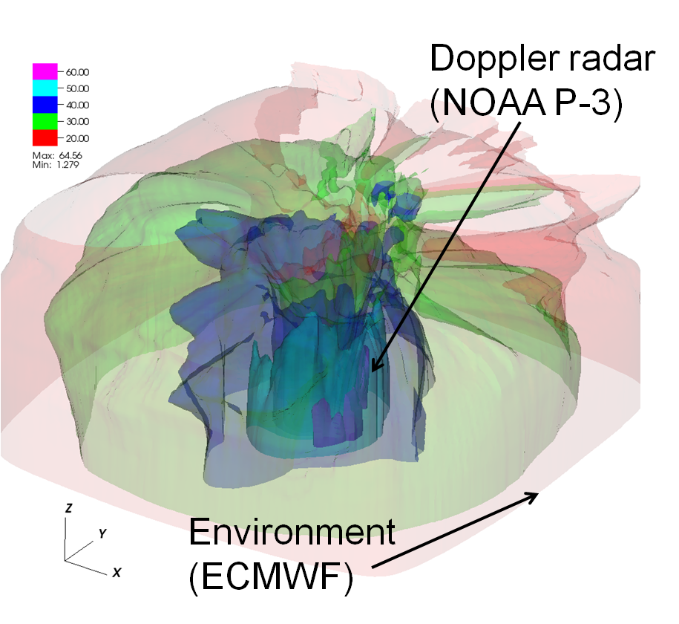

Figure 1. A 3D depiction of the merged vortex used to initialize Hurricane Guillermo into HIGRAD. Shown are isosurfaces of wind speed (m s-1) with opacity scaling that allows a view of the inner core of the storm (from Doppler radar analyses) as well as the blending into the environment (from ECMWF analyses). The grid volume is storm-centered and shows an inner portion (roughly 500 km on each side) of the full model domain and up to 22 km in the vertical. See text for more details on the model grid.

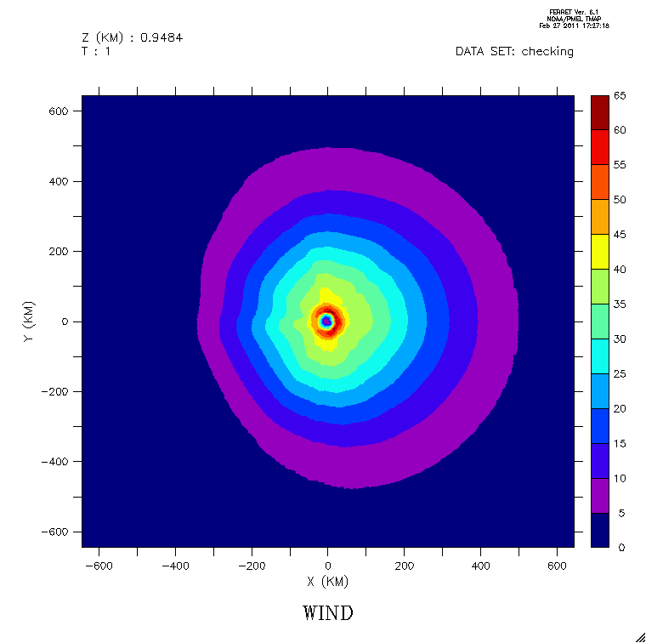

Figure 2. A horizontal cross section of the merged vortex used to initialize Hurricane Guillermo (1997) in HIGRAD showing wind speed at ~ 1 km altitude on the full model domain.

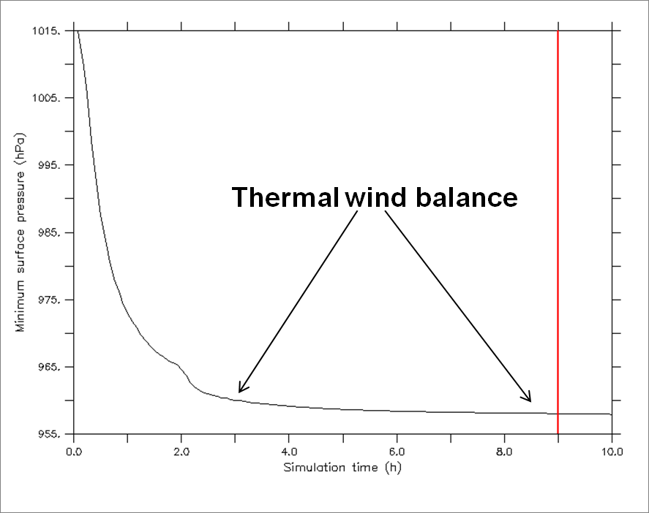

Figure 3. Time series of the minimum pressure in HIGRAD for the dynamic initialization of the merged Guillermo vortex. The vertical line at 9 h marks when the initialization was stopped and the nudging coefficient set to zero.

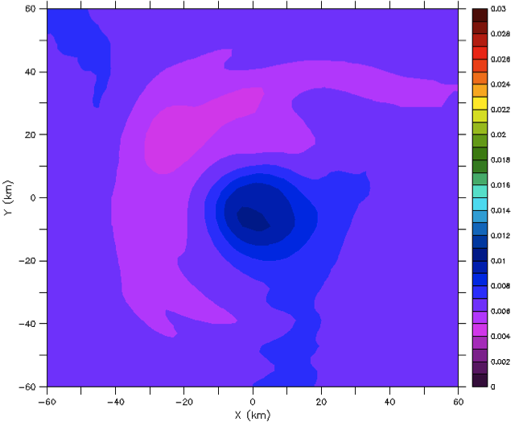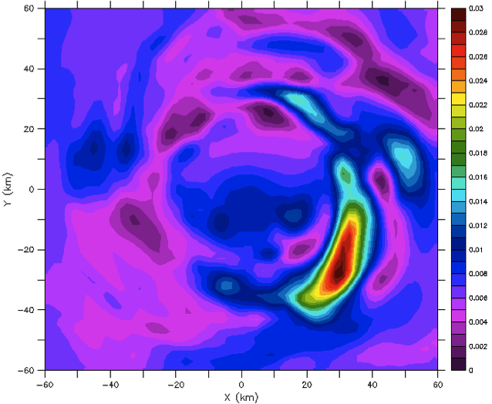

**(a)**

**(b)**

Figure 4. Horizontal cross sections of water vapor mixing ratio (kg kg-1) at 5 km height after (a) 9 h of the dynamic initialization (nudging) procedure and (b) 10 minutes of observational moisture forcing (see eq. 6) added after the 9 h nudging period. Only the inner part of the model domain that corresponds to the Doppler analysis is shown.

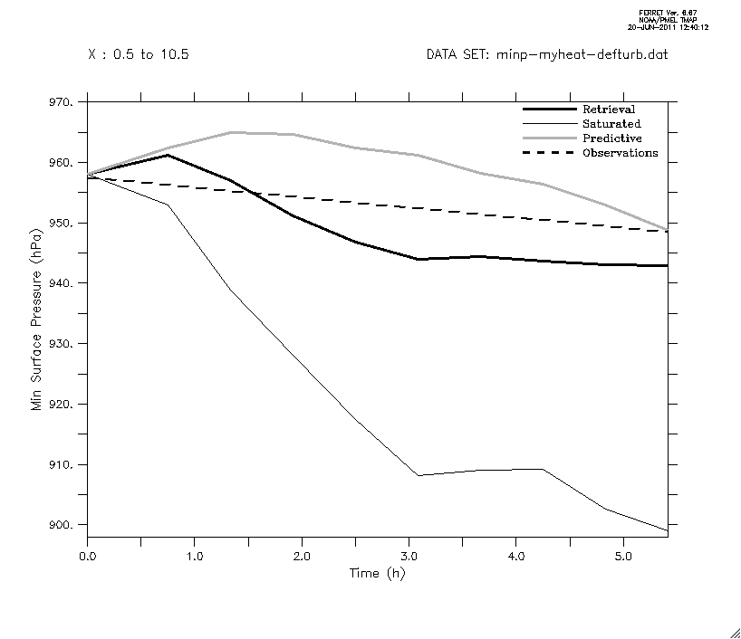

Figure 5. Time series of minimum surface pressure (hPa) for the Guillermo numerical simulations discussed in section 2. Values are plotted for all ten aircraft composite times (see Table 1 in Reasor et al. 2009) with 0 h representing the spun-up, merged vortex of Guillermo. The thick, black line is the retrieval run, the thin, black line is the saturated run and the gray line is the predictive run. The dashed line shows the observations from the NHC interpolated to the aircraft times.

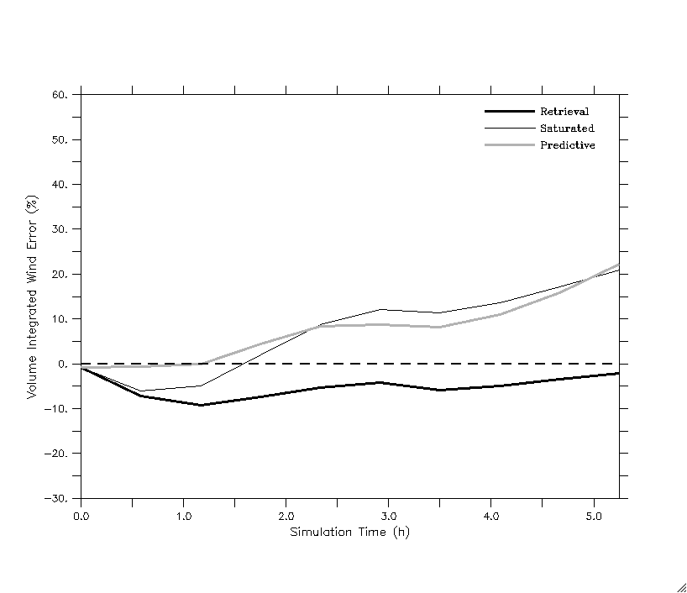

Figure 6. Time series of model simulated wind speed errors relative to Doppler radar observations, computed according to (8). The dashed line highlights zero error. All other lines are described in the legend.

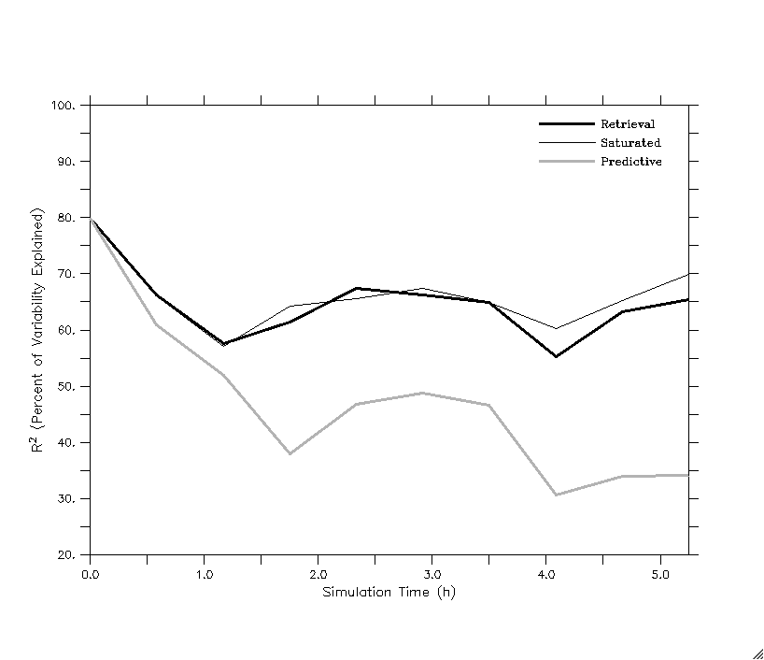

Figure 7. Time series of the square of the correlation coefficient (a measure of how well the model simulations capture the variability in the observations) expressed as a percentage for the simulated wind speed relative to the Doppler radar observations. See legend for simulation name.

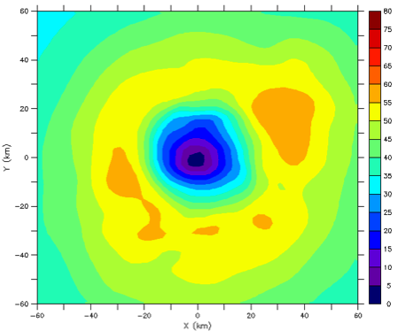

**(a)**

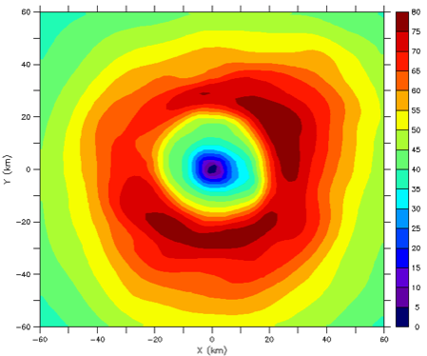

**(b)**

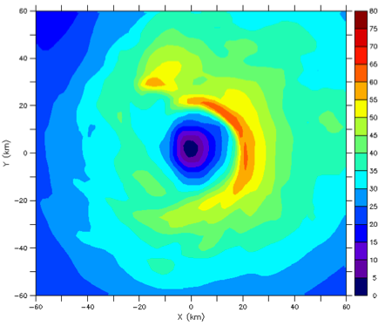

**(c)**

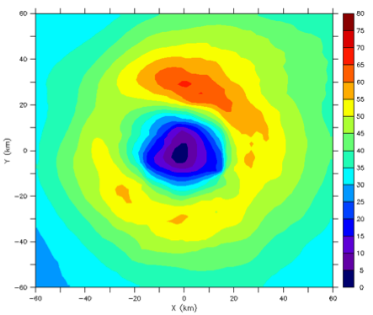

**(d)**

Figure 8. Horizontal cross sections of Guillermo’s wind speed (m s-1) at 1 km height after 3.5 h of simulation for (a) the retrieval run, (b) the saturated run and (c) the predictive run. Panel (d) shows the Doppler radar observations at 2225 UTC 2 August 1997 at which time the simulations are valid. Only the inner part of the model domain that corresponds to the Doppler analysis is shown.

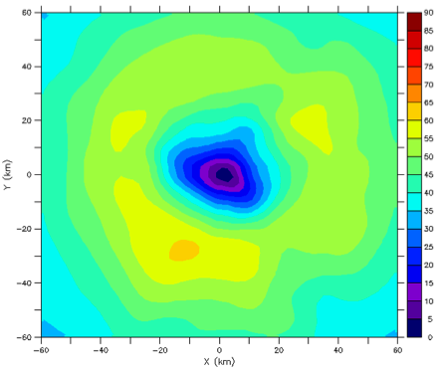

**(a)**

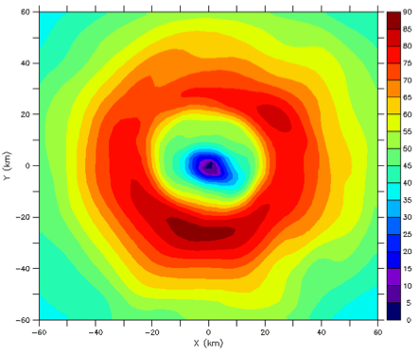

**(b)**

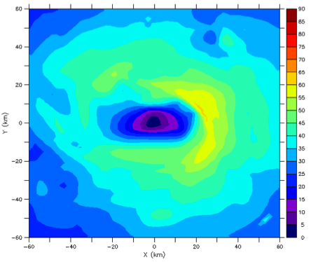

**(c)**

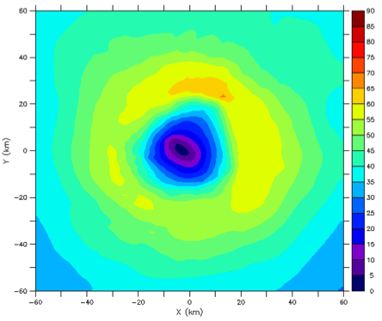

**(d)**

Figure 9. Same as in Fig. 8 only at 5.25 h into the simulations for (a), (b) and (c) with the Doppler radar analysis in (d) at 2404 UTC 3 August 1997. Note the extended color scale relative to Fig. 8.

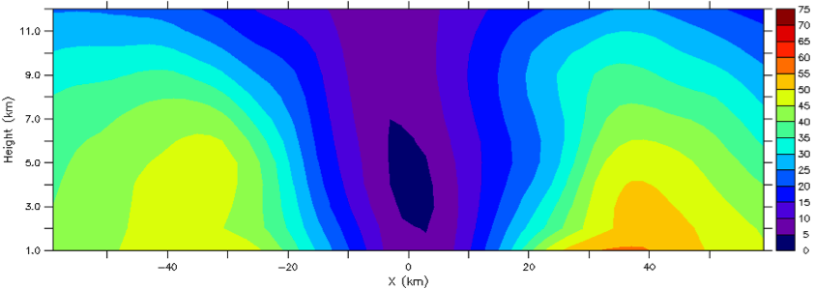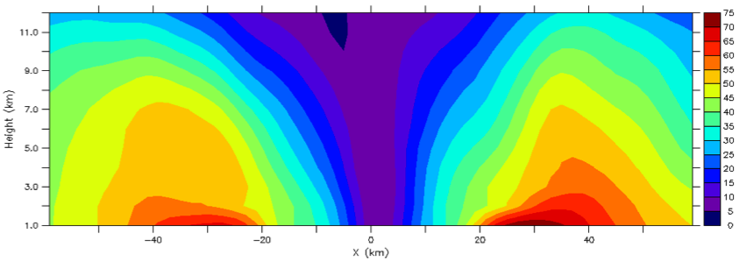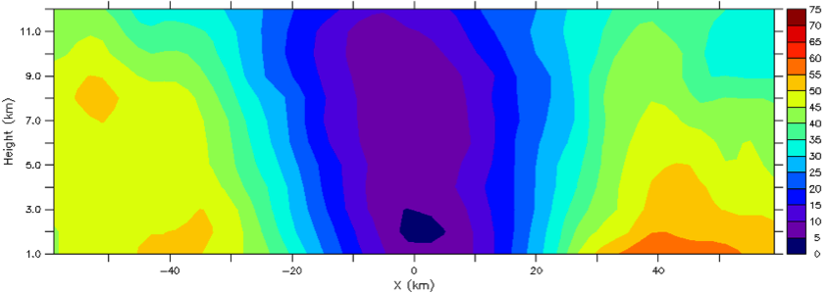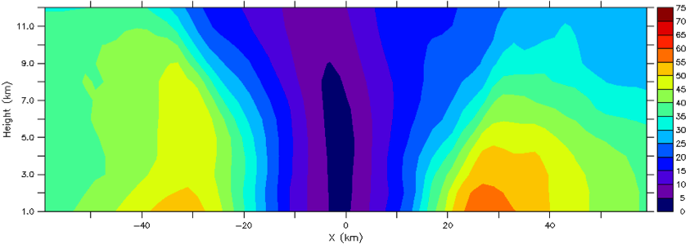

(a)

(b)

(c)

(d)

Figure 10. Time averaged vertical cross-sections (at y = 0) of wind speed (m s-1) between 1 – 12 km height for the inner part of the model domain that corresponds to the Doppler radar observations. (a) the retrieval run, (b) the saturated run, (c) the predictive run and (d) the Doppler radar observations.

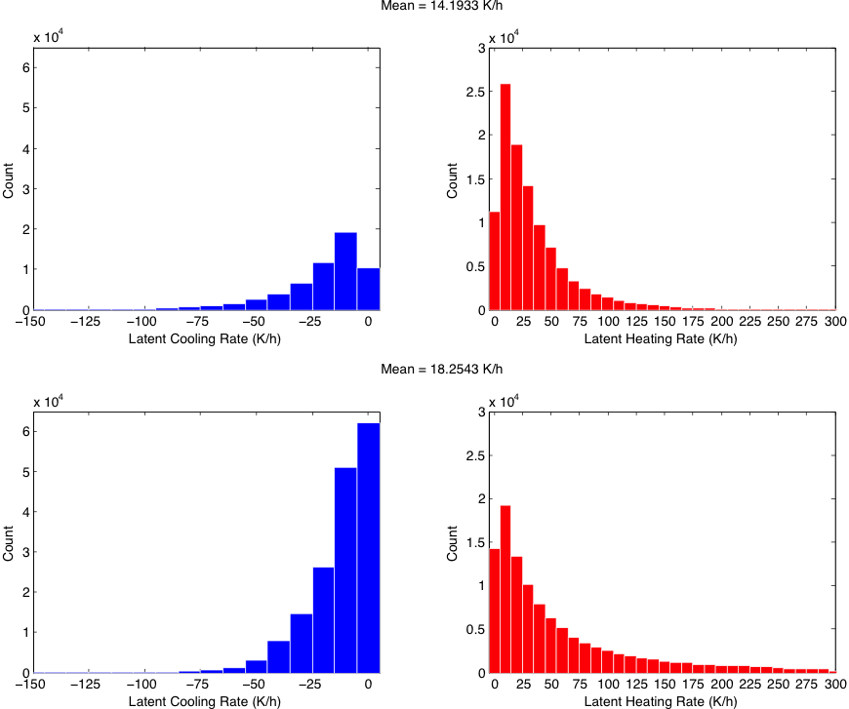

**(b)**

**(d)**

**(c)**

**(a)**

Figure 11. Histograms of latent cooling and heating rates from the latent heat retrievals in (a) and (b) and the predictive simulation in (c) and (d). Note the different y-axis scale in the heating figures. The data shown here for the latent heat retrievals and predictive run incorporates values over the radar portion of the domain (120 km in horizontal and 1 – 10 km in vertical) for several snapshots in time corresponding to the Doppler radar composite periods shown in Table 1 of Reasor et al. (2009). Note that the first Doppler composite was used to spin-up Guillermo so data here are shown for the other nine periods, which covers ~ 5.25 hours of the predictive run model simulation. Latent cooling/heating rates less than 0.25 K h-1 are not shown in the figure so visual comparisons are more meaningful. The mean values displayed above each set of data incorporate all latent heating and cooling values.

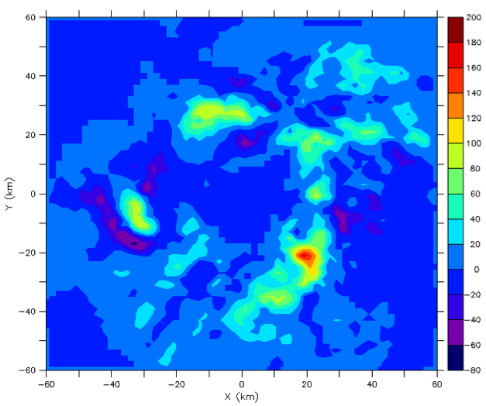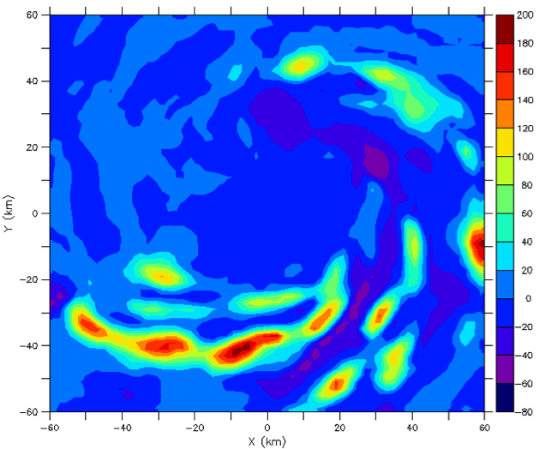

**(a)**

**(b)**

Figure 12. Horizontal cross-sections of latent heating rate (K h-1) averaged over a 1 – 5 km layer for the (a) retrievals (observations) at 2225 UTC 2 August 1997 and (b) predictive simulation at 3.5 h (valid at observation time).

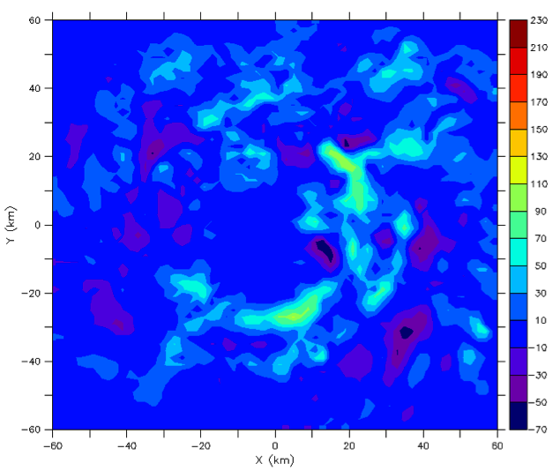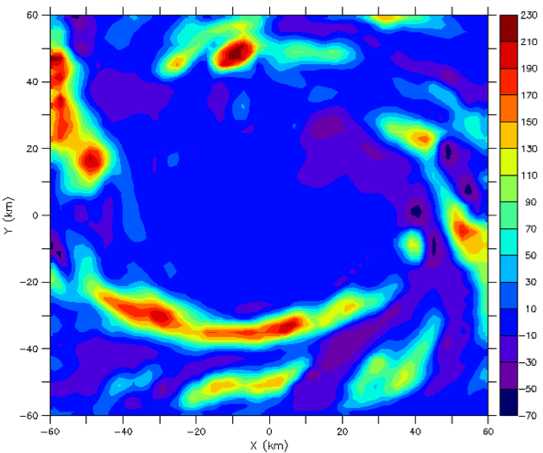

**(a)**

**(b)**

Figure 13. Horizontal cross-sections of latent heating rate (K h-1) averaged over a 1 – 5 km layer for the (a) retrievals (observations) at 2333 UTC 2 August 1997 and (b) predictive simulation at 4.5 h (valid at observation time).

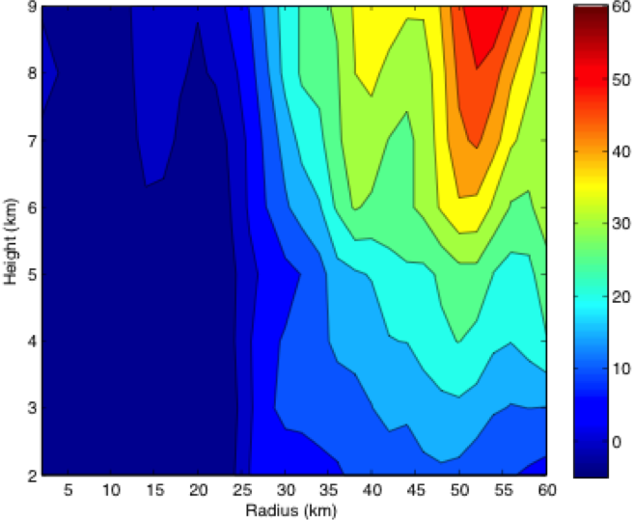

(b)

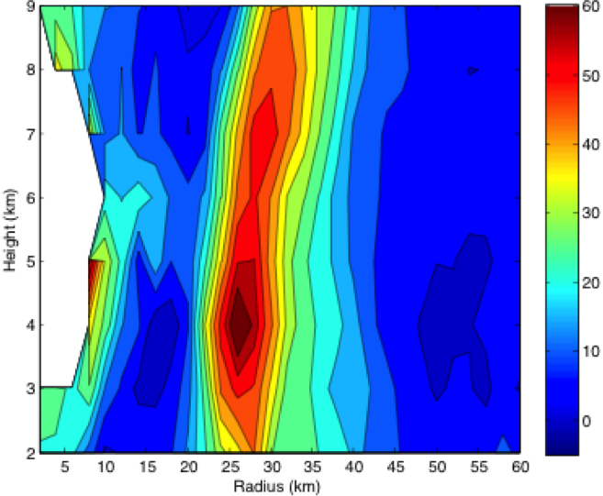

(a)

Figure 14. Azimuthal and time mean latent heating/cooling (K h-1) from (a) the latent heat retrievals and (b) the predictive simulation. Note that zero values were removed from the data before the averaging was performed.