Evolution of Hurricane Dennis from the ER-2

In this chapter, we examine time-coincident data from three instruments onboard the ER-2, the across-track scanning Advanced Microwave Precipitation Radiometer (AMPR), the High-Altitude MMIC Sounding Radiometer (HAMSR), and the X-band, dual-beam ER-2 Doppler Radar (EDOP). Since these observations are not accompanied by associated radiative transfer and radar modeling, the analysis will be more of a qualitative nature aimed towards understanding the microphysical and dynamical evolution of Hurricane Dennis.

- Instrument description.

Figure 1 depicts the configuration and coverage capabilities of each of these instruments during TCSP. For both the AMPR and HAMSR, the on-Earth swath width is 40-km. However, for channels whose effective altitude response originates at higher altitudes (e.g., 10-km), the effective swath width is closer to 20-km, as noted in Figure 1.

The AMPR is 4-channel radiometer with window channels centered at 10.7, 19.35, 37.1 and 85.5 GHz. With an ER-2 flight speed of 200 m s⁻¹ at 20-km altitude, the scanning rate (50 samples scan⁻¹) provides contiguous 85 GHz imagery with a resolution of 700-m, nearly 20 times finer than the SSMI. As a consequence of their larger beamwidth, the lower frequency channels (e.g, 2.8-km at 10 GHz) produce overlapping samples. The receive polarization state at nadir is linear 45º and changes from fully horizontal polarization (H) at the scan start to fully vertical polarization (V) at the scan end. This results in a polarization mixing across the scan, but within ±15 degrees of nadir the polarization state of the AMPR is relatively constant at 45º linear (Vivekanandan et. al, 1993). The AMPR has a long lineage, participating in 14 coordinated field experiments since 1990. These include the Convection and Moisture Experiment (CaPE) (Vivekanandan et. al, 1993; Turk et. al, 1994), TOGA-COARE (McGaughey et. al, 1996), and many of the Convection and Moisture Experiments (CAMEX) (Kakar et. al, 2006), among others. Since these AMPR observations respond to the presence of liquid and ice hydrometeors, they are useful for examining the performance of mesoscale prediction models in representing the observed microphysical cloud structure (McFarquhar et.al, 2006).

The HAMSR has 25 channels total; eight within the 5-mm (60 GHz) O₂ band and ten surrounding the 118.75 GHz O₂ resonance (both used for tropospheric temperature sounding), and seven channels near and within the H₂O (water vapor) absorption band between 166 to 183.31 GHz, used for tropospheric moisture sounding (Lambrigtsen et. al, 2002). The 60 and 183 GHz bands are similar to corresponding channels on the Advanced Microwave Sounding Unit (AMSU) and Microwave Humidity Sounder (MHS) onboard the NOAA and METOP satellite platforms, respectively. Similar to the AMPR, HAMSR scans across-track (15 samples scan⁻¹), with a nadir resolution of 2-km and 1-km across-track (250-m along-track) pixel spacing. Since precipitation alters the response of the 183 GHz channels compared to their rain-free values, these channels have been investigated for improvements to precipitation retrieval techniques (Bennartz and Bauer, 2003; Staelin and Chen, 2000). Also, owing to the greater sensitivity to clouds and precipitation at 118 GHz compared to 60 GHz, channels within the 118 GHz O₂ complex are also responsive to the vertical structure of precipitation-sized hydrometeors (Gasiewski et. al, 1990).

b) ER-2 missions dedicated to Hurricane Dennis.

Although the focus area for TCSP was planned to be the Eastern Pacific, the unusually early genesis of tropical disturbances in the Eastern Caribbean prompted three ER-2 missions dedicated to the formation and evolution of Hurricane Dennis, depicted in Figure 2, where the ER-2 flight tracks are overlaid on nearby-time 85 GHz passive microwave imagery from the Special Sensor Microwave Imager (SSMI) onboard the DMSP polar-orbiting satellites. The first overpass occurred on July 5 (Figure 2a). In order to sample the developing circulation from different wind directions, a coordinated ER-2/P-3 “Figure-4” pattern was flown, with a downwind leg from 2120-2149 UTC. On July 6, the takeoff of the P-3 was delayed, allowing the ER-2 to fly repeated overpasses from different directions beginning at 2144 UTC (Figure 2b). The P-3 arrived on station near 0040 UTC on July 7 and two coordinated ER-2/P-3 overpasses were made until the ER-2 departed the area. On July 9, while Dennis was in a re-intensification phase after crossing Cuba, the ER-2 flew two E-W and two W-E solo straight-leg overpasses between 1330-1500 UTC, directly over the eye (Figure 2c). In each panel of Figure 2, 85 GHz SSMI brightness temperatures (T_{B}) less than ~200 Kelvin indicate radiometrically cold upwelling thermal emission representative of convective clouds. In the following section, we will specifically focus on the analysis of the data from the four ER-2 overpasses on July 9.

c) AMPR and HAMSR Observations from July 9.

The four ER-2 overpasses from July 9 (Figure 2c) are displayed in the four panels of Figure 3 by twelve-minute flight segments of the 85-GHz AMPR imagery, remapped on top of nearby-time visible satellite imagery from GOES-12. The small black dot at the center of each panel represents the low pressure center, and the circle depicts the 25-km radius of maximum winds during this time. Each overpass takes place approximately 25 minutes after the previous overpass. Pass 1 occurred between 133455-134645 UTC, Pass 2 between 140221-141411 UTC, Pass 3 between 142154-143343 UTC, and Pass 4 between 145011-150201 UTC.

The key feature is a band of heavy convection located on the east side of the radius of maximum winds, which begins to organize during the first two overpasses (Figures 3a and 3b). By the third overpass, this same area of deep convection has rapidly intensified and begins to take on the shape of an incomplete eyewall along the SE side, with 85 GHz T_{B} values falling near 100 K, then warms to 150 K with more symmetrical eyewall development along the E and W sides.

To investigate this feature further, each panel of Figure 4 displays imagery from all four AMPR channels and a selection of HAMSR channels for each of these four overpasses. From top to bottom, the four AMPR channels are depicted, followed by channels 9-14 (118 GHz band) and 19-25 (183 GHz band) from HAMSR. The response of the AMPR channels to tropical rainfall has been well-documented in many published studies (Vivekanandan et. al, 1993, and many others) and is briefly summarized here. In general, for precipitation and clouds the 10 and 19 GHz data exhibit T_{B} warming against the radiometrically cold ocean background. The across-track polarization twist of the AMPR is also noticeable in the 10 GHz imagery, where over clear sky the T_{B} gradually warms (or cools, depending upon flight direction) in the across-track direction. 37 GHz imagery is double-valued, since similar T_{B} depressions can result from regions of no precipitation (water vapor radiometrically warms of the radiometrically cold ocean) and precipitation (frozen hydrometeor scattering processes radiometrically cools the radiometrically warm upwelling emission). At 85 GHz, the surface is nearly masked and water vapor emission alone is sufficient to maintain the 85 GHz T_{B} near 260 K. The increased scattering cross section (albedo exceeding 0.9) of precipitation-sized (1 mm and greater) ice further enhances the scattering efficiency at 85 GHz, resulting in 85 GHz T_{B} depressions, the magnitude of which depends upon ice particle size, density, and vertical extent (McGaughey et. al, 1996) and the vertical profile of cloud liquid water and water vapor (these purely absorbing species reduce the overall scattering albedo). Owing to its sub 1-km horizontal resolution, the 85 GHz AMPR channels captures fine-scale convective features and T_{B} values near or below 100 K have been noted in several analyses.

Unlike previous ER-2 data analyzed from CAMEX-3 (Hood et. al, 2006) and TOGA-COARE (Turk et. al, 1998), these convective-induced 85-GHz T_{B} scattering depressions are not accompanied by significant depressions at 37 GHz. The only notable 37 GHz scattering depression (220 K) occurred during the third overpass (third panel from the top in Figure 4c). A side effect of a cross-track scanning instrument such as AMPR is that precipitation features can appear displaced nearer to the scan edge, depending upon frequency and cloud geometry. The location of the convective region noted in the 85 GHz image of Pass 3 (fourth panel from the top of Figure 4c) lying along the southern edge of the eyewall lies further to the south (and mostly outside of the swath) than the same feature in the 10 GHz image. This could result from an outward tilting eyewall (tilted towards the south) such that off-nadir scans are responding to lower altitude emission at 10 GHz, but the higher-level ice hydrometeors from the tilted eyewall are not sampled until several scans later. Further evidence of this can be seen in the asymmetric nature of the inner eye as seen in the 37 GHz image of Pass 3 (third panel from the top in Figure 4c). In this case, some AMPR scans sample the lower part of the tilted eyewall (near 260 K) while other sample the surface inside of the eyewall (near 220 K). Evidence of tilted eye structures have been noted in other passive microwave observations. Turk et. al. (2005) simulated the fore and aft viewing capabilities of the WindSat 37 GHz channel under cases of known shear in tropical cyclones, and found similar features in the simulated 37 GHz imagery. From further analysis of these four overpasses, it appears that the eyewall is most strongly sheared to the south-southeast near the time of Pass 3. By the time of Pass 4 (25 minutes later), the eyewall has developed convection on the west side and the convection to the south is outside of the AMPR swath, and the structure in the 37 GHz image appears more symmetric.

The vertical weighting functions of HAMSR channels 9-14 peak between the surface and 400 hPa, respectively (channels 15-18 peak higher, between 250 and 40 hPa and are not shown here). While the clear-sky values of these six channels does not vary much in less cloudy areas (see left side of Figures 4a-4d before the ER-2 entered the eyewall area), they are significantly effected by the presence of scattering processes, similar to the 85-GHz AMPR channel. The difference is that the 85 GHz channel lies in a window channel where the oxygen absorption is weak and the main gaseous absorption is from the water vapor continuum, but the scattering-induced T_{B} depressions in this selection of 118 GHz channels are arising from stronger absorption within the sharp oxygen line (Gasiewski et. al, 1990). HAMSR channel 9, centered 5.5 GHz below 118.75 GHz, lies on the far lower wing of the 118.75 GHz O₂ line and is therefore similar in appearance to the nearby 85 GHz AMPR channel for all ER-2 overpasses (fourth and fifth panels from the top in all four overpasses of Figure 4). As the HAMSR channels move closer to 118.75 GHz, the stronger O₂ absorption at higher altitudes gradually begins to lower the overall ice scattering albedo. For HAMSR channel 14 centered 1.2 GHz below 118.75 GHz (the tenth panel from the top of Figure 4), only the regions of strongest convection exhibit T_{B} depressions against the background, especially for Pass 3, which suggests that the total ice water path extends higher than the 400 hPa pressure level.

For HAMSR channels 20-25 (channel 19 at 166 GHz is 17 GHz below the 183.31 GHz H₂O line), the vertical profile of water vapor is superimposed upon the vertical hydrometeor profile. The magnitude of the T_{B} depression at each of these channels depends upon the reduction in single scattering albedo owing to the purely absorbing water vapor. Since the surface is mostly opaque in these channels, it is difficult to see any evidence of shear in these HAMSR data. They do show the vertical motion which elevates the ice hydrometeors to the upper level of the hurricane are most apparent during Pass 3, and that this region is confined to a very small region of the eyewall. Analysis of the EDOP vertical radar reflectivity profile during Passes 3 and 4 is shown in Figure 5. This shows that the regions of 85 GHz T_{B} near 100 K in Pass 3 are associated with a narrow, elevated column of hydrometeors extending past 15 km elevation. By the time of Pass 4, this same column extends to only 7 km.

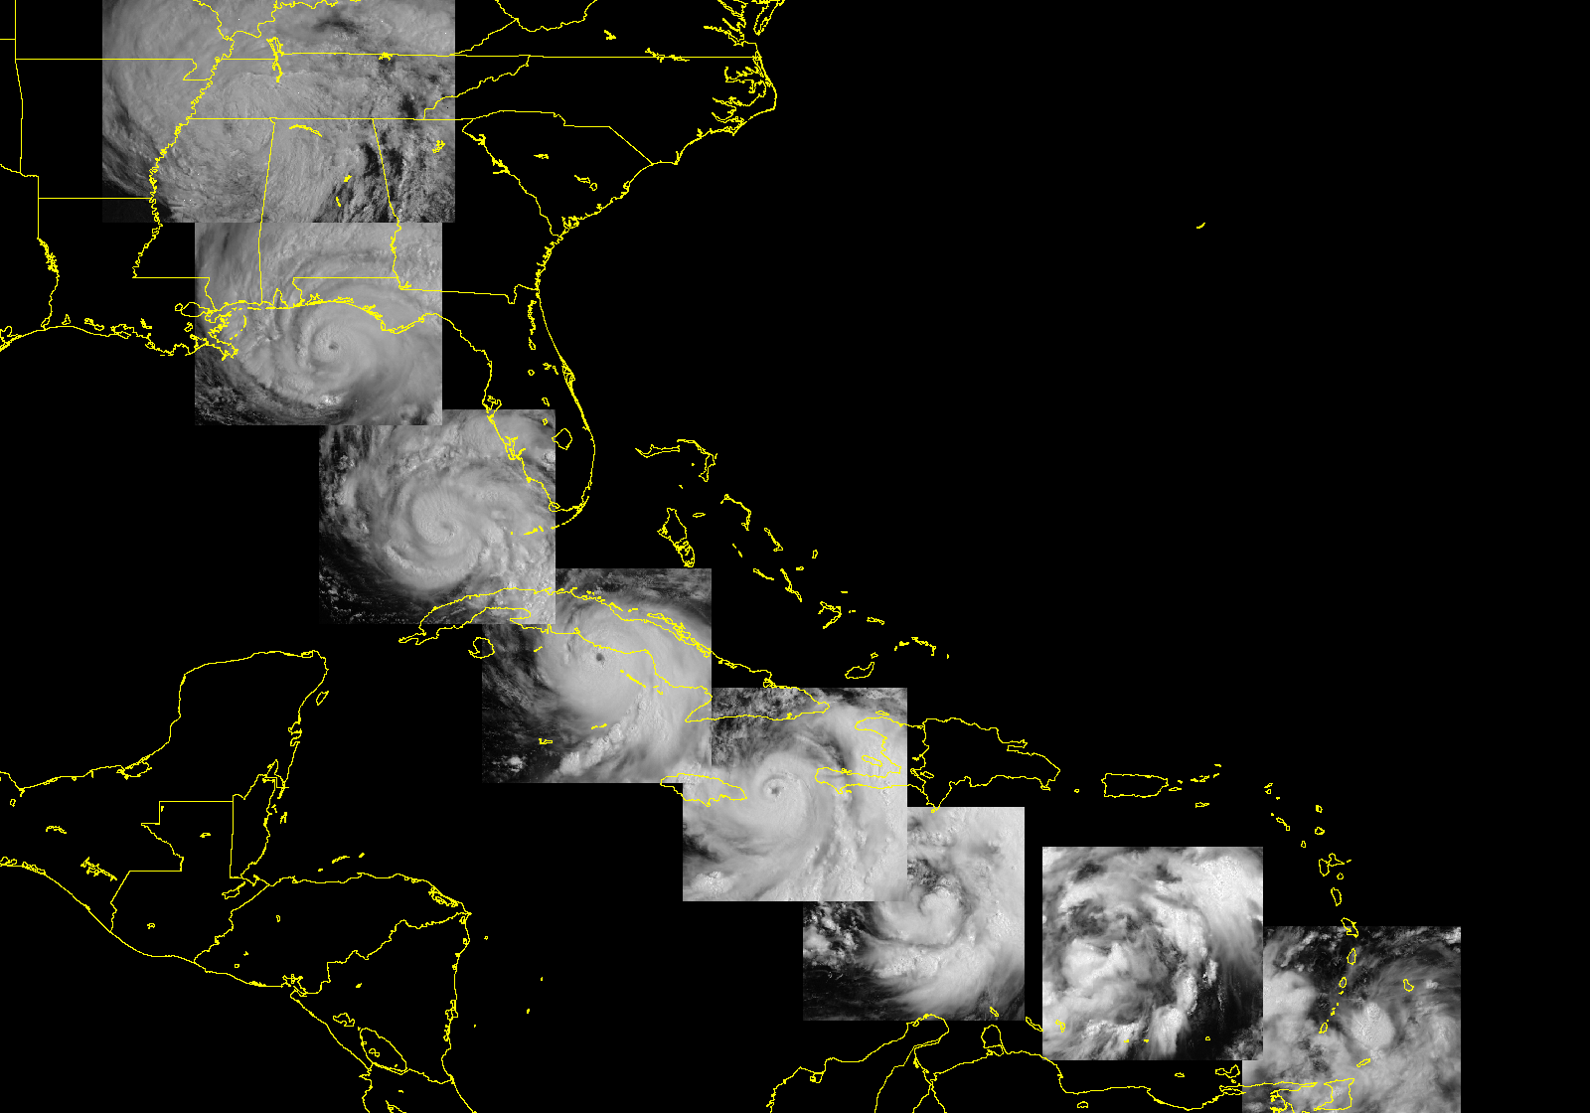
July 4 18Z: Organizes into Tropical Depression 4 near Grenada
July 5 12Z: Strengthens into Tropical Storm Dennis
July 6: Continues to intensify to 60-kts max
July 7 0Z: Reaches hurricane strength and begins a 24-hour period of very rapid intensification
July 8 03Z: Landfall with 120-kt winds, crosses Gulf of Guacanayabo and intensifies to 130-kts at 12Z, then begins to weaken to while crossing western Cuba
July 9 12Z: Moves over warm waters and begins its second rapid intensification phase
July 10 12Z: Reaches 120-kts, makes landfall at 20Z with 105-kts
Evolution of Hurricane Dennis
July 4 – July 11, 2005
July 11: Tropical depression moves N and heavy rainfall floods many parts of the Southeast

(Not used)

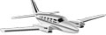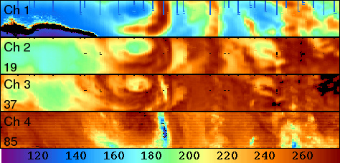
Flight subtrack
40-km swath width for AMPR/HAMSR channels sensing near the surface
NASA ER-2
20-km flight altitude
200 m/s airspeed
Advanced Microwave Precipitation Radiometer (AMPR) and High-Altitude MMIC Sounding Radiometer (HAMSR) scan across-track
NOAA WP-3D
5-km flight altitude
~100 m/s airspeed
X-band dual-beam ER-2 Doppler Radar (EDOP)
Fixed Nadir beam
Fixed 20º forward beam
~10 min ER-2 flight time =
120 km along-track
20-km swath width for AMPR/HAMSR channels sensing at 10-km

Figure 1. Configuration of the AMPR, HAMSR and EDOP instruments onboard the ER-2 aircraft during TCSP.

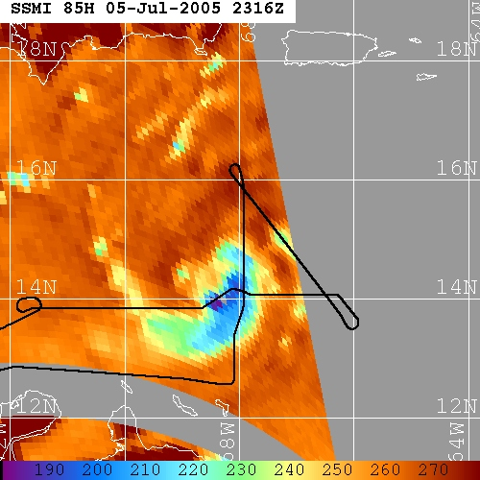
a) July 5 On-Station Pattern
ER-2 entry

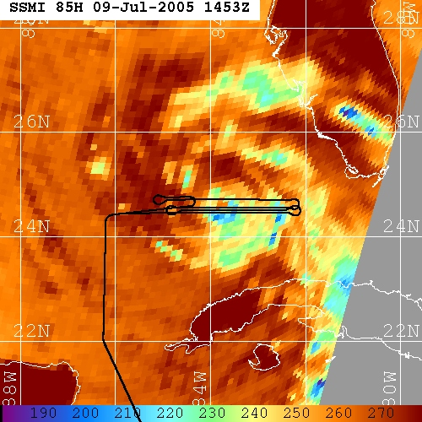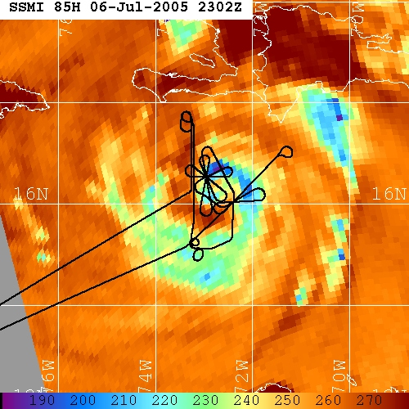
b) July 6-7 On-Station Pattern
c) July 9 On-Station Pattern
ER-2 entry
ER-2 entry

Figure 2. On-station ER-2 flight tracks for the three TCSP missions dedicated to the development and evolution of Hurricane Dennis, overlaid on nearby-time 85-GHz imagery from the SSMI. a) July 5. b) July 6-7. c) July 9.

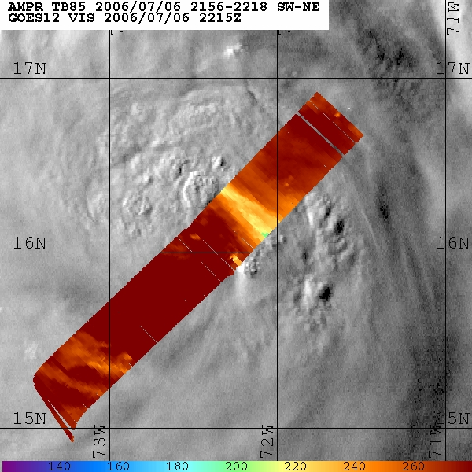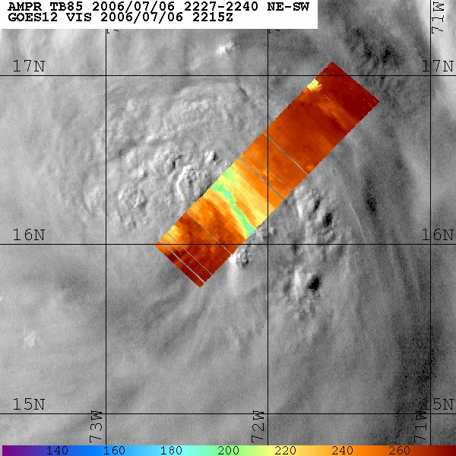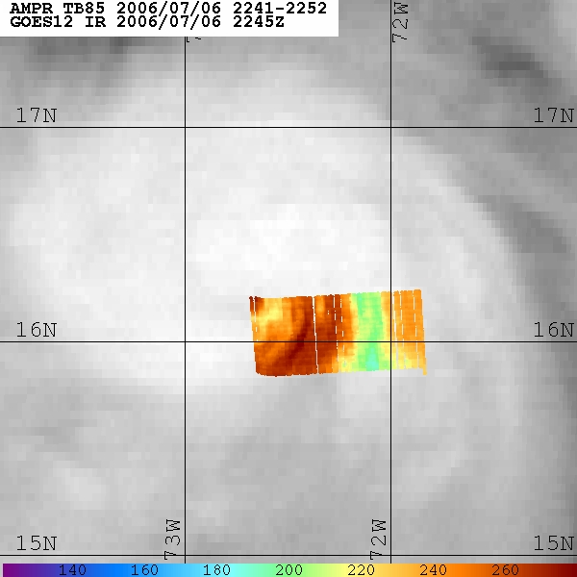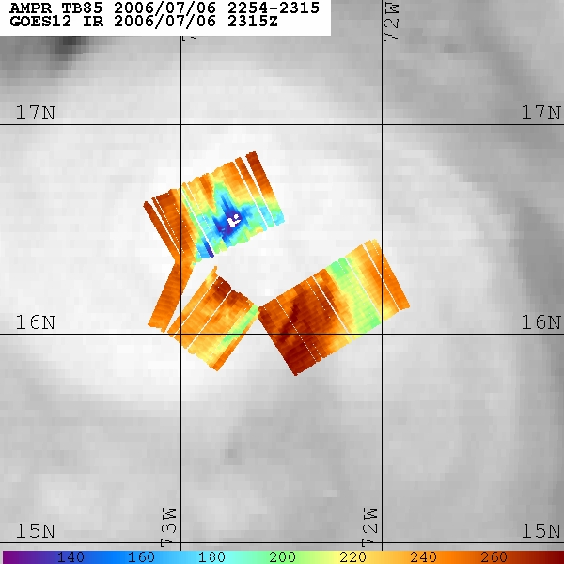
6 Jul 2213 UTC
6 Jul 2237 UTC
6 Jul 2245 UTC
6 Jul 2305 UTC
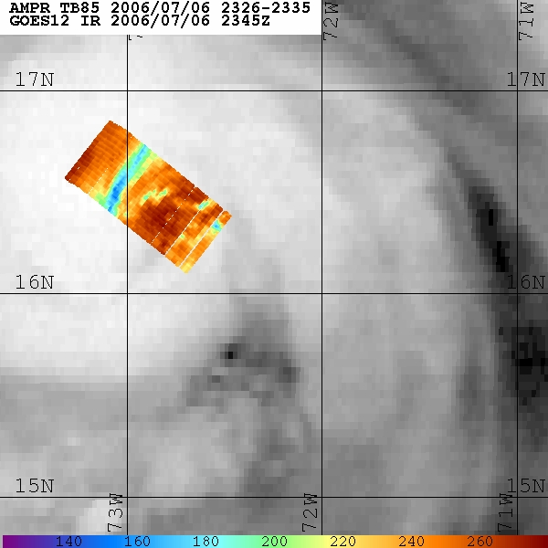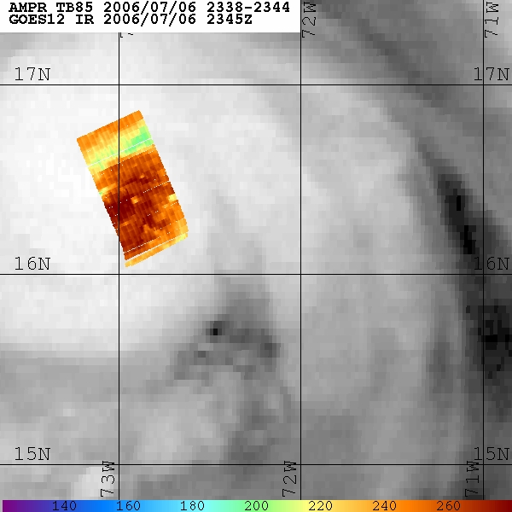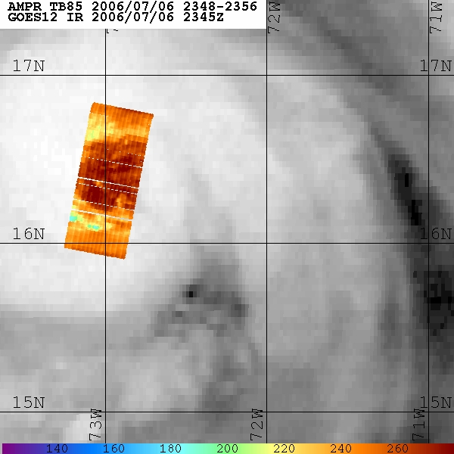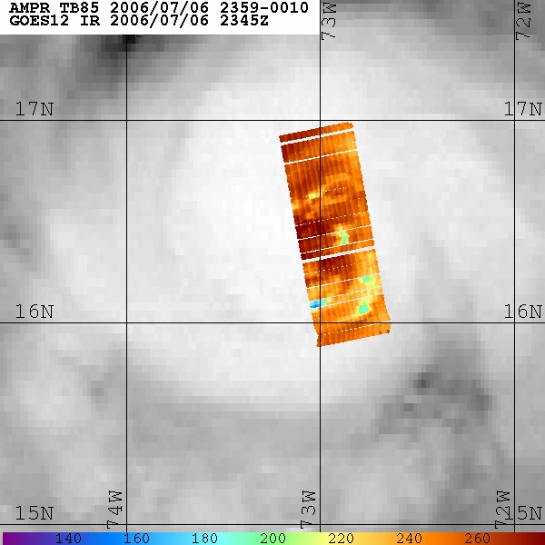
6 Jul 2330 UTC
6 Jul 2341 UTC
6 Jul 2351 UTC
6 Jul 0005 UTC
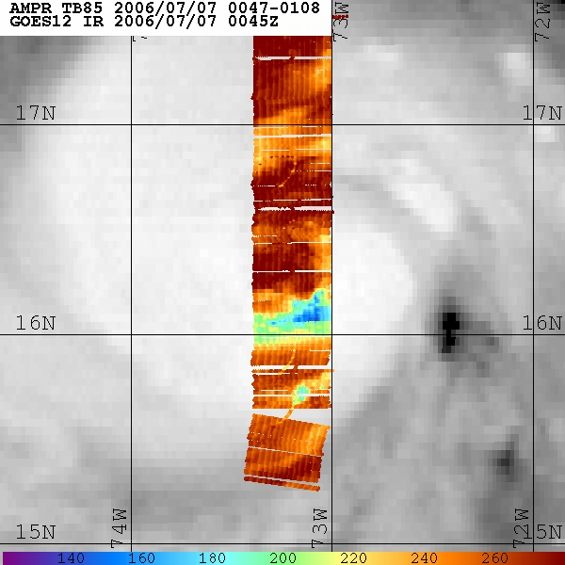
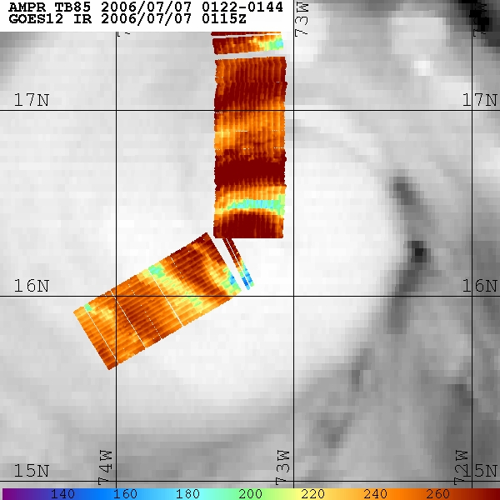
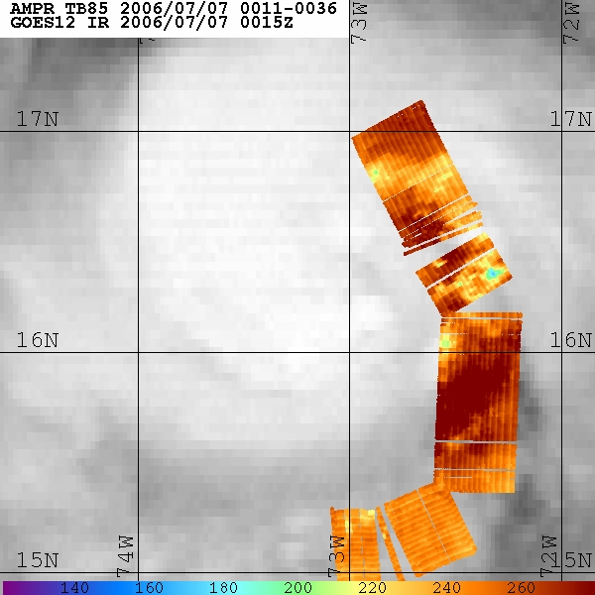
6 Jul 0020 UTC
6 Jul 0058 UTC
6 Jul 0130 UTC

(Not used)
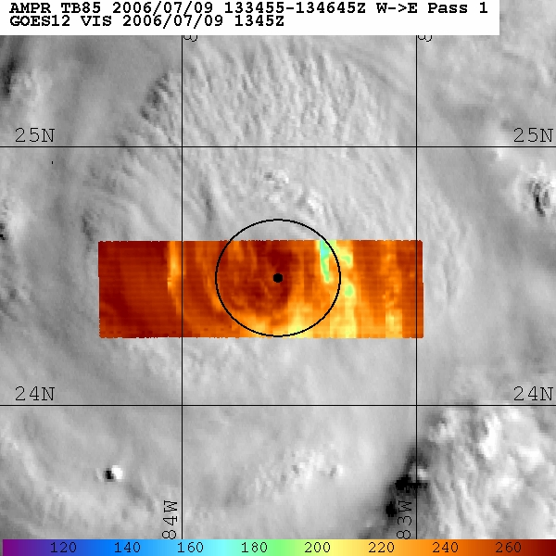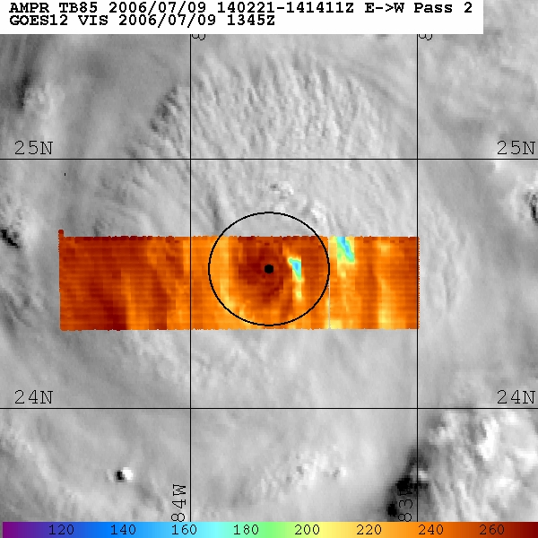

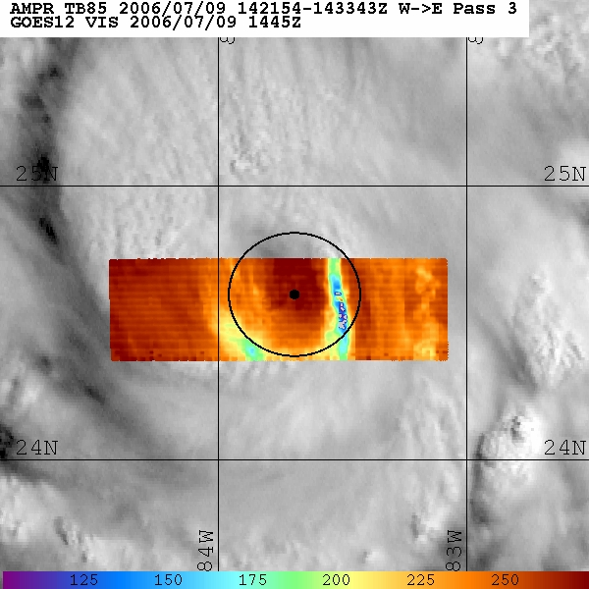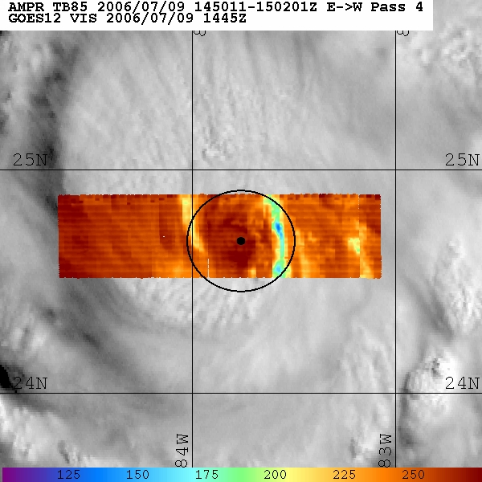

Figure 3. Twelve-minute flight segments of the 85-GHz AMPR imagery from the four ER-2 overpasses on July 9, overlaid on nearest-time visible satellite imagery from GOES-12. The small black dot at the center of each panel represents the low pressure center and the circle depicts the 25-km radius of maximum winds during this time. (a) Pass 1 from 133455-134645, (b) Pass 2 from 140221-141411, (c) Pass 3 from 142154-143343, (d) Pass 4 from 145011-150201.
AMPR July 9 Pass 1 AMPR July 9 Pass 2
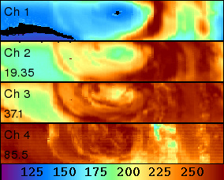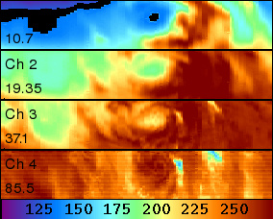

HAMSR July 9 Pass 1 HAMSR July 9 Pass 2
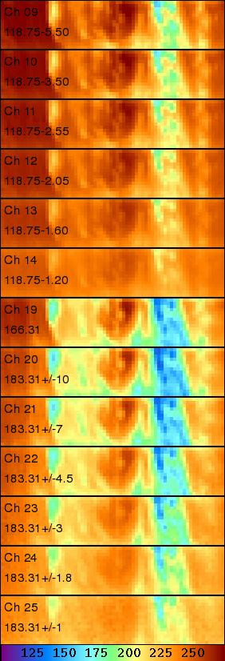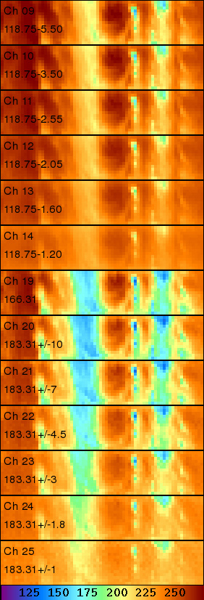
133455 Time 134645 140221 Time 141411
AMPR July 9 Pass 3 AMPR July 9 Pass 4
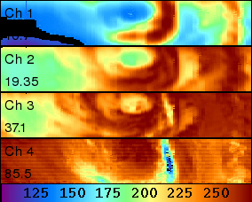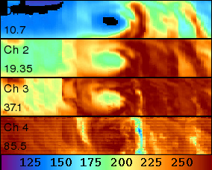

HAMSR July 9 Pass 3 HAMSR July 9 Pass 4
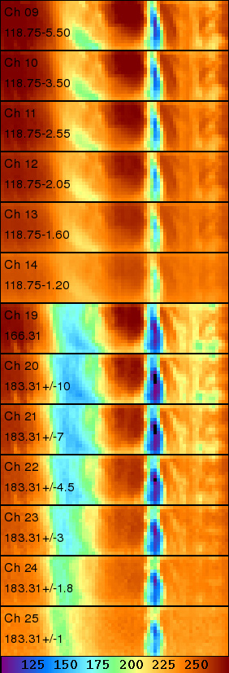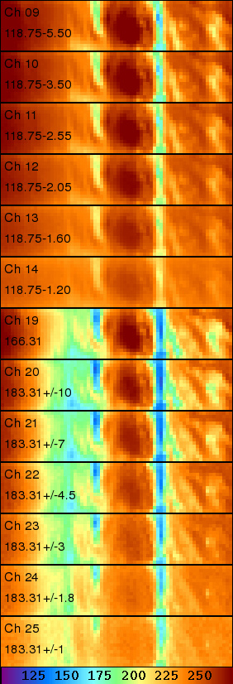
142154 Time 143343 145011 Time 150201
Figure 4. Segments of the AMPR and HAMSR imagery during the four ER-2 overpasses from Figure 3. For each overpass, the four AMPR channels are depicted, followed by channels 9-14 (118 GHz band) and 19-25 (183 GHz band) from HAMSR. (a) Pass 1 from 133455-134645, (b) Pass 2 from 140221-141411, (c) Pass 3 from 142154-143343, (d) Pass 4 from 145011-150201.

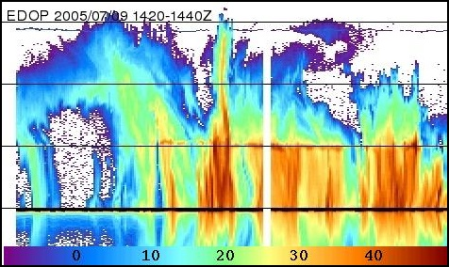

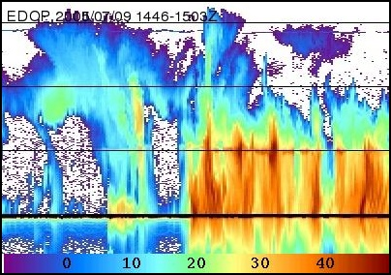

Figure 5. Nadir EDOP reflectivity profile (scale in dBZ units at bottom of image) from July 9 ER-2 pass 3 (top) and pass 4 (bottom). Gridlines are spaced 5-km in the vertical direction. The area below the solid black line represents the mirror-image return.
REFERENCES

Bennartz, R. and P. Bauer, 2003: Sensitivity of microwave radiances at 85-183 GHz to precipitating ice particles. Radio Sci., 38, 8075-8090.
Gasiewski, A.J. Barrett, J.W., Bonanni, P.G., and Staelin, D.H., 1990: Aircraft Based Radiometric Imaging of Tropospheric Temperature Profiles and Precipitation Using the 118.75 GHz Oxygen Resonance. J. Appl. Meteor., 29, 620-632.
Hood, R.E., D. Cecil, F.J. LaFontaine, R. Blakeslee, D. Mach, G. Heymsfield, F. Marks, Jr., E. Zipser and M. Goodman, 2006: Tropical cyclone precipitation and electrical field information observed by high altitude aircraft instrumentation. J. Atmos. Sci., 63, 218-233.
Kakar, R., M. Goodman, R. Hood, A. Guillory, 2006: An Overview of the Convection and Moisture Experiment (CAMEX). J. Atmos. Sci., 63, 5-18.
Lambrigtsen, B., and A. Riley, 2002: Microwave scattering observed in convective cells during CAMEX-4. 25th AMS Conf. Hurricanes Trop. Meteor., San Diego.
McGaughey, G., E. J. Zipser, R. W. Spencer, and R. E. Hood, 1996: High-resolution passive microwave observations of convective systems over the tropical Pacific Ocean. J. Appl. Meteor., 35, 1921–1947
Skofronik-Jackson, G.M. and J.R. Wang, 2000: The estimation of hydrometeor profiles from wideband microwave observations. J. Appl. Meteor., 39, 1645-1656.
Skofronik-Jackson, G.M., J.R. Wang, G. Heymsfield, R. Hood, W. Manning, R. Meneghini, J. Weinman, 2003: Combined radiometer-radar microphysical profile estimations with emphasis on high-frequency brightness temperature observations. J. Appl. Meteor., 42, 476-487.
Staelin, D., and F. Chen, 2000: Precipitation observations near 54 and 183 GHz using the NOAA-15 satellite. IEEE Trans. Geosci. Rem. Sens., 38, 2322-2332.
Turk, J., J. Vivekanandan, F.S. Marzano, R.E. Hood, R.W. Spencer, and F.J. LaFontaine,1994: Active and passive microwave remote sensing of precipitating storms during CaPE. Part I: Advanced Microwave Precipitation Radiometer and polarimetric radar measurements and models. Meteorology and Atmospheric Physics, Special Issue on Physical Retrievals of Hydrological Variables from Space-Based Microwave Instruments, v. 54 (1-4), p. 3-27.
Turk, J., F.S. Marzano, A. Mugnai, 1998: Effects of degraded sensor resolution upon passive microwave retrievals of tropical precipitation. J. Atmos. Sci., 55, 1689-1705.

Turk, F.J., S. Di Michele, J. Hawkins, 2005: Observations of tropical cyclone structure from Windsat. IEEE Trans. Geoscience Remote Sensing, 44, 645-655.
Vivekanandan, J., J. Turk, and V.N. Bringi, 1993: Comparisons of precipitation measurements by the Advanced Microwave Precipitation Radiometer and multiparameter radar. IEEE Trans. on Geosci. and Remote Sens., 31, No. 4, 800- 870.

