Latent Heating Uncertainty Estimation
Data is 4-D (x,y,z,t)
Concerned with deep convective cells, chose a sample of the latent heating fields with vertical velocity > 5 m/s.

The distribution…approximately lognormal.
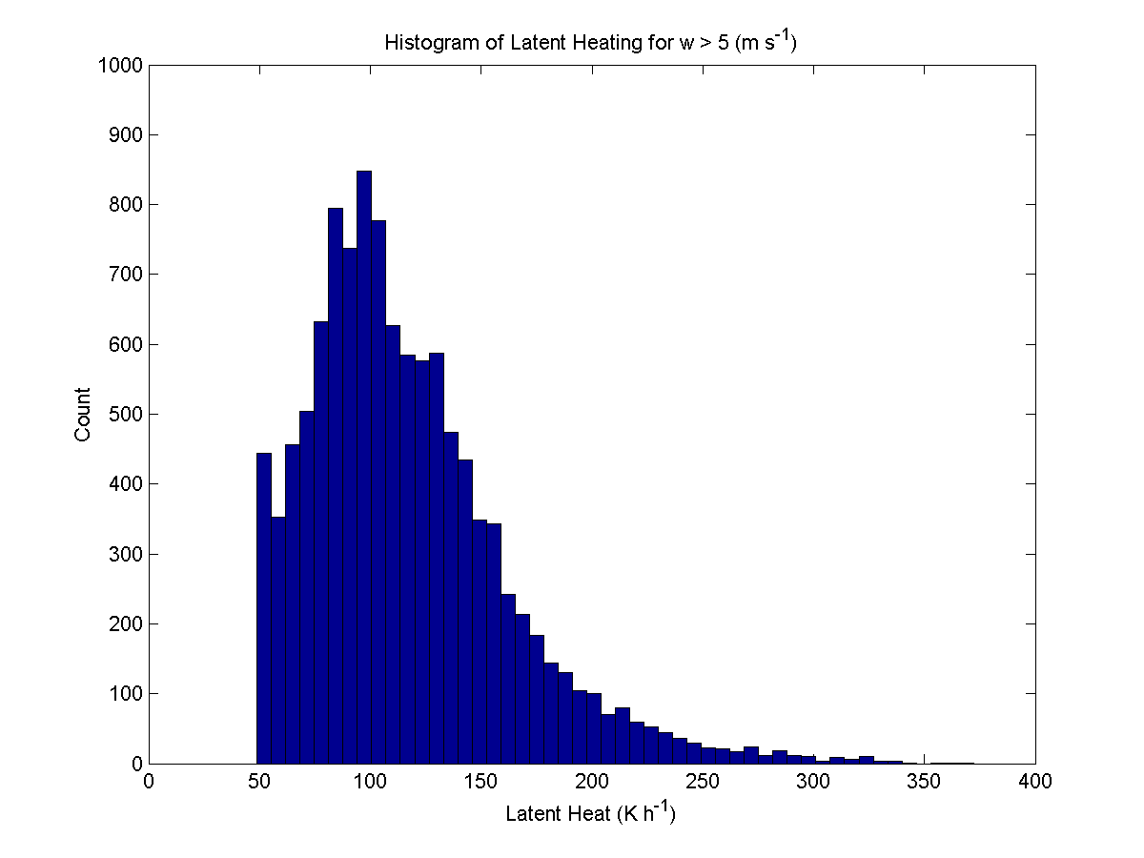
The arithmetic mean of this data (rounded to the nearest whole number) = 117 K/h. In order to estimate the uncertainty in this mean value, can utilize the bootstrap method (works for any distribution, but most often used for non-parametric datasets). Estimation of the uncertainty in the mean (including the bootstrap method) is sensitive to the degrees of freedom in the dataset. To estimate the degrees of freedom, I relied on a combination of statistical (auto-lag correlation) and physical reasoning. Auto-lag in time revealed that each point was independent by about 30 minutes (convective lifetime). One degree of freedom in the vertical was used at each point (column of atmosphere). Auto-lag on several convective cells in the x- and y-directions revealed an independent spatial scale of ~ 12 km in each direction (convective cell size in P-3 radar data).
Example lag correlation in x-direction. The y-axis is the zero-crossing in indice space (each indice is 2 km). The x-axis is the number of lags done along the x-direction.
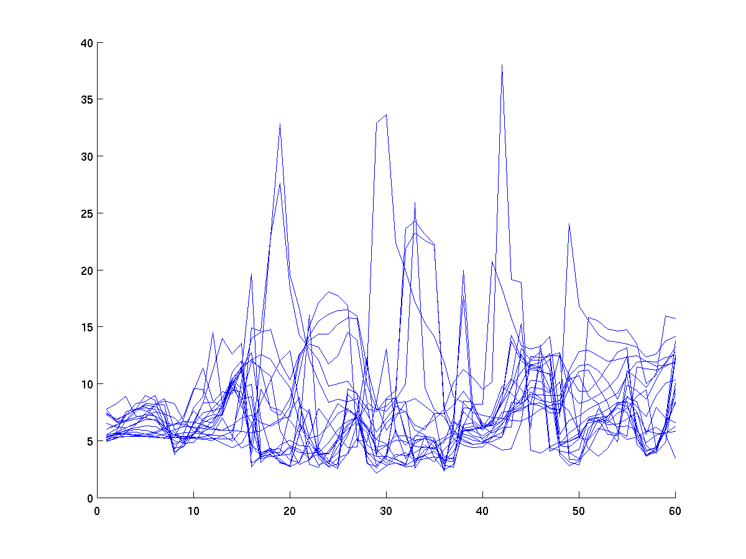
Number of degrees of freedom in total dataset: = 1000. The sample (w > 5 m/s) of data I took from the total dataset represents ~3% of the total sample, thus there are 30 degrees of freedom in my dataset. This means that there were ~30 independent deep convective cells in the Hurricane Guillermo (1997) P-3 dataset. This seems reasonable since there are not many deep convective cells seen in the vertical motion fields and there were more at the beginning of the time period. The small percentage occupied by the deep convective cells is consistent with other studies (i.e. 5%; Black et al. 1996).
Summary of final statistics, rounding to the nearest whole number…
Mean = 117 K/h
95% confidence intervals on the mean (lower, upper) = (101 K/h, 133 K/h). The ~16 K/h uncertainty represents 14 % of the mean value.

