A Proxy for High-Resolution Regional Reanalysis for the Southeast United States: Assessment of Precipitation Variability

Lydia Stefanova, Vasubandhu Misra, Steven Chan, Melissa Griffin, James J. O'Brien and Thomas J. Smith III

- Center for Ocean-Atmospheric Prediction Studies (COAPS), The Florida State University, Tallahassee, FL, USA
- Southeast Ecological Science Center, U.S. Geological Survey (USGS), c/o Gainesville, FL, USA
Abstract
A variety of practical applications, such as hydrological and ecological modeling, require high-resolution meteorological data sets. A crucial, yet notoriously difficult to model, component of such data sets is precipitation. Here, we present an analysis of the seasonal, subseasonal, and diurnal variability of rainfall from the COAPS Land-Atmosphere Regional Reanalysis for the Southeast at 10-km resolution (CLARReS10). Most of our analysis focuses on the representation of summertime subseasonal and diurnal variability. Summer precipitation in the Southeast is a particularly challenging modeling problem because of the variety of regional-scale phenomena, such as sea breeze, thunderstorms and squall lines, tropical storms, and hurricanes, which are barely resolved in coarse atmospheric reanalyses, but which contribute significantly to the hydrological budget over the region.
The National Centers for Environmental Prediction (NCEP) – Department of Energy (DOE) Reanalysis II (R2) and the European Centre for Medium-Range Weather Forecast (ECMWF) 40-year Reanalysis (ERA40) have been dynamically downscaled with the NCEP/Experimental Climate Prediction Center (ECPC) Regional Spectral Model (RSM). The downscaling has been performed over the Southeast United States at a horizontal resolution of 10 km for the period 1979–2001. The resulting regional reanalyses are compared to gridded observations and station data.
We find that the downscaled reanalyses show good agreement with observations in terms of both the relative seasonal distribution and the diurnal structure of precipitation. The spatial distribution of precipitation has a wet bias over most of the region. There are noticeable differences between the two simulations: CLARReS10-ERA40 (the downscaled ERA40) tends to be wetter than CLARReS10-R2 (the downscaled R2), and the diurnal precipitation maximum occurs earlier in the day in CLARReS10-ERA40.
- Introduction
The scientific community involved with the hydrological, ecological and biological modeling of the Earth system is showing a growing demand for reliable high-resolution meteorological data sets that provide fine spatial and temporal detail of near-surface variables. A conventional global or regional reanalysis is very resource-intensive. Furthermore, the degree to which the assimilation of observations, such as radiosondes, which are sparse in space and time, would be beneficial when reanalysis grids are approaching 10-km or higher resolutions is unclear.
This paper is devoted to examining the seasonal and boreal summer diurnal variability of precipitation in two regionally downscaled dynamical model integrations over the Southeast United States. The Southeast United States are of particular interest for such downscaling, given the large proportion of agricultural lands, endangered habitats, and large cities with water management concerns in the region. Precipitation, especially of convective nature, is one of the most challenging variables for any reanalysis. A high-resolution model is a necessary prerequisite for the accurate representation of convective precipitation in a region with complex coastal geometry.
The present work is motivated by a similar kind of model integration over California (Kanamitsu and Kanamaru 2007; Kanamaru and Kanamitsu 2007b), wherein it was shown that high-resolution downscaling from a coarse-resolution reanalysis produces regional features that are in encouraging agreement with station observations. Such dynamical downscaling is made viable by assuming that small scales are governed by the large-scale forcing and any feedback from the small to the large scales is insignificant. In fact, Kanamaru and Kanamitsu (2007b) showed that a regional model with high spatial resolution forced at the lateral boundaries by a realistic large-scale forcing is capable of generating features that are comparable, and in some instances an improvement, to the much more resource-intensive North American Regional Reanalysis (NARR; Mesinger et al. 2006). Von Storch et al. (2000) claimed that such dynamical downscaling analysis from a coarser reanalysis may be considered “a poor person’s data assimilation technique”, since it doesn’t require the direct assimilation of observations.
There has been a growing recognition that nudging the state variables toward the large-scale forcing can significantly reduce regional climate model drift in the interior of the regional domain (von Storch et al. 2000; Castro et al. 2005; Kanamaru and Kanamitsu 2007a). As a result, the large-scale analyses, such as the NCEP-NCAR reanalysis (Kalnay et al. 1996), the NCEP-DOE reanalysis II (hereafter R2; Kanamitsu et al. 2002) or the ECMWF’s ERA40 (hereafter ERA40; Uppala et al. 2006), can be downscaled continuously in time for the period of the available reanalysis without periodically reinitializing the regional model. This continuous dynamic downscaling from reanalysis is far less expensive than conventional data assimilation and provides meteorological data sets that are self-consistent (i.e., whose energy and water budgets are completely accountable; Kanamitsu and Kanamaru 2007).
Seasonal forecasts for the summer season in the Southeast United States present a significant challenge. Many of the seasonal prediction models exhibit extremely poor skill in precipitation and surface temperature forecasts over the region (Stefanova et al. 2011). A high-resolution model is essential in capturing the spatial and temporal distribution of rainfall in the region. Lim et al. (2010) showed that a downscaling of R2 with RSM at 20 km over the Southeast results in a reduced wet bias and a more realistic spatial pattern of summer precipitation, with improved spatial and temporal correlation of rainfall and reduced mean square error. In this paper, we present an analysis of the seasonal, subseasonal, and diurnal variability of rainfall from the COAPS Land-Atmosphere Regional Reanalysis for the Southeast at 10-km resolution (hereafter CLARReS10). The R2 (at a resolution of approximately 1.875 degrees latitude and longitude) and ERA40 (at a resolution of 2.5 degrees latitude and longitude) have been dynamically downscaled with RSM, resulting, respectively, in the CLARReS10-R2 and CLARReS10-ERA40 data sets. The downscaling has been performed over the Southeast United States at a horizontal resolution of 10 km for the period 1979–2001. The two downscaled reanalyses are compared to gridded observations and station data. Specifically, this paper analyzes the ability of such continuous dynamical downscaling over the Southeast United States to create a realistic temporal structure of precipitation. In addition to addressing the average annual cycle, the paper focuses on the summertime precipitation variability. The summer season in the Southeast United States supports a variety of pertinent small-scale features (such as sea breeze, thunderstorms and squall lines, tropical storms, and hurricanes) that are barely resolved in many of the existing atmospheric reanalyses. These phenomena do, however, contribute significantly to the hydrological budget over the region (e.g. Winsberg 2003; Misra et al. 2010).
The remainder of this paper is structured as follows: section 2 provides details about the regional model, domain, and initial and boundary conditions; section 3 describes the validation data sets; section 4 presents the study results; and finally, section 5 briefly summarizes the study findings.

- Model description and forcing
This study uses the RSM model originally developed at NCEP (Juang and Kanamitsu 1994) and now maintained at the Experimental Climate Prediction Center at the University of California at San Diego (UCSD) (Kanamitsu and Kanamaru 2007). An attractive feature of the RSM is the scale-selective bias correction (SSBC). It allows the downscaling (or nesting) ratio to be much greater than 1:3 (used typically in other regional models; Warner et al 1997); Kanamaru and Kanamitsu (2007a) show that SSBC makes the solution from the RSM relatively insensitive to the size of the regional domain and the location of the lateral boundaries. In independent regional modeling studies with other regional climate models, it has been shown that spectral nudging of the smallest wave numbers (or largest wavelengths of the regional domain) toward the large-scale forcing is necessary to avoid unrealistic regional climate model drift (von Storch et al. 2000; Castro et al. 2005).
The regional model domain extends from 24⁰N to 36⁰N and from 90⁰W to 76⁰W (Fig. 1). RSM uses the winds, temperature, humidity, and surface pressure of the global reanalyses (either R2 or ERA40) at six-hourly intervals as lateral boundary conditions. In the interior of the domain, RSM uses SSBC with a damping scale of 1000 km, which nudges the large-scale features within the regional domain toward the global reanalysis. The RSM model configuration used here is shown in Table 1. For this study, the most important change to the RSM version used by Kanamitsu and Kanamaru (2007b) and Kanamaru and Kanamitsu (2007) is the replacement of the Oregon State University land surface scheme (Pan and Mahrt 1987) with the more recently developed NOAH land surface scheme (Ek et al. 2003). The sea surface temperatures for these integrations are from the National Oceanic and Atmospheric Administration (NOAA) Extended Reconstruction Sea Surface Temperature analysis version 3 (ERSSTV3; Smith et al. 2008). The model deep convection is parameterized using the simplified Arakawa-Schubert scheme (SAS; Pan and Wu 1995), and shallow convection is parameterized following Slingo (1987).
- Validation data sets
We use the following observational station and gridded data sets for model validation :
- Monthly: PRISM gridded precipitation at 4-km resolution (Daly et al. 1994) and National Climate Data Center (NCDC) monthly station climatology for the period 1971–2000 available online from http://www.ncdc.noaa.gov/oa/documentlibrary/pdf/eis/clim20eis.pdf
- Daily: NOAA Climate Prediction Center (CPC) Daily US Unified Precipitation at 0.25° (1979–1998) (Higgins et al. 1996)
- Hourly: Automated Surface Observing Stations (ASOS) and Automated Weather Observing Stations (AWOS) observations from NCDC (http://www.ncdc.noaa.gov/oa/climate/stationlocator.html)
Additionally, hourly precipitation from two new-generation reanalyses—NCEP’s Climate Forecast System Reanalysis (CFSR; Saha et al. 2010) and NASA’s Modern Era Retrospective Analysis for Research and Applications (MERRA; Bosilovich et al. 2008)—have been used for comparison.
- Results
  - Seasonal cycle
The seasonal cycle was calculated over nine broad subregions (north and south Alabama and Georgia, South Carolina, the western and eastern Florida Panhandle, and central and south Florida; red boxes in Fig. 1). The regions were selected to be of equal size (3°-by-2°) and roughly fit within the geographical state boundaries. The average precipitation of each calendar month is divided by the average annual total precipitation (Fig. 2; note the wet bias in both CLARReS10-R2 and CLARReS10-ERA40) to give each month’s fractional contribution to the annual average (Fig. 3). Here the observed values (PRISM, black dashed line) are compared to the global reanalyses (R2, blue dots; ERA-40, red dots) and to the corresponding regional reanalyses (CLARReS10-R2, blue line; CLARReS10-ERA40, red line).
In the majority of the subregions the observations indicate a primary annual peak of rainfall in the boreal summer preceded by a secondary peak in the boreal spring months. North Alabama is the only subregion without an observed summer precipitation peak. In south Alabama and north Georgia the summer peak is present but secondary to the spring peak, and in south Florida the spring peak is nearly absent. Overall, the large-scale reanalyses have a tendency to underestimate the contribution of the spring precipitation peak to the annual total and to overestimate the contribution of the summer precipitation peak. In the majority of subregions the benefit of downscaling is a reduction of this bias. In both CLARReS10-R2 and CLARReS10-ERA40 the relative dry bias in the spring months is reduced (especially in north Florida and south Alabama). In the summer months the CLARReS10 data sets reduce the positive biases of their respective global reanalyses. For both seasons, the amount of bias reduction is larger for the downscaling of R2 compared to the downscaling of ERA40 (not because the downscaled R2 is much closer to observations than the downscaled ERA40, but rather because the global R2 is further away to begin with). However, both the global and regional reanalyses incorrectly generate a summer precipitation maximum over north Alabama and overestimate the summer maxima for north Georgia and south Alabama, and, to a lesser extent, those for South Carolina and south Georgia. Over Florida, however, the seasonal cycle of the regional reanalyses matches well with observations. This is attributed to the improved simulation of the coastal land-sea breeze phenomenon that is resolved in the CLARReS10 data sets. Misra et al. (2010) showed that at a 10-km resolution the diurnal variability of the low-level winds, boundary layer and temperature gradients is significantly improved compared to the large-scale reanalysis.
A similar comparison of the two global and two regional reanalyses with observations for a number of Florida stations (Fig. 4) highlights the potential benefit of reanalysis downscaling for local applications. Here, instead of comparing area averages, station observations are compared to the corresponding reanalysis grid point closest to the particular station’s coordinates. These plots demonstrate that the regionally averaged results are similar to those obtained at a single point: the global reanalyses tend to overestimate the contribution of summer precipitation to the annual total and to underestimate the contribution of the spring and winter precipitation. In contrast, both regionally downscaled reanalyses are relatively closer to the observations of the seasonal cycle of precipitation.
  - Summer mean and variance
We next examine the reanalyses’ climatological means and variances for the summer months, June, July and August (JJA) (Fig. 5). The well-known overall wet bias of R2 (Kanamitsu et al. 2002) is apparent (Fig. 5a), as is the more realistic mean JJA precipitation from ERA40 (Fig. 5b). CLARReS10 reduces the wet bias of R2 (Fig. 5c) but introduces a wet bias to ERA40 (Fig. 5d). This suggests that the wet bias in CLARReS10 summer precipitation north of Florida is a reflection of the RSM model bias rather than a consequence of biases in the large-scale reanalysis. In both regional downscalings the average summer precipitation rate is overestimated by about 2 to 3 mm/day (or approximately 6 to 9 cm/month). However, the local maxima in south Florida, western central Florida and the Florida Panhandlea are present (if overestimated) in the CLARReS10 data sets.
The interannual variance of JJA mean rainfall as illustrated by the standard deviation shows that both R2 and ERA40 capture the high variance in the Florida Panhandle; however, R2 (unlike ERA40) underestimates the variance over southwest and central Florida. The magnitudes and geographical distribution of interannual variance of summer precipitation are simulated relatively well in the CLARReS10 data sets, with foci of variance around the central Florida Panhandle and the western coast of central Florida.
  - Summer precipitation frequency
Is the excess of precipitation in the downscaled reanalyses, particularly outside Florida, the result of an increased number of rainy days or an increased frequency of heavy precipitation events? To address this question, we calculated the average percentage of days in JJA with precipitation exceeding (a) 1 mm (Fig. 6) and (b) 20 mm (Fig 7) for the two CLARReS10 downscaled reanalyses and the CPC Daily US Unified Precipitation, as well as area averages (over the boxes in Fig. 1) of the percentage of days in JJA exceeding a threshold of 0.5, 1, 5, 10, 15, 20, and 30 mm. The latter averages were calculated for the two global reanalyses, their corresponding downscaled reanalyses, and CPC Daily US Unified Precipitation (Fig. 8).
Outside Florida, both regional reanalyses overestimate the overall frequency of rainy days (daily precipitation exceeding 1 mm) by roughly 5 to 15 percentage points and the standard deviation of that frequency by up to 25 percentage points. CLARReS-R2, with its reduced frequency of rainy days outside Florida, conforms to the observations better than CLARReS10-ERA40 does. In most of Florida, this frequency is underestimated, particularly by CLARReS10-R2. In general, the average frequency of rainy days in summer is higher in the CLARReS10-ERA40 downscaling than in CLARReS10-R2.
Both in Florida and in the remainder of the domain, days with heavy (>20 mm) precipitation are also more frequent in CLARReS10-ERA40 compared to CLARReS10-R2. Over Florida both downscaled reanalyses demonstrate a pattern similar to observations in terms of the spatial distribution, with a broad maximum over peninsular Florida and the Gulf. The percentage of heavy precipitation days in Florida in CLARReS10-R2 is in very good agreement with the observations; however, in the southern part of the Florida peninsula, CLARReS10-ERA40 overestimates the frequency of heavy precipitation days by up to 25 percentage points. Outside Florida, heavy precipitation days are more frequent in the downscaled reanalyses than they are in observations, especially in CLARReS10-ERA40. Both regional reanalyses correctly identify a relatively high interannual variability of the number of heavy precipitation days in the Florida panhandle.
For all nine subregions of the domain, R2 overestimates the probability of precipitation exceeding any threshold (Fig. 8). At the same time, the frequency of relatively light (<5 mm) precipitation days is somewhat underestimated. ERA40, on the other hand, overestimates the frequency of days with up to 10 mm of precipitation, and underestimates the frequency above that threshold. Averaged over the subregions, both CLARReS10 data sets are very close in terms of their probabilities of exceedance, with the exception of South Florida, where CLARReS10-ERA40 strongly overestimates the frequency of precipitation days at all thresholds above 5mm, while CLARReS10-R2 matches well with the observed frequencies. In the remainder of the domain, both CLARReS10 generally underestimate the frequency of days with light precipitation (<5mm), and slightly overestimate the frequency of days with precipitation greater than 5mm.
We now turn to the ability of the regional downscaling to distinguish between wet and dry years. The three driest years (1980, 1990, 1993) and the three wettest years (1989, 1992, 1994) within the period 1979–2001 were selected on the basis of the region-averaged precipitation anomalies from a study by Chan and Misra (2010). Comparison of the downscaled reanalyses with the corresponding observations demonstrates that, not surprisingly, rainy days are generally more frequently observed in wet years than in dry years, and that this interannual variation of the frequency of rainy days is relatively well captured by both regional reanalyses, especially over peninsular Florida and east of the Appalachians (Figs. 9 and 10).
  - Diurnal cycle
The diurnal cycle of summer precipitation in the coastal regions of the Southeast United States is dominated by the sea breeze effects (Byers and Rodebush, 1948). The sea breeze circulation is set into motion by the land-ocean temperature gradient. Along the Florida peninsula, on average, the sea breeze peaks earlier at the east cost than at the west coast, and the timing of the peak increases going from south to north; maximum sea breeze thunderstorm activity is found in the southwest corner of the peninsula (Schwartz and Bosart 1979, Blanchard et al. 1985, Michaels et al. 1987).
The average time of diurnal summer rainfall maximum from CLARReS10-R2 and CLARReS-ERA40 (Fig. 11) illustrates the diurnal evolution of model convection. Along the coast, precipitation peaks in the late afternoon, between 20 and 22 GMT (4pm and 6pm EDT) in CLARReS10-R2 and generally about an hour or two earlier in CLARReS10-ERA40. Inland maxima are achieved in the early evening, between 22 and 24 GMT (6pm and 8pm EDT; CLARReS10-R2) and between 21 and 23 GMT (5pm and 7pm EDT; CLARReS10-ERA40). The difference between CLARReS10-R2 and CLARReS10-ERA40 is shown in Fig. 11, bottom left. Gridded hourly observations are not available for the period 1979-2001. Instead, we compare the timing of diurnal maximum of precipitation to that of the NCEP/ Environmental Modeling Center (EMC) US gridded multi-sensor estimated hourly precipitation analysis at 4 km for the period 2004-2009 (Lin and Mitchel 2005; Fig. 11, bottom right). A qualitative comparison between this analysis and the two CLARReS10 data sets, assuming that the interannual variability of the timing of precipitation maximum is negligible, suggests that the CLARReS10-ERA40 is better at representing the diurnal cycle of Florida, while CLARReS10-R2 is better at representing the diurnal cycle in the remainder of the domain.
The hourly evolution of the precipitation rate during an average summer day for several stations throughout the region (Fig. 12) illustrates the skill of the CLARReS10 data set in simulating the diurnal variability of rainfall. The reslts were also compared to the “parent” global reanalyses and to the CFSR and MERRA reanalyses. The summertime diurnal cycle in CLARReS10 is in very good agreement with station observations, particularly in Florida, and an improvement over both R2 and ERA40. Both CLARReS10-R2 and CLARReS10-ERA40 are also clearly superior to the new-generation global reanalyses (CFSR and MERRA).
- Summary and conclusions
In this study we dynamically downscaled two large-scale global reanalyses to a high-resolution 10-km grid over the Southeast United States. The continuous downscaling was performed over two decades of data. The resulting two data sets, which we call CLARReS10, show significant improvement in their rendition of the means and variance of seasonal cycle and summer season rainfall over most of the Southeast United States, and especially over Florida, as evidenced by comparisons to gridded and station observations. Likewise, the simulation of the diurnal cycle of rainfall, particularly over Florida, is in very good agreement with station observations and a clear improvement over the coarser global reanalyses CFSR and MERRA, as summarized in Fig. 13.
Given the degree of success in simulation of the characteristics of regional precipitation by the dynamic downscaling of global reanalyses over the Southeast United States and the cost-effectiveness of such downscaling, we strongly believe that this approach to regional reanalysis is a viable proxy for conventional reanalysis. Nonetheless, high quality conventional reanalyses remain essential for the initialization of future extended re-forecasts.
Acknowledgements
The authors would like to express their gratitude to Dr. Kei Yoshimura for his assistance with the RSM model, Ms. Lauren Moeller for her help with data aggregation and storage, Ms. Kathy Fearon for her editorial comments, Dr. David Sumner for his helpful comments and thoughtful critique of the manuscript, and The Florida State University shared High-Performance Computing facility and staff for providing computational resources for this study.
The CPC Daily US Unified Precipitation and NCEP-DOE Reanalysis II data were provided by the NOAA/OAR/ESRL PSD, Boulder, Colorado, USA, from their web site at http://www.esrl.noaa.gov/psd/; PRISM monthly precipitation was provided by the PRISM Climate Group at Oregon State University from their website at http://www.prism.oregonstate.edu; ECMWF-ERA40 Reanalysis data were provided by the ECMWF from their data server at http://data.ecmwf.int. MERRA data were made available by the Global Modeling and Assimilation Office (GMAO) and the GES DISC.
Funding for this project was provided by grants from NOAA, USDA CREES and USGS.
References
Blanchard DO, López RE (1985) Spatial patterns of convection in South Florida. Mon Wea Rev 113:1282–1299.
Byers HR, Rodebush HR (1948) Causes of thunderstorms of the Florida peninsula. J Meteorol 5:275-280
Castro CLS, Pielke RA, and Leoncini G (2005) Dynamical down-scaling: Assessment of value retained and added using the Regional Atmospheric Modeling System (RAMS). J Geophys Res 110, doi:10.1029/2004JD004721
Chan SC, Misra V (2010) A diagnosis of the 1979-2005 Extreme rainfall events in the southeastern United States with isentropic moisture tracing. Mon Wea Rev 138:1172-1185
Chou MD, Suarez MJ (1994) An efficient thermal infrared radiation parameterization for use in General Circulation Models. Technical Report Series on Global Modeling and Data Assimilation, National Aeronautical and Space Administration/TM-1994-104606, 3, 85 p
Chou MD, Lee KT (1996) Parameterizations for the absorption of solar radiation by water vapor and ozone. J Atmos Sci 53:1203–1208
Daly C, Neilson RP, Phillips DL (1994) A statistical-topographic model for mapping climatological precipitation over mountainous terrain. J Appl Meteorol 33:140-158.
Ek MB, Mitchell KE, Lin Y, Rogers E, Grunmann P, Koren V, Gayno G, and Tarpley JD (2003) Implementation of Noah land surface model advances in the National Centers for Environmental Prediction operational mesoscale Eta model. J Geophys Res 108: D228851, doi:10.1029/2002JD003296
Higgins RW, Janowiak JE, and Yao Y-P (1996) A gridded hourly precipitation data base for the United States (1963-1993). NCEP/Climate Prediction Center Atlas 1, National Centers for Environmental Prediction, 46p
Hong S-Y, Pan H-L (1996) Nonlocal boundary layer vertical diffusion in a medium-range Forecast model. Mon Wea Rev 124:2322–2339
Juang H-M, Kanamitsu M (1994) The NMC nested regional spectral model. Mon Wea Rev 122:3-26
Kalnay E et al. (1996) The NCEP/NCAR 40-year reanalysis project, Bull Amer Meteorol Soc 77:437-471.
Kanamaru H, Kanamitsu M (2007a) Scale-selective bias correction in a downscaling of global analysis using a regional model. Mon Wea Rev 135:334-350
Kanamaru H, Kanamitsu M (2007b) Fifty-seven-year reanalysis downscaling at 10km (CaRD10). Part II: Comparison with North American Regional Reanalysis. J Climate 20:5572-5592
Kanamitsu M, Ebisuzaki W, Woollen J, Yang S-K, Hnilo J, Fiorino M, and Potter GL (2002) NCEP-DOE AMIP-II reanalysis (R-2), Bull Amer Meteorol Soc, 83:1631–1643
Kanamitsu M, Kanamaru H (2007) Fifty-seven-year reanalysis downscaling at 10km (CaRD10). Part I: System detail and validation with observations. J Climate 20:5553-5571
Lim Y-K, Stefanova LB, Chan SC, Schubert SD, and O'Brien JJ, 2010: High-resolution subtropical summer precipitation derived from dynamical downscaling of the NCEP/DOE reanalysis: How much small-scale information is added by a regional model? Clim Dyn 35, doi: 10.1007/s00382-010-0891-2
Lin Y, Mitchell KE (2005) The NCEP stage II/IV hourly precipitation analyses: development and applications. Preprints 19th Conf on Hydrology, Amer Meteorol Soc, San Diego CA 9-13 Jan 2005
Messinger F, Dimego G, Kalnay E, Mitchell K, Shafran P, Ebisuzaki W, Jovic D, Woollen J, Rogers E, Berbery E, Ek M, Fan Y, Grumbine R, Higgins W, Li H, Lin Y, Manikin G, Parrish D, Shi W, 2006: North American Regional Reanalysis. Bull Amer Meteorol Soc 87:343-360
Michaels JP, Pielke R, McQueen JT, Sappington DE (1987) Composite climatology of Florida summer thunderstorms. Mon Wea Rev 115:2781-2791
Misra V, Moeller L, Stefanova L, Chan S, O’Brien JJ, Smith TJ III, Plant N (2010) The influence of Atlantic Warm Pool on Florida sea breeze. J Geoph Res (in review).
Pan H-L, Mahrt L (1987) Interaction between soil hydrology and boundary layer developments. Boundary-Layer Meteorol 38:185-202
Pan H-L, Wu W-S (1994) Implementing a mass-flux convective parameterization package for the NMC Medium Range Forecast Model. Preprints, 10th Conf. on Numerical Weather Prediction, Portland, OR, Amer Meteorol Soc, pp96–98.
Saha S et al. (2010) The NCEP climate forecast system reanalysis. Bull Amer Meteorol Soc, DOI : 10.1175/2010BAMS3001.1
Schwarts BE, Bosart L (1979) The diurnal variability of Florida rainfall. Mon Wea Rev 107:1535-1545
von Storch H, Langenberg H, Feser F (2000) A spectral nudging technique for dynamical downscaling purposes. Mon Wea Rev 128:3664–3673
Slingo JM (1987) The development and verification of a cloud prediction scheme for the ECMWF model. Q J Roy Meteorol Soc 113:899–927
Smith TM, Reynolds RW, Peterson TC, Lawrimore J (2008) Improvements to NOAA's historical merged land-ocean surface temperature analysis (1880-2006). J Climate 21:2283-2296
Stefanova L, Misra V, O’Brien JJ, Chassignet EP, Hameed S (2011) Hindcast skill and predictability for precipitation and two-meter air temperature anomalies in global circulation models over the Southeast United States. Clim Dyn 36, doi: 10.1007/s00382-010-0988-7
Uppala SM et al (2006) The Era-40 re-analysis. Q J Roy Meteorol Soc, DOI 10.1256/qj.04.176
Warner TT, Peterson RA, Treadon RE (1997) Tutorial on lateral boundary conditions as a basic and potentially serious limitation to regional numerical weather prediction. Bull Amer Meteorol Soc 78:2599-2618
Winsberg MD (2003) Florida Weather. University Press of Florida, 218p

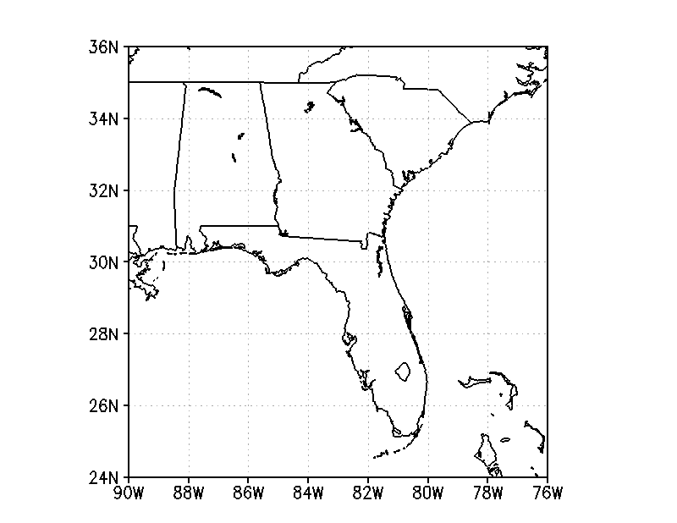
Chattanooga
Melbourne
West Palm Beach
Miami
Daytona
Tallahassee
Savannah
Augusta
Tampa
Charleston
Montgomery
Macon
Fig. 1 Model domain. Red boxes indicate nine 3⁰-by-2⁰ regions used for area-averaging. Labeled squares show the stations whose observations of hourly precipitation were used for diurnal cycle assessments
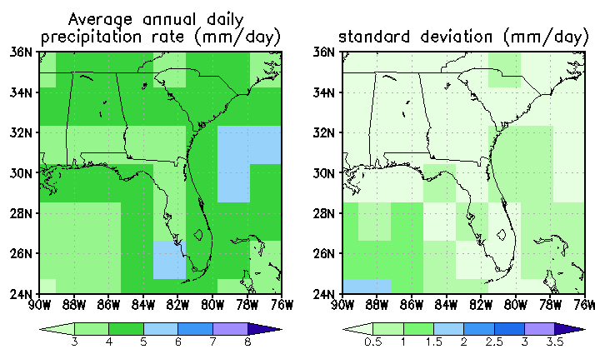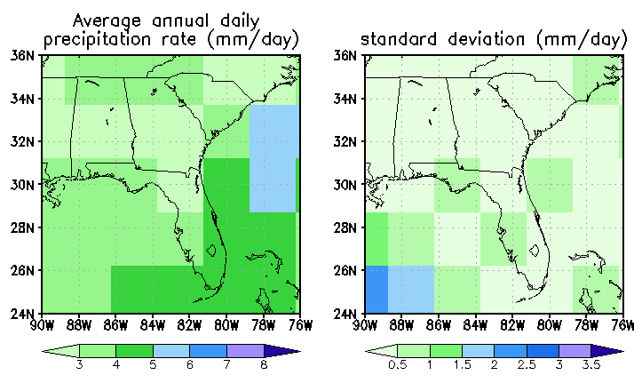
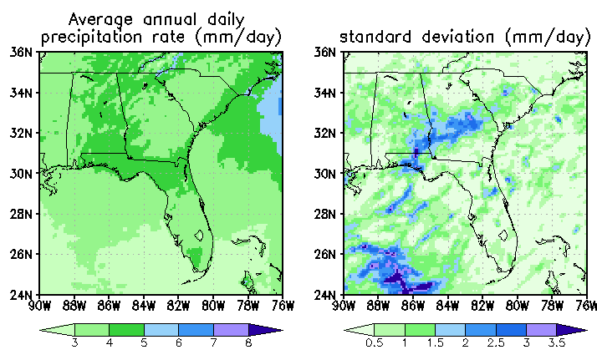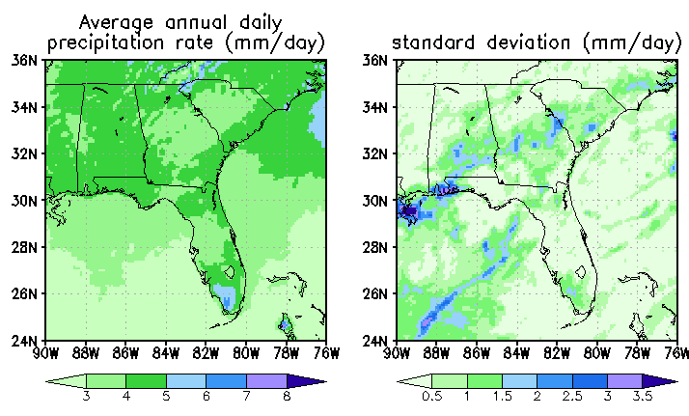
(a)
(b)
(c)
(d)
(e)
(f)
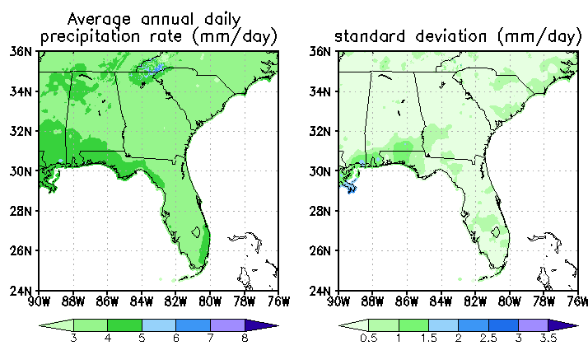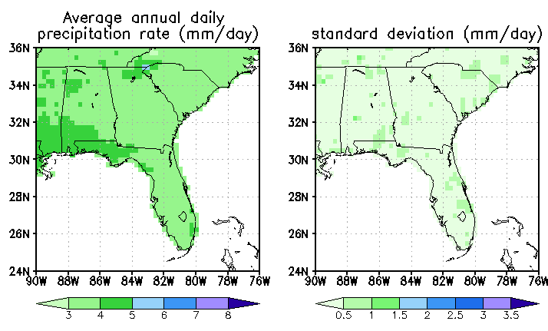
Fig. 2 Average annual precipitation rate (mm/day) and standard deviation from (a) R2, (b) ERA40, (c) CLARReS10-R2, (d) CLARReS10-ERA40, (e) CPC Daily US Unified Precipitation, and (f) PRISM
Fig. 3 Fractional contribution of calendar month (1-12) to the annual total, averaged over the boxes shown in Fig. 1

Fig. 4 Fractional contribution of calendar month (1-12) to the annual total
(a)
b
(b)
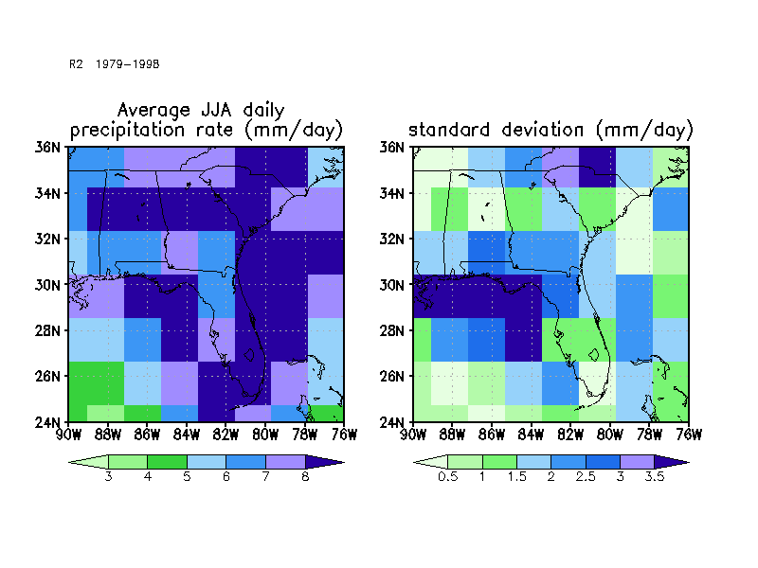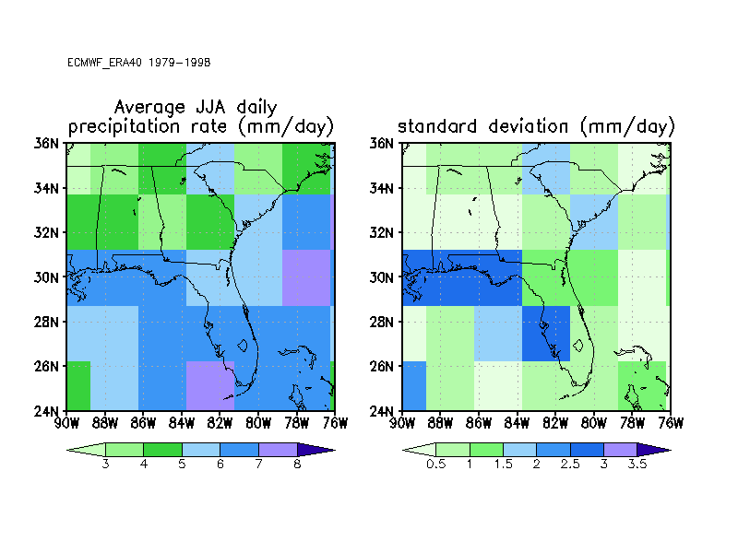
(c)
(d)
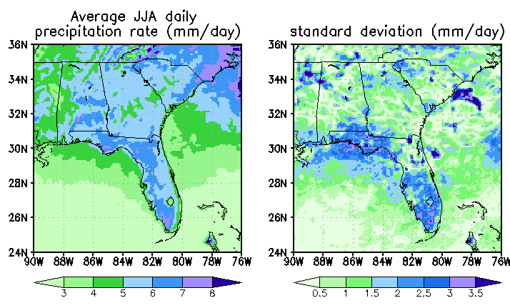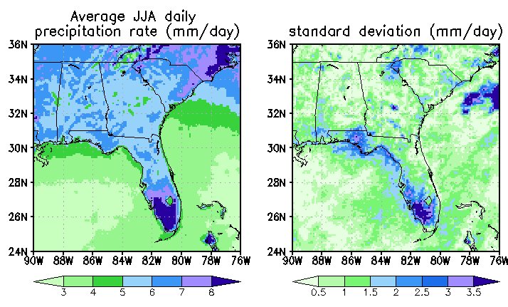
(e)
(f)
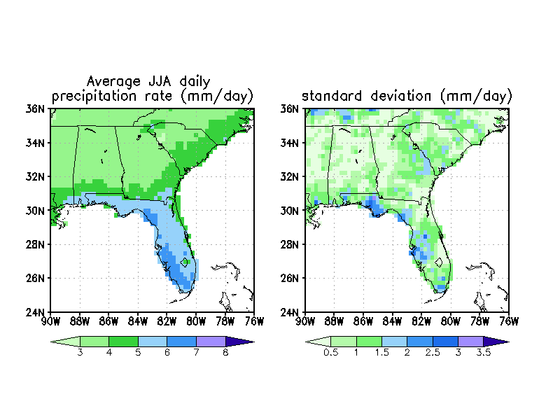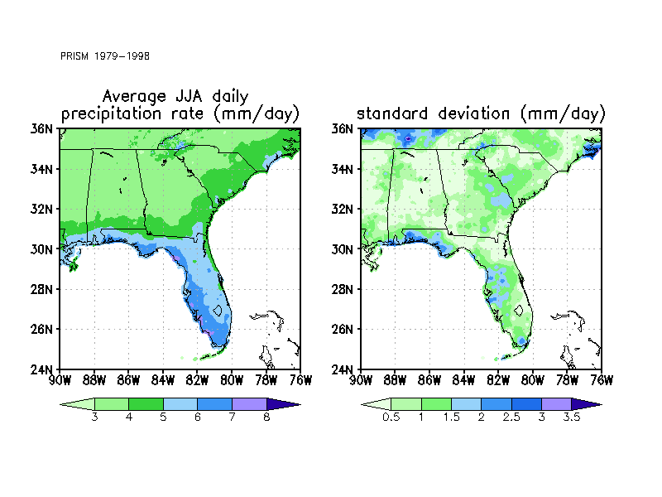

Fig. 5 Average summer (JJA) precipitation rate (mm/day) and standard deviation from (a) R2, (b) ERA40, (c) CLARReS10-R2, (d) CLARReS10-ERA40, (e) CPC Daily US Unified Precipitation, and (f) PRISM

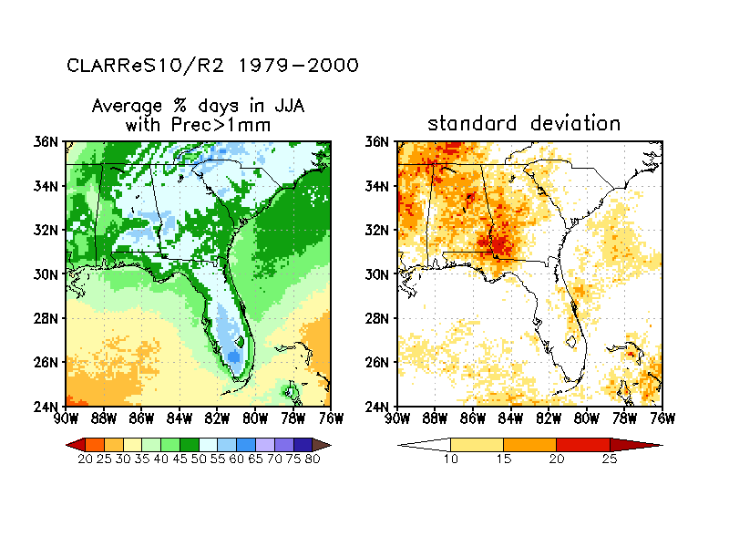
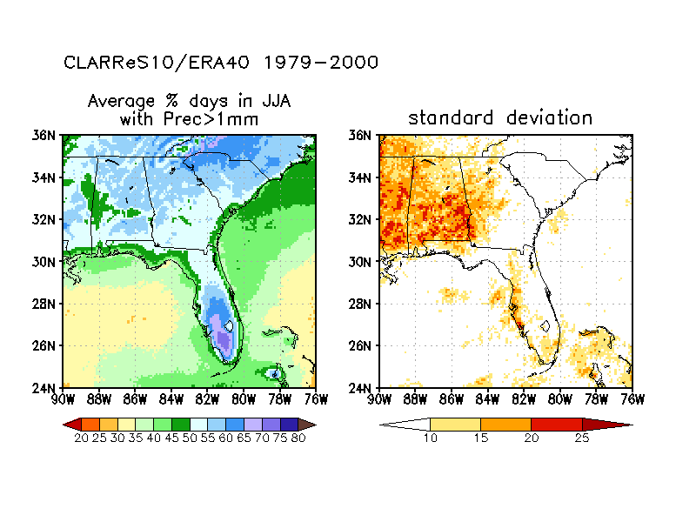
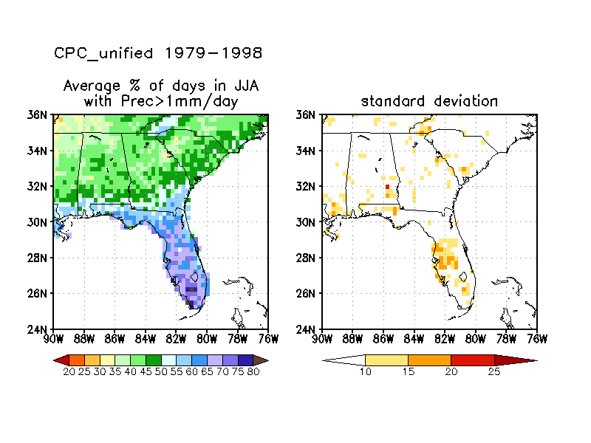

Fig. 6 Average percentage of days in JJA with precipitation rate exceeding 1 mm (left column) for CLARReS10-R2 (top row), CLARReS10-ERA40 (middle row), observations (CPC Daily US Unified Precipitation, bottom row), and standard deviation (right column)

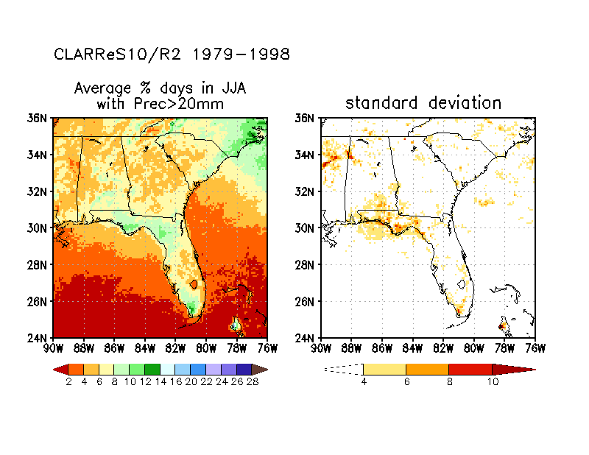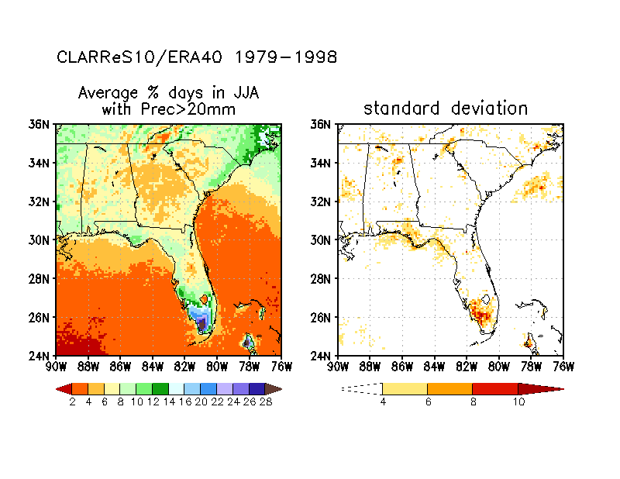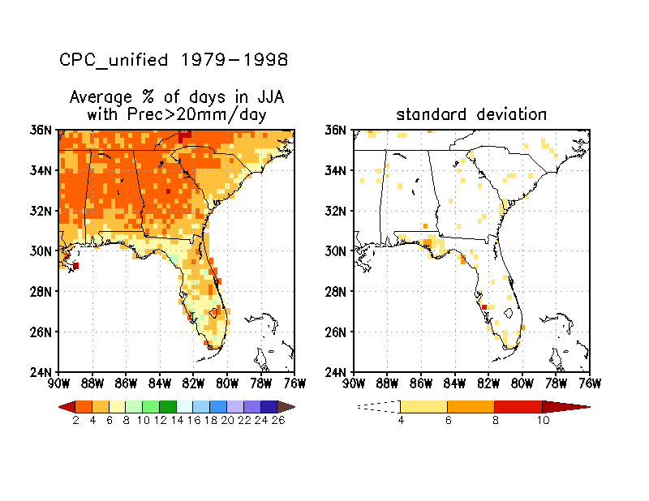

Fig. 7 As Fig. 6 but for precipitation rates exceeding 20 mm. (Note the change in the color bar values)

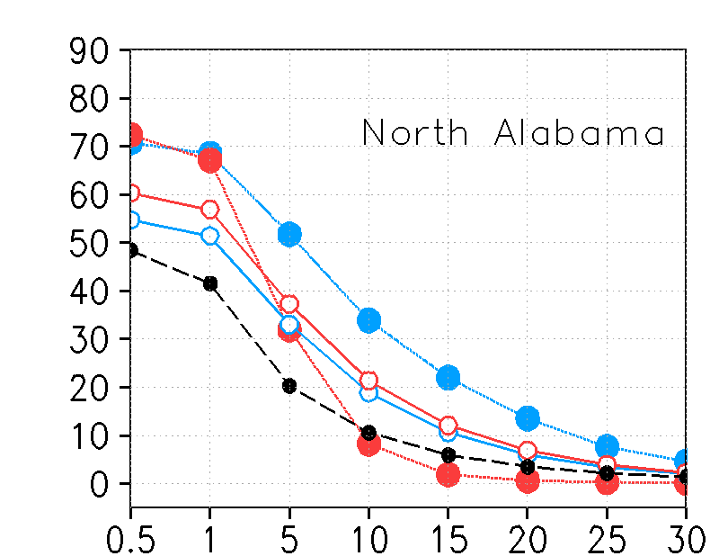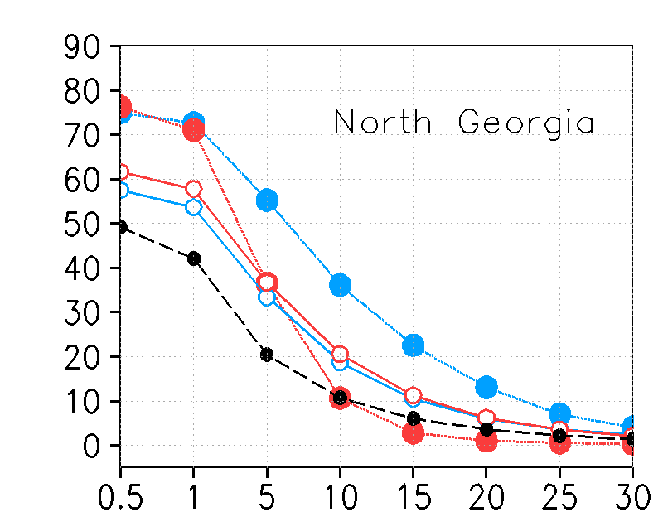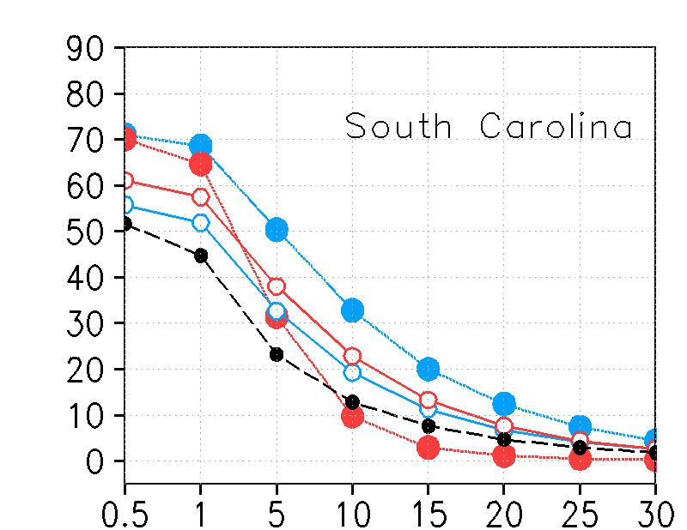
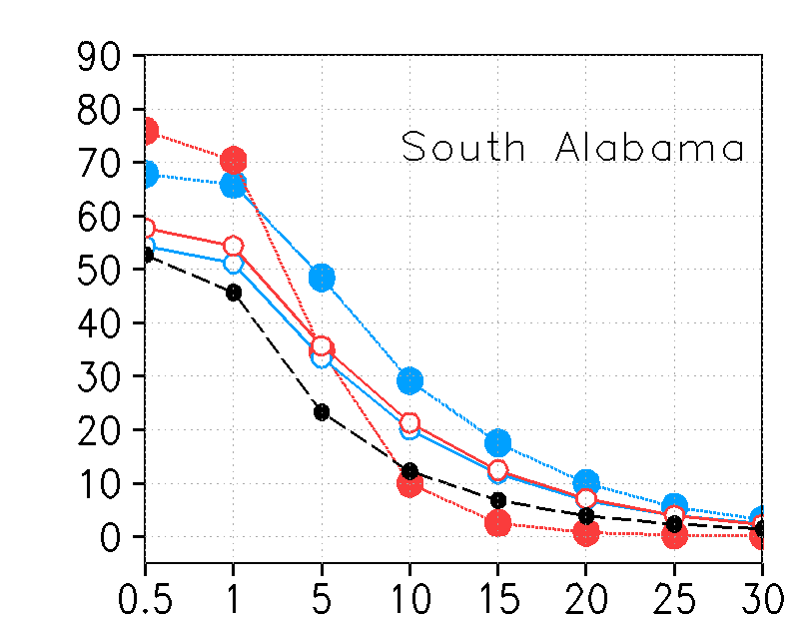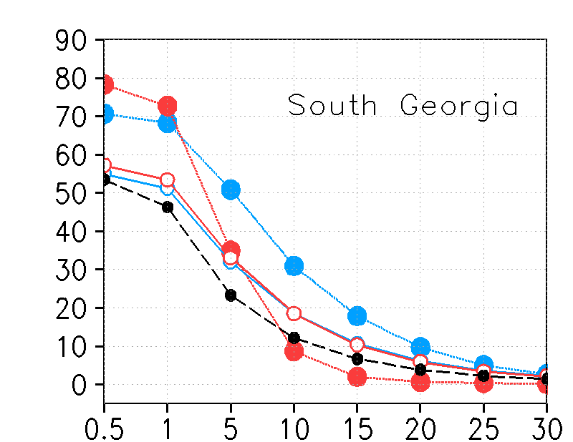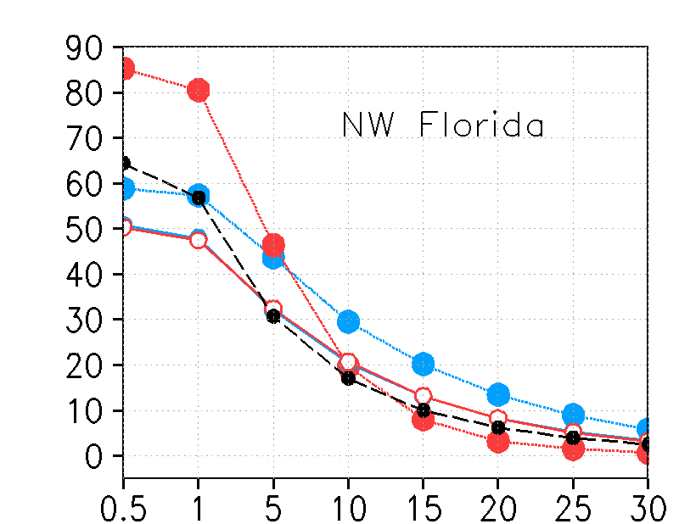
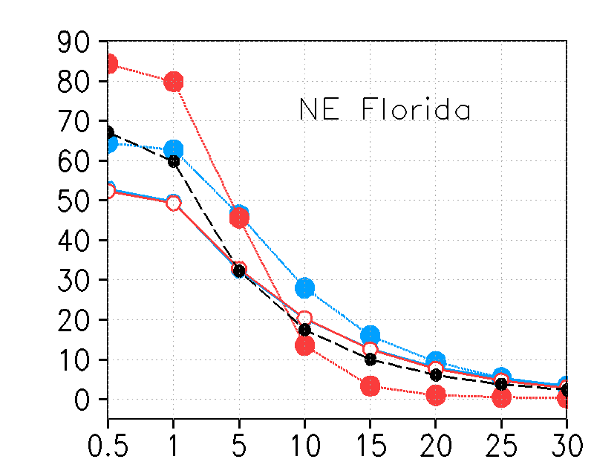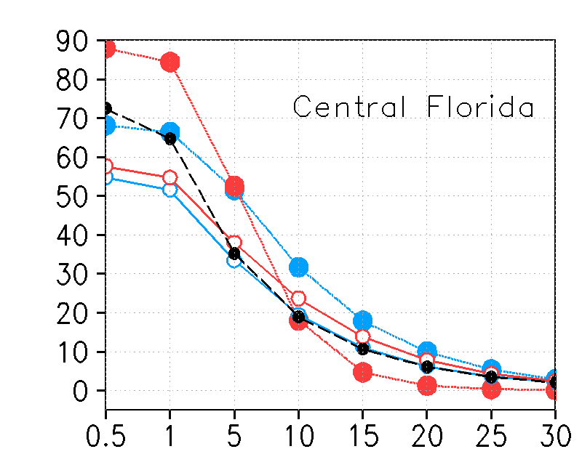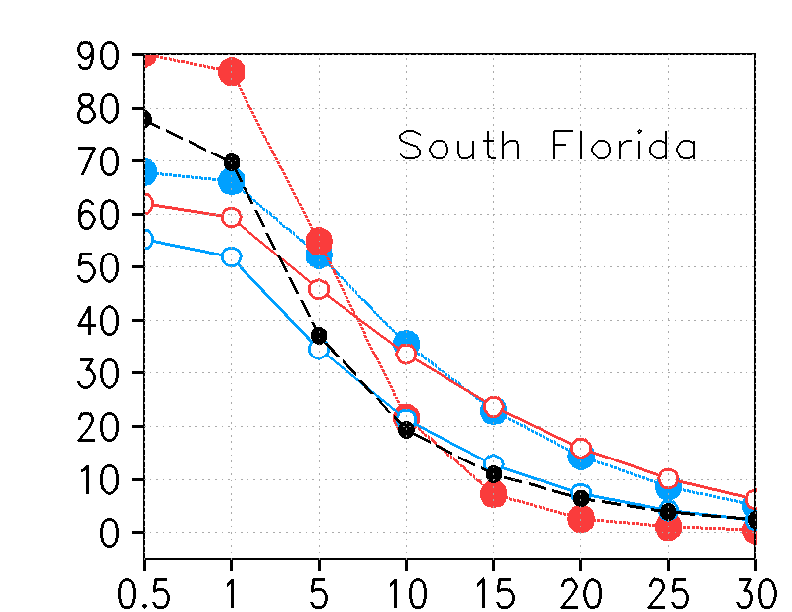
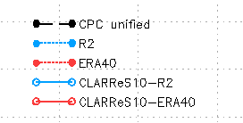
Fig. 8 Area-averaged percentage of JJA days with precipitation exceeding the threshold indicated on the x-axis (mm). The area averaging is performed over the boxes defined in Fig. 1
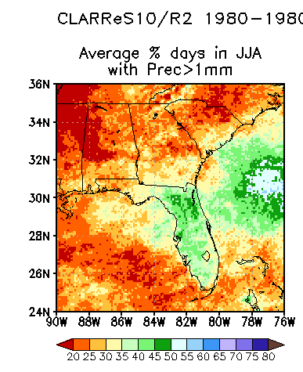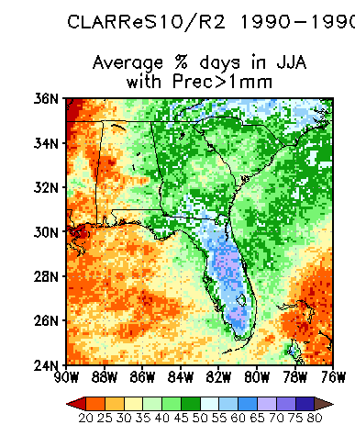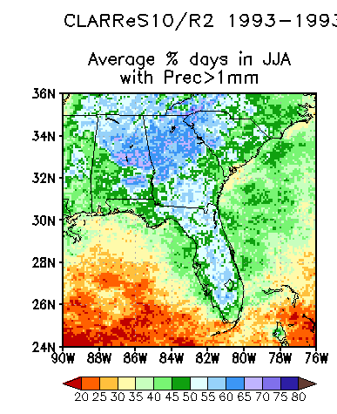
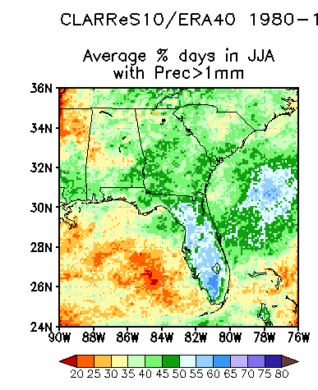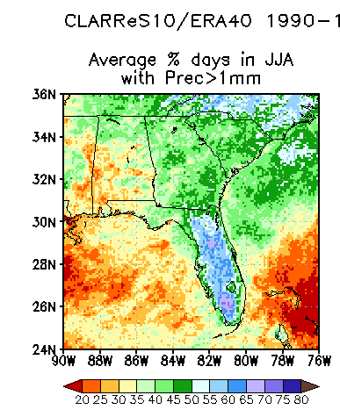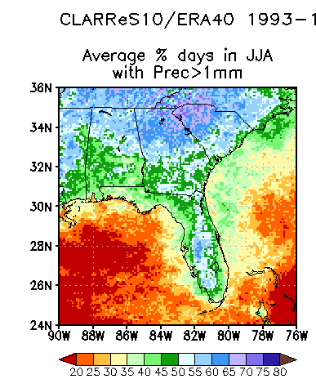
1990
1980
1993
1990
1980
1993
1990
1980
1993
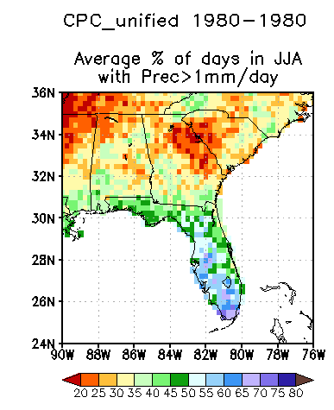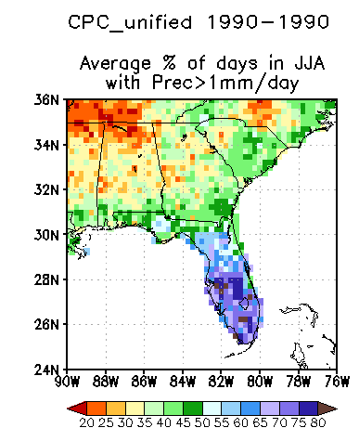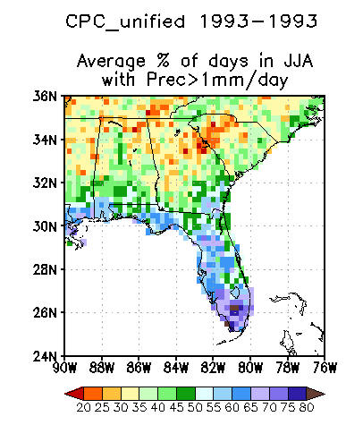
Fig. 9 Percentage of JJA days with precipitation exceeding 1mm during the three driest years for the Southeast United States: 1980 (left column), 1990 (middle column), and 1993 (right column) from CLARReS10-R2 (top row), CLARReS10-ERA40 (middle row), and observations (CPC Daily US Unified Precipitation, bottom row)
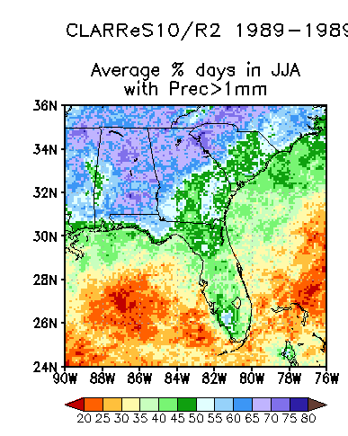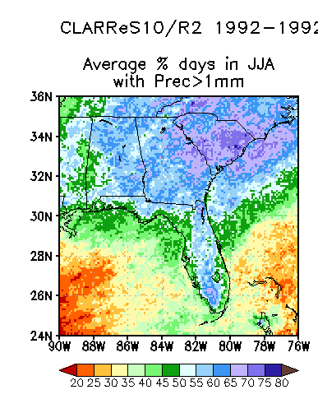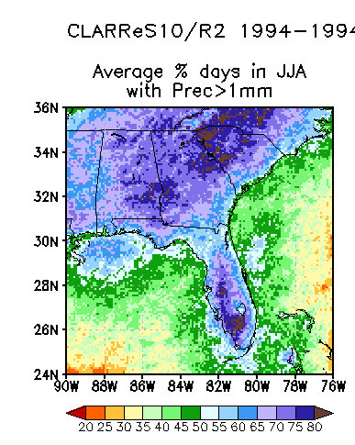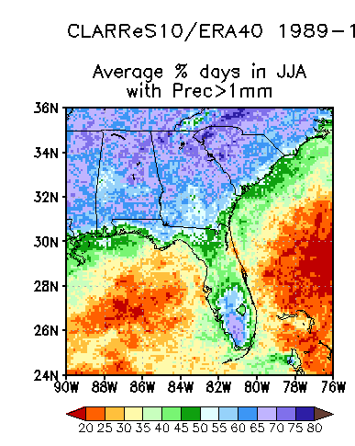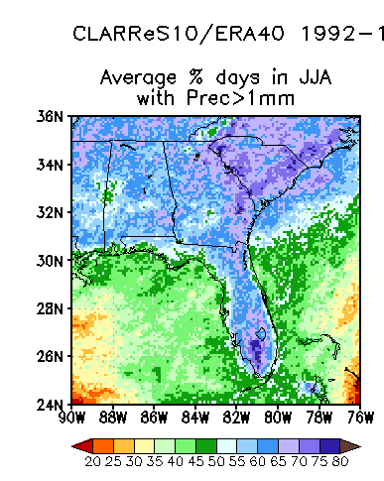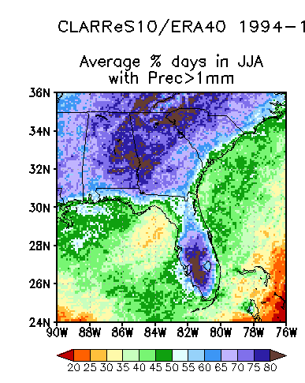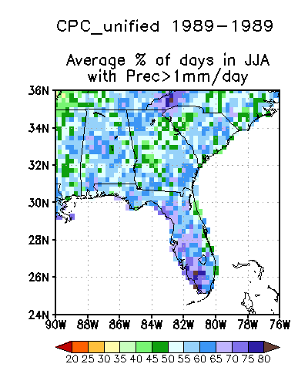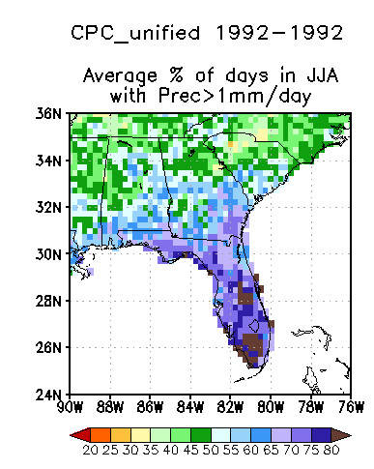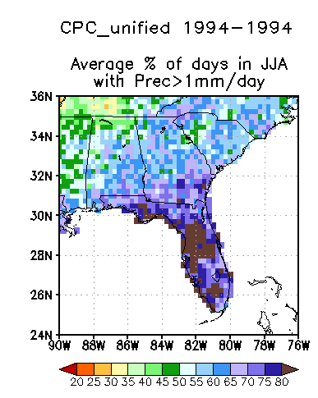
1992
1989
1994
1992
1989
1994
1992
1989
1994
Fig. 10 Percentage of JJA days with precipitation exceeding 1mm during the three wettest years for the Southeast United States: 1989 (left column), 1992 (middle column), and 1994 (right column) from CLARReS10-R2 (top row), CLARReS10-ERA40 (middle row), and observations (CPC Daily US Unified Precipitation, bottom row)

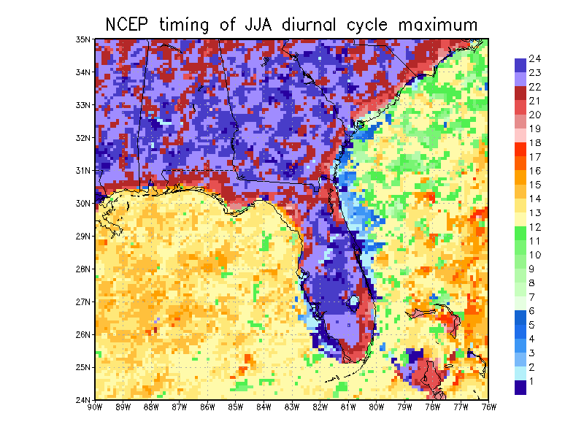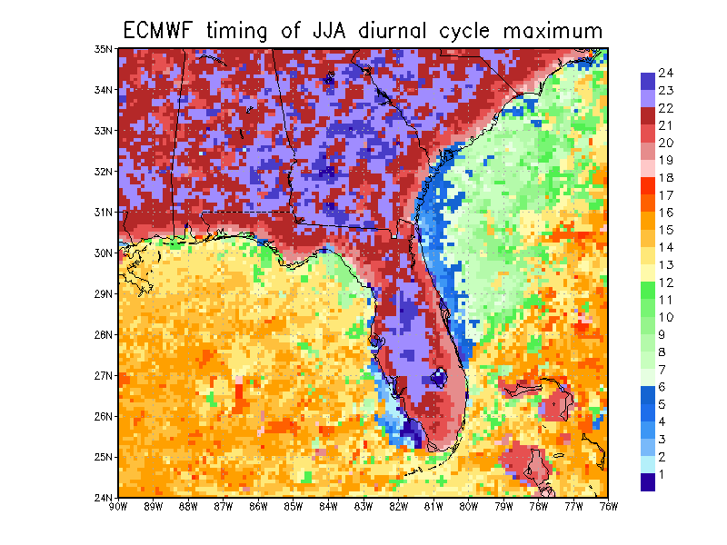
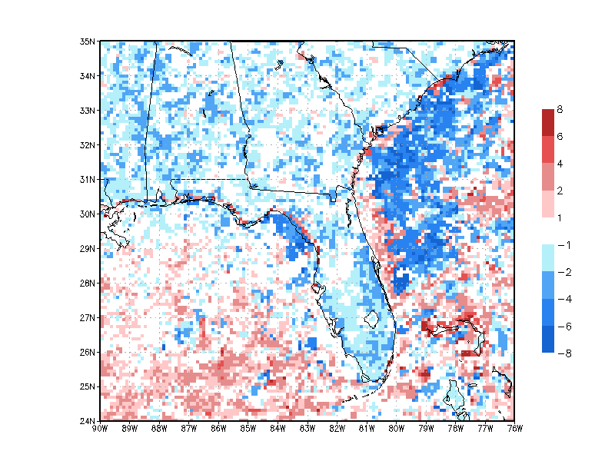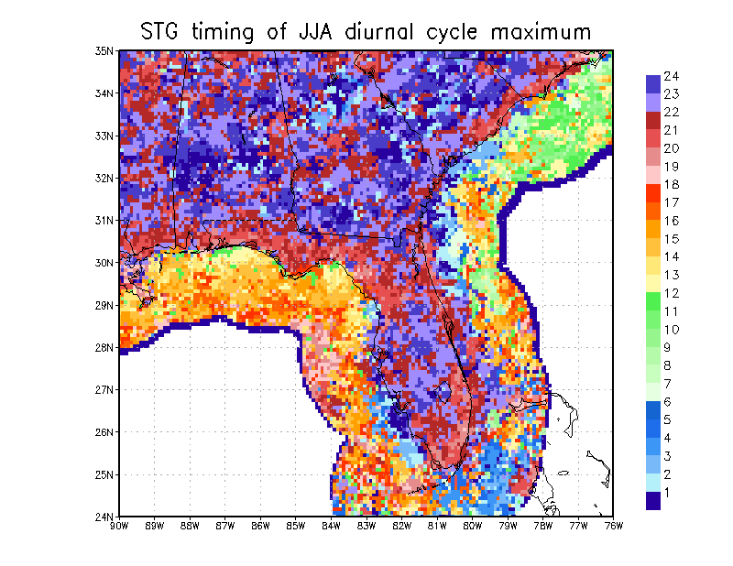
Fig. 11 Average timing of 1979-2001 JJA diurnal maximum (GMT) between CLARReS10-R2 (top left) and CLARReS10-ERA40 (top right); the difference in timing (CLARReS10-R2 minus CLARReS10-ERA40) (bottom left); and the average timing of JJA diurnal maximum from NCEP/EMC multi-sensor estimate for 2004-2009 (bottom right)
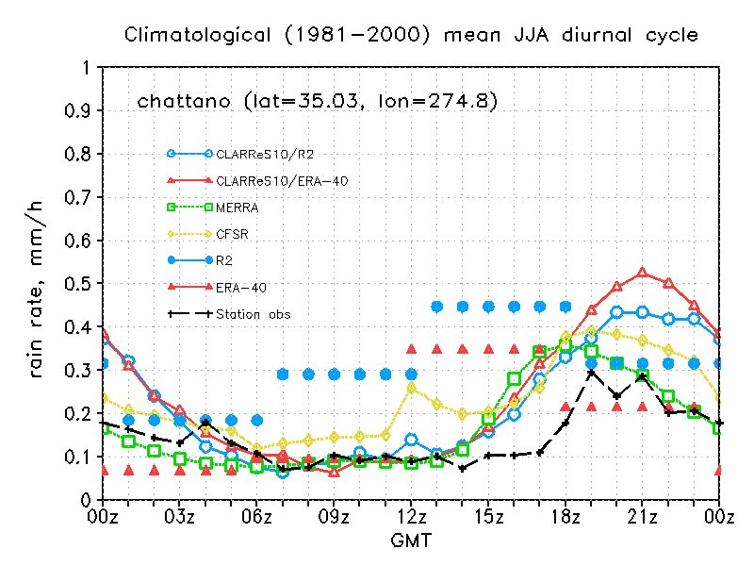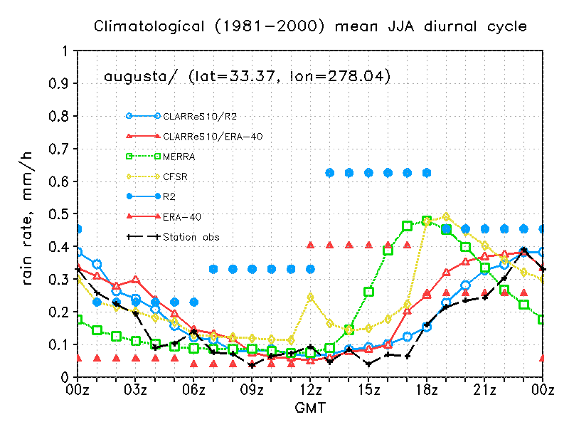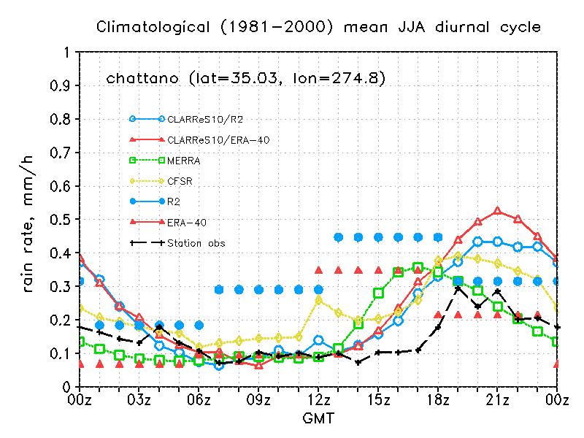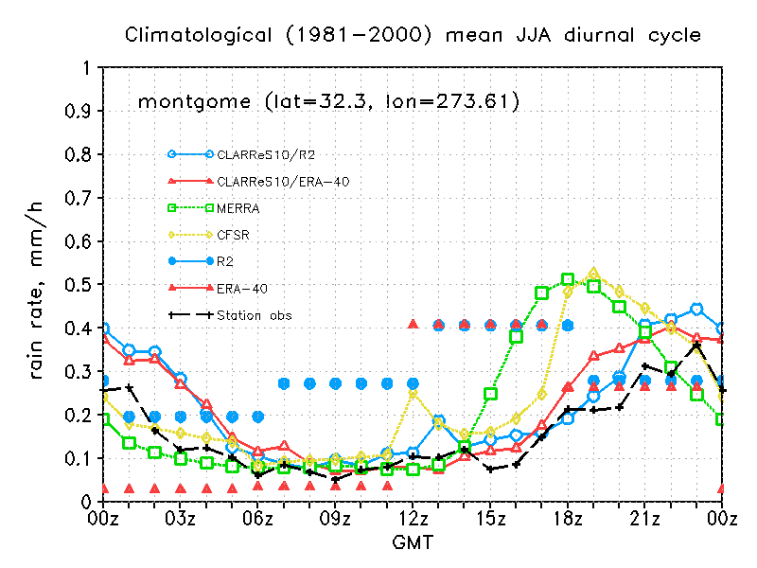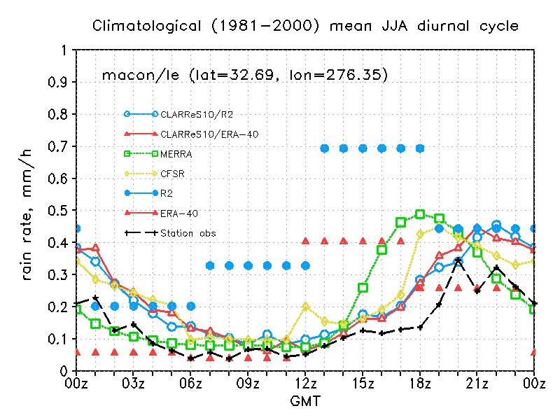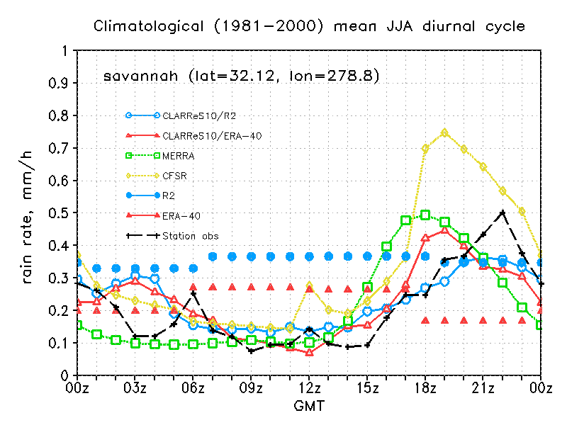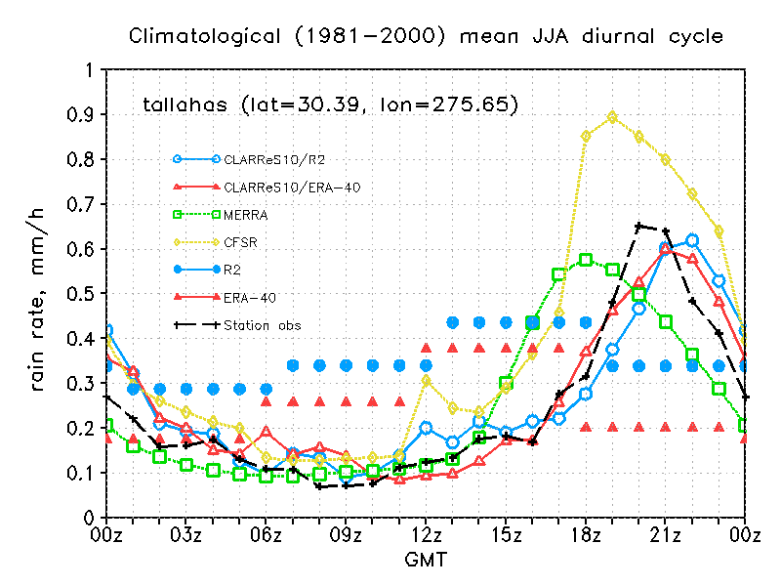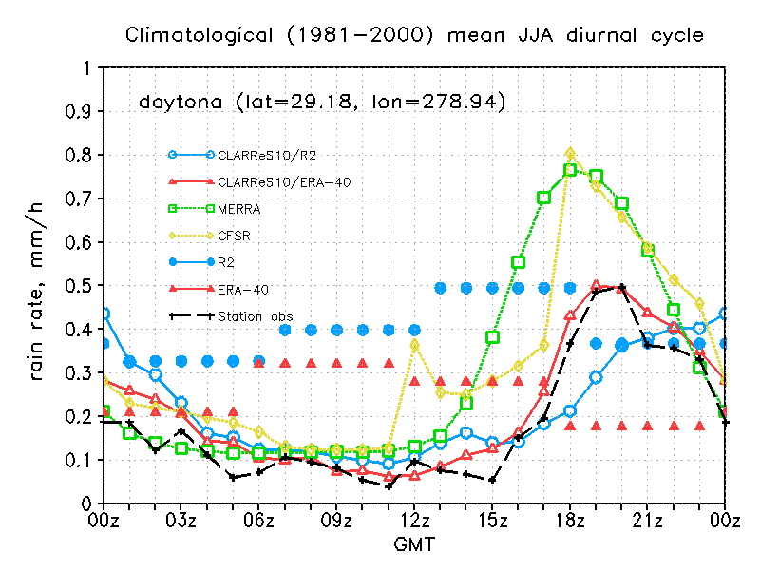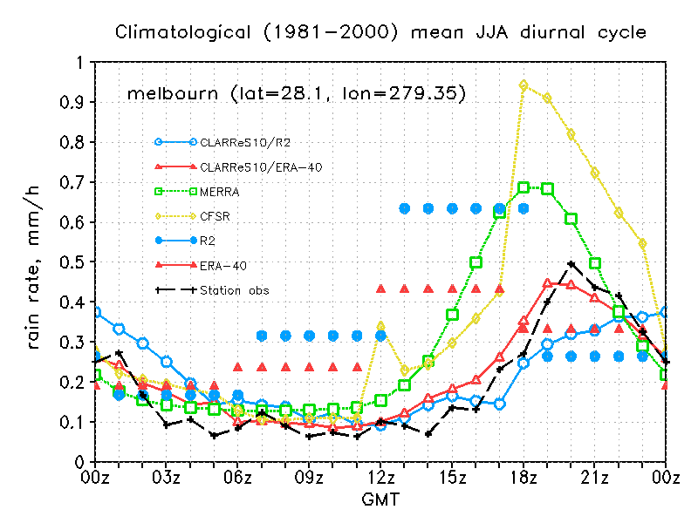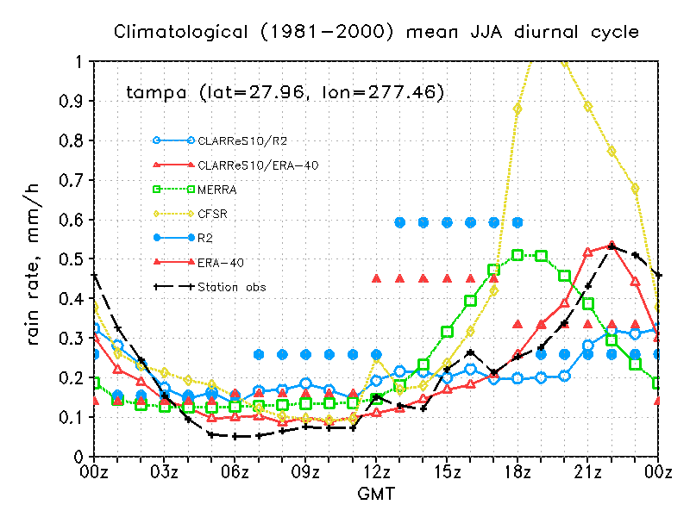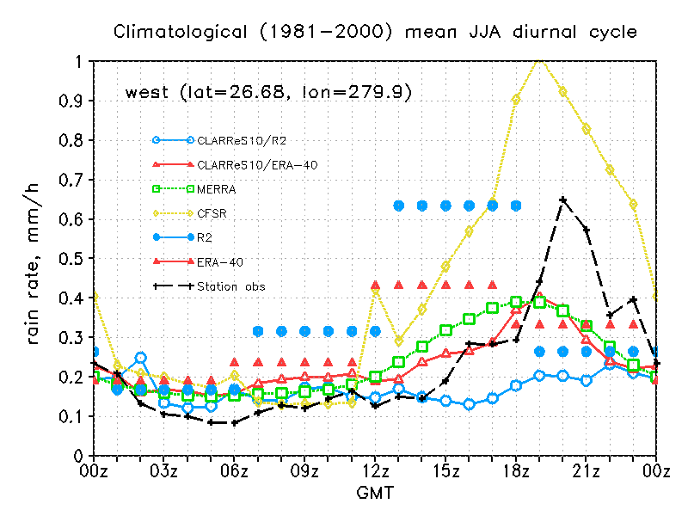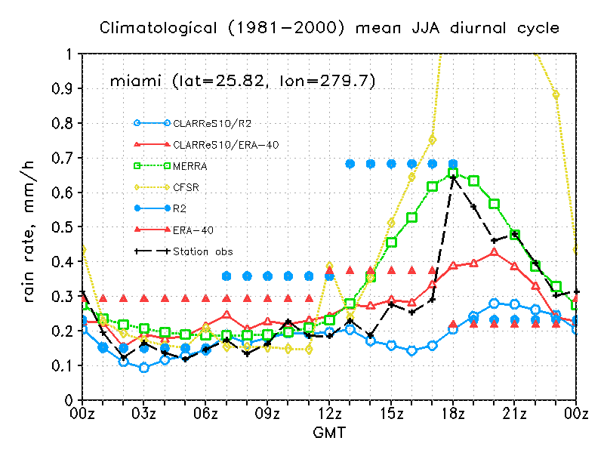

Fig. 12 JJA diurnal cycle of precipitation for several stations from the two global reanalyses (R2 and ERA40), their regionally downscaled counterparts (CLARReS10-R2 and CLARReS10-ERA40), MERRA, CFSR, and station data, as a function of GMT; EDT=GMT-4. The stations, going from left to right and from the top down are: Chattanooga TN, Augusta GA, Montgomery AL, Macon GA, Savannah GA, Tallahassee FL, Daytona FL, Melbourne FL, Tampa FL, West Palm Beach FL, and Miami FL

correlation
Fig. 13 Correlation of the JJA average daily cycle with observed station data for CLARReS10-R2, CLARReS10-ERA40, MERRA, and CFSR. The series have been sorted by descending value of the correlation of CLARReS10-R2 with station observations. The station abbreviations on the abscissa are as follows: ASH – Ashville, NC; AUG – Augusta, GA; CHAR – Charleston, SC; DAY – Daytona, FL; MAC – Macon, GA; MEL – Melbourne, FL; MIA – Miami, FL; MON – Montgomery, AL; TAM – Tampa, FL; WES – West Palm Beach; TAL – Tallahassee, FL; SAV – Savannah, GA. Note that while at a number of stations the diurnal cycle of CFSR has correlations comparable to CLARReS10, the actual precipitation amounts (Fig. 12) significantly exceed those observed.

 | Feature | Reference
1 | Dynamics: hydrostatic primitive equations with spectrally transformed onto Fourier basis functions | Juang and Kanamitsu (1994)
2 | 10-km horizontal resolution; 28 vertical layers; 4-min resolution orography | Kanamaru and Kanamitsu (2007)
3 | Planetary boundary layer processes | Hong and Pan (1996)
4 | Shortwave and longwave radiation | Chou and Lee (1996); Chou and Suarez (1994)
3 | Shallow convection | Slingo (1987)
4 | Deep convection: Simplified Arakawa-Schubert Scheme | Pan and Wu (1995)
5 | Boundary forcing: scale selective bias correction | Kanamaru and Kanamitsu (2007)
6 | Land surface: Noah; 4 soil layers | Ek et al. (2003)

Table 1 RSM configuration and main features

