Climate Outlook and Precipitation Forecast for the Contiguous United States in 2005
May Update

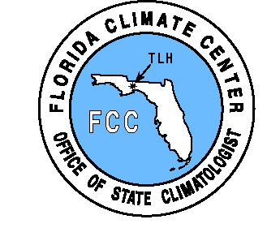


Dr. James J. O’Brien, State Climatologist

And

Mr. David F. Zierden, Assistant Research Climatologist

Center for Ocean-Atmospheric Prediction Studies

And

The Florida Climate Center

THE FLORIDA STATE UNIVERSITY

200 Johnson Building

Tallahassee, FL 32306-2840

May 18, 2005

Summary

Forecast Summary

- Neutral ENSO conditions (neither El Niño nor La Niña) will persist through the summer of 2005.

- Shifts in climate patterns are much weaker during the neutral phase than during El Niño or La Niña.

- Near-normal climate patterns are a common misconception of the neutral phase. A wide range of possibilities with little predisposition towards wet or dry is a better characterization of neutral climate patterns.

- In May and June, the predominant feature is a large area of increased probability of abnormally wet conditions in the Great Plains area.

- A multi-year drought is still affecting some of the western United States.

- Near-record low snow accumulations this winter will have a drastic impact on water supplies and moisture conditions in the Pacific Northwest.

- Above normal rainfall and snow pack this winter have improved conditions in the Southwest more than at any time in the last five years.

- Recent heavy rainfall in the Southeast in March and April greatly diminished the fears of unusually dry conditions in the early summer. May rainfall has been near or above normal.

Introduction

The natural variability of rainfall in the United States can disrupt planning of events affected by droughts, floods, and unusual rainfall. While “weather” may only be predicted a few days in advance, new understanding of “climate” variability caused by El Niño and La Niña permits probabilistic forecasts of more or less than normal rainfall. These forecasts, under certain conditions, have skill out to 6 months.
The El Niño-Southern Oscillation (ENSO) describes the fluctuation of sea surface temperatures along the equator in the eastern and central Pacific Ocean. The temperatures in this area can rise to over 10º F above normal at times (called an El Niño event), while falling to several degrees cooler than normal at other times (La Niña). The relationship between sea surface temperatures in the tropical Pacific Ocean and seasonal precipitation and temperature patterns in North America is now well-established and is used as a tool by NOAA’s Climate Prediction Center to forecast seasonal rainfall and temperature trends up to a year in advance.
El Niño and La Niña are the strongest drivers of the climate of North America, with impacts that vary across the different regions. These oceanic events shift the position of the jet streams across the continent, which act to steer the fronts and weather systems. Change the predominant tracks of the weather systems, and you change the resulting climate. Because the jet streams are strongest in winter months, the climate shifts are also more pronounced in the cold season. The Southeast U.S. experiences particularly strong climate shifts, with Florida feeling the greatest impacts. El Niño typically brings 30%-40% more rainfall and cooler temperatures to Florida in the winter, while La Niña brings a warmer and much drier than normal winter and spring. These forecasts, under certain conditions, have skill out to 6 months.
Drought conditions in many areas of the country can be triggered several months in advance by climatic conditions that affect the storage of water in such systems as mountain snow pack, soil moisture, surface water systems, and groundwater levels. Drought indices such as the Palmer Drought Severity Index attempt to track moisture through the hydrologic cycle and can be useful in indicating current dry conditions that may worsen over time.
In this report the Florida Climate Center will present and discuss current conditions through a variety of products that represent present moisture levels and water storage that could adversely affect moisture levels in the coming few months. A detailed precipitation forecast will also be presented for contiguous United States. The precipitation forecast will be presented graphically as a detailed month-by-month forecast that designates the probability of rainfall falling into four major classes (abnormally wet, extremely wet, abnormally dry, extremely dry). Finally, the climate forecast will be discussed in context with the current conditions in various regions of the country which we believe to be at an unusually high or unusually low risk of drought near the July Fourth holiday.

Current ENSO State

- Neutral conditions (neither El Niño nor La Niña) will affect the climate of the U.S. through the summer of 2005.

The first step in formulating the precipitation forecast is to assess the current and projected state of the tropical Pacific Ocean. Once the likely ENSO phase has been determined for the upcoming season, precipitation projections are made based on historical weather observations from similar ENSO phases.
While sea surface temperatures in the equatorial Pacific Ocean approached weak El Niño thresholds by some measures this past winter, the atmospheric and climatic responses were more consistent with neutral conditions. there was a degree of warming of sea surface temperatures in the central Pacific near the international date line in the fall of 2004, the progress towards an El Niño slowed and there was been no further eastward spread during the last winter months. Ocean temperatures in the eastern Pacific near the coast of Peru (the traditional El Niño region) remain cool or close to normal. Cool upwelling remains strong and fishing is productive, opposite of the warmer waters and drastically reduced catches usually characteristic of an El Niño. The warming was neither persistent nor widespread enough to classify as an El Niño according to the JMA index.

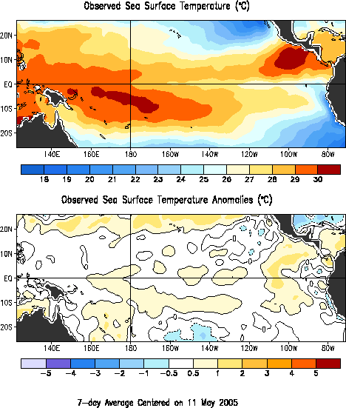

The latest sea surface temperature analysis indicates near normal conditions in the tropical Pacific Ocean. A large area of warm water has now appeared in the eastern Pacific near the coast of Peru. This warming may or may not be a precursor to a developing El Niño. Regardless, any further warming will be slow to occur and there is no chance that an El Niño will develop in time to affect this summer’s weather. Sea surface temperatures remain near normal in the central and western Pacific, consistent with neutral ENSO phase. The precipitation forecast in this report is based on the assumption of continued near normal sea surface temperatures in the tropical Pacific.

Recent Precipitation

Presented in the next two color plates are precipitation totals and departures from normal from the last 30 and 90 days. These plates show total precipitation, departures from normal, and percent of normal in separate maps. Rainfall surpluses are indicated in shades of green while areas with deficits are colored in brown.
Areas of excess rainfall in the last 90 days include much of the Western U.S., including the Northwest, where rainfall totals are in excess of several hundred percent of historical normal. In the Southeast, the heavy rains of March and April are still apparent and cover most of Florida, Georgia, and south Alabama. The most significant rainfall deficits are seen in the central U.S., including the whole Mississippi Valley.
More recently, the 30-day maps show more recent beneficial rainfall in the West, where rainfall totals are exceed 200 percent of normal over a large portion of the area. In the Southeast, Florida, Georgia, and Alabama continue near or above normal while the southern Mississippi valley has seen a recent drying trend.

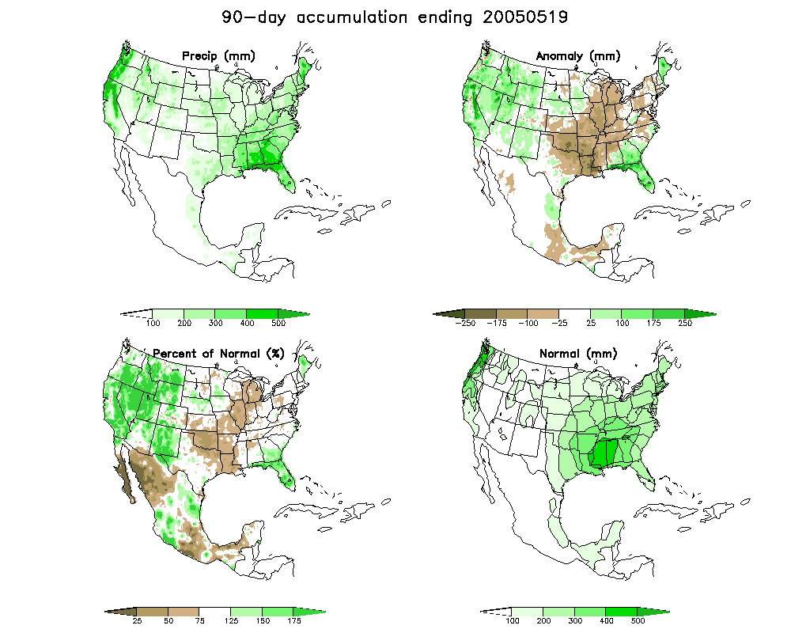

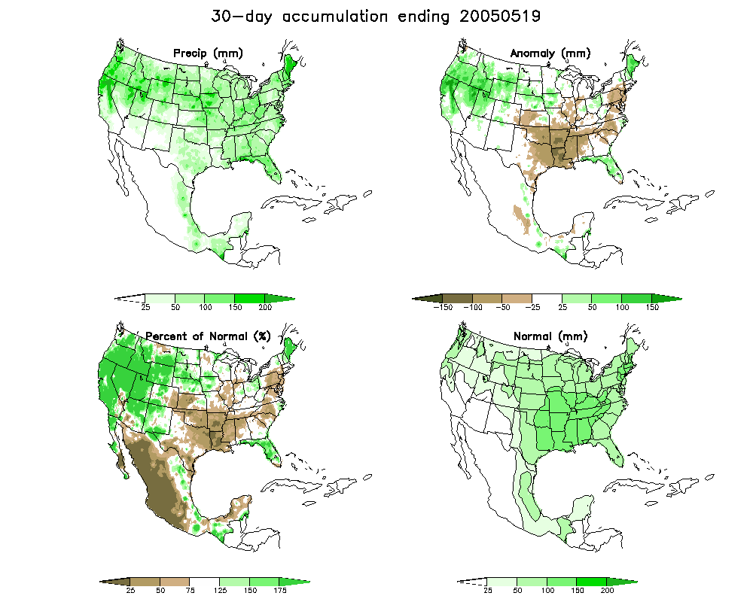

U.S. Drought Monitor

The National Weather Service and the National Drought Mitigation Center have recently teamed up to produce the U.S. Drought Monitor, a weekly graphical product that attempts to combine all aspects of drought into one easy-to-understand product. Highlights of the current Drought Monitor include the lack of drought in the eastern U.S., with the exception of some localized pockets that bear watching. Florida has been relatively drought-free since July of 2002.
The plentiful winter rains that the Southwest has enjoyed this year have dramatically improved conditions in California, Colorado, Nevada, Utah, New Mexico, and Arizona. This region has been plagued by moisture deficits and varying degrees of drought since at least the year 2000. The current Drought Monitor map now represents this area as drought-free, with only isolated pockets of hydrologic concerns remaining. The cool and wet pattern has continued through the spring, improving the water situation to the best it has been in the last five years.
The Drought Monitor map also highlights the regions of greatest concerns. The most concerning is the continued drought in the Pacific Northwest, particularly when looking at Washington, Oregon, Montana, and Idaho. Near record low snow packs in the mountain regions was a key to this area and will be discussed in more detail later in this report. While the recent cool and wet weather has been welcome and slowed the snowmelt, long-term deficits remain and the lack of snowpack will ensure water concerns in the coming warm season.

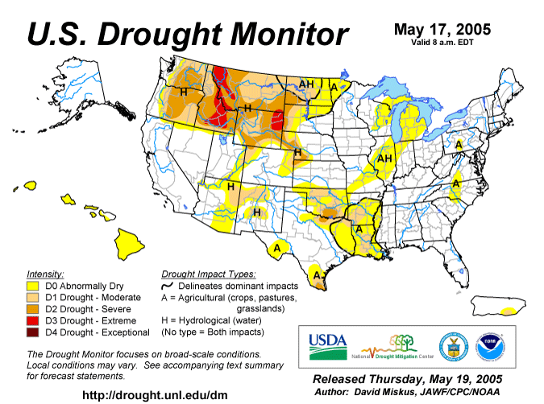

Palmer Drought Severity Index

A wide range of drought indices have been developed that attempt to track moisture surpluses or deficits over time and more specifically, how they impact all or part of the hydrologic cycle. Some indices are more indicative of recent rainfall and include the crop moisture index and the Keetch-Byram Drought index. Others react to rainfall over longer time periods and are more representative of hydrologic drought. Of these, the Palmer Drought Severity Index (PSDI) is the most well-known and is frequently used for making policy decisions on water supply and demand issues. The PSDI has well documented shortcomings in some regions of the country (mountain west) and for many applications. Nevertheless, it is necessary to monitor the PSDI as it can have great implications in policy decisions in some locations.
The map on the following page shows the current PSDI values. Of note is the excess moisture in the Southwest. The Palmer also indicates a continuation of moist conditions in parts of the Southeast and Northeast. Of particular note is the improvement the Palmer index has shown in the northwest, where parts of Montana and Wyoming are still considered dry, but a great improvement over what was seen in our March report.
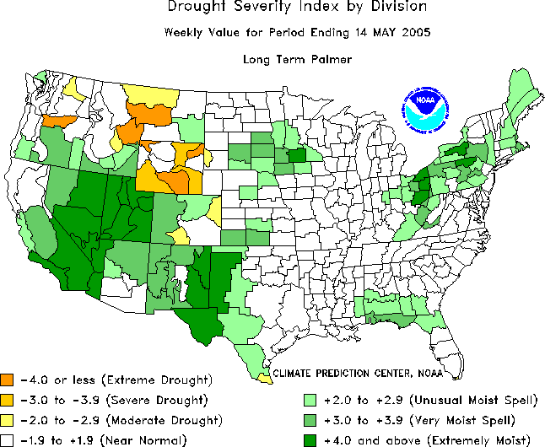

Snow Pack

Snow pack, or winter accumulations in the higher elevations, is without a doubt the most pressing water supply issue facing the United States at the present time. Accumulated snowfall is the primary water source for rivers, reservoirs, and groundwater recharge in much of the western United States. A shortage of snowfall in the winter months directly affects water supplies in the following spring and summer. April 1st is commonly designated as the date of peak snow pack and levels at that time are considered a good indicator of water supplies for the coming water year.
Currently, the mountain west is sharply divided into two regimes. The first is the Southwest, where snow pack ranges from near normal to well above normal. This area includes the states of California, Nevada, Utah, New Mexico, Arizona, and Colorado. This plentiful snow pack should result in few water availability issues in the coming months. The second area is the Pacific Northwest, where snow levels are at or near record low levels as we approach the date of peak snow pack. This will translate directly into water shortages and drought conditions in the coming months. Current snow pack is represented in the graphic on the following page.

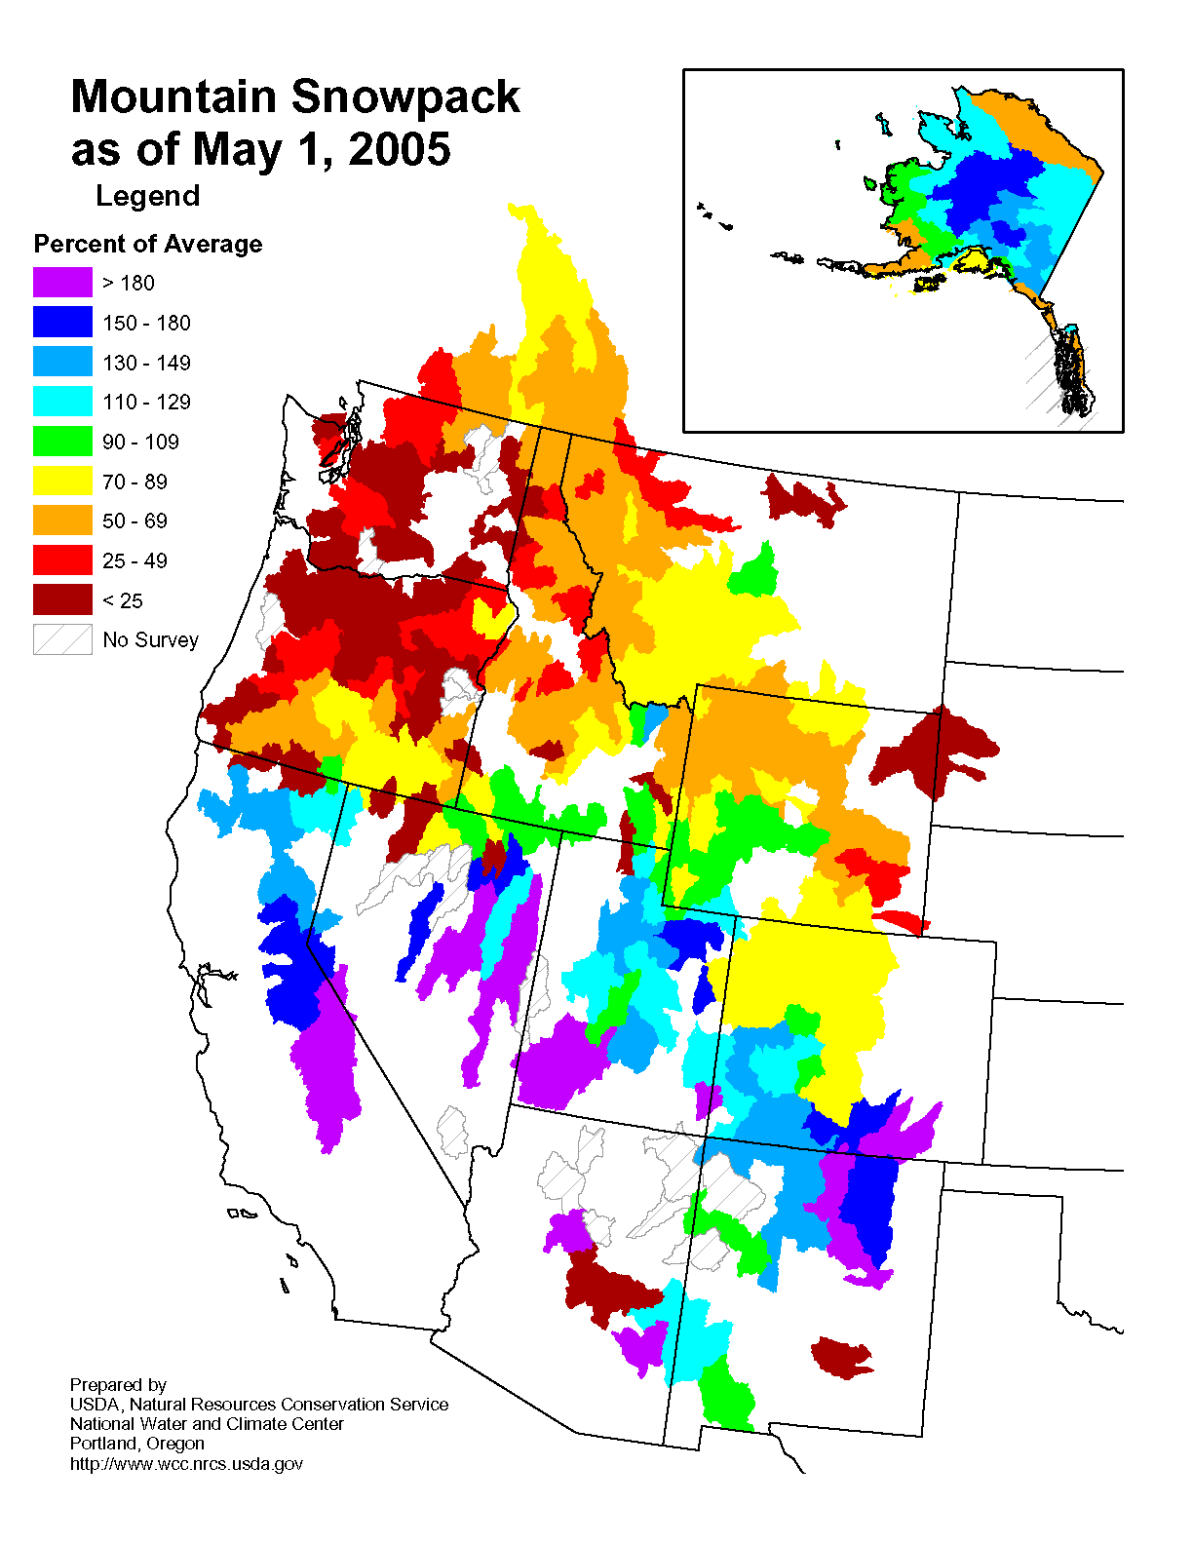

Precipitation Forecast Methodology

Given our understanding of El Niño and La Niña and their associated climate shifts, it is possible to make projections of monthly precipitation amounts up to a year in advance. The Pacific Ocean has a tremendous capacity to store heat, and changes in ENSO State are slow to occur. It is this “memory” that provides our predictive capability.

This report utilizes new method of climate forecasting developed at the Florida Climate Center based on historical data and their probability distributions. Hence, the forecast products are probabilistic in nature, and address the chances that precipitation totals will fall within a specific range, rather than predicting just one value.
In previous climate studies assessing the impacts of ENSO on temperature and precipitation, we have used the Japan Meteorological Agency (JMA) index and their definitions of El Niño and La Niña to categorize the different regimes. A list of El Niño, La Niña, and neutral years using the JMA classification is given below. Since 1948, there have been 12 El Niño’s, 13 La Niña’s, and 27 neutral years. More information on the JMA index can be found at: http://www.coaps.fsu.edu/research/jma_index1.shtml

El Niño, La Niña, and Neutral Years

El Niño Neutral La Niña
1951 1949 1980 1950
1958 1951 1981 1955
1964 1953 1982 1956
1966 1954 1984 1957
1970 1959 1986 1965
1973 1960 1990 1968
1977 1961 1991 1971
1983 1962 1993 1972
1987 1963 1994 1974
1988 1967 1995 1976
1992 1969 1996 1988
1998 1975 1997 1999
2002 1978 2001 2000
1979

Let us take a close look at January precipitation in Florida’s climate division 4 as an example. To fully understand the method, we first need to examine the probability distributions associated with El Niño and La Niña. Over 100 years of historical January precipitation is divided into three groups, El Niño, La Niña, and neutral. Then, histograms are constructed for each of the three categories of January precipitation and are plotted on a common axis (see the figure below on the left). The peak of these graphs represents the mean January precipitation for each ENSO phase. However, the spread of these histograms shows that wide range of values is possible during each ENSO phase. The figure on the right conveys the same information, just presented in as the exceedence probability for each ENSO phase.

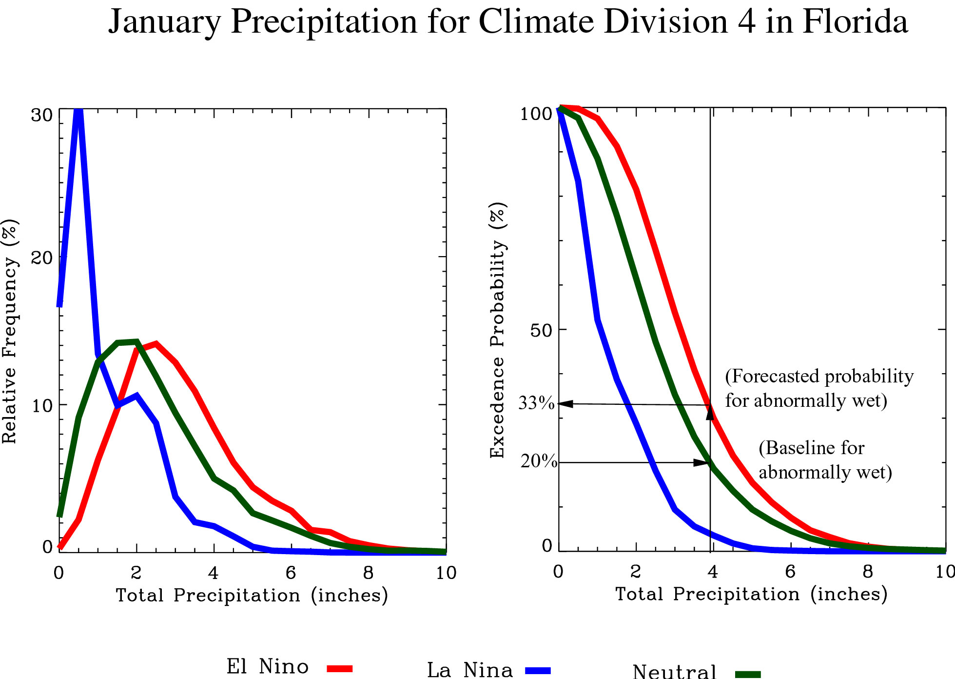

In our method of climate forecasting, we first establish a baseline based on the probability distribution for the neutral ENSO phase. From this distribution, normal precipitation is defined as the median plus or minus 30% (or around one standard deviation). Abnormally wet is defined as the highest 20% of occurrences, and extremely wet refers to the top 10%. Likewise, abnormally dry is designated by the lower 20% of occurrences and extremely dry by the lowest 10%. The precipitation amounts corresponding to the breaks between categories are determined from the neutral distribution. This is an important facet of our forecasting method, using the neutral distribution as a baseline. Most other climate forecasting centers use normal (or long-term average) as the baseline, which combines historical observations from all three ENSO phases.
The actual forecast addresses the shift in probabilities associated with each of the precipitation categories. This is accomplished by taking the values associated with each precipitation category and computing new probabilities base on the El Niño distribution. The excedence curves from Florida’s climate division 4 will be used as an example. The 20% baseline value (or cutoff for abnormally wet) is determined to be 3.9 inches from the neutral distribution. Following that amount to the El Niño distribution, we determine the probability of abnormally wet (3.9 inches or greater) is now 33% when an El Niño occurs. This climate division would be colored green (25%-35%) on the forecast map for abnormally dry in January. This technique is repeated for each precipitation category.
In this report, we use the method described above to forecast monthly probabilities for four precipitation categories (abnormally wet, extremely wet, abnormally dry, extremely dry). The forecast is made for each climate division in the contiguous United States for the months of January through June of 2004. The forecast is presented in map form, with each climate division colored to correspond to the probability of precipitation in the four designated categories. Yellow, orange, and red colors indicate and increased risk of dry conditions or a decreased risk of wet. Greens and blues correspond to and increased chance of wet conditions or a decreased chance of dry.

Precipitation Forecast Results

Given that the Pacific Ocean surface temperatures will remain near normal through the spring of 2004, any shifts in rainfall probabilities for the months of January through June are relatively weak. While El Niño or La Niña can increase the likelihood of abnormally dry or abnormally wet conditions by up to three times some parts of the United States, shifts in climate patterns associated with neutral conditions are much weaker. A common misconception is that neutral conditions favor seasonal rainfall and temperature patterns that are close to normal. In reality, a wide range of conditions are possible during the neutral ENSO phase with little predisposition towards wet, dry, warm, or cool. In the forecast for the coming three months, we did find some minor shifts in rainfall probabilities that may be useful for planning purposes. Also, the lack of a shift towards wet or dry conditions may be useful information as well.
In May and June, the predominant feature is a large area of increased probability of abnormally wet conditions in the Great Plains area. Affected states include South Dakota, Nebraska, Iowa, Kansas, and Oklahoma. By July, the shift towards wetter fades somewhat in the Great Plains. In the Southwest, we are predicting an increased chance of dry conditions in the month of July, but the shift in probabilities is relatively weak.

Regional Discussion

The Southeast

Prior to March, Florida and parts of South Georgia and South Alabama had begun to accumulate rainfall deficits. South Florida was particularly concerning, as this area had missed the brunt of the rainfall from the recent fall hurricanes and the continued dry trend was beginning to escalate the wildfire danger, a worrisome trend during the winter dry season. In fact, the Keetch-Byram Drought Index had risen to over 550 over much of the peninsula during the month of February. However, March and April precipitation has been both plentiful and frequent, easing the immediate wildfire concerns. May has brought a return to near normal precipitation, and being the dry season the KBDI has begun to rise. However, the index values remain below or near normal for this time of year and do not indicate an increased threat of wildfire at this time. Shown below are maps of the Keetch-Byram Drought Index (KBDI) in both Florida and Georgia
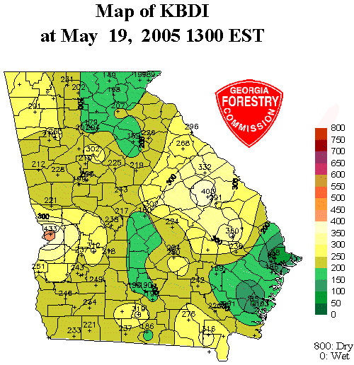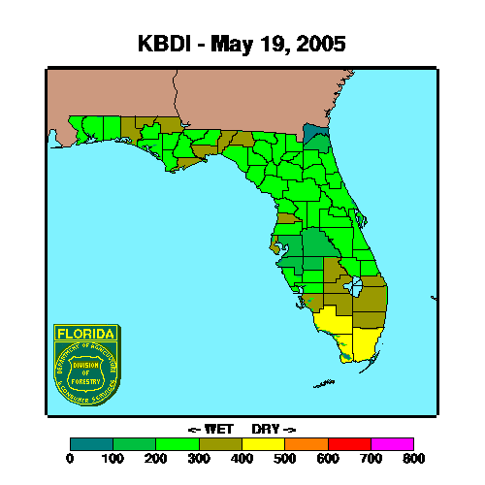

Soils, surface water, and groundwater have now been replenished and the Southeast wildfire threat remains below its seasonal normal. With the precipitation forecast favoring near-normal rainfall in the months of May through July, we do not anticipate any large scale moisture concerns in the Southeast U.S.

The Southwest

As mentioned earlier, the Southwest had been mired in the midst of a multi-year drought, the degree of dryness varying from one location to another and from year to year. The good news is that this winter’s precipitation has been the best in years, from rainfall in the lower elevations and further south to above normal snow pack accumulated in the mountains.
Our precipitation forecast calls for a slightly increased risk of below normal precipitation over the next three months. However, the Southwest is already further ahead of where they were at this point in the five previous years. In times of normal or above normal moisture, wildfire risk does not peak until late summer in this region. We expect this to be the case in 2005 year and a much improved climate for fireworks sales and distribution. States that should be much improved from previous years include New Mexico, Colorado, Arizona, Utah, Nevada, Texas, and California.

The Pacific Northwest

The Pacific Northwest is far and away the most problematic region of the country for fireworks distributions. The near-record low snow accumulations will put water supplies and storage in a hole that cannot be made up, despite rainfall patterns in the next four months. The spring so far has been cool and rainy, which has eased or delayed the impacts the low snowpack may have on the hydrologic system. The recent rainfall has improve the situation to a little less dire than indicated in our previous report as the July fourth holiday approaches.

References

Brenner, James: Southern Oscillation Anomalies and Their Relationship to Wildfire
Activities in Florida, International Journal of Wildland Fire, 1, 73-78.

Bove, M. C. and J. J. O’Brien, 2000: PDO Modifications of U.S. ENSO Climate
Impacts, COAPS Technical Report.

Green, P. M., D. M. Legler, C. J. Miranda, and J. J. O’Brien, 1997. The North
American Climate Patterns Associated with the El Niño-Southern Oscillation.
COAPS Project Report Series 97-1.

Jones, C. S., J. F. Shriver, and J. J. O’Brien, 1999: The effects of El Niño on Rainfall
And Fire in Florida. The Florida Geographer, 30, 55-69.

Sittel, M. 1994. Differences in the Means of ENSO Extremes for Temperature and
Precipitation in the United States. COAPS Technical Report 94-2.

Swetnam, T. W. and J. L. Betancourt, 1990: Fire-Southern Oscillation Relations in the
Southwestern United States. Science, 249, 1017-1020

